Joanne Tsai (chihant)
76107-D4 Writing about Data
Graph and Text Results
Results
From the data analysis on articles written for the same news, we can observe that the articles published by New York Times have a higher average readability grade level than those published by Newsademic. There is a 5.028 average readability grade level gap between the two corpora: the average readability level of New York Times articles is 14.336, whereas the average readability level of Newsademic articles is 9.308. This size of the difference is relatively big on a scale of 0 to 25.
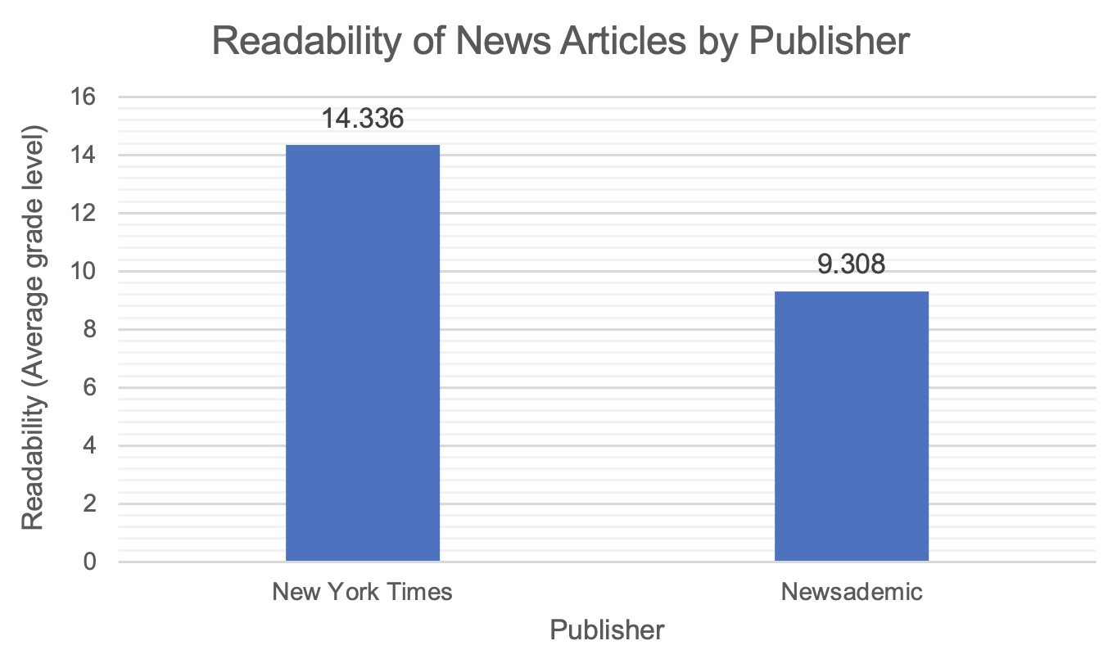

Figure 1: Average readability grade levels of news articles published by New York Times and Newsademic

From the New York Times corpus, the average readability can be demonstrated by the sentence from the article Cuba Resets the RevolutionCuba Resets the Revolution, “Cuba, instead, continued to rely on one export commodity — sugar — which the Soviet Union bought at subsidized prices,” which has an average grade level of 14.06. From the Newsademic corpus, the sentence from End of Revolution in Cuba?, “At the time the U.S. was an enemy of the communist Russian led Soviet Union,” has an average readability of 9.54, which is the closest to the overall average of all Newsademic news articles.
The readability level of New York Times articles ranges from 12.6 to 17.22, while that of Newsademic articles ranges from 7.64 to 10.56. It is to be observed that the maximum grade level of Newsademic articles is lower than the minimum level of New York Times articles.

