This is a list of goats that we currently have for sale.

Dolly. She is 2 years old and is an angora.

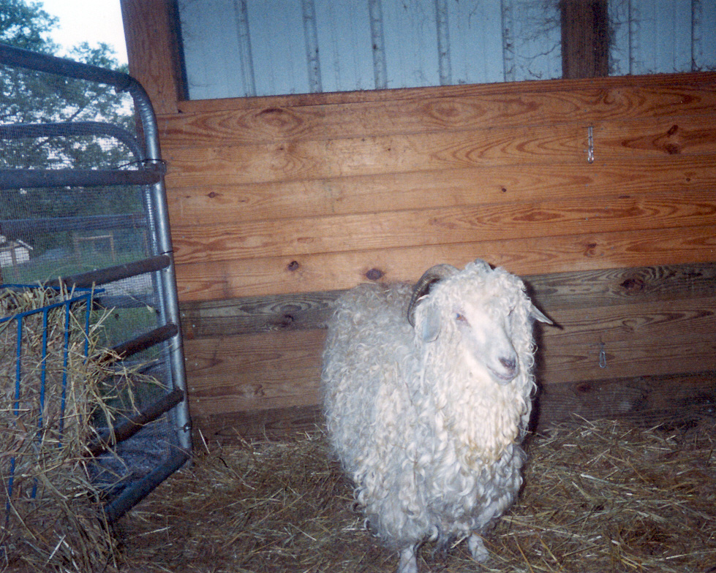

Dolly. She is 2 years old and is an angora.

Dolly. She is 2 years old and is an angora.

