This exam consists of 5 pages and 12 questions. Total points are 100. Allot 1 min/2 points. On questions with choices, all of your answers will be graded and the best scoring answer will be used. Use the space provided.

1. (2 pts) Which of the following does **NOT** play a predominate role in the energetic of protein folding (circle best answer)?

a) van der Waals forces

b) hydrogen bonds

c) electrostatic forces

d) hydrophobic effect

2. (4 pts) Briefly discuss why all of the following compounds are soluble in water and then indicate which of the three would be the most soluble in water. Justify your answer.

a) methanol (CH3OH)

b) ethanol (CH3 CH2OH)

c) propanol (CH3 CH2CH2OH)

3. (3 pts) Briefly relate **one** of the following two properties of water to its molecular structure.

**Choice A:** density of ice.

**Choice B:** heat capacity of liquid water.

4. (6 pts) The peptide bond is described as “planer and trans”. Briefly describe why the peptide bond has these characteristics.

5. (9 pts) Two different proteins (A and B) contain an imidazole group as part of one of their amino acids. The structure of these two proteins is shown on the right. The “+” symbols refer to positive charges. [Hint: The imidazole is shown in the deprotonated state.]



i) (1 pt) Which of the following amino acid has an imidazole as part of its sidechain (circle correct answer):



Glutamine Asparagine Histidine Lysine Arginine.

ii) (4 pts) Assume that the pKa of the imidazole group in protein A is 6, predict the pKa of this group in protein B. Briefly justify your answer.

iii) (4 pts) Sketch, in the box on the right, the % activity of protein A as a function of pH, assuming the protonated form of the imidazole is the active form. The pH range should be from 4 to 8. Be sure to label the axes.

6. (12 pts) You wish to make a buffer solution at pH = 4. The reaction that you are buffering produces acid, i.e. it will lower the pH. Your choices of weak acids for the buffer are:

i) Acetic acid (pKa=5.0),

ii) Pyruvic acid (pKa = 2.0)

iii) Tris (pKa =8.0)

a) (2 pts) Which buffer would you choose and why?

b) (4 pts) Sketch the titration curve for the buffer of your choice in the space on the right. Be sure to label both axes and indicate the major features (buffer region and eq. point) on this curve.

c) (6 pts) Assuming that you are beginning with the fully protonated form of the buffer (HA), calculate how many **equivalents** of NaOH would you need to add to the solution of protonated weak acid. Show your work on the back of pg 1, write your answer here:

7. (16 pts) Draw the chemical structure of a dipeptide in the box on the right , at pH = 7 (4 pts). Your first amino acid can be any acidic residue and your second amino acid should be **completely** non-polar, but do not use isoleucine (Ile) or alanine (Ala).

i) label the amino- and carboxy-terminus of your peptide and give the names of the two amino acids in the correct order (2 pts)

ii) Indicate the peptide bond (1 pt)

iii) circle the mainchain atoms (1 pt)

iv) indicate one hydrogen bond donating group on the mainchain atoms with the square box (2 pts)

v) estimate the net charge on your peptide, **assuming that the pH is the same as the pKa value of your acidic residue**. For partial credit, show your work on the back of the previous page, write your answer in the space to the right (4 pts):



vi) Do you expect your peptide to bind to the protein shown on the right? Justify your answer (2 pts)



8. (10 pts) You are trying to sequence a **12 residue** peptide using Edman degradation. The following peptide sequences were obtained after cleavage of the initial peptide with the indicated cleavage reagents. You can assume that it was possible to sequence the first five residues of each peptide. The peptide begins with the sequence: Ala-Gly-Val-Met-Glu

CNBr fragments: CNBr 1: Ala-Gly-Val-Met CNBr 2: Val-Gln-Asp-Thr CNBr 3: Glu-Arg-Trp-Met

Trypsin Digest: P1 : Ala-Gly-Val-Met-Glu P2: Trp-Met-Val-Gln-Asp

i) (6 pts) Determine the sequence of the original peptide. Instead of writing out the sequence, just give the correct order of the CNBr fragments, e.g. 1-2-3. Justify your approach on the back of the previous page.

|  |  |  |
| --- | --- | --- |
|  | **Amino acid** | **ε** |
| Trp | 5,050 M-1cm-1 |
| Tyr | 1,440 M-1cm-1 |
| Phe | 220 M-1cm-1 |

ii) (4 pts) What is the absorbance at 280 nm for a 1 uM (10-6 M) solution of this peptide?



9. (10 pts) Please do **one** of the following three choices.

**Choice A:** Briefly describe the molecular basis of the hydrophobic effect and indicate its role in the stability of folded proteins.

**Choice B:** Briefly describe conformational entropy and indicate its role in the stability of folded proteins.

**Choice C:** Briefly describe the role of van der Waals forces in the formation/stability of secondary **and** tertiary structures of proteins.

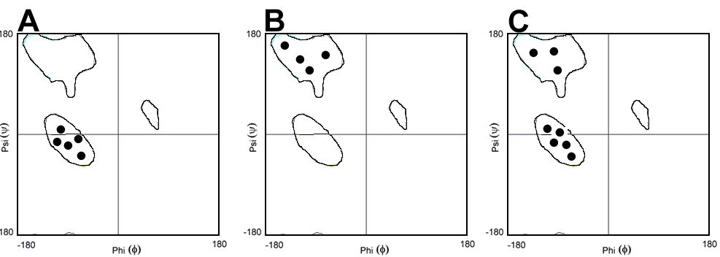

10. (16 pts) Three Ramachandran plots are shown on the right, labeled A, B, C.

i) (2 pts) What do the regions enclosed by contour lines represent?

ii)(3 pts) Indicate which plot corresponds to which secondary/super-secondary structure (circle correct answer)

A B C helical peptide

A B C β-sheet

A B C βαβ

iii) (6 pts) Pick any **one** of the above three secondary/super-secondary structures and briefly describe its structure (a sketch is an acceptable answer). Your sketch should indicate the location of hydrogen bonds and sidechain atoms.

iv) (3 pts) For the same structure that you picked in iii), describe the **main** energetic feature that is important for its stability.

11. (6 pts) Please do **one** of the following four choices:

**Choice A:** A protein consists of the following sequence of polar (open circles) and non-polar (closed circles) amino acids. Indicate which part of the protein will likely be helical and which part sheet? Briefly justify your answer.



**Choice B:** An isoleucine residue is buried in the core of a globular protein. In a mutant protein the isoleucine is replaced by an alanine residue. Briefly discuss how this replacement will affect **either** the enthalpy **or** the entropy associated with unfolding of the protein.



**Choice C:** A protein unfolds with an enthalpy of +200 kJ/mol and an entropy of 600 J/mol-K. How much of this protein is unfolded at 330K?

**Choice D:** What is a disulfide bond and why does it stabilize proteins which contain them?

ΔG0 = -RTlnKeq

R=8.3 J/mol-K

ΔG = ΔH - TΔS

For the reaction: N ⇔ U:

Keq = [U]/[N]

fu = Keq/(1+Keq)

fn = 1/(1+Keq)

12. (6 pts) Please do **one** of the following two choices.

**Choice A:** Using immunoglobulins (antibodies) as an example, briefly describe:

i) quaternary structure

ii) protein domains.

**Choice B:** Draw a “cartoon” diagram of an antibody and indicate on your diagram the following:

i) the location of the hypervariable loops.

ii) an Fab fragment

iii) Where the antigen binds.