Due Sunday October 6, 2019 ~90 min
1. (10 pts, 15 min) The regulation of the oxygen affinity of Hb by bisphosphoglycerate (BPG) is important in adaptation of oxygen delivery at high altitudes.
i) Open the Jmol page for this question. The structure of deoxy hemoglobin with BPG bound is shown on the left. The structure of oxy-hemoglobin is shown on the right. In the deoxy structure, measure the distance between the two NE2 atoms on the histidine residues that contact the BPG (shown in spacefill). You can highlight the two atoms on each histidine by checking the “His” box. What is this distance? (2 pts)
ii) Now measure the size of the potential BPG binding pocket on oxy-hemoglobin by measuring the distance between the two NZ atoms on the lysine residues. You can highlight the two atoms on each lysine by checking the “Lys” box.
iii) Discuss why BPG cannot bind to oxygenated hemoglobin (2 pts).
iv) If His145 on the β-chains of hemoglobin were replaced by aspartic acid would it be necessary to have much higher, or much lower, BPG level to achieve the same effect on oxygen delivery. Why? [His 145 is one of the His residues from the β-chain that is shown in the diagram of the BPG - hemoglobin complex in lecture 13, it is also the histidine whose atoms are highlighted on the left Jmol page when you click “His”]. (4 pts)

2. (5 pts, 15 min) You are investigating cooperative binding to a protein that has four binding sites for a ligand and you experimentally measure the first (K_{A1}) and last (K_{A4}) values by measuring the binding at very low and very high ligand concentration. These are macroscopic K_{A} values. You obtain values of 4 x 10⁴ M⁻¹ and 0.25 x 10⁴ M⁻¹, i.e. the last K_{A} is smaller than the first, suggesting weaker binding and negative cooperativity. Is this actually the case?

3. (6 pts, 15 min) A dimeric protein shows two K_{D} values, the first K_{D} is 10⁻⁴ M and its second K_{D} is 10⁻⁵ M. Its Hill coefficient is 1.5.
i) Sketch, in the diagram on the right, the Hill plot for this protein (2 pts).
ii) Estimate the K_{D}^{OBS} from your Hill plot, this is the ligand concentration to give Y=0.5 (2 pts).
iii) Indicate the distribution of bound ligands you would expect to see when Y=0.5, using the lower diagram. Briefly justify your drawing (2 pts).

4. (5 pts, 15min) Most enzymes contain functional groups in their active site that assist in performing a chemical reaction. Antibodies also act as catalysts if they preferentially bind to the transition state of the reaction, i.e. the K_{D} for binding to the transition state is smaller than the K_{D} for binding to the substrate. These catalytic antibodies are called Abzymes. Abzymes usually do not contain any groups that directly assist in the mechanism, yet they still catalyze the reaction. Explain why these antibodies are catalysts. [Hint: The reaction rate depends on the concentration of the transition state, how will adding an Abzyme to a solution of substrate affect the concentration of the transition state?]
Fun fact: Catalytic antibodies can be used to treat cocaine overdose by catalyzing the hydrolysis of cocaine, as shown to the right.

5. (5 pts, 20 min) A sequence alignment of a number of ribonucleases is shown below. Ribonucleases degrade RNA molecules. The pH dependence of k_{CAT} is shown on the right. You can view the enzyme using JMol using the link on the problem set page. The JMol page provides instructions on how to visualize the location of individual residues, or multiple residues.
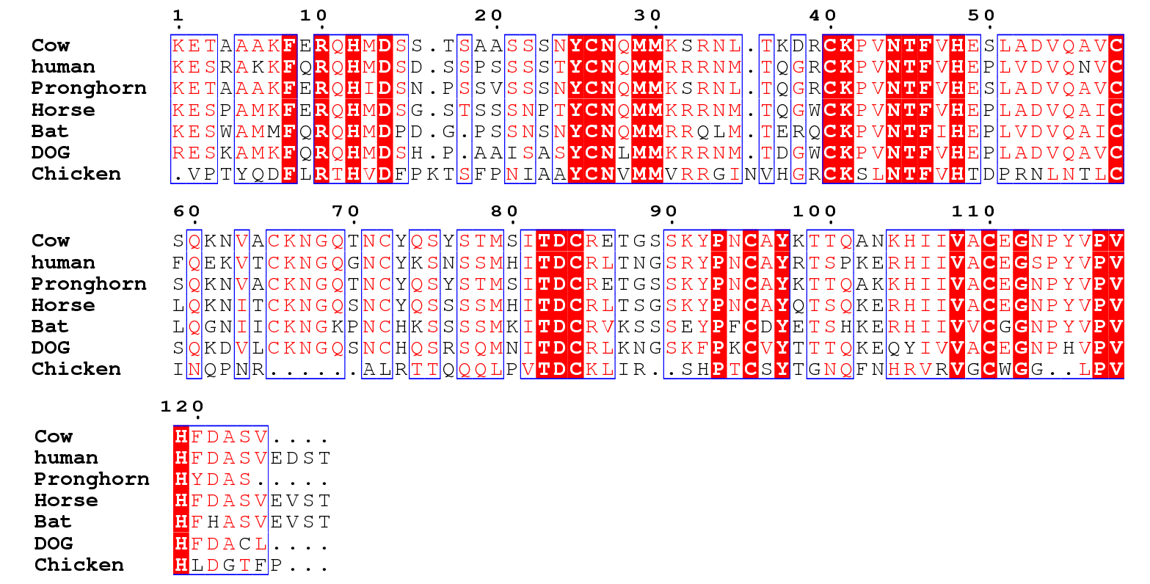
Use this information to determine the key catalytic residues for ribonuclease. Briefly justify your answer.

6. (7 points, 10 min) The following question will require you to visualize some trypsin structures using Jmol. The URL to the Jmol page can be found on the problem set page. These enzymes have various mutations (amino acid changes). Depending on your last name, select the appropriate mutant enzyme (i.e. Trp2-Trp6) and answer the following questions.
Trp2: Moza Al Shurkri, Aya Al-Ansari, Mohammed Al-Lakhen
Trp3: Asma Al-Maraghi, Amna Al-Sayegh, Lulwa Alhaddad, Alreem Alkhanji
Trp4: Sara Alyafei, Maryam Aslam, Laila Assami
Trp5: Mahnoor Fatima, Haher Habboub, Mohammad Hammad
Trp6: Syeda Hira Hashim, Thamanna Muhammed Hashir, Ayah Salameh, Mohammed Sayed
i) State which residue was altered in your assigned protein and how it was altered (Sample answer: Asp189 to Ala) (2 pts).
ii) Sketch both the wild-type (no mutations) and your enzyme, indicating the location of the amino acid change in your particular enzyme. The level of detail that you should provide is indicated in the sketch on the right. Note that this sketch has several errors and missing functional groups (e.g. atoms are missing from the sidechain of the substrate). Your sketch should portray the correct structure of the enzymes as you would find in the starting (ES) complex (5 pts).

