Due Sunday – September 15. This problem set should take you ~95 min to complete.
1. (6 pts, 15 min) You are growing a 0.5 L culture of bacteria in growth media that is buffered with 0.05 M Succinate, at an initial pH = 6.2. After 6 hours of growth, the pH rises to 6.5 due to the release of organic bases by the bacteria. Since the bacteria grow optimally at pH 6.2 you would like to return the pH back to 6.2. How many moles of HCl would you need to add to the 0.5 L culture to restore the pH to 6.2? You can assume that the pK_{a} values of succinate are 4.2 and 5.6.
Hint: Try one of the following,
- Sketch a titration curve to approximate how many equivalents of acid you would need to move from a pH of 6.5 to 6.2.
- Sketch a curve of fraction protonated versus pH (for the appropriate pKa value) to help you figure out the number of equivalents that would be required to move the pH from 6.5 back to 6.2.
2. (5 pts, 10 min) The sequence of three tripeptides are given below. Which of these peptides will bind most tightly a positively charged surface, assuming pH=6.0? Use the pKa values from lecture 5. Briefly justify your answer with reference to the sequence of each peptide. (The different amount of binding to the surface would potentially provide a mechanism to purify the peptides from each other).
A: Ala-Glu-Leu B: Ala-His-Leu C: Ala-Lys-Leu
3. (12 pts, 20 min) Digestion of a peptide with Trypsin, Chymotrypsin, and Cyanogen bromide produced the sequence data given below. Note that it was only possible to perform Edman degradation for seven cycles, i.e. it is only possible to determine the sequence of the first seven residues of any peptide, even though the peptide may have been longer.
i) Determine the sequence of the original peptide. Show how you arrived at the sequence and demonstrate that your final answer is consistent with the experimental data (10 pts).
a) The products from Cyanogen bromide treatment gave peptides with the following sequences:
Arg-Ser-Cys-Met Gly-Arg-Ser-Thr-Gly Trp-Gly-Ala-Val-Ile-Leu-Met
b) Trypsin digestion produced one free amino acid (not identified), and the following peptide sequences: Ser-Thr-Gly Ser-Cys-Met-Trp-Gly-Ala-Val
c) Chymotrypsin digestion produced the sequences of the following peptides:
Arg-Ser-Cys-Met-Trp Gly-Ala-Val-Ile-Leu-Met-Gly
ii) Draw the chemical structure of the b₁ ion that would be measured by mass spectrometry and give its mass (2 pts).
4. (5 pts, 5 min) You are sequencing a small protein by mass spectrometry and find the following masses for the b-fragments. What is the sequence of the protein? A table of residue masses is provided on the following page: b₁=58 b₂=129 b₃= 242 b₄= 405 b₅= 518
The following questions (6-8) will require you to view JSmol structures.
5. (3 pts, 10 min) Use the protein G structure to learn more about β-stands. Please answer the following questions:
i) What strand contains residues 42 and 47 (counting strands from the amino terminus).
ii) What is the distance between the mainchain nitrogen atoms of residue 42 and 47? (spanning 5 residues)
Can’t find the amino terminus? Try the following using the menu: Color:Structures:Cartoon:By scheme:Group. The amino terminus will be blue.
6. (4 pts, 10 min) Use the protein G structure to learn more about α-helices. Please answer the following questions:
i) What is the distance between the mainchain nitrogen of Ala 26 and Asn 37?
ii) How many residues would be required to span this distance if these residues were in a β-strand?
iii) Determine the relationship between hydrogen bonded residue in a helix. If the “i^{th}” residue is the C=O acceptor, which residue is providing the donor (e.g i+2).
7. (5 pts, 10 min) The absorbance (A) of a solution of protein G was measured at λ=280 nm and found to be 0.75. The path length is 1cm. Using the composition from the Jmol page (see instructions on the page), and the extinction coefficients given in lecture, determine the concentration of the protein in solution. Please show your work.
8. (5 pts, 10 min). The Ramachandran plot for proline is shown on the right. Explain why the plot for proline is much more restrictive than the other 18 amino acids.

9. (5 pts, 5 min) Below are the Ramachandran plot for two proteins.
i) Match the protein (A or B) to its corresponding Ramachandran plot. Please justify your answer.
ii) Glycine appears to be very rare in both of these proteins. How could you conclude that from the Ramachandran plots alone?

Protein A Protein B
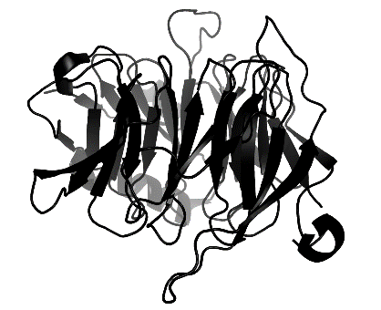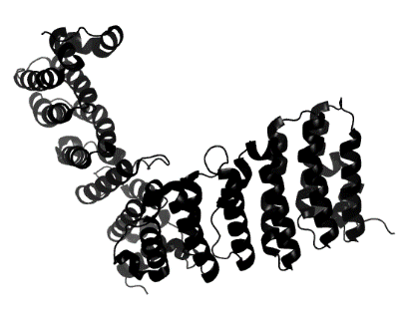

Plot 1
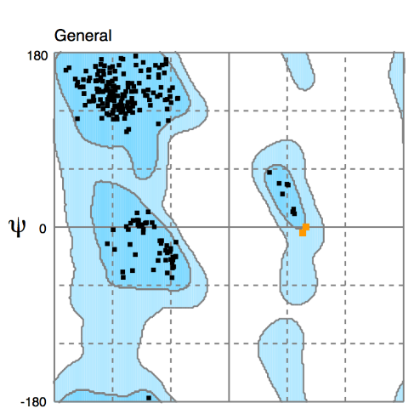 Plot 2
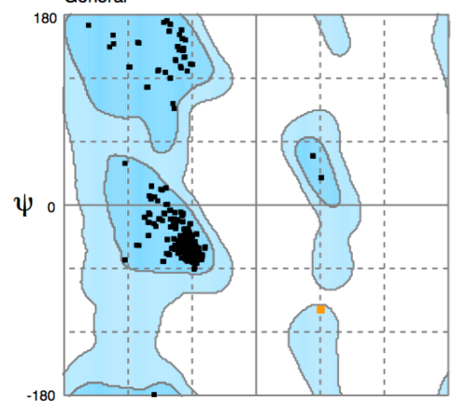

X axis - φ

