Problem Set 2: Due Sunday September 8 Estimated time: 80 min
1. (6 pts, 10 min) Imagine a solution of water that is divided into 20 cubes and each cube contains one water molecule. The entropy of this solution is zero because exchanging one water molecule for another does not change anything. In other words, there is only one way to arrange 20 identical molecules and S=RlnW, W=1.
i) Calculate the entropy associated when one of the water molecules is replaced by a Na ion. Is the entropy change positive or negative, is this favorable or unfavorable?
2. (4 pts, 5 min) A Venn diagram that organizes the amino acids by the properties of their sidechains is shown on the right. Glycine is omitted since its sidechain is just a hydrogen atom. As the diagram suggests, a sidechain can be non-polar, charged (in the pH range 0 to 10), or polar. Some amino acids belong to more than one set, e.g. all charged residues are also polar.
i) Two amino acids are very clearly in the wrong set. Which are they and where should it be placed? Briefly justify your answer.
3. (10 pts, 15 min) An enzyme contains a single histidine (His) that must be deprotonated for the enzyme to be active. NMR (nuclear magnetic resonance) was used to measure the fraction protonated for this residue, utilizing the fact that the chemical shift (=absorption wavelength) of the protons on the sidechain change due to protonation/deprotonation.
i) What is the chemical shift of the fully protonated His? Briefly justify your answer (1 pt).
ii) Determine the pKa of the histidine from the chemical shift data (2 pts).
iii) Plot the curve of activity versus pH, your x-axis should be from pH=4 to pH=10 (submit the plot) (4 pts).
iv) The pKa for the sidechain on this His is different than free His (pK_{a} = 6). Based on the shift in pK_{a}, what type of environment surrounds this residue in the protein, i.e. are there positively or negatively charged groups near the His? Justify your answer (3 pts).
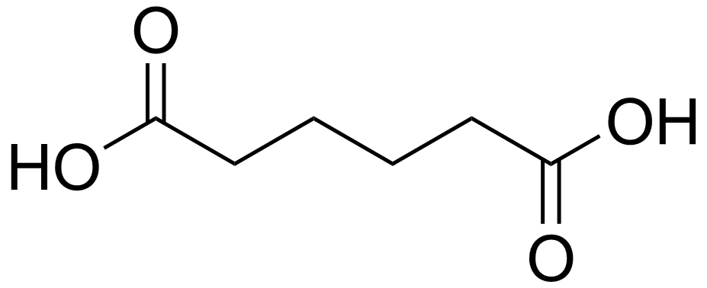
4. (16 points, 25 min) You are required to make a 500 ml solution of 0.2 M adipic acid to use as a buffer to perform a biochemical experiment at pH 6. You only have the fully protonated form of this acid in the lab (shown on the right), plus 1M solutions of HCl and NaOH. Assume that the pK_{a} values for adipic acid are 4.4 and 6.4.
i) Sketch a titration curve for adipic acid (4 pts).
ii) How many moles of adipic acid would you need for your buffer solution (2 pts)?
iii) Why does your answer to part ii) not depend on the pH of the solution (2 pts)?
iv) Calculate the number of equivalents of HCl (or NaOH) that you would need to adjust the pH of the solution. Briefly explain your choice of HCl (or NaOH) (4 pts).
v) Convert the equivalents of HCl (or NaOH) to number of moles (2 pts).
vi) Explain why the two pKa values are different, even though the same chemistry occurs for each ionization (4 pts).
5. (15 points, 25 min) View the JSmol structure associated with your last name (see webpage) and answer the following questions. Please indicate your “section” on your homework (A, B, or C)
i) Draw the chemical structure of this three-amino acid peptide, assuming pH = 7.0. Omit hydrogens attached to carbon (5 pts).
ii) Write the correct sequence of your peptide. You will need to look at the sidechain groups to determine the identity of each amino acid residue; the labels provided by JSmol are erroneous (2 pt).
iii) Draw a dotted line on your diagram that completely encloses all the mainchain atoms of this peptide (2 pt).
iv) Which pair of labeled atoms (A-F) on the Jmol structure represent the peptide bond, indicate this bond on your sketch (2 pts).
v) Which labeled atom can act as a hydrogen bond acceptor? Indicate this atom on your sketch and draw a water molecule forming a hydrogen bond with this atom (2 pts).
vi) Which labeled atom (or pairs of atoms) on the Jmol structure can act as a hydrogen bond donor? Indicate this atom on your sketch and draw a water molecule forming a hydrogen bond with this atom (2 pts).

