**Lecture 39: tRNA Charging, Codon-anticodon Interactions, Intro. to Protein Syn.**

**RNA molecules involved in protein synthesis:**

a) mRNA – messenger RNA is copy of the DNA that encodes a gene. mRNA specifies the order of amino acids to be used in making the protein.

b) tRNA – transfer RNA is the dictionary the converts the codon to a specific amino acid. One part of the tRNA recognizes the codon, the other part contains the aminoacid to add.

c) rRNA – ribosomal RNA is found in the ribosome and is responsible for most of the function in protein synthesis.

**tRNA:** Although it varies, there are generally 25-45 different tRNAs/organism. This complex single chain RNA molecule structure is stabilized by W-C H-bonds, non-W-C H-bonds, and phosphate-metal interactions.

* **Acceptor stem:** amino acids are attached to the 3' terminus of the tRNA by enzymes called **aminoacyl-tRNA Synthetases (aaRS).** These enzymes attach the *correct* amino acid to the *correct* tRNA. There are ~25-30 of these enzymes, essentially one for each amino acid. This process is often referred to as “charging” the tRNA.
* 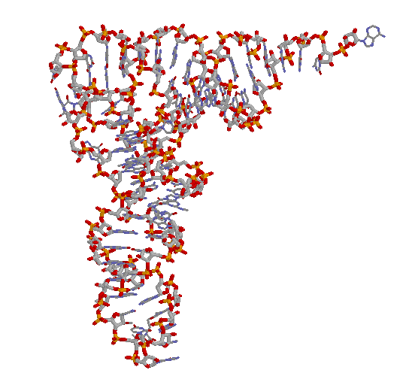**Anti-codon arm**: contains the anticodon triplet that translates the codon in mRNA to an amino acid. Watson-Crick H-bonds are used here.

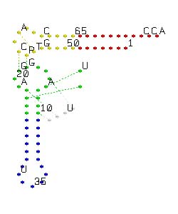

**"Charging" of tRNA:** amino acyl tRNA synthetases.

**tRNA Charging: [AAX + ATP → AAX-AMP + 2 Pi] + tRNAX → tRNAx-AAX + (AMP +2Pi)**

**1. Activation of Amino acids (2 ATP equivalents)**



**2. Transfer to tRNA**



**Codon-Anticodon Interactions**



|  |  |  |  |  |  |
| --- | --- | --- | --- | --- | --- |
| **5' Base** | **Middle Base** | | | | **3'** |
|  | **U** | **C** | **A** | **G** |  |
| **U (=T)** | Phe | Ser | Tyr | Cys | **U** |
|  | Phe | Ser | Tyr | Cys | **C** |
|  | Leu | Ser | **Term** | **Term** | **A** |
|  | Leu | Ser | **Term** | Trp | **G** |

1. Charged tRNAs are selected by ribosomes solely through codon-anticodon interactions.

2. Degeneracy at the third position of codon-anticodon pairing allows multiple codons/tRNA.

**Example:** pairing combinations for tRNAPhe (superscript ‘Phe’ indicates that this tRNA will be attached to Phenylalanine.)

i) The codon-anticodon pairing is **anti-parallel**, as are most pairings of nucleic acid strands:a)

ii) The anticodon on the tRNA is 5'-GAA-3'.

iii) The complementary codons in the mRNA are 5'-UUC-3' and 5'-UUU-3'.

iv) The anticodon GAA can pair with either codon due to degeneracy at the third position (wobble basepair).

**Protein Synthesis - Overview:**



1. The information content of the mRNA is *translated* into a polypeptide chain by the **ribosome**. Three nucleotide bases, or a **codon**, encode each amino acid.
2. mRNA is the template, and synthesis of the polypeptide chain proceeds in the **amino→carboxy** direction as new amino acids are added to the carboxy terminus of the growing peptide chain.

**A. Features of the mRNA** (Example - Synthesis of Met-Lys-Ala).

**Beginning with the DNA:**

**TTGACA**TTTATGCTTCCGGCTCG**TATAAT**GTGTG**G**AAT**TGTGAGCGGATAACAATTTCACACA**GGAGGAACAGCT**ATGAAAGCTTAATTTATG.**

**AACTGT**AAATACGAAGGCCGAGC**ATATTA**CACAC**C**TTAACACTCGCCTATTGTTCCCGTGTGTCCTCCTTGTCGA**TACTTTCGAATTAAATAC**.

-35 -10 → Lac operator

Promoter mRNA start

**The mRNA:**

*Without punctuation:*

**G**AAUUGUGAGCGGAUAACAAUUUCACAC**AGGAGG**AACAGCU**AUGAAAGCUUAAUUUAUG.....**

*With punctuation*

**G**AAUUGUGAGCGGAUAACAAUUUCACAC**AGGAGG**AACAGCU**AUG,AAA,GCU,UAA,UUU,AUG...**

**fMet-Lys-Ala-STOP**

|  |  |  |  |
| --- | --- | --- | --- |
| **Ribosome Binding Site (RBS)**: (Shine-Dalgarno [SD] sequence-AGGAGG.)  *Positions mRNA on the ribosome so that the correct start codon is used.*  *Complementary to 16s rRNA in 30s subunit.*  The optimal spacing between the SD sequence and the AUG is 6 or 7 bases. | **Start codon:** AUG codes for the 1st amino acid, always a modified methionine (N-formyl methionine, fMet).  *This codon sets the reading frame.*    N-formylMet Met | **Codons:** Each triplet of bases following the start codon codes for one amino acid.  *Translation performed by appropriately charged tRNAs.* | **Stop codon:**  Signals end of the protein (UAG, UAA, UGA)  Protein is hydrolyzed from last tRNA. |

**Ribosome -** The ribosomal subunits and their RNA components are named for their sedimentation coefficients, S, which is a measure of how rapidly they move when a centrifugal force is applied. 50s+30s=70s!



|  |
| --- |
| **50S Subunit**   * 31 Proteins * 23S and 5S rRNA |
| **30 S Subunit**   * 21 proteins * 16S rRNA - *binds to Ribosome Binding Site (SD) on mRNA.* |

**Polypeptide Synthesis:**

1. The polypeptide grows stepwise as a ribosome-bound, peptidyl-tRNA. Discrete sites on both ribosomal subunits are involved in elongation.

a) The **A site** binds the **aminoacyl-tRNA** (charged tRNA) corresponding to the next amino acid.

b) The **P site** holds the **peptidyl-tRNA** at the start of each cycle **-** the growing chain.

c) The **E site** is the **exit** site for the uncharged tRNA, site after peptide bond formation.