**Lecture 29: Glycolysis**

**Key Terms:**

1. **Glycolysis:**
2. **Location**: cytosol
3. **Input**: glucose
4. **Output**: pyruvate



1. **Net energy prod.**: 2 ATP, 2 NADH
2. **Key controlling step**: PFK

* **Kinase (X + ATP → X-P + ADP)**
* **Dehydrogenase (Redox)**
* **Substrate-level phosphorylation**



**1. Hexose kinase Reaction**: Glucose + ATP → Glucose-6-P + ADP



**What you should note:**

* Reactions on the left with unfavorable energy changes (red arrows) become favorable in glycolysis due to coupling.
* The energy released (yellow highlight) from oxidation and dephosphorylations on the left is efficiently captured as NADH or ATP in glycolysis.

Group transfer reaction: Phosphate is transferred from ATP to glucose.



* Traps glucose in the cell as G-6-P
* Favorable hydrolysis of ATP **directly coupled** to phosphorylation of glucose.
* Transfer of the phosphate group on ATP to water is negligible because water is excluded from the active site by a conformational change of the enzyme. Binding of the substrates causes a large change in the structure of the enzyme to produce the catalytically competent conformation.

**Glucose accumulation in cell – An example of indirect coupling:**

Hexose kinase keeps the concentration of glucose inside the cell below its equilibrium value, making the flow of glucose into the cell spontaneous (ΔG<0). Calculate the sign of the Gibbs Free energy for the transport of glucose across the cell membrane in the absence (left) and presence (right) of hexose kinase activity to see that this is the case.



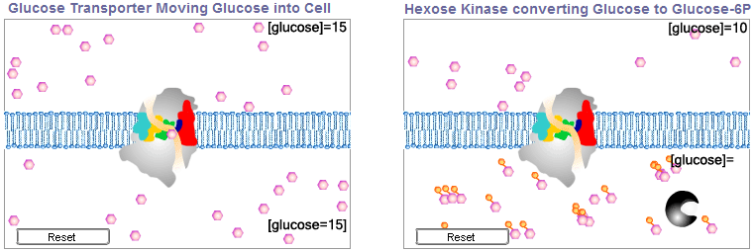

**3. Phosphofructokinase (PFK):**



Fructose -6-P + ATP→ Frucose-1,6-bis phosphate (F16P)

* Favorable hydrolysis of ATP **directly coupled** to phosphorylation of fructose-6-P.

**4. Aldolase Reaction-Indirect Coupling.** The large free energy change in the last step of glycolysis (PEP to pyruvate) keeps the concentration of all previous intermediates low, allowing the aldolase reaction to proceed spontaneously.



**5. Glyceraldehyde-3-P Dehydrogenase:** This reaction proceeds in two steps. The first step is the oxidation of the aldehyde to the carboxylic acid using NAD+ as the electron acceptor. This results in the formation of a covalent enzyme intermediate. The second step is the phosphorylation of the carboxylic acid by inorganic phosphate. Both reactions are catalyzed by a single enzyme.



The Reaction Steps are (see diagram to right)

I. ES complex, active site Cys is deprotonated.

II. Thio group is a nucleophil, attacks aldehyde, proton is transferred to NAD+ as a hydride (H-), net transfer of 2 electrons and one proton.

III. NADH is released. 3-P-G remains bound to the enzyme as a stable thioester intermediate.

IV. Attach of Pi, producing 1,3-bisphosphoglycerate

