Lecture 25: Lipids Horton 9.1-9.3, Nelson & Cox 10.1

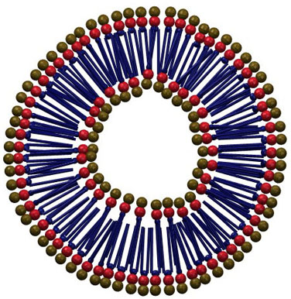

A. Fatty Acids:
A1. Structure:
A2. Nomenclature for fatty acids:
# Carbons | Name
12 | Lauric acid
14 | Myristic acid
16 | Palmitic acid
18 | Stearic acid
20 | Arachidic acid
18:1 cΔ9 (C₉ = C₁₀) | Oleic

A3. Thermal Transitions in Fatty Acids:
- As the length of the chain increases, so does T_{M.}
- The presence of a cis double bond drops the melting temperature.

A4. Interaction with water

1. Fatty acids form micelles, aggregates of fatty acids with a polar (charged) surface and a hydrophobic, waterless, interior. The assembly of micelles is spontaneous and driven by the hydrophobic effect.

2. The CMC (critical micelle concentration) is the highest concentration of monomeric fatty acids in solution.

3. The non-polar interior can dissolve hydrophobic compounds (oily 'dirt'), therefore, fatty acids and modified fatty acids (e.g. SDS) are the principal components of soaps.

4. Free fatty acids are essentially toxic since they can dissolve normal cell membranes in the same way soap would. Therefore, fatty acids are incorporated into triglycerides, phospholipids, or transported on proteins.

B. Waxes: Ester of a fatty acids and an alcohols, e.g. beeswax:
CH₃(CH₂)₂₉O-CO-(CH₂)₁₄CH₃

C. Triglycerides:

Trans/unsaturated-Fat:
Corn "oil" is a complex mixture of unsaturated triglycerides that are extracted from corn. Corn oil, as with most triglycerides from plants (e.g olive oil), is a liquid at room temperature. To make solid margarine from corn oil it is necessary to convert the double bonds to single bonds by the addition of hydrogen - the product is referred to as "hydrogenated" oil. This involves the reaction of the triglyceride with hydrogen gas (H₂) and a catalyst, giving the products shown to the right.
i) Why is corn oil a liquid at room temperature?

ii) Why does hydrogenation raise the melting temperature of the triglyceride, such that it forms a solid at room temperature?

The health effects on consuming too much trans-fatty acids in triglycerides are:
- trans fats interfere with absorption of essential fatty acids.
- trans fats modify the properties of the lipid bilayer in cells.
- trans fats can change the ratio of blood lipo-proteins, potentially leading to coronary diseases.

Phospholipids:
Glycerophospholipids:
- Head group + phosphate + glycerol + two fatty acids (acyl chains) of various types form a phospholipid.
- Various head groups are attached to the phosphate, giving a diverse set of lipids.
- The nomenclature indicates the type of fatty acid attached to the 1 and 2 positions of glycerol as well as the type of head group on the phosphate.
Head group(-X) | Name of Phospholipid | Net Charge
none | phosphatidic acid (PA) | -1
Choline (-C-C-N⁺(CH₃)₃) | Phosphatidylcholine (PC), called lecithin | 0 (zwitterion)
Serine (linkage via sidechain) | Phosphatidylserine (PS) | -1

Physical Properties of Pure Lipid Bilayers:

1.Phospholipids self-assemble in water to form bilayers (two opposing layers of phospholipids). Bilayers are formed instead of micelles because the cross section of the head group is roughly equal to the cross section of the 2 fatty acid chains found in phospholipids.

2. The bilayers form closed, water filled, vesicles with a 40-50 Å thick wall. The non-polar acyl chain width is about 30 Å.
3. Permeability properties:
- Charged compounds do not cross the bilayer.
- Polar ones infrequently.
- Non-polar ones readily.

