**Lecture 19: Inhibitors II & Introduction to Retroviruses.**

**Mixed Inhibition**

|  |  |
| --- | --- |
|  | **Mixed Inhibitor** |
|  |  |
| **No Inhibitor Present** |  |
|  |
|  |  |
|  | **α** = ratio of slopes  (+I/no inh)  **KI = [I]/(α-1)**  **α’** = ratio of y-intercept  (+I/no inh)  **KI’ = [I]/(α’-1)** |

* **T**he inhibitor binds to **both** [E] and [ES].
* The binding site of the inhibitor is **not** at the active site.
* The inhibitor binding causes a change in the conformation of the protein that affects either substrate binding, the chemical step or both.
* KI characterizes dissociation from (EI)
* KI characterizes dissociation from (ESI)
* *Both* VMAX and KM can be altered by mixed inhibitors since the precise geometry of the active site is altered when the inhibitor is bound. The change in VMAX and Km can be used to find KI and KI’.



|  |  |  |
| --- | --- | --- |
|  | **Binds to (E)** | **Binds to (ES)** |
| **Mixed type** | **Yes (diff affinity)** | **Yes (diff affinity)** |
| Uncompetitive | no | Yes |
| Noncompetitive | Yes (same affinity) | Yes (same affinity) |

**Obtaining KI and KI for Mixed Inhibitors:**

The values of α and α' can be easily found from the slope and intercept of double reciprocal plots.

The six easy steps are:

1. Obtain v versus [S] in the *absence* of inhibitor.

2. Obtain v versus [S] in the *presence* of a *fixed* and *known* concentration of inhibitor.

3. Plot both data sets on a double reciprocal plot

4**. α = ratio of the slopes.**

5. **α' = ratio of Y-intercepts.**

6.  and 

**Example:**

|  |  |  |  |  |  |
| --- | --- | --- | --- | --- | --- |
| **[S] mM** | **v**  **([I]=0)** | **v**  **I=10**μM | **1/S** | **1/V**  **([I]=0)** | **1/V**  **I=10**μM |
| 1 | 16.7 | 2.9 | 1.0 | 0.060 | 0.340 |
| 5 | 50.0 | 10.0 | 0.2 | 0.020 | 0.100 |
| 10 | 66.7 | 14.3 | 0.1 | 0.015 | 0.070 |
| 20 | 80.0 | 18.2 | 0.05 | 0.0125 | 0.055 |

**KI - Obtain α - ratio of slopes.**

Slope [I=0]:

Slope [IB]:

α =slope([IB]>0)/slope([I]=0): KI:

**KI’ Obtain α' – ratio of y-intercepts:**

α' = y-int([IB]>0)/y-int([I]=0): K’I:

**Suicide Inhibitors**



* Inhibitor binds and forms a covalent bond with the enzyme, inactivating it.
* Nerve gas sarin modifies the active site serine in the serine esterase acetylcholine esterase

**Human Immunodeficiency Virus (HIV)**

The normal flow of information in cells is: DNA → mRNA → protein

In retroviruses, the genetic information is stored in RNA (vRNA) which must be first be copied into DNA. The flow of information in retroviruses is: vRNA → DNA → mRNA → protein

→ vRNA

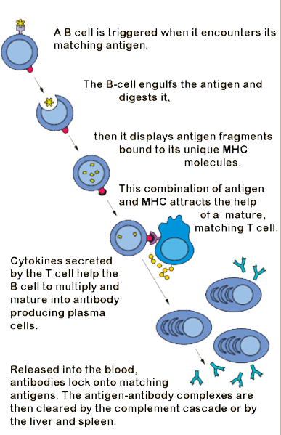**Central Role of T-helper (TH) Cells in Immunity:**

* Activate B-cells so that they can differentiate into plasma cells → secrete antibodies that inactivate pathogens (bacteria, viruses).
* Infection of the TH cells by HIV results in loss of TH cells.
* HIV infected individuals cannot make antibodies against relatively harmless pathogens and will die from common infections or rare cancers.

**HIV Viral Infection of T-Helper Cells:**

1. Viruses bind to molecules displayed on the TH cell surface.

2. The virus then fuses with the cell membrane and releases its RNA genome from its lipid envelope.

3. The enzyme **reverse transcriptase** first makes a double-stranded DNA copy of the viral RNA molecule. This process is error prone, leading to mutations in the virus. *These mutations cause drug resistant strains of the virus to arise.*

4. The DNA is integrated into the host cell’s DNA by an enzyme called **integrase**.

5. Integrated DNA produces vRNA, the genetic material for new virus particles. mRNA is also made from this DNA, to produce proteins for new particles.

6. Immature (extra long) viral proteins are made from mRNA.

7. **HIV protease** required for maturation of viral proteins , by cleaving them into smaller proteins that form the mature virus.

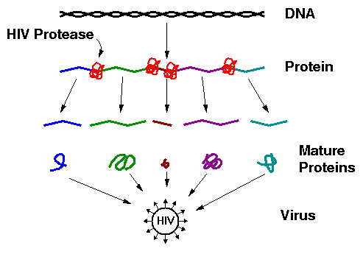The virus particle contains reverse transcriptase, integrase, and HIV protease (in addition to the vRNA genetic material).