**Lecture 11: Ligand Binding Measurements**

**Goals:**

* Identify protein-ligand interactions
* Relate binding kinetics to interactions
* Use KD to characterize strength of binding
* Obtain KD from:
  + Raw data
  + Binding curve
  + Scatchard plot
  + Hill plot

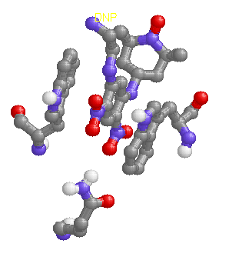**Stabilization of Antibody-Antigen Complexes:**

Any (and all) of the following energetic terms may be important for binding of ligands to proteins.



|  |  |  |
| --- | --- | --- |
|  | Anti -DNP | Anti-PCP |
| Hydrophobic effect |  |  |
| hydrogen bonding |  |  |
| van der Waals |  |  |
| Electrostatic Interactions |  |  |

**i) Anti-dinitrophenyl antibody:** The structure of the antibody-DNP complex is an example of how an antibody binds a small chemical.

**ii) Anti-Phencyclidine (PCP, angel dust) antibody – drug detoxification.**

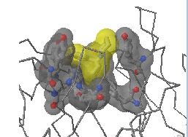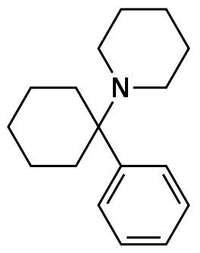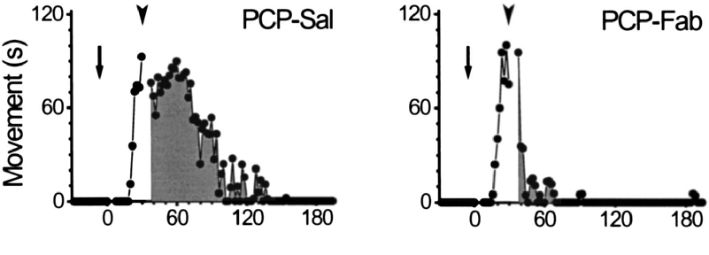

**Ligand Binding Measurements: Reading:** Nelson pp 155-157.

**A. Fundamentals of Ligand Binding:**

M = macromolecule

L = ligand

* Ligands collide with their targets, at a rate of *kon*. Usually this is diffusion limited and occurs at a rate of about 108 sec-1M-1 (108 collisions/sec at a concentration of 1M).
* The ligand leaves its binding site at a rate that depends on the strength of interaction between the ligand and the binding site. Off-rates (*koff*) can range from 106 sec-1 (weak binding) to 10-2 sec-1 (strong binding).



* If there is more than one binding site, the binding may be c**ooperative** if the binding to one site affects the binding to another.
  + A single binding site must always be non-cooperative.

The equilibrium constant for binding is given by:



where [ML] is the protein-ligand complex, [M] is the concentration of free macromolecule, and [L] is the ligand. For example, [M] could be an FAB fragment and [L] could be a hapten.

The representation of KEQ in term of kinetic rates comes from expressing the change in [ML] as a function of time, and then setting this change to zero at equilibrium:



Usually, the term **KA** , or **association constant**, is used for the equilibrium constant. Don't get this confused with the acidity constant used to describe acid-base reactions.

This equilibrium constant is related to the free energy of binding in the usual way. Notice that KA is no longer dimensionless, as it was for protein folding, so you much *always* work in molar units when calculating energies:



[Usually reaction direction is P+L→(PL)]

It is very useful to define a **dissociation constant, KD**:



**The KD has units of molarity and is the ligand concentration where [M]=[ML].**

The KD serves a similar role as the acidity constant, marking the point of half-saturation (see below).

* Ligands with low KD values bind tightly.
* Ligands with high KD values bind weakly.



**Fractional Saturation.**

The **fractional saturation**, Y (θ is also used), is defined as:



Y is just the amount of protein with bound ligand, divided by the *total* concentration of protein, [MT].

Note: [MT] is always constant in a given experiment, the ratio of [M] to [ML] changes as the ligand concentration changes.

Using the expression for KA and KD:



Y various from 0 to 1. A plot of Y versus [L] is often referred to as a **binding, or saturation, curve**.

**Data Analysis Methods – Obtaining KD from Y.**

The fractional saturation would be experimentally obtained as a function of free ligand concentration. There are two common ways to obtain Y:

* Equilibrium dialysis
* Spectrophotometric measurements.

These data would look like:

|  |  |
| --- | --- |
| **[L]** | **Y** |
| 0 | 0.00 |
| 0.5 uM | 0.10 |
| 5 uM | 0.50 |
| 50 uM | 0.90 |

The KD can be determined by one of the following three methods:

1. Directly from the binding curve (or raw data) by determining the [L] which gives Y = 0.5.



2. Since it is experimentally difficult to find the exact [L] such that Y=0.5, the usual approach is to measure Y for a number of values of [L] and then determine KD by one of the following two graphical methods, both of which produce a straight line for non-cooperative binding.

a) **Scatchard Plot**: (you are not responsible for this derivation):



which is the **Scatchard** equation.

A plot of Y/[L] *versus* Y will give a straight line with a **slope of -1/KD**.

b) **Hill Plot:**

*log*(Y/(1-Y)) versus *log*[L]

**x-intercept is *log*KD**.

Slope is one for non-cooperative binding.

When Y=0.5, L=KD: *log* (0.5/0.5)=*log*(1)=0, x-int. = *log*KD