***Example Question2:*** The denaturation curves for both wild-type and mutants of a protein were measured to obtain ΔHo and ΔSo. Explain the energetic effects due to the alteration of Thr53 to Met.

|  |  |  |
| --- | --- | --- |
|  | **Wild-Type** | **Mutant** |
| ΔHo | 210.0 kJ/mol | 206 kJ/mol |
| ΔSo | 616 J/mol-deg | 611 J/mol-deg |
| Tm | 341 K | 337 K |



**Lecture 10: Super-Secondary Structure + Immunoglobulins**

**Key Terms:**

* Hapten
* Epitope
* Antigen
* B cells/T cells
* Quaternary Structure: 2L+2H
* Immunoglobulin fold/disulfide bond
* Fab fragment/Fv fragment
* Hypervariable region/Complementary determining region (CDR)

**Additional Features of Tertiary Structure:**

**Domains (Motifs**): Segments of proteins that generally fold as independent units. Each domain generally has a specific function, e.g. binding to DNA.

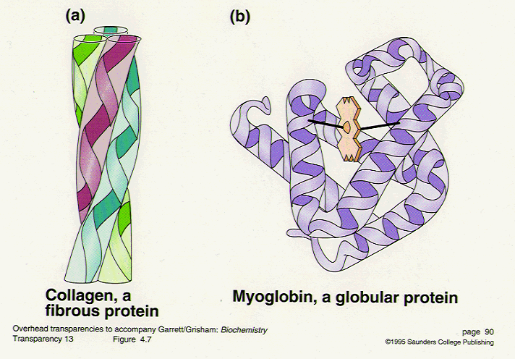

**Non-globular proteins (Fibrous)**

* Stabilized by similar interactions as globular proteins
* Often play a structural role, e.g. collagen

**Disulfide Bonds:** The formation of a covalent disulfide bond between two cysteine (Cys) residues can contribute to the stability of protein tertiary structure. The "S-S" bond covalently crosslinks two regions of the structure that may be distant in sequence, but nearby in the folded state.



Disulfide bonds are generally found in proteins that function outside of the cell, *e.g.* extracellular enzymes, antibodies, *etc*. They stabilize the protein by reducing the entropy of the unfolded state.

**Supersecondary Structures:** Structural motifs that make up larger proteins.

You should be able to:

* Sketch these structures (mainchain)
* Be aware of the mainchain configuration of residues in these structures (α, β)
* Describe the energetics that stabilize these structures.

|  |  |
| --- | --- |
| **β-barrel:** | **βαβ:** |
| **Ig Fold** |  |

**Overview of the Immune System**

**Three key properties of the immune system:**

|  |  |
| --- | --- |
| * High diversity |  |
| * High specificity |  |
| * Exclusion of self |  |

**A. Some Terms:**

**Antigen:** Foreign material that is recognized by the immune system. An antigen is usually a protein, but it can be a peptide, or carbohydrate.

**Epitope:** Region of an antigen to which the antibody binds.

**Hapten:** A small chemical that is recognized by an antibody, but cannot generate an immune response by itself.

**B. Cellular Immunity:** Specialized cells, called **B-cells** produceimmunoglobulins (antibodies). **TH-cells** aid B-cells in the production of antibodies. The HIV virus infects and kills TH-cells, greatly reducing the ability of HIV patients to produce antibodies against *any* pathogen, causing AIDS, or acquired immunodeficiency syndrome, i.e. a deficient immune response.

**C. Antibody Structure:**

**C.1 Quaternary structure:**



* 2 Light + 2 heavy chains.
* Light chains are identical on any given Ab.
* Heavy chains are identical on any given Ab.
* Variable region of both heavy and light are responsible for binding antigen. The sequence of these differ, depending on the specificity.
* Two binding sites/molecule.
* Chains held together by disulfide bonds and non-covalent forces.

**C.2 Primary structure.**

* V-region, ~110 amino acids, different sequence between antibodies with different specificities.
* Hypervariable regions. 3 per V region, highly different sequences between antibodies with different specificities.



* 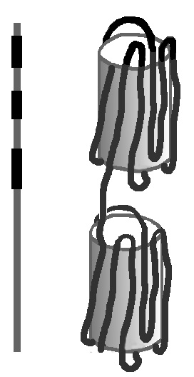Constant region - conserved sequence on all antibodies. 110 residues on L-chain, 330 residues on H-chain.

**D. Antibody Fragments:**

**FAB Fragment:** Cleavage of the antibody at the junction between the antigen binding region and the constant region produces two Fab fragments and one Fc fragment. The Fab fragments retain specific binding of antigen, but no biological function.

**Fv Fragment:** Fab fragments can be further reduced to Fv fragments, consisting of the 1st immunoglobulin fold (variable regions) from the heavy and light chain. The Fv domain is the smallest unit that can bind antigen.



**E. Applications of Antibodies.**

**Immune system:** Antibodies bind to pathogens (bacteria, viruses), leading to their inactivation.

**Protein purification:**  antibodies specific for a protein can be used to purify that protein.

**Labeling components of a cell:** Antibodies with attached fluorescent groups can be used to localize proteins within a cell.

**Blood transfusions & Blood Type:**

* Blood group antigens are carbohydrates on red blood cells (RBC)
* Can have type A, type B, both (AB) or neither (O), depending on genes.
* You have antibodies against other blood types present in your blood, but not your own (type A has anti-B).
* Antibodies will bind to red blood cells that enter during a transfusion with the wrong blood type, leading to severe problems.

**Universal donor –** type O – no antigens on RBC, no antibody binding.

**Universal acceptor –** type AB – no antibodies to bind to the incoming red blood cells.