**Lecture 9: Hydrophobic Effect, Amphipathic Structures, Protein Stability**

* Understand relationship between size of non-polar sidechain and hydrophobic effect.
* Identify helices and sheets based on location of non-polar residues.
* Determine the ΔHo and ΔSo from thermal denaturation curves.
* 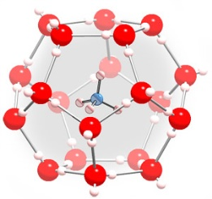Predict amount of folded protein, given ΔHo and ΔSo.
* Interpret changes in ΔHo and ΔSo due to mutations.

**ΔSo -  Hydrophobic effect - Entropy Changes of the Solvent:** The hydrophobic effect is due to the entropy of the *water* in the system. When a non-polar side chain is exposed to water it orders, or decreases the entropy, of the water molecules. However, when the non-polar residue becomes buried in the non-polar center of the protein it releases all of the water which coated it. The released water can now freely diffuse in the solvent, resulting in an increase in entropy of the water, thus non-polar groups are “forced” into the non-polar core of the protein.

*What is W and S for the* ***water*** *molecules in the folded state and in the unfolded state?*



The **hydrophobicity** depends on the non-polar surface area. Glycine is set to zero on this plot to account for the contribution of the mainchain. Note that amino acids with larger non-polar sidechains cause a larger decrease in the entropy of the water when they become exposed. *Why?*

**Overall entropy change:**

ΔSoOBS= ΔSoConformational + ΔSoSolvent

Note that these are opposite in sign, for N→U, ΔSoConformational is large and positive (favorable), while ΔSoSolvent is large and negative (unfavorable for unfolding), overall the entropy of unfolding is positive, favoring the unfolded form of proteins.

*If the overall entropy of unfolding is favorable, why do proteins fold at all?*

**Energy Balance:** An *estimate* of the contribution of the entropy (-TΔSo) and enthalpy to the overall energy of the folded and unfolded state for a 50 residue protein is illustrated below. Although the energies associated with each term are large, the overall difference in energy between the folded and unfolded state are quite small, about 20 kJ/mol in this case.

**Interplay between 1o, 2o and 3o structure.**

If α-helices and β-sheets are equally stable from the perspective of vdw and H-bonds between mainchain atoms, why is one favored over another?

1. Draw an alanine residue and a serine residue. Which is non-polar and which is polar?

2. Where do you find the non-polar Ala sidechains on your helix (H-bond the C=O of i to the NH of i+4 on the paper strip).

**Ala**-Ser-Ser-**Ala**-**Ala**-Ser-Ser-**Ala**-Ser-Ser

1 2 3 4 5 6 7 8 9 10

3. What pattern is present in the distribution of polar and non-polar residues in this two stranded β-sheet?

**Ala**-Ser-**Ala**-Ser-**Ala**-Ser-**Ala**-Ser

**Ala**-Ser-**Ala**-Ser-**Ala**-Ser-**Ala**-Ser

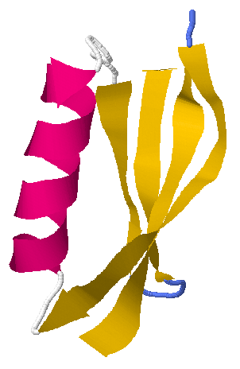

Many protein structural elements are amphipathic – meaning that one face is polar and the other face is non-polar.

**Thermal Denaturation of Proteins:** The relative energy of the native and unfolded state can be changed with temperature. Unfolding occurs at high temperature due to the positive ΔSo during unfolding making ∆Go<0, due to the -T ΔSo contribution the standard energy 

* ΔH0 and ΔS0 are obtained from experimental data
* ΔG0 is calculated from ΔH0 and ΔS0
* KEQ is calculated from ΔG0
* fN and fU are predicted from KEQ.

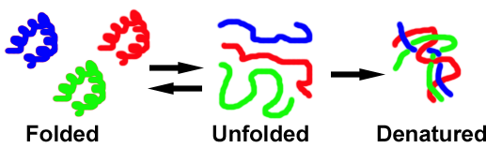**Temperature Dependence of Protein Stability:**





**Obtaining ΔH0:** The temperature dependence of the equilibrium constant can be used to determine ΔHo. Equating the two expressions for ΔGo:



This is the equation of a straight line, if *ln*KEQ is plotted versus 1/T. This plot is referred to as a **van't Hoff** Plot.

Slope = -ΔHo /R **ΔHo = -slope × R**

**Obtaining ΔSo:** Once the enthalpy is known, the change in entropy can be calculated from the TM and from ΔHo. At the melting temperature, TM, the energy difference between the native and unfolded states is zero.

**Example 1:**Given ΔHo and ΔSo, predict the fraction unfolded at any Temp.

You work for a company that uses an enzyme to make the amino acid Lysine, an important amino acid in dinosaur food at Jurassic park. Your supervisor tells you to increase the production of lysine. The reaction is normally run at 290 K (~ room temperature). You know that the rate of the reaction, and therefore the Lysine production, will increase at higher temperatures. Consequently, you increase the reaction temperature to 310K (37o C). Given the following thermodynamic properties of the unfolding of the enzyme used in the reaction: ΔHo= +300 kJ/mol, ΔSo= +1000 J/mol-K, have you just lost your job?

i. Calculate ΔGo at the required temperature, ΔGo=ΔHo-TΔSo

**ΔGo = 300 – (310)x(1.0) = -10 kJ/mol**

ii. Calculate KEQ at the required temperature:  **= e+10/2.57 = e4 = 48.9**

iii. Calculate *fU*  using KEQ: **fu = 48.9/(1+48.9) = 0.98.**

**Example 2:** The denaturation curves for both wild-type and mutants of a protein were measured to obtain ΔHo and ΔSo. *Explain the effects on both ΔHo and ΔSo.*

|  |  |  |
| --- | --- | --- |
|  | **Wild-Type** | **Mutant (Thr → Met)** |
| ΔHo | 210.0 kJ/mol | 206 kJ/mol |
| ΔSo | 616 J/mol-deg | 611 J/mol-deg |
| Tm | 341 K | 337 K |

**Analysis of Enthalpy Changes:**

∆HoOBSERVED = ∆HoVdW + ∆HoH-bond+ ∆HoElectrostatic

Enthalpy to unfold the mutant is lower, indicating fewer interactions have to be broken to unfold. *What interaction is important here?*

**Analysis of Entropy Changes:** ∆SoOBSERVED = ∆SoCONFORM + ∆SoH2O

* Each ∆So is a vector with sign and magnitude:
  + ∆SoCONFORMATIONAL is large and positive for N→ U
  + ∆SoH2O is large and negative for N→ U
* Consider each buried non-polar group to contribute to the overall hydrophobic effect:

∆SoH2O=∑∆So1-H2O + ∆So2-H2O+…+∆Son-H2O

= ∆SoNot 53 H2O+∆So53 H2O

* The overall entropy for unfolding the mutant is smaller because |∆SoH2O| is larger for Met.

**Example 3**: Drug discovery.

* In order or a potential drug to inhibit its target (a misbehavin’ enzyme) it has to bind to it.
* The binding of the potential drug often increases the thermal stability.
* Shifts in TM can be used to identify potential drugs based on their ability to stabilize the protein from denaturing.