Lecture 9: Protein Stability & Super-secondary structure.
- Determine the ΔHº and ΔSº from thermal denaturation curves.
- Predict amount of folded protein, given ΔHº and ΔSº.
- Interpret changes in ΔHº and ΔSº due to mutations.
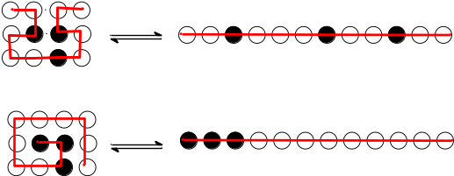Interplay between 1º, 2º and 3º structure.
If α-helices and β-sheets are equally stable from the perspective of vdw and H-bonds between mainchain atoms, why is one favored over another?

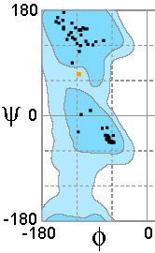

Many protein structural elements are amphipathic:

The periodicity (residues/turn) in a helix is:____________
What pattern is present in the distribution of polar and non-polar residues in an amphipathic α-helix?
Ala-Ala-Thr-Ala-Glu-Lys-Val-Phe-Lys-Gln-Tyr-Ala-Asn-Asp
-b--------------b---------------b---b----------------b—b------------

The periodicity (residues/turn) in a strand is:____________
What pattern is present in the distribution of polar and non-polar residues in an amphipathic β-sheet?
Met –Thr-Tyr-Lys-Leu-Ile-Leu-Asn
---------------b---------b--------b-------
Thermal Denaturation of Proteins: The relative energy of the native and unfolded state can be changed with temperature. Unfolding occurs at high temperature due to the positive ΔSº during unfolding making ∆Gº<0, due to the -T ΔSº contribution the standard energy 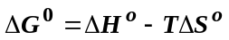
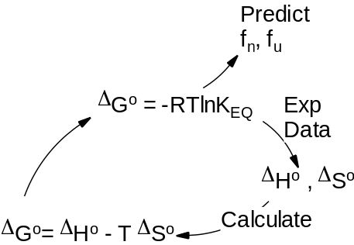
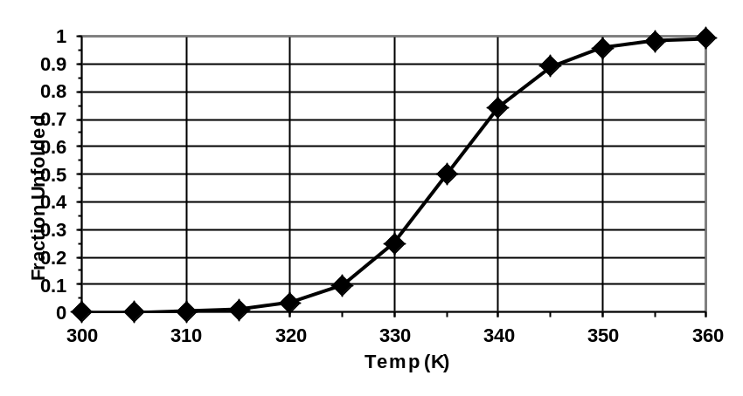

- ΔH⁰ and ΔS⁰ are obtained from experimental data
- ΔG⁰ is calculated from ΔH⁰ and ΔS⁰
- K_{EQ} is calculated from ΔG⁰
- f_{N} and f_{U} are predicted from K_{EQ}.

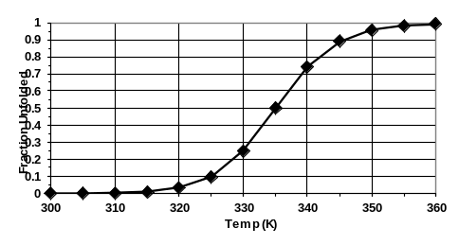
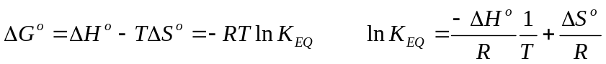Obtaining ΔH⁰: The temperature dependence of the equilibrium constant can be used to determine ΔHº. Equating the two expressions for ΔGº, and performing a little algebra:
This is the equation of a straight line, if lnK_{EQ} is plotted versus 1/T.
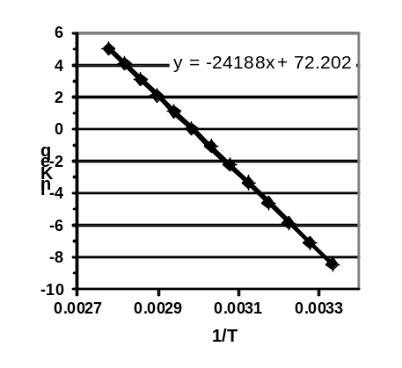
Slope = -ΔHº /R ΔHº = -slope × R
This plot is referred to as a van't Hoff Plot.
Obtaining ΔSº: Once the enthalpy is known, the change in entropy can be calculated from the T_{M} and from ΔHº. At the melting temperature, T_{M}, the energy difference between the native and unfolded states is zero.

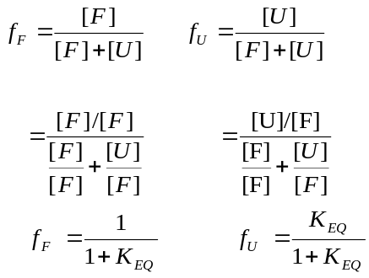Example 1: Given ΔHº and ΔSº, predict the fraction unfolded at any given temperature.
You work for a company that uses an enzyme to make the amino acid Lysine, an important amino acid in dinosaur food at Jurassic park. Your supervisor tells you to increase the production of lysine. The reaction is normally run at 290 K (~ room temperature). You know that the rate of the reaction, and therefore the Lysine production, will increase at higher temperatures. Consequently, you increase the reaction temperature to 310K (37º C). Given the following thermodynamic properties of the unfolding of the enzyme used in the reaction: ΔHº= +300 kJ/mol, ΔSº= +1000 J/mol-K, have you just lost your job? (RT=2.57 kJ/mol at 310 K).
i. Calculate ΔGº at the required temperature, ΔGº=ΔHº-TΔSº
ΔGº = 300 – (310)x(1.0) = -10 kJ/mol
ii. Calculate K_{EQ} at the required temperature: 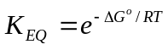 = e^{+10/2.57} = e⁴ = 48.9
iii. Calculate f_{U} using K_{EQ}: f_{u} = 48.9/(1+48.9) = 0.98.
Example 2: Application of Thermal Unfolding to Drug Discovery:
- Thermal unfolding of proteins can be easily followed using a non-polar fluorescent molecule that only becomes fluorescent when the non-polar core of the protein is exposed during unfolding. The amount of fluorescence is proportional to the amount of unfolding.
- Drugs candidates that are potential inhibitors bind to the protein.
- The protein-drug complex is more stable than the protein in the absence of the drug.
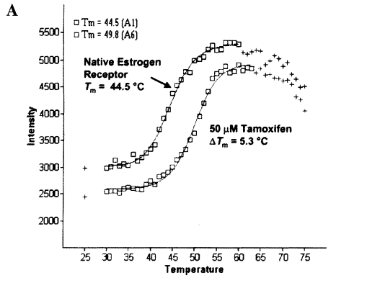

Example 3: The denaturation curves for both wild-type and mutants of a protein were measured to obtain ΔHº and ΔSº. Explain the effects on both ΔHº and ΔSº.
 | Wild-Type | Mutant
ΔHº | 210.0 kJ/mol | 206 kJ/mol
ΔSº | 616 J/mol-deg | 611 J/mol-deg
Tm | 341 K | 337 K
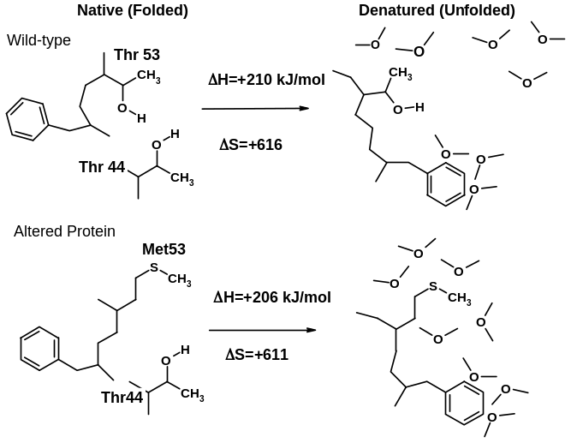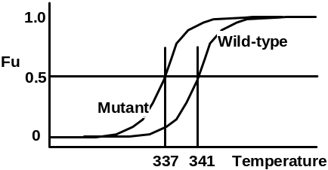

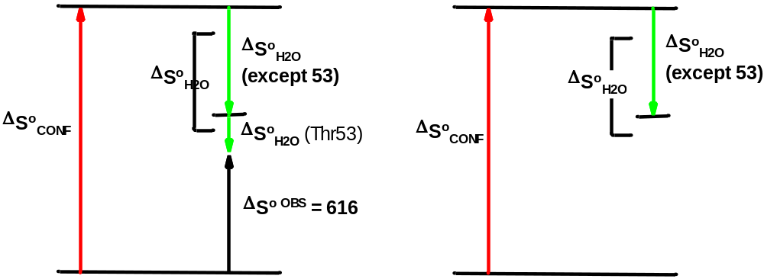

Supersecondary Structures: Structural motifs that make up larger proteins.
You should be able to:
- Sketch these structures (mainchain)
- Be aware of the mainchain configuration of residues in these structures (e.g. α, β)
- Describe the energetics that stabilize these structures:
β-barrel: | βαβ:

