Lecture 7: Secondary Structure
Assigned reading: Horton - 3.5, 4.1, 4.3-5, 4.6. Nelson & Cox 4e & 5e: 4.1-4.2.
Key Terms:

- Torsion angles
- peptide bond
- phi and psi angles.
- α-Helix
- Parallel β-Sheets
- Antiparallel β-Sheets

7A. Configurational Geometry of Proteins:
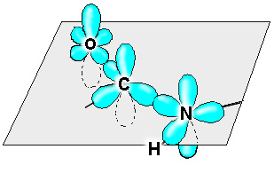
Each residue in a polypeptide has three bonds between mainchain atoms that are potentially free to rotate. The rotation angle about a bond is referred to as a torsional angle. A torsional angle defines the relative orientation of four atoms in space and it is the angle between two planes. The torsional angle between the N and C_{α} bond is shown to the right.
C_{i-1} - N (Peptide bond): The four atoms that make up this bond are planar due to the hybridization properties of the carbonyl carbon and the nitrogen (both sp₂). In addition, free rotation about the bond is not possible since the p_{z} orbitals of oxygen, carbon, and nitrogen form a delocalized system. Rotation about the peptide bond would break the interaction between the p_{z} orbital of the nitrogen and carbon atoms, and is therefore unfavorable. The peptide bond is said to be a "partial double bond".
The N-H group within the peptide bond can only act as a hydrogen bond donor. The partial negative charge on the nitrogen is delocalized.
Cis and trans Peptide Bonds: Two possible orientations of the peptide bond that maintain the p_{z} interaction between the carbon and nitrogen are possible. They are related by a 180º flip of the peptide bond, giving two possible conformations, the trans form and the cis form. For most peptide bonds, the trans form is ~1000 more stable than the cis form. The exception is for peptide bonds involving proline, in which the ratio is reduced to 5:1.
N - C_{α} & C_{α} - C Bonds: The torsional angles associated with each of these bonds are defined as:
Φ (Phi), the bond between N and C_{α}
Ψ (Psi), the bond between C_{α} and C.
There is free rotation about both of these bonds. In the case of a simple molecule, such as a 1-chloro-1-fluoroethane three different conformations are generally considered stable, as shown on the right. However, the presence of the bulky atoms on the sidechain restricts the possible phi and psi angles of most residues to 3 pairs of values (a distribution around these values is observed):

Φ = -60°, and Ψ = -45°.
Φ = +60°, and Ψ = +45°.
Φ = -120°, and Ψ = 125°.
7B. Common Secondary Structure: α-Helix and β-strand/sheet:
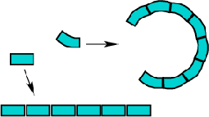
Proteins consist of a linear chain of amino acids, with each amino acid representing a build block. The shape of each block depends on the Φ and Ψ angle of each residue. In regular secondary structures these angles are the same for each residue, and thus the shape of each building block, or amino acid, is the same.
If a series of identically shaped objects are laid end-to-end they will form some type of geometrical structure. In two dimensions there are two possibilities, either a straight chain or some type of circle (which may or may not be closed). A straight chain occurs if the is no curvature in the block, while a circle will result if there is any degree of curvature. The radius of the circle is related to the degree of curvature.

In the case of three dimensional building blocks that have some degree of curvature on both faces, the two dimensional circular structure becomes a helix. If the building block is a perfect rectangular prism (e.g a brick), then the structure will remain linear.
Given the possible values of Φ and Ψ angles, many different shapes of the amino acid building block are possible and therefore many different three dimensional structures are possible. Only two are commonly observed in proteins, the right-handed alpha helix and beta-structures. A left-handed alpha helix is also stable, but relatively rare .
These conformations are stable because they:
- Maximize mainchain hydrogen bonding
- Maximize van der Waals interactions of mainchain atoms.
- Minimizing steric clashes (unfavorable vdw interactions) of mainchain and sidechain atoms.
The regular repeating secondary structures of proteins (α-helix and β-sheet) have characteristic values of the Ψ and Φ torsional angles that are the same for each residue within the element of secondary structure. In both of these structures each peptide bond is rigid and planar and in the trans conformation.
α-Helix Structures (Φ = -60°, Ψ = -45°)
Dimensions, geometry, & H-bonds

3.6 residues/turn
pitch = 5.4 Å/turn
rise/residue = 1.5 Å
H-bonds || to helix axis.
Sidechains point outwards
Right handed

Beta Structures (Φ = -120°, Ψ = 125°)
1. β-Hairpins (two strands connected by a sharp turn)
2. β-Sheets
a. parallel
b. antiparallel

H-bonds perpendicular to direction of strands.

Sidechains point up and down, above and below the sheet.

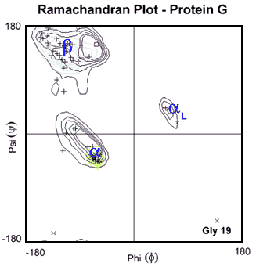
Ramachandran Plot: The phi and psi angles for each residue in a protein are neatly summarized in this plot. The horizontal and vertical axis represent the phi and psi angles of residues. A single point in the plot represents a single conformation of one residue in the protein. The phi and psi angles that are found for each residue in beta-structures, right- and left-helices are labeled. The contour lines surround regions of low energy. The more contour lines, the lower the energy. The + symbol in this plot represent the phi and psi angles for each residue in a protein called protein G. Note that almost all of the residues adopt phi and psi angles that are compatible with either beta-structure or an right-handed helix.

7C. Non-regular secondary structures: Sharp turns in proteins, particularly at the ends of beta-strands and beta-hairpins, have a characteristic geometry and sequence. As with other forms of secondary structure, these turns are stabilized by hydrogen bonding. These turns often contain glycine at position 3, because of its unique conformational properties.

