$q_{\text{total}}=\sum{(f_{\text{HA}}⋅q_{\text{HA}}+f_{A−}⋅q_{A−})}$Determining pI:
The overall charge on a molecule as a function of pH can be calculated by summing the contribution from each ionizable group:
i) Identify all ionizable groups on the molecule & their charge when protonated and deprotonated.
ii) Use the known pK_{a} of each group to determine the fraction protonated (f_{HA}) and deprotonated (f_{A-}) at the required pH.
iii) Calculate the overall charge by summing the contribution of each group.
Example: What is the net charge on glycine at pH=8?

These calculations are repeated for multiple pH values, to give a plot of charge versus pH:

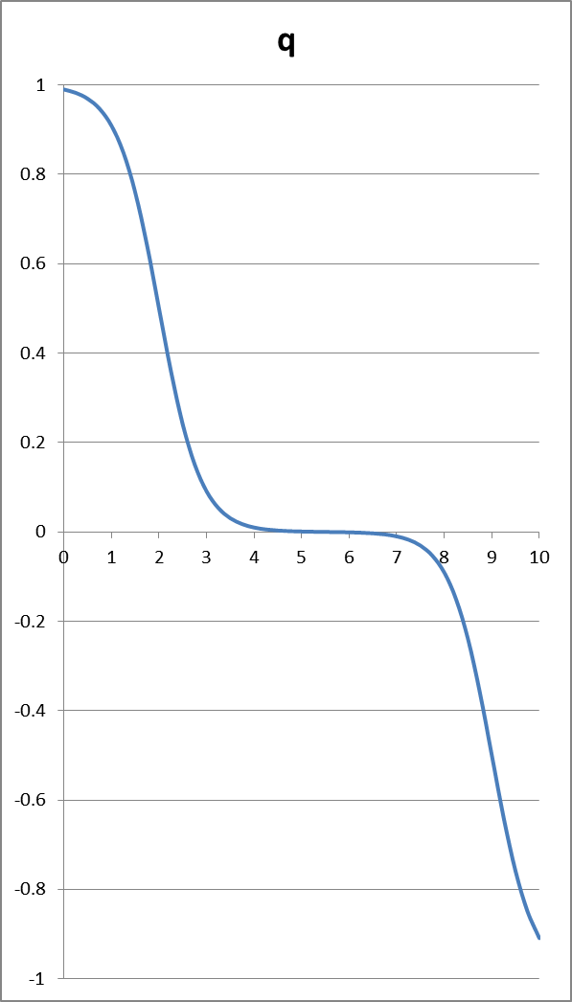
pI = 5.5
pH = pI, average charge over all molecules in solution is zero

when pH < pI, q is positive

when pH > pI, q is negative

