**Lecture 3: Acid-Base Chemistry.**

**Learning Goals:**

* Compare relative acid strength based on pKa values of weak acids.
* Predict protonation state given pH of the solution and the pKa of the acid.
* Understand effect of molecular structure on pKa.

**Why pH is important in Biochemistry.**

i) Molecular interactions can be sensitive to pH. ii) Biological activity can be sensitive to pH.

Changing the pH can change the charge on molecules. e.g. ionized groups required for function.



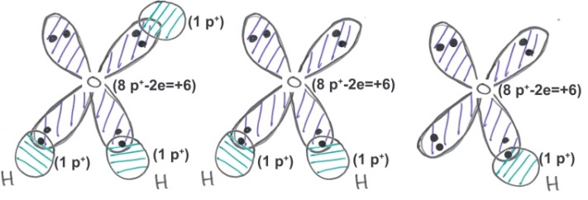**Ionization Properties of Water:**

Water can gain a proton on one of its lone pair orbitals to become a hydronium ion (H3O+, often abbreviated H+) or it can lose a proton to become a hydroxide ion (OH-)

**pH:** pH is measured as the -log[H+],



smaller pH, more acidic the solution, higher [H+].

Neutral pH is 7.0. At this pH there are an equal number of H+ and OH- ions in solution. [H+]=10-7 M.

***pH is a property of the solution, and can be changed.***

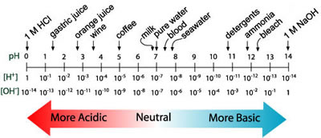

**Acids and Bases:**

* Acid: can donate protons to water, forming its conjugate base and a hydronium ion.
* Strong acid – always completely deprotonated (pKa <= 2).
* Base: can accept protons

The following describes ionization or *dissociation* of the proton from the acid.



**Monoprotic acid**: releases one proton (Acetic acid)

**Diprotic acid**: releases two protons (Malonic acid)

**Triprotic acid**: releases three protons (Phosphoric acid)

**Characterization of Acid Strength Using pKa.**

*Equilibrium Constants:* Why is the ratio of products to reactants a constant when a system is at equilibrium?

Consider a simple reaction:



Equations that describe the rate of change of [A] and [B] are:



at equilibrium d[A]/dt=0



The complete equilibrium expression is:

HA +H2O → A- + H3O+

Since the concentration of water is essentially constant, it can be ignored and we can write a modified equilibrium reaction that just focuses on the species of interest:

HA → A- + H+

and write the equilibrium constant for that dissociation:

$${K_{EQ}=K}_{a}=\frac{\left[A^{-}\right][H^{+}]}{[HA]}$$

This is given a special name, the 'k-a', or 'k-acidity'. The acidity constant, Ka is a *fundamental* property of the acid, it does **not** depend on the pH of the solution. However, it does depend on the chemical structure ***and*** the environment of the acidic group.

**When the [H+] = Ka, then exactly ½ of the acid is protonated.**



**pKa**: Since the pH scale is used to characterize [H+], it is useful to express the acidity constant in the same way, by taking its negative log, giving the “p-K-a”:

pKa = - log Ka

**When the pH = pKa, then exactly ½ of the acid is protonated.**

**Acid Strength and pKa**

*How do the KA & pKa vary as the acid strength increases?*

HA → A- + H+

Strong acid:

Weak acid:

**Prediction of Protonation State at any pH:**



In many cases only one of the two species (protonated or deprotonated) may be biologically active.

Given the pKa of the ionizable group, and the pH of the solution, we would like to calculate the following:

* The fraction that is protonated: *fHA.*
* The fraction that is deprotonated: *fA-*

**We need to know R in terms of pH and pKa.**

Beginning with the equilibrium constant for ionization: 



Take *–log* of both sides:



**Example:**

a) Calculate the fraction protonated of the side chain of Histidine, an amino acid found in proteins. pKa = 6.0.

b) Plot the % activity as a function of pH, assuming “HA” is active.

|  |  |  |  |
| --- | --- | --- | --- |
| **pH** | **R=10(pH-pKa)** | **FHA=1/(1+R)** | **Δ=pH-pKa** |
| **4** | R = 10 (4 - 6) = 10-2 | FHA = 1/(1 + 0.01) = 0.99 | -2 |
| **5** | R = 10 (5 - 6) = 10-1 | FHA = 1/(1 + 0.10) = 0.91 | -1 |
| **6** | R = 10 (6 - 6) = 100 | FHA = 1/(1 + 1) = 0.5 | 0 |
| **7** | R = 10 (7 - 6) = 10+1 | FHA = 1/(1 + 10) = 0.091 | +1 |
| **8** | R = 10 (8 - 6) = 10+2 | FHA = 1/(1 + 100) = 0.01 | +2 |



**Important general features to note:**

i) when pH = pKa -2, fHA = 0.99

ii) when pH = pKa -1, fHA = 0.91

**iii) when pH = pKa fHA = fA- = 0.5**

iv) when pH = pKa+1 fHA = 0.09

v) when pH = pKa+2 fHA = 0.01

**Chemical Structure and Acidity:**

Key Concepts:

* The strength of an acid depends on the ability to break the A-H bond, e.g. NH versus OH.
* For a given type of acid, the strength depends on the relative stability of HA and A-, which can be affected by the chemical groups nearby *and* the environment (see next lecture).

Chemical bonding and effects on pKa:

|  |  |  |
| --- | --- | --- |
|  | Amine pKa ~ 10  (Lys sidechain) | *Easier to break an N-H bond versus an O-H bond, therefore an amine is a stronger acid than an alcohol.* |
|  | Ethanol pKa ~ 14  (Ser,Thr sidechain) | *Alcohol is a weak acid because of highly localized negative charge on the oxygen, deprotonated species is high energy.* |
|  | Acetic Acid pKa ~ 4.0  (Glu,Asp sidechain) | *Negative charge delocalized over C=O, lower in energy, therefore a carboxylate is a stronger acid than an alcohol.* |
|  | Carboxy pKa ~ 2.0  group on an amino acid. | *Electronegative nitrogen can withdraw some charge from the negatively charged carboxylate, giving a stronger acid than just the COOH.* |