**Lecture 2: Molecular Forces, Water & Hydrogen Bonds**

**Key Terms:**

* Enthalpic Interactions:
  + Electrostatics
  + van der Waals
  + Hydrogen bonds
* Polar bonds
* Electronegativity
* Polar solvents
* Water structure
* Hydrogen bond (donor & acceptor)
* Driving force for dissolving ions
* Hydrophilic (polar) compounds.
* Hydrophobic (nonpolar) compounds and entropy of water.
* Amphipathic/amphiphilic compounds.

**Key Concepts:**

* Importance of weak interactions in biological systems
* Identification and properties of hydrogen bonds
* Contribution of enthalpy and entropy to molecular behavior

**2A. Molecular interactions**

i) Electrostatics: The force between two charged particles is:

$$E∝\frac{q_{1}q_{2}}{Dr}$$

The force depends on the charges of the particles (q1, q2), distance (r) between the two charges, and the dielectric constant (D) of the media. The dielectric constant depends on the solvent. Water has a high dielectric constant.

How strong are electrostatic interactions?

Na+  Cl- = ~-600 kJ/mol *in vacuum*

*Given that the dielectric constant of water is 80, what is the energy of interaction in water (D=1 in vacuum).*

ii) van der Waals (induced dipole-induced dipole < induced dipole-dipole < dipole-dipole) – an electrostatic interaction that does **not** involve **formal** **charges**. Partial charges may be temporary (induced dipole) or permanent (dipole). van der Waals interactions between molecules with permanent dipoles are generally stronger.

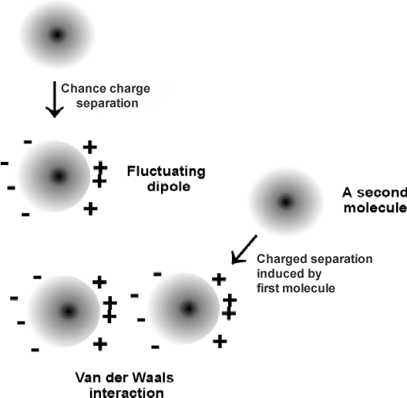

Although weak, the effects of van der Waals are easily observed→

Boiling points of hydrocarbons:

isobutane: 261 K

butane: 272 K

*Same number of carbons, why the difference in boiling points?*

*How strong are van der Waals forces?*

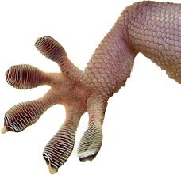

***Reflection****: What is an advantage of weak interactions?*

**2B. Polar bonds & Molecules**

**Polar Bond:** A bond is polar if there is a *significant* difference in the electronegativities of the participating atoms, giving an *appreciable* dipole moment. (The electronegativities increase across the periodic table).

|  |  |  |  |  |  |  |  |
| --- | --- | --- | --- | --- | --- | --- | --- |
| 1  **H**  2.1 |  |  |  |  |  |  | 2  **He** |
| 3  **Li**  1.0 | 4  **Be**  1.5 | 5  **B**  2.0 | 6  **C**  2.5 | 7  **N**  3.0 | 8  **O**  3.5 | 9  **F**  4.0 | 10  **Ne** |

The **dipole moment, μ,** is defined by the following equation:.

The dipole moment is proportional to the difference in the electronegativities of the two atoms: | μ|=∆E

***Reflection:*** *How do we know which bonds are polar?*

**Polar molecule**: A molecule is considered polar if it is has a *permanent* *dipole moment* associated with it. *Is CO2 a polar molecule? Why or why not?*

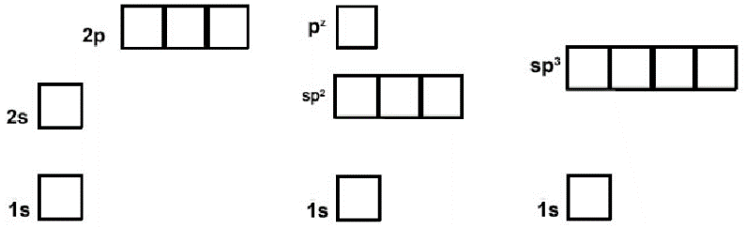**2C. Structure of Water**

1. Oxygen has 8 electrons. The molecular orbitals in water are complex, however we can understand most of the properties of water by assuming that oxygen forms sp3 hybrid orbitals.
2. The orbitals in oxygen are populated such that two orbitals are filled and two contain one electron each.
3. The filled orbitals cannot form bonds and are often called *lone pairs*.
4. The half-filled orbitals participate in the formation of a *sigma* bond between oxygen and hydrogen.

***Reflection****: Is water a polar solvent?*

The interaction between the oxygen on one molecule and the hydrogen on another is an example of a **hydrogen bond.**

**Biochemical Significance of Hydrogen Bonds in Water:**

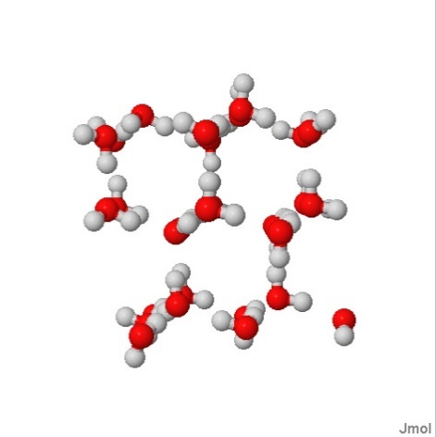i). In ice, the hydrogen bonds cause the formation of cavities in the ice, lowering the density of the solid.

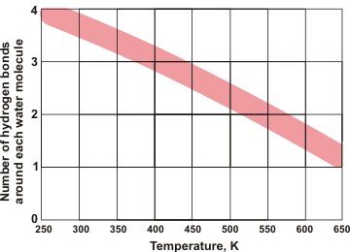ii) In liquid water, the hydrogen bonds persist, and are transient, generating small short-lived (ns lifetime) clusters of "ice" in liquid water.

iii) Hydrogen bonds are present over a wide temperature range 3-3.5 bonds/water at room temperature. Note that water molecules in vapor (i.e. steam) can form hydrogen bonds. This allows water to absorb heat without a large increase in temperature, giving water a high heat capacity.

**2D. General Description of Hydrogen Bonds**

i) Formation of H-bonds is primarily an electrostatic attraction between:

* Electropositive hydrogen, attached to an electronegative atom is the hydrogen bond **donor** (*i.e.* NH).
* Electronegative hydrogen bond **acceptor** (*e.g.* the lone pairs of oxygen in the case of water, or C=O group of an amide).

*Note that the proton is* ***NOT*** *transferred to the acceptor, it remains covalently bonded to the donor. The Hydrogen bond is the interaction between the donor and acceptor.*

* The energy released when H-bonds form depends on the distance and angle of the bond.

***You should know the ideal distance and angle. This will be explored in the next recitation.***

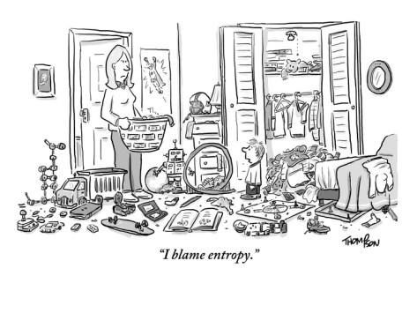**2E. Solvation – It is all about reaching the lowest energy.**

ΔHo : Enthalpy – A change in the electronic configuration of the system that either releases heat (ΔHo <0) or absorbs heat (ΔHo >0). **Release of heat is favorable**.

ΔSo: Entropy – A change in the number of configurations of the system (disorder). Either increasing the disorder (ΔSo>0) or decreasing the disorder (ΔSo<0). **Increase in entropy is favorable. Ordering systems is unfavorable, it takes energy.**

**Balance of net changes in enthalpy and entropy determine the equilibrium position of the reaction.**

**ΔGo = ΔHo - TΔSo**

*What is the sign of ΔGo if a compound is very soluble in water? Positive or negative?*

**i) Hydrophilic** (water-loving, polar) compounds (*e.g.* methanol):

ΔH<0 – usually favorable

ΔS>0 – always favorable (entropy of mixing, see separate handout)



**ii) Solvation of ions** (**ΔH<0 & ΔH>0)**

* Energy is required to break the ionic bonds in the crystal. ∆Ho>>0. Heat was added to system, very unfavorable.
* A large dipole moment on water means that the solvent molecules can interact favorably with charged solute molecules. This is energetically very favorable. ∆Ho<0, releases heat.
* Overall ΔHo can be positive (unfavorable) or negative (favorable), depending on the balance of these two terms. It depends on the salt. For CaCl2 heat is released, i.e. the interactions with water release more heat than was consumed to break the ionic bonds.

Hypothetical reaction for forming a solution of Ca+Cl, the atoms are first separated in vacuum (1) and then the ions are dissolved in water (2). The net change in enthalpy is negative, heat is released when CaCl2 is dissolved in water.

***Question:*** *When ammonium sulfate (NH4Cl)dissolves in water the solution becomes cold, indicating that the reaction consumes heat, and therefore should be unfavorable from an enthalpic point of view. Why is ammonium sulfate still very soluble in water?*

**iii) Hydrophobic** (water-hating, nonpolar) compounds (*e.g.* methane).

**ΔH<0 – favorable (stronger vdw with water than non-polar solvent)**

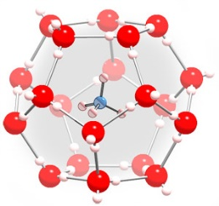

*If heat is released when methane goes into water (favorable from an enthalpic point of view), why is its solubility low?*

[**http://chem.ps.uci.edu/~kcjanda/Group/Research_hydrates.html**](http://chem.ps.uci.edu/~kcjanda/Group/Research_hydrates.html)

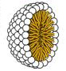**iv) Amphipathic** (or amphiphilic) compounds are both polar (usually charged) and have a substantial nonpolar section (*e.g.* fatty acids). These can form micelles if the nonpolar part is sufficiently large. Micelles are aggregates of amphipathic molecules that sequester the nonpolar part on the inside, much like the inside of an orange.