Lecture 2: Molecular Forces, Water & Hydrogen Bonds
Key Terms:

- Enthalpic Interactions:
  - Electrostatics
  - van der Waals
  - H-bonds
- Polar bonds
- Electronegativity
- Polar solvents
- Water structure
- Hydrogen bond (donor & acceptor)
- Driving force for dissolving ions
- Hydrophilic (polar) compounds.
- Hydrophobic compounds and H₂O entropy
- Amphipathic or amphiphilic compounds.

Functional Groups:
1. Which of the following is an ester?

2. Name the functional groups on these four amino acids (building blocks of proteins). Which are common to all?

2A. Molecular interactions
i) Electrostatics: The energy between two charged particles is:
$E=\frac{1}{4{\text{πε}}_{0}}\frac{q_{1}q_{2}}{\text{Dr}} ε_{o}=8\text{.}\text{854}×{\text{10}}^{−\text{12}}{C^{2}}/N⋅m^{2}$The energy depends on the distance (r) between the two charges and the dielectric constant (D) of the media. A high dielectric constant, such as that found in water (~80), is important because the forces between charges are attenuated, reducing charge interactions.

How strong are electrostatic interactions?
Na⁺ Cl⁻ = ~-138 kJ/mol in vacuum (r=10 A)

Given that the dielectric constant of water is 80, what is the energy of interaction in water (D=1 in vacuum).
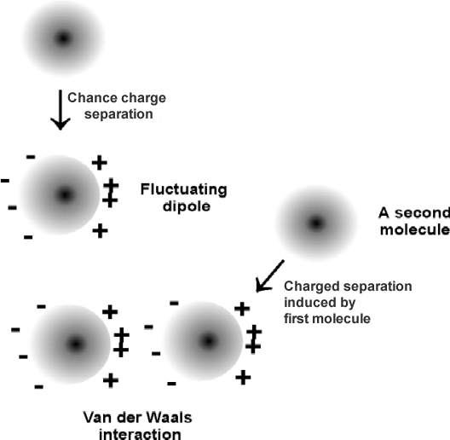
ii) van der Waals (induced dipole-induced dipole < induced dipole-dipole < dipole-dipole) – an electrostatic interaction that does not involve formal charges. Charges may be temporary (induced dipole) or permanent (dipole).

How strong are van der Waals forces?
A. Boiling points of hydrocarbons:
isobutane: 261 K
butane: 272 K
Same number of carbons, why the difference in boiling points?
B. Biomechanics of Adhesion (Gecko)

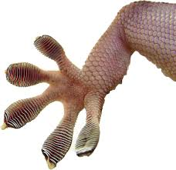

2B. Polar bonds & Molecules
A bond is considered to be polar if there is a significant difference in the electronegativities of the participating atoms, giving an appreciable dipole moment. (The electronegativities increase across the periodic table).
The dipole moment, μ, is defined by the following equation:.
1  H  2.1 |  |  |  |  |  |  | 2  He
3  Li  1.0 | 4  Be  1.5 | 5  B  2.0 | 6  C  2.5 | 7  N  3.0 | 8  O  3.5 | 9  F  4.0 | 10  Ne
$$μ=\sum_{\text{All}\text{atoms}}{\text{qr}}$$

The direction of the dipole moment is from negative to positive (however some draw it the other direction). We are going to worry about the partial charges (δ+/δ-) and the size of the dipole. The size of the dipole moment is proportional to the difference in the electronegativities of the two atoms:
| μ| ∝∆E.

Polar molecules: A molecule is considered polar if it is has a permanent dipole moment associated with it. Does CO₂ behave as a polar molecule? Why or why not?
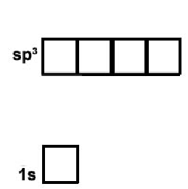
2C. Structure of Water – A Polar Molecule.
- Oxygen has the following electronic configuration: 1s²2s²2p⁴.
- The molecular orbitals in water are complex, however we can understand most of the properties of water by assuming that oxygen forms sp³ hybrid orbitals and H uses its 1s orbital.
- The orbitals in oxygen are populated such that two orbitals are filled and two contain one electron each.
- The filled orbitals cannot form bonds and are often called lone pairs.
- The half-filled orbitals participate in the formation of a sigma bond between oxygen and hydrogen.
- "Bent" water molecule generates a permanent dipole moment, making water a polar solvent with a high dielectric constant.
- The interaction between the oxygen on one molecule and the hydrogen on another is an example of a hydrogen bond.
Biochemical Significance of Hydrogen Bonds in Water:
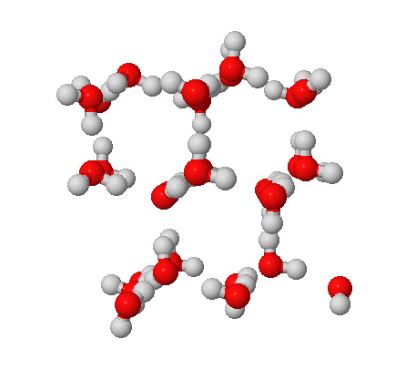
i). In ice, the hydrogen bonds cause the formation of cavities in the ice, lowering the density of the solid.
ii) In liquid water, the hydrogen bonds persist, and are transient, generating small short-lived (nsec) clusters of "ice" in liquid water.
iii) Hydrogen bonds are present over a wide temperature range 2-4 bonds/water at room temperature.
iv) The hydrogen bonds in water allow water to absorb heat without a large increase in temperature, giving water a high heat capacity.
2D. Hydrogen Bonds – Be able to identify donors and acceptors and judge based on distance, angle, and partial charges, the relative strength of H-bonds.
i) Formation of H-bonds is primarily an electrostatic attraction between:
- Electropositive hydrogen, attached to an electronegative atom is the hydrogen bond donor (i.e. NH)
- Electronegative hydrogen bond acceptor (e.g. the lone pairs of oxygen in the case of water, or C=O group of an amide).
- The energy released when H-bonds form depends on the distance and angle of the bond. The actual distance dependence will be explored in in the problem set. You should know the ideal distance.

Overall Energy: 20 kJ/mole is released when an H-bond forms.
How does this compare to the strength of a typical C-C bond?
Why might this difference be important in biochemistry?
2E. Solvation – It is all about reaching the lowest energy.
ΔHº = Hº_{Aq} - Hº_{SOLID} : Enthalpy – A change in the electronic configuration of the system that either releases heat (ΔHº <0) or absorbs heat (ΔHº >0). Release of heat is favorable.
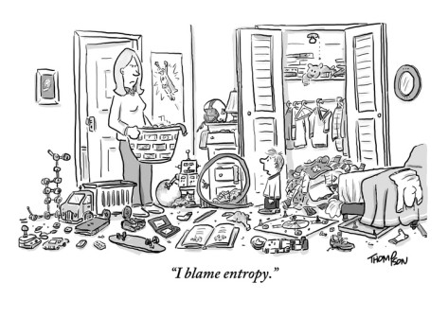
ΔSº = Sº_{Aq} - Sº_{SOLID}: Entropy – A change in the number of configurations of the system (disorder). Either increasing the disorder (ΔSº>0) or decreasing the disorder (ΔSº<0). Increase in entropy is favorable.

Balance of net changes in enthalpy and entropy determine the equilibrium position of the reaction.

ΔGº = ΔHº - TΔSº ΔGº <0 – favorable

i) Solvation of Salts (ions) ΔH<0 or ΔH>0
- Energy is required to break the ionic bonds in the crystal. ∆Hº>>0. Heat was added to system, unfavorable.
- A large dipole moment on water means that the solvent molecules can interact favorably with charged solute molecules. This is energetically favorable. ∆Hº<0, releases heat.
- Overall ΔHº can be positive (unfavorable) or negative (favorable), depending on the balance of these two terms. It depends on the salt (neg for CaCl₂)
Question: Why does NH₄Cl readily dissolve in water, yet the solution becomes cold, indicating that the reaction consumes heat, and therefore should be unfavorable?

ii) Hydrophilic (water-loving, polar) compounds (e.g. methanol):
ΔH<0 – usually favorable
ΔS>0 – always favorable (Why?)

iii) Hydrophobic (water-hating, nonpolar) compounds (e.g. methane).
ΔH<0 – favorable (stronger vdw with water than non-polar solvent)
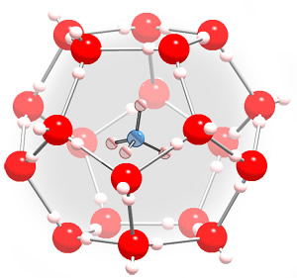

http://chem.ps.uci.edu/~kcjanda/Group/Research_hydrates.html
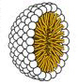
iv) Amphipathic (or amphiphilic) compounds are both polar (usually charged) and have a substantial nonpolar section (e.g. fatty acids). These can form micelles if the nonpolar part is sufficiently large. Micelles are aggregates of amphipathic molecules that sequester the nonpolar part on the inside, much like the inside of an orange.

