**Lecture 1: Introduction to Biochemistry**

Dr. Gordon Rule - [rule@andrew.cmu.edu](mailto:rule@andrew.cmu.edu) Mellon Inst 246A

OLI course can be found at: *http://oli.web.cmu.edu*or *via* Canvas. **OLI Course Key:**

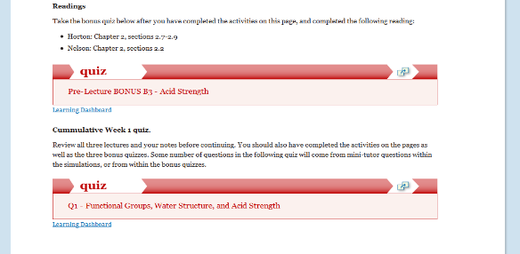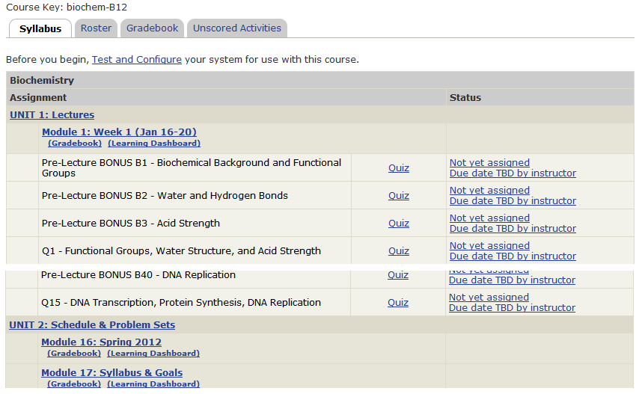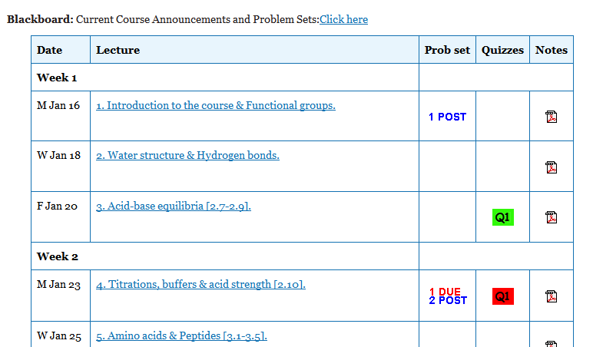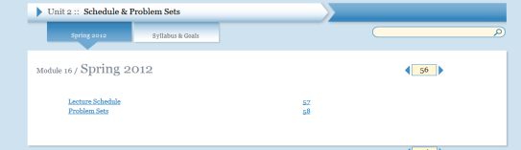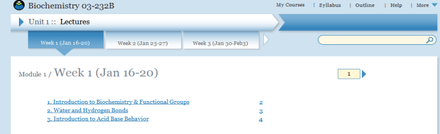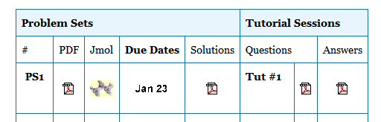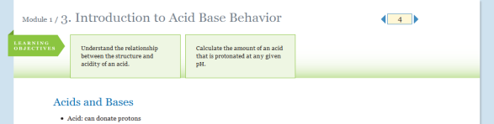

|  |  |
| --- | --- |
| check | Checkpoint: Test prior knowledge |
| lbd | Learn by doing: Learn a concept by performing the activity. |
| digt | Did I get this?: Test your understanding after activity. Test major concepts on a page. |
| quiz | Grades recorded:   * Bonus quiz (39) * Weekly quiz (15) |

**Course Grading**

|  |  |  |
| --- | --- | --- |
| Problem sets (11) | 10% | Lowest three dropped, due Monday in class or by 3:30 PM (DH 1321) |
| OLI quizzes (15) | 10% | Lowest 5 of 15 dropped. Due Monday by 11:59 PM. |
| Bonus quizzes (OLI/Canvas) | 3.5% | OLI quizzes close 2 AM day of lecture, Canvas quiz in recitation. |
| In-class exams (3) | 50/45/40% | Half of lowest one dropped (e.g. 2 x20%, 10%) |
| Final exam (comprehensive) | 30/35/40% |  |

**Tentative letter grades**: A>90, B>80, C>70, D>50.

**Problem Sets and Academic Integrity:** Any material that is submitted for grading should be your own work. Please feel free to discuss general approaches with your classmates, but write your solutions individually.

**Your Weekly Schedule:**

* Bonus OLI quiz before *each* lecture.
* Attend lecture
* Review notes after lecture in preparation for recitation, and the weekly OLI quiz.
* Weekly OLI quiz on weekend, due Monday.
* Problem set on weekend, due Monday.

**General Advice:***Do your best to maintain a healthy lifestyle this semester by eating well, exercising, getting enough sleep and taking some time to relax. This will help you achieve your goals and cope with stress.*

*There are many helpful resources available on campus and an important part of the college experience is learning how to ask for help. Asking for support sooner rather than later is often helpful.* ***Please feel comfortable approaching me in requesting extensions for problem sets and to adjust exam schedules depending on demands in your other courses or other issues in your life.***

**Advice for this course:**

1. Time spent learning structures and concepts in the first 5 weeks of class will be *very well* spent.

2. Do the OLI activities. This allows you to assess your understanding of the material well before the exams.

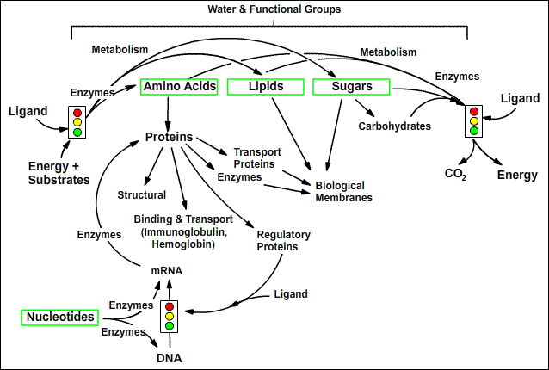**Course Overview (see syllabus for more details)**

**Lecture 1 learning goals:**

* Predict the formation of ions and their charge from electronic configuration.
* Infer orbital hybridization from molecular geometry.
* Identify functional groups.

**Chemistry Review:**

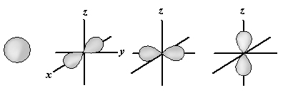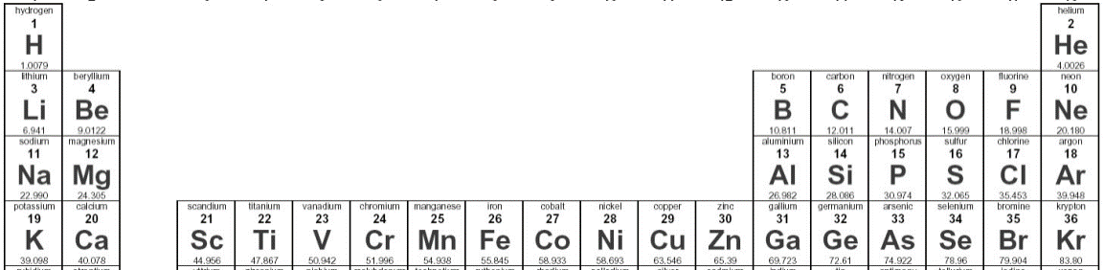**Atomic Orbitals:** All orbitals hold at most 2 electrons. The *s* orbital is spherically symmetric. The three *p* orbitals (*px, py, pz)* are bi-lobed and hold a total of 6 electrons (2 each x3).

**Order of filling:** 1s, 2s, 2p, 3s, 3p. When orbitals of equal (or near equal) energy are filled (e.g. 2p) the electrons fill the orbitals with one electron/orbital first. *Why?*

**Shells:** 1st = 1s, 2nd = 2s + 2p, 3rd = 3s + 3p

**Ne (10 e)**

**Na+ (10 e)**

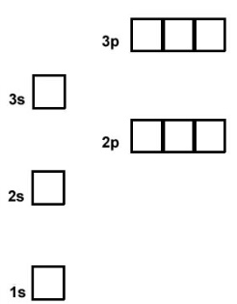**Stable electronic configuration -** Filled shells are most stable due to interaction between electrons and shielded nuclear charges. One or two electrons above the filled shells are easily removed.

* Nobel gasses (e.g. He/Ne/Ar)
* Ions (e.g. Na/Mg/Cl)

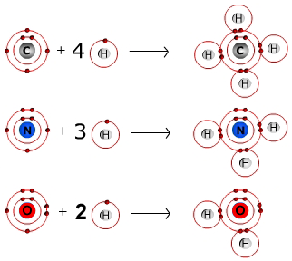**Covalent bonds** occur due to the sharing of electrons between atoms. Two half-filled orbitals combine to form the bond, *lowering the energy of the system.*

**H: 1 bond**

**C: 4 bonds**

**N: 3 or 4* bonds**

**O: 2 or 3* bonds**

**S: 2 bonds**

**P: 5 bonds**

*When protonated; the proton is added to a full orbital.

*Why does carbon (6 e) form four bonds?* 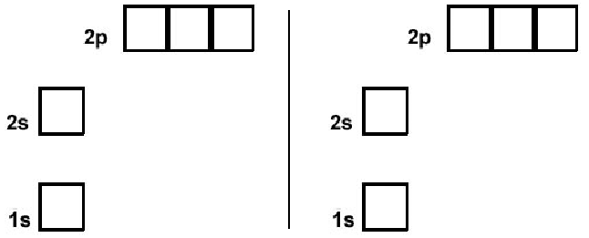

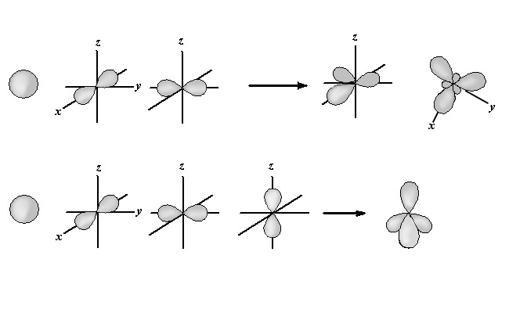

**Hybrid Orbitals**: Carbon (and nitrogen, and oxygen) usually form *hybrid* orbitals, which show a mixture of *s* and *p* character.

**sp2:** The s and two of the p-orbitals combine, giving three (3) sp2 orbitals that are equal in energy. **Note**, one of the p orbitals is still present.

**sp3:** The s and all three of the p-orbitals combine, giving four equivalent (4) sp3 orbitals.

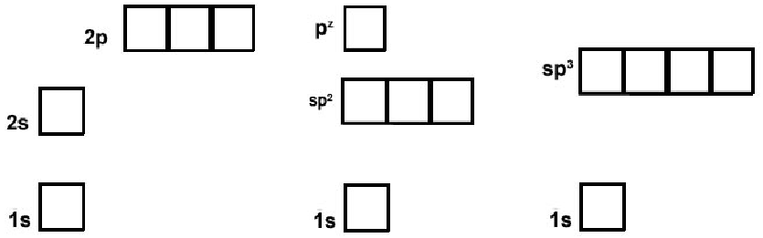

The geometrical property of the hybrid orbitals affects the shape of the molecule.

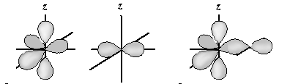**Double bonds** occur when two atoms share two pairs of electrons, e.g. C=O

* One bond is directly between the atoms, called a sigma (σ) bond (similar to a single bond). Between sp2 of C and py of O.
* 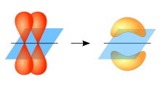The second bond is formed by overlap of the pz orbitals, called a pi (π) bond.

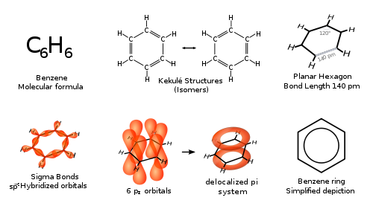**Aromatic Compounds**

* Ring formation - can contain carbon and nitrogen.
* Atoms are planer, therefore sp2 hybridized. The sp2 orbitals used to form single bonds.
* Remaining pz orbitals form a delocalized ring of electrons, giving rise to a “partial” double bond between adjacent atoms.
* Delocalized electrons represented by ring on diagram.
* Absorb UV/visible light

**Representation of molecules in biochemistry** – typically hydrogens on carbon are omitted, you should add a sufficient number of hydrogens to complete the valance of carbon (4). For example – propane (C3H8)

**Organic molecules and Functional Groups:** A functional group is a subset of atoms within a larger molecule, e.g. methyl group, ethyl group. Functional groups have unique properties.

**Non-Polar:**

**Polar:**



**Name the functional groups on these α-amino acids:**