Problem Set 6:
1. The Jmol page associated with this problem set shows wild-type and a mutant HIV protease in complex with a number of different HIV drugs. One of these drugs is the same as the one presented in class. This drug contains a cyclohexane ring and it binds to the wild-type enzyme with high affinity. The cyclohexane ring interacts with Val82 on the wild-type (non-mutant) enzyme.
Three different drugs, with alteration in the cyclohexane ring, have been developed for the purpose of inactivating a mutant HIV protease. Enzyme kinetic data for the three different inhibitors are plotted. Please answer the following questions.
i) What feature of the HIV life-cycle leads to a high level of mutations in the HIV genetic material?
ii) Which residue is altered in the mutant HIV protease? That is, what has the valine at position 82 been changed to? You will need to use the structure of the mutant to determine this.
iii) Explain, with reference to the structure of the enzyme-inhibitor complex for the wild-type and mutant enzymes, why the affinity to the original cyclohexane drug has been decreased by this mutation.
iv) Which of the three drugs would be the worst inhibitor of the mutant protease? Justify your answer with reference to the kinetic data, as well as the interaction between the drug and the mutant enzyme. A simple sketch of the interaction between the drug and the inhibitor would be useful.
v) Which of the three drugs would be the best inhibitor of the mutant protease? Justify your answer with reference to the kinetic data, as well as the interaction between the drug and the mutant enzyme. A simple sketch of the interaction between the drug and the enzyme would be useful.
vi) Assume that the drug concentration is 1 nM, and that the Km for the uninhibited enzyme is 1 uM, calculate the dissociation constant (K_{D}) for drug 1. Note K_{D} = K_{I}.
Structures of Drugs:
J-mol page instructions:
- The “Wild-type+CycloHex” button will load the “wild-type” or non-mutant enzyme with the original drug bound.
- The “simple view” button will show the backbone of the protein, the sidechain of key residues, and the bound drug.
- The check boxes will add surfaces to the indicated features, to orient you with respect to the molecule.
- The “Mut+cyclohexane” button will load the mutant HIV protease and the original, non-modified drug. This drug has a cyclohexane group that contacts the enzyme and is the same as the drug from lecture.
- The buttons labeled “Drug1”, “Drug2”, etc. will load the structure of the mutant HIV protease with a different drug bound in the active site.
2. Compound I is an allosteric inhibitor of HIV reverse transciptase and compound II is a competitive inhibitor of the enzyme. Which will be the better inhibitor if the substrate concentrations are high in the cell? Briefly justify your answer.
3. Lovastatin is an inhibitor of HMG-CoA reductase, an enzyme in the synthesis pathway of cholesterol. This enzyme catalyzes the reaction shown at the top of the figure. SCoA is a large organic group that is bound to the rest of the substrate via a -S- bond.
The structure of lovastatin is shown on the lower part of the figure on the right. The regions labeled “A” and “B” represent part of the active site of HMG-CoA reductase.
i) Is lovastatin a competitive or allosteric inhibitor? Briefly justify your answer.
ii) Two regions of Lovastatin that interact with the enzyme are indicated, “A” and “B”. What type of amino acid residues would you most likely find on HMG-CoA reductase that would contact these two regions? Would they be polar or non-polar? What type of interaction between the indicated region and the enzyme would stabilize the bound drug? Justify your answer.
4. α-Amanitin is a natural product that is a potent inhibitor of eukaryotic RNA polymerase.
i) What are the consequences to the cell of inhibiting its RNA polymerase?
ii) Where is α-Amanitin produced – what organism makes it (please use the web)?
iii) Both rifampicin and α-Amanitin inhibit RNA synthesis. Rifampicin can be used to treat bacterial infections, but α-Amanitin cannot. Why?
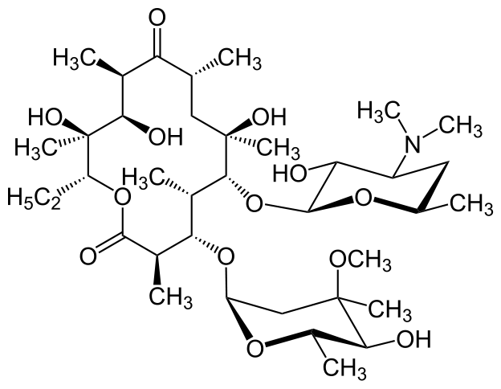
5. The antibiotic Azithromycin binds to the exit tunnel of the prokaryotic ribosome. It was originally isolated from a soil fungus. Its structure is shown on the right.
i) What are the typical uses of this antibiotic (please cite your source)?
ii) Which steps of protein synthesis could still occur, and which would be prevented in the presence of this antibiotic?
6. The partial sequence of the gene is indicated below (both strands are given). The amino acid sequence for this gene is given below the DNA sequence. The three bases to use as the PAM sequence are bold and highlighted in yellow. The start and stop codons are highlighted in green and red, respectively.
ATG...AAGCGTGGACCGTACGTCGTACAACTACGACCGCGTAATTTGGCGACATTT...TAACCTTTA
TAC...TTCGCACCTGGCATGCAGCATGTTGATGCTGGCGCATTAAACCGCTGTAAA...ATTGGAAAT
Met...LysArgGlyProTyrValValGlnLeuArgProArgAsnLeuAlaThrPhe...
i) Give the sequence of the 5’ end of the guide RNA that would target this gene. Your answer should be first 20 bases (see slide 40 in lecture 5)
ii) You wish to change the Leu codon (bold, underlined) to a Glycine. Give the sequence of a template DNA that would cause this change after Cas9 caused the double stranded break. Indicate the important features of the template DNA.
iii) If you only wanted to inactive this gene, is a template DNA necessary?
7. Charpentier and Doudna investigated the degree of complementarity between the guide RNA and the DNA that is required for activation of Cas9 (Science, 2012, Vol 337, Pg 816). They changed the sequence of the target DNA while keeping the sequence of the guide RNA (crRNA-sp2) constant. Their data is shown on the right. The red bases indicate the region of the mismatch between the RNA and the DNA target. They investigated 6 different mismatches. The DNA substrate is a 2640 bp double stranded DNA that is cleaved into two fragments by Cas9. The lane labeled “WT” was obtained using target DNA that was complementary to the guide RNA over the full length, i.e. it is the positive control. The 2640 bp fragment is efficiently cleaved to 1880 and 800 (these sum to ~2640)
i) Can Cas9 cleave the target, even where there are mismatches between the guide RNA and the target? Briefly justify your answer.
ii) Does the location of the mismatches matter? That is, is it important to have pairing close to the PAM or pairing at the 5’ end of the guide RNA?
8. You are trying to use CRISPR-Cas9 to inactivate the target shown below. However, similar sequences are found at three other locations in the genome and these could potentially be cleaved by Cas9, leading to changes at more than one location in the genome. The alignment of these sequences with your target is shown below, with the sequence differences in bold and highlighted.
i) Discuss the likelihood of Cas9 cleaving each of the three off-target sequences.
1 2
12345678901234567890
Target: -----GGACCGTACGTCGTACAACTACGACCGCGTAATTTGGCGACA-----
Off-A: -----GGACCGTACGTCGAAGGGCTACGACCGCGTAATTTGGCGACA-----
Off-B: -----GGACCGTACGACGTACAACTACGACCGCGTTTTTTGGCGACA-----
Off-C: -----GGACCGTACGTGGTACAACTACGACCGCGTAATTTAACGACA-----

