1. Two different antibodies (Ab_A, Ab_B) are being tested as treatments for Covid-19 infection. Both of these antibodies bind to a surface protein on the virus, the spike protein, preventing the virus from entering the cell (physical blocking). A plot of fractional saturation versus the concentration of the spike protein (in nM) is shown on the right. Please answer the following questions.
i) What is the K_{D} for each antibody?
ii) Which of these antibodies will be more effective against Covid-19? You can assume that the concentration of spike protein is 10 nM during an infection. Justify your answer.

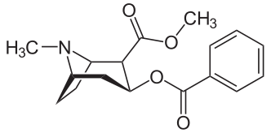
2. The Jmol page contains the structure of a complex between an immunoglobulin (antibody) and cocaine. The chemical structure of cocaine is shown on the right. Only the very top part of the immunoglobulin (Fv region) is shown on the Jmol page.
i) Describe the energetics of the interaction between Tryptophan33H and the bound cocaine. Your answer should discuss what stabilizes the bound cocaine, e.g. H-bonds, electrostatics, van der Waals, or the hydrophobic effect.
ii) Describe the interaction(s) between Tyrosine32L and the bound cocaine. Your answer should discuss what stabilizes the bound cocaine, e.g. H-bonds, electrostatics, van der Waals, or the hydrophobic effect.
iii) How would changing tyrosine32L to phenylalanine affect the affinity of cocaine to the antibody? Would the cocaine binding be stronger or weaker? Justify your answer.
https://www.andrew.cmu.edu/user/rule/03_131/Pset/PS03/ps03_jmol_b.html
3. What disease is the drug Trastuzumab used to treat? Briefly describe how it works to cure the patient (please use the web and provide the appropriate citation).
4. Write a short paragraph on Hers’ disease. Your essay should discuss:
i) The normal function of the enzyme that is affected by this genetic disease.
ii) The consequence of loss of function to the individual.
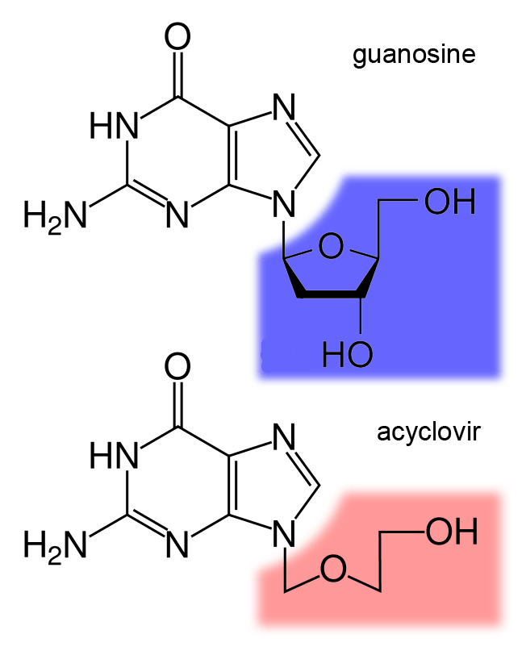
(please use the web and provide the appropriate citation).
5. Acyclovir is an antiviral agent. The structure of acyclovir and guanosine (deoxy) are shown on the right.
i) Use the web to find out what kind of viral infections are typically treated with acyclovir.
ii) How do you think acyclovir works to inhibit replication of the virus?

6. Fragile X-syndrome is due to an excessive number of CGG repeats in a gene called FMR1. Normal individuals have between 5 and 40 repeats while affected individuals have more than 200. The beginning of the gene is shown below with the CGG repeats highlighted in yellow and the start codon for the protein in green.
1 ctcagtcagg cgctcagctc cgtttcggtt tcacttccgg tggagggccg cctctgagcg
61 ggcggcgggc cgacggcgag cgcgggcggc ggcggtgacg gaggcgccgc tgccaggggg
121 cgtgcggcag cgcggcggcg gcggcggcgg cggcggcggc ggaggcggcg gcggcggcgg
181 cggcggcggc ggctgggcct cgagcgcccg cagcccacct ctcgggggcg ggctcccggc
241 gctagcaggg ctgaagagaa gatggaggag ctggtggtgg aagtgcgggg ctccaatggc
During the normal replication of DNA you would find the following replication structure (the CGG repeats are highlighted and alternate bold/not bold).
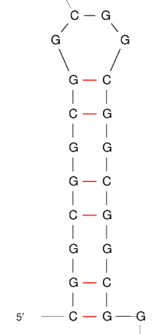
5’----TGCCAGGGGGCGTGCGGCAGCGCGGCGGCGGCGGCGG
3’----ACGGTCCCCCGCACGCCGTCGCGCCGCCGCCGCCGCCGCCGCCGCCGCCG---5’
Please answer the following questions:
i) What are the disease symptoms due to fragile x-syndrome (please use the web).
ii) Postulate how DNA polymerase activity could increase the number of repeats. As a hint, the CGG repeats can form stabile hairpin structures, as shown on the right. Please do not use the web to answer this question.

