This exam contains 100 points on 6 pages. Allot 1 min/2 pts. Please use the space provide, or the back of the previous page. In questions with choices, all answers will be graded and you will receive the highest grade. Be sure to make it clear which choice you are answering.

**Section A: Multiple Choice (8 pts)**

1. In DNA sequencing which of the following nucleotides are "colored"?

a) ddNMPs (dideoxynucleotide monophosphates)

b) dNTPs (deoxynucleotide triphosphates)

c) NTPs (nucleotide triphosphates)

d) dNMP (deoxynucleotide monophosphates)

e) None of these are correct.

2. In DNA sequencing, the largest colored DNA fragment is detected first, followed by the other fragments from largest to smallest.

a) True

b) False

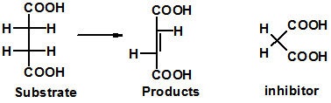3. The substrate and product of an enzymatic reaction are shown on the left. An inhibitor is show on the right. This is a

a) allosteric inhibitor

b) competitive inhibitor

4. Which of the following activities **cannot** be accomplished by the HIV reverse transcriptase enzyme

a) RNA polymerase, using RNA as the template.

b) DNA polymerase, using DNA as the template.

c) DNA polymerase, using RNA as the template.

d) Ribonuclease activity, digestion of RNA.

**Section B: Short Answer**

1. (4 pts) Briefly describe the structure of a virus and explain why they are not considered to be living organisms.

2. (9 pts) Provide an overview of the HIV life cycle, in your answer you want to address:

i) Name the key enzymes that are involved in the life cycle

ii) Briefly describe the function of the key enzymes.

iii) Explain why they are particularly good drug targets.

3. (2 pts) The active site of HIV protease contains two aspartic acid residues and a valine at position 82. What is the function, or role, of the two aspartic acid residues in the enzymatic mechanism?



4. (12 pts) Two inhibitors (drugs) (A and B) of HIV protease are shown below. The normal substrate for the enzyme is shown on the right. All diagrams show the sidechain of Val 82, which is part of the HIV protease enzyme.

i) Explain why these are competitive inhibitors of the enzyme (6 pts).



ii) Draw on the double reciprocal plot the line you would expect to observe for inhibitor A and inhibitor B. The plot already contains the line that would be obtained in the absence of inhibitor. **Justify** your answer with a brief discussion of interaction between the enzyme and the inhibitors. (6 pts).



5. (6 pts)



i) Is the base a purine or a pyrimidine (circle correct answer)?

ii) Label **all** hydrogen bond donors (d) and acceptors (a) on the base.

6.(5 pts) Please do one of the following two choices.

**Choice A:** What is the principal difference between the *chemical* structure of RNA and DNA? How does this difference affect the stability of RNA versus that of DNA.

**Choice B:** Briefly describe the major and minor grooves in DNA. Where do proteins typically bind, in the major or minor groove? Why?

7. (14 pts) The following diagram shows the addition of a UTP to an existing chain.



i) identify the phosphodiester bond in the existing chain.

ii) Indicate the 5’ and 3’ end of the existing chain.

iii) What type of enzyme is likely catalyzing this reaction?

iv) How would the enzyme know to add a U to existing chain?

v) Briefly indicate how the chemical bond forms between the existing strand and the new base would occur. You need not draw a chemical structure.

vi) Write the sequence of the product of the reaction.

8. ( 4 pts) What are the two general classes of HIV reverse transcriptase inhibitors?



9. (4 pts) Please do choice A or choice B.

**Choice A**: The double stranded structure of DNA is shown on the right. What are the errors in the structure, if any?

**Choice B:** Two possible basepairs are shown on the right, which of these two is most likely to be found in DNA, why?



10. (6 pts) Briefly explain the mechanism by which drug resistant HIV viruses develop.

11. (18 pts) You wish to amplify a gene from a drug resistant virus with the eventual goal of producing the protein in bacteria for further study. The nucleotide sequence of the region that contains this gene is shown below, with the sequence of the gene in uppercase letters. The amino acid sequence of the protein is also given.

MetArgTyrValAlaValTyrArgArgSerIleLeuProGlyTyrSerAlaSerAspSerSTP

ggcctaggtATGCGGTACGTAGCGGTATATAGGCGATCGATTCTGCCCGGGTATAGCGCTAGCGATAGCTAAcgcgttagtagta

ccggatccaTACGCCATGCATCGCCATATATCCGCTAGCTAAGACGGGCCCATATCGCGATCGCTATCGATTgcgcaatcatcat

The plasmid that your plan to insert the PCR product into has a single BamH1 site (G^GATCC), so your PCR product should look like:

MetArgTyrValAlaValTyrArgArgSerIleLeuProGlyTyrSerAlaSerAspSerSTP

**GGATCC**ATGCGGTACGTAGCGGTATATAGGCGATCGATTCTGCCCGGGTATAGCGCTAGCGATAGCTAA**GGATCC**

**CCTAGG**TACGCCATGCATCGCCATATATCCGCTAGCTAAGACGGGCCCATATCGCGATCGCTATCGATT**CCTAGG**

i) Give 12 bases of the sequence of the right and left PCR primers that you would be need to produce this product (6 pts)

ii) Briefly describe the steps involved in a PCR reaction and why amplification of the target region occurs (6 pts).

iii) How will digesting your PCR product with BamH1, and the plasmid with BamH1, allow you to insert the PCR product into the plasmid? A well-labeled diagram is an acceptable answer (6 pts)

12. (8 pts) You sequence the wild-type and mutant versions of this gene to determine what mutation is responsible for drug resistance. The location of the mutation is indicated with a “*” and the peak associated with that change is green. The first forty bases of sequence from the wild-type are also given. Identify the altered amino acid in the mutant gene. Please indicate how you obtained your answer.

(The sequence of the PCR product and the protein sequence of the wild-type protein are repeated here for your convenience.)

MetArgTyrValAlaValTyrArgArgSerIleLeuProGlyTyrSerAlaSerAspSerSTP

**GGATCC**ATGCGGTACGTAGCGGTATATAGGCGATCGATTCTGCCCGGGTATAGCGCTAGCGATAGCTAA**GGATCC**

**CCTAGG**TACGCCATGCATCGCCATATATCCGCTAGCTAAGACGGGCCCATATCGCGATCGCTATCGATT**CCTAGG**

G=black, C=blue, A=green, T=red.

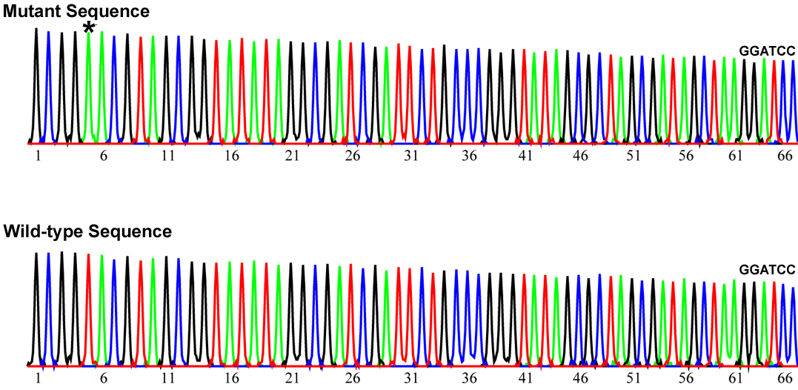

The first forty bases from data for the sequence of the wild-type:

**1 10 20 30 40**

GCGGTACGTAGCGGTATATAGGCGATCGATTCTGCCCGGG

**Codon Table:**

|  |  |  |  |  |  |
| --- | --- | --- | --- | --- | --- |
| **5' Base** | **Middle Base** | | | | **3'** |
|  | **T** | **C** | **A** | **G** |  |
| **T** | Phe | Ser | Tyr | Cys | **T** |
|  | Phe | Ser | Tyr | Cys | **C** |
|  | Leu | Ser | **Term** | **Term** | **A** |
|  | Leu | Ser | **Term** | Trp | **G** |
| **C** | Leu | Pro | His | Arg | **T** |
|  | Leu | Pro | His | Arg | **C** |
|  | Leu | Pro | Gln | Arg | **A** |
|  | Leu | Pro | Gln | Arg | **G** |
| **A** | Ile | Thr | Asn | Ser | **T** |
|  | Ile | Thr | Asn | Ser | **C** |
|  | Ile | Thr | Lys | Arg | **A** |
|  | **Met** | Thr | Lys | Arg | **G** |
| **G** | Val | Ala | Asp | Gly | **T** |
|  | Val | Ala | Asp | Gly | **C** |
|  | Val | Ala | Glu | Gly | **A** |
|  | Val | Ala | Glu | Gly | **G** |

**14. Bonus (4 pts)** What was the sequence of the primer that was used for sequencing?