**1.** (10 pts, 10 min) AZT is a competitive inhibitor of HIV reverse transcriptase. Its structure is shown on the right, along with one of the normal substrates for the enzyme, dTTP.



i) Why is it not possible for AZT to be incorporated into the growing polymer?

ii) What would have to be added to the AZT such that it could be added to the primer by a polymerase?

iii) If AZT were used by a polymerase, would elongation (addition of the next base) be possible? Why or why not?

**2.** (10 pts, 5 min) Acyclovir is an antiviral agent. The structure of acyclovir and guanosine (deoxy) are shown on the right.

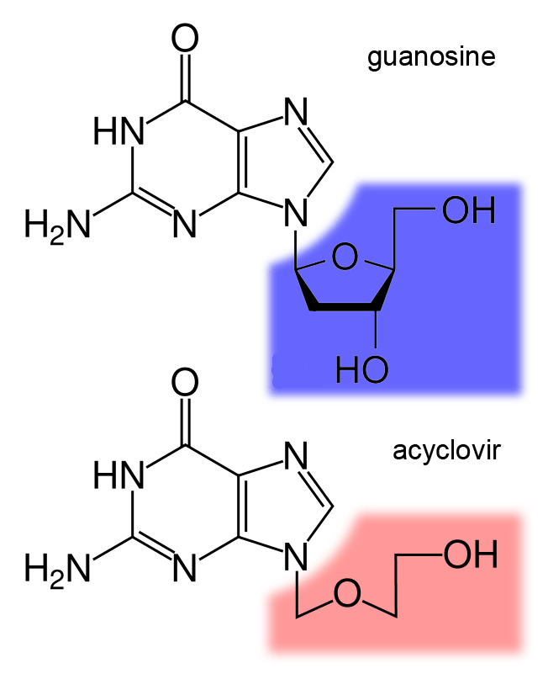

i) Use the web to find out what kind of viral infections are typically treated with acyclovir.

ii) How do you think acyclovir works to inhibit replication of the virus?

**3.** (15 pts, 25 min) Two sequencing reactions are shown below. The top sequence is of a mutant HIV protease gene and the bottom is from a wild-type virus. Your ultimate goal is to determine how a mutation may have affected binding of the drug to the HIV protease. *You will need to download the problem set to get the data in color. Sequence files are also downloadable, if you want to use bioinformatics tools (recommended). You can translate the DNA sequence at:* [*http://web.expasy.org/translate/*](http://web.expasy.org/translate/)*. (This will give the one letter code for the amino acids, a conversion chart is given on the last page of this problem set.) Alternatively you can use Blastn to align the mutant sequence data to the wildtype sequence.*

i) Determine the change in the DNA sequence and the resultant change in protein sequence. You will need to consult the known DNA/protein sequence of HIV protease (see lecture notes) to determine the correct reading frame.

ii) Does this mutation affect the substrate specificity of HIV protease (the types of substrates it likes to act on), or the ability of the enzyme to cleave peptide bonds? Why?

iii) The anti-viral drug that inhibits HIV protease is shown on the right. How might you modify the drug such that it would bind, and effectively inhibit, the activity of the virus containing the mutant protease? To aid in the visualization of the enzyme-inhibitor complex, you can utilize the HIV jmol page for this problem set. This Jmol page will allow you to load the structure of HIV protease with a number of different mutations – you need to determine the correct mutation (part i) to select the correct structure to view.

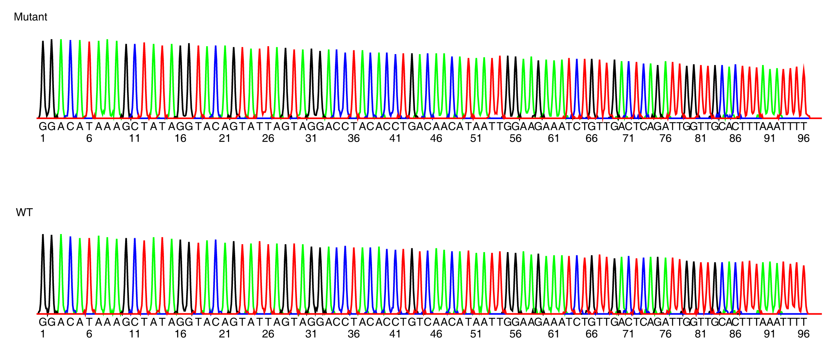

**4.** (10 pts, 15 min)Solve the following forensic case. DNA was isolated from the victim, collected from the crime scene, and from three suspects. The DNA was subjected to PCR using primers that amplify a region of the chromosome that is known to contain tandem repeats, which are sequences that are repeated multiple times on the same chromosome. The number of tandem repeats differs from one individual to another, causing the length of the PCR product to differ. For example one chromosome could look like this, with three tandem repeat (see above), while a chromosome might have four, giving a larger PCR product. Note that since we have two copies of each chromosome there are two possible PCR products, one from each chromosome. It is possible to have the same number of tandem repeats on each chromosome.



After PCR the DNA was separated by size and stained to visualize the DNA fragments. In the image on the right shows the sizes of DNA fragments for each of the following samples:

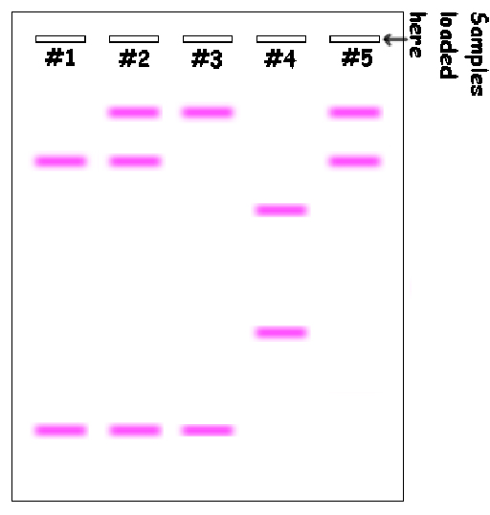

1. Lane 1 – Victim’s blood
2. Lane 2 – Blood at crime scene (victim+criminal)
3. Lane 3 - Suspect #1
4. Lane 4 - Suspect #2
5. Lane 5 - Suspect #3

Bands towards the bottom of the diagram are smaller. Bands at the same position have the same size. The circled band will be used for problem 5.

i) Who is no longer a suspect? Please justify your answer.

ii) On the basis of the above data, who is still a suspect for the crime? Please justify your answer.

iii) Is the individual identified in part ii) definitely guilty?

**5.** (10 pts, 15 min) The smallest PCR product (circled in the above image) was sequenced and its sequence was:

GCTGTAGCCATTGGGCCCTTTAAAGGGCCCTTTAAAGGGCCCTTTAAACCGCGTGAGTCA

i) What is the sequence of the tandem repeat?

ii) How many tandem repeats are present in this DNA?

iii) Give the sequence of the left and right PCR primers that would have been used to produce this PCR product. Assume that the PCR primers are 8 bases long.

|  |  |  |  |  |  |
| --- | --- | --- | --- | --- | --- |
| alanine | ala | A | leucine | leu | L |
| arginine | arg | R | lysine | lys | K |
| asparagine | asn | N | methionine | met | M |
| aspartic acid | asp | D | phenylalanine | phe | F |
| cysteine | cys | C | proline | pro | P |
| glutamic acid | glu | E | serine | ser | S |
| glutamine | gln | Q | threonine | thr | T |
| glycine | gly | G | tryptophan | trp | W |
| histidine | his | H | tyrosine | tyr | Y |
| isoleucine | ile | I | valine | val | V |