**Lecture 34: Genetic Diseases Associated with Meiosis, Introduction to Mendel**

1. Given the following chromosomes in this cell, generate a karyotype. Is this individual male or female?



2. Draw the cell at metaphase 1 in meiosis.



3. Draw the cells after cytokinesis in meiosis I.



4. Draw the gametes (sperm, egg) produced after meiosis II. How do they differ?



5. What happens if there is non-disjunction in meiosis I (both homologous chromosomes go to one pole of the cell), with normal separation of the chromatids in meiosis II? What do the gametes look like?



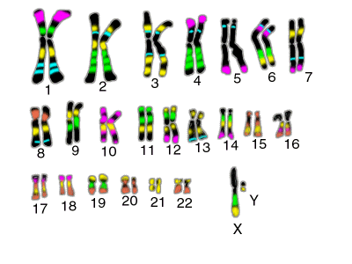6. What happens when a normal gamete joins with the gametes produced in 5?

Modern Karyotype mapping – gene specific stains make it easier to identify homologous chromosomes.

**Genetic Diseases caused by Non-disjunction:**

**Aneuploid** fertilized egg/embryo may have:

1. 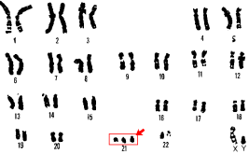one less chromosome – monosomy
2. one extra chromosome – trisomy

Most common diseases are associated with trisomy and involve smaller chromosomes:

**Autosomal**

* Downs syndrome – trisomy 21 (1/1000 for 30 yr old mothers, 1/12 for 50 yr old mothers)

**Sex Chromosomes**

* Klinefelter syndrome – trisomy – XXY (1:1000)
* Turners syndrome – monosomy – XO (1:5000)

**Mendelian Genetics – you can learn a lot from peas.**

**Trait:** Any aspect of the appearance of an organism.

**Phenotype:** Observed characteristic, depends on genotype.

**Genotype:** Actual DNA composition of the organism.

**Dominant allele**: Single copy of allele gives rise to observed phenotype, usually symbolized with uppercase letters (A).

**Recessive allele:** both copies of alleles are required to observe phenotype, usually symbolized with lowercase letters (a).

**Codominance:** Both alleles contribute to phenotype.

**Homozygous:** Both alleles of a gene are the same (AA)

**Heterozygous:** Two different alleles (Aa)

**Sex-linked**: trait associated with the X-chromosome

Peas were a very good model system, it was easy to breed pea plants using manual cross-pollination (instead of the more usual self-pollination), they grow quickly, and have easy to observe traits.

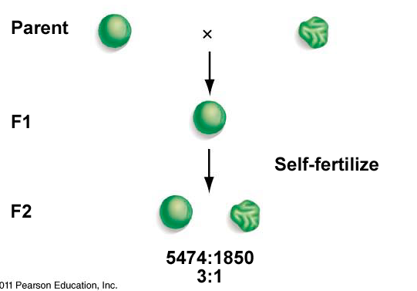**Monohybrid Cross:**

* Crossed homozygous plants, one parent with round seeds, other with wrinkled seeds.
* First filial (F1) generation was all smooth.
* Second generation (F2) was 75% smooth, 25% wrinkled.

How to predict the phenotype and genotype of the F1 and F2 offspring:

-Assign symbols to genes

-Determine frequency of gametes

-Consider all possible combinations.

**Dihybrid Cross: How to two different traits (color and shape) segregate?**

**Unlinked: Genes exist on different chromosomes (left side of page)**

**Linked: Genes exist on the same chromosome (right side of page)**

**Outcome of the first cross (F1) is the same, regardless of the linkage.**



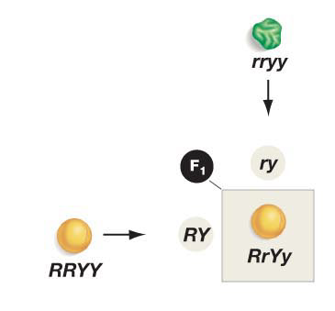

**Outcome of the F1 x F1 will differ for unlinked (left) and linked (right):**



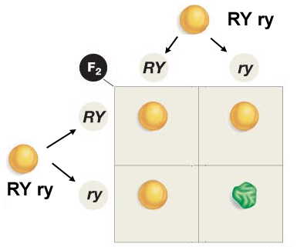

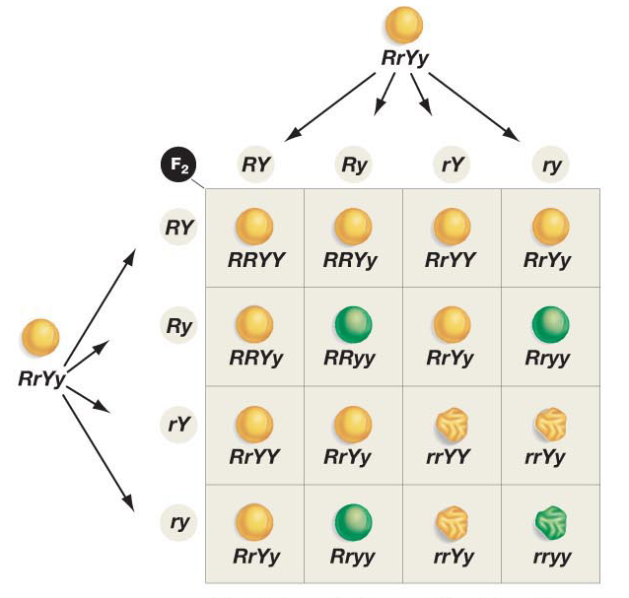



**Mendel observed:**