**Lecture 31: Anaerobic Metabolism & Introduction to Genetics**



**Anaerobic Metabolism (Fermentation):**

* Glycolysis contains one oxidation step that converts NAD+ to NADH
* The NADH normally is converted back to NAD+ by electron transport.
* In the absence of oxygen, this cannot occur and the cell will become depleted of NAD+.

*What will happen to glycolysis where there is no oxygen as an electron acceptor?*

*Humans:*

*Yeast:*

**Introduction to Genetics - Eukaryotic Chromosome Structure.**

* The **linear** DNA is condensed by wrapping around histones. 8 histones 2x(H2A, H2B, H3, H4) forming a nucleosome. H1 histone positions the DNA on the nucleosome.
* The nucleosomes associate to form a polymer, which are further packed into chromosomes.
* This allows a very long DNA strand to be packaged into a very small space.

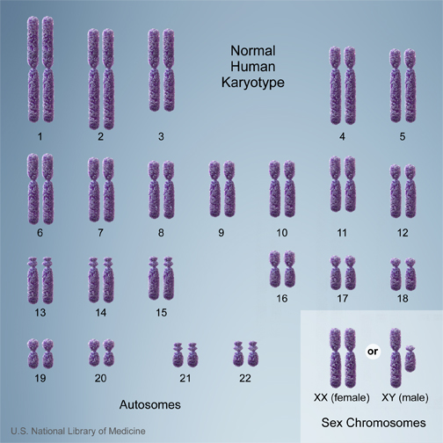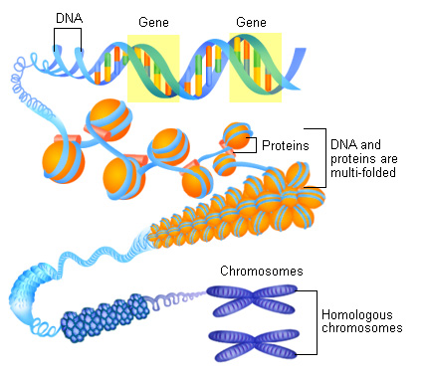

**Telomere** – the end of a chromosome, repetitive sequence: TAGGGTTAGGGTTAGGG…..

**Centromere** – structure at the center of a chromosome.



**Chromatid** – arms of the chromosome.

**Homologous chromosomes:** Two chromosomes that have the same organization of genes. One inherited from the mother, other from the father. There are usually differences between the genes (e.g. Hb and Hbs – normal and sickle cell Hb).

**Karyotype**  - Appearance of the chromosomes in a cell.

**Autosomes** – non-sex chromosomes

**Diploid** – two copies of each autosome.

**Sex chromosomes** – male = xy, female = xx

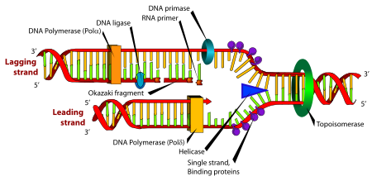**Replication of Linear Chromosomes – What to do at the ends?**

* The lower strand can be replicated to its end as part of the leading strand synthesis.
* The upper strand cannot because it cannot be primed.
* 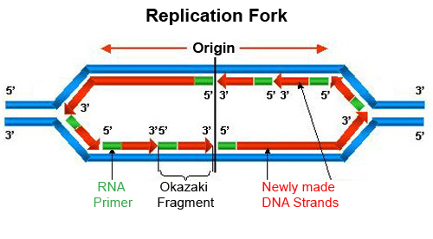Chromosomes would shorten after each replication.

Polδ = Pol III Polα = Pol I Gyrase = Toposiomerase



**Telomerase –** A reverse transcriptase with its own template.



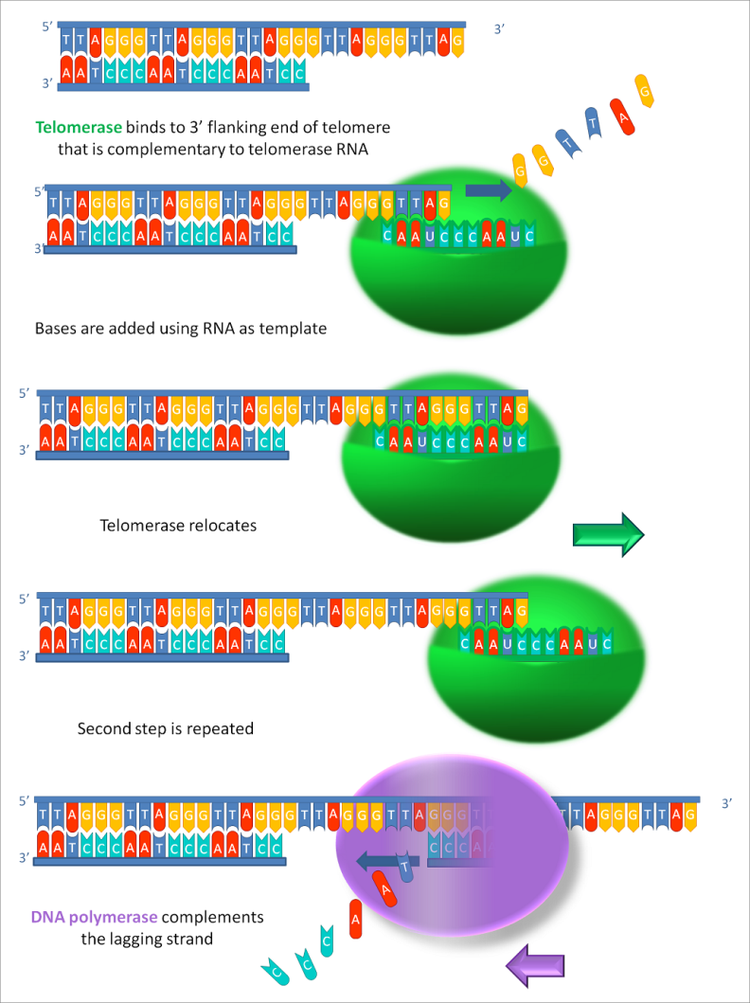

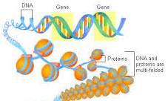**Histone Modification and Regulation of Gene Expression:**

* DNA that is highly condensed is not available for transcription.
* Modification of histones can restructure the chromosome, allowing or inhibiting transcription.
* Common modification of histones include:
  + Acetylation of lysine residues
  + Phosphorylation of Serine and Tyrosine residues
  + Methylation of lysine residues.



The site of and type of modification can affect whether the DNA is accessible for transcription. For example, methylation of lysine at position 4 or 27 in a histone causes different conformational changes in the histone, affecting DNA binding.

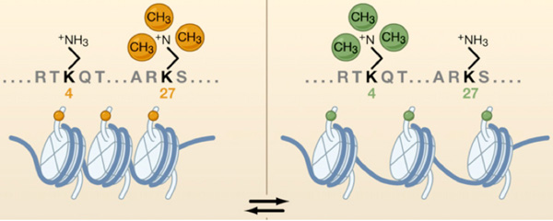

**Comparison of Regulation and Diversity of Eukaryotic and Prokaryotic Proteins:**

**Prokaryotic Cells Eukaryotic Cells**

Transcriptional Control

Repressors Repressors

Activators Activators (enhancers/transcription factors)

**DNA accessibility (histone modification)**

mRNA Stability and Processing

mRNA stability (poly A)

Alternative spicing