**Lecture 30: Electron Transport & ATP Synthesis**

**Electron transport**



**Location**: Inner mitochondrial membrane

**Input**: NADH, FADH2

**Output**: Proton gradient across inner membrane, higher proton concentration between the two membranes.

**Overview:**

* The energy captured by oxidation steps in glycolysis and the TCA cycle are stored on NADH and FADH2.
* These compounds are oxidized in the electron transport chain, releasing additional energy as electrons are removed from them.
* This energy is stored in a **proton gradient** across the inner mitochondrial membrane.
* *The energy stored in this gradient is used to produce ATP*.
* Final electron acceptor is oxygen.

Addition of electrons to oxygen releases energy: O2 + 4 H+ + 4 e- = O2 + 2 H2 → 2 H2O

**Energy Changes in Electron Transport**

**Oxidation of NADH**

***Complex I*: NADH →NAD+**



* **NADH is oxidized back to NAD+.**
* **The electrons from NADH are transferred coenzyme Q, a non-polar electron carrier.** The membrane must be fluid for it to diffuse from one complex to the next.
* **Four protons** are pumped from the inside (matrix) to the intermembrane space for each pair of electrons processed.

***Complex III*:**

* Electrons from CoQH2 passed to cytochrome c.
* **Four protons** are pumped for each pair of electrons processed.

***Cytochrome C****:* A small iron containing protein that shuttles electrons, one at time, from III to IV.

***Complex IV*: Cytochrome c oxidase**

* Donates a total of *four* electrons to O2.
* Pumps an additional **two protons** for each pair of electrons that are processed.

***Oxidation of FADH2***

***Complex II*: FADH2→FAD**

* Two electrons from FADH2 are transferred to CoQ.
* Does not pump any protons.
* CoQ goes to complex III
* Remaining path is the same as NADH oxidation:

Complex III – 4 protons pumped/pair of electrons.

Complex IV - 2 protons pumped/pair of electrons.

*Let’s count how many protons are pumped by the oxidation of one NADH:*



*Let’s count how many protons are pumped by the oxidation of one FADH2:*

**ATP Synthesis (Oxidative phosphorylation):**



***ATP synthesis*** *is attained by coupling the energy stored in the proton gradient to the chemical synthesis of ATP.*

*The enzyme that accomplishes this coupling is called* ***ATP-synthase****. This is called* ***oxidative phosphorylation*** *since the generation of ATP is coupled to oxidation.*

***9 H+ = 3 ATP synthesized***

**Structural Features:**

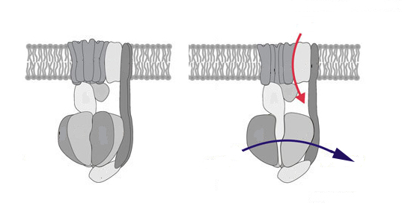

1. The Fo Complex

* Membrane-spanning, multi-protein complex.
* Responsible for coupling the movement of three protons to 120° rotations of the **γ-subunit**.

2. The F1 Complex

* Attached to Fo, it protrudes into the mitochondrial matrix.
* Composed of five different subunits: α3β3γδε



* The γ subunit is the shaft at the center of the α3β3 disk. **γ rotates 120o/3 protons.**
* The β subunits are asymmetric due to their interactions with the γ-subunit (allosteric effects).

1. One conformation of the β subunit has very **low affinity** for both ADP and ATP.
2. One conformation of the β subunit has **high affinity for ADP and Pi**.
3. One conformation of the β subunit has **high affinity for ATP**.

**How the motor works**:

* Every time three proton move through the complex, the γ subunit rotates 120°.
* The rotation of γ subunit changes the conformation of the β-subunits such that the Gibbs energy of the bound ADP + Pi becomes higher than the energy of ATP, thus ATP forms spontaneously from the bound ADP and Pi.
* The newly-formed ATP is released with the transport of three additional protons.
* The actual synthesis, or formation of the bond between ADP and PI, is catalyzed by conformational changes of the β-subunit that occur as a consequence of the rotation.
* Since all three β subunits are functioning at the same time, the transport of 9 protons in a complete cycle produces 3 ATP.

|  |  |  |
| --- | --- | --- |
| **NADH** | **~10 protons pumped** | **~ 3 ATP** |
| **FADH2** | **~6 protons pumped** | **~2 ATP** |