# Lecture 29 – Glycolysis & TCA Cycle.

1. **Location**: cytosol
2. **Input**: glucose
3. 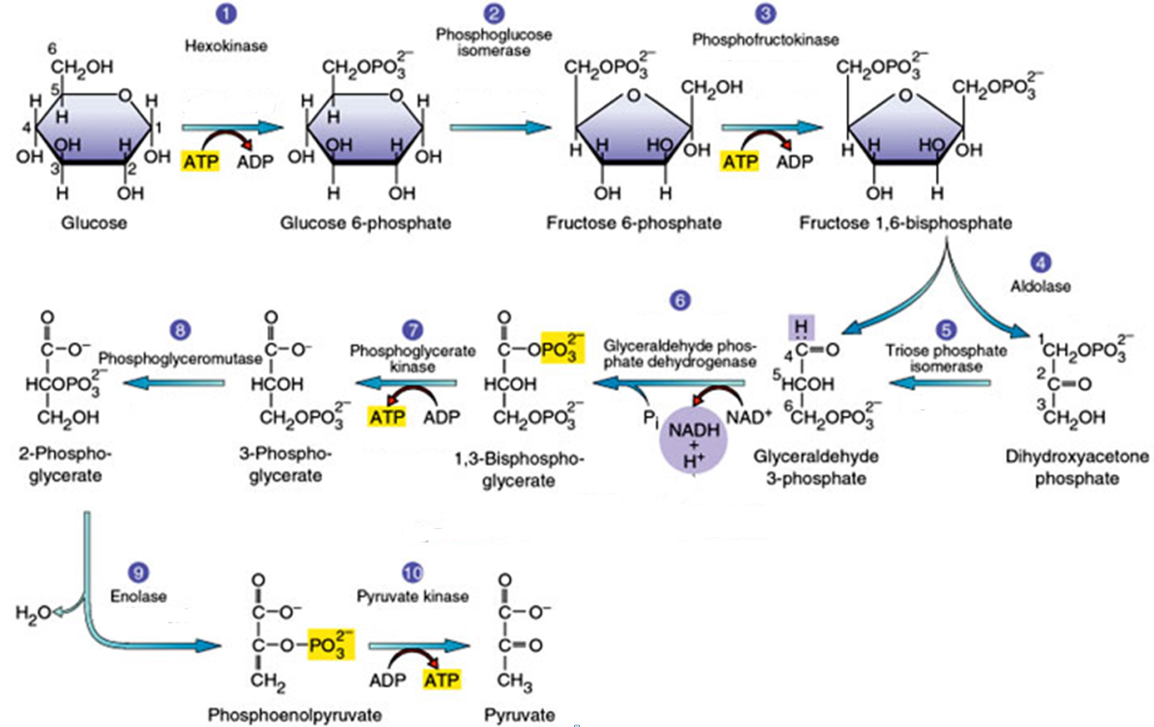**Output**: pyruvate (X2)
4. **Net energy prod.**: 2 ATP, 2 NADH
5. **Key controlling step**: PFK (phosphofructose kinase)

**Energy changes in glycolysis consist of three separate phases:**



Steps 1-3: Formation of fructose 1,6 phosphate from glucose. This **requires** 2 ATP molecules.

Step 6: Oxidation of glyceraldehyde-3-phosphate to 1,3 phosphoglycerate by a dehydrogenase. This single step generates all of the energy in glycolysis. Most of this energy is captured on NADH or used to make ATP in the later steps in the pathway.

Steps 7,10: These steps generate a total of four ATP molecules. This is called **substrate level phosphorylation,** since the phosphate is transferred from a substrate to ADP to form ATP.

**Regulation of Glycolysis:**

Phosphofructose kinase (PFK) is:

* Inhibited by ATP, stabilizes an inactive allosteric conformation.



* Activated by ADP, stabilizes an active allosteric conformation.
* This is referred to as **feedback inhibition** since a compound that is produced by the pathway (ATP) inhibits an earlier step.
* Also inhibited by citrate, feedback regulation from the next pathway.

**TCA (Tri-carboxylic acid) Cycle** (Also known as the citric acid cycle or the Krebs cycle.)

**1. Location:** Mitochondrial matrix

**2. Input:** pyruvate

**3. Output:** CO2,

**4. Energy Production:** NADH, FADH, GTP

**5. Key Controlling Step:** Pyruvate dehydrogenase.



* **Catabolic role**: Amino acids, fats, and sugars enter the TCA cycle to produce energy.
* **Anabolic role**:TCA cycle provides starting material for fats and amino acids.

**Overall Carbon Flow:** All of the carbons that are input as **pyruvate** are released as **CO2**. This is as highly oxidized as carbon can get:

* One carbon is removed converting pyruvate to acetyl-CoA.
* The two carbons in acetyl-CoA are condensed with 4 carbons to form citrate.
* Citrate loses two carbons as CO2.

Net: pyruvate (C3) → 3 x CO2.



**2. Energetics of the TCA Cycle:**

In contrast to glycolysis, most of the energetic currency is in the form of redox reactions, only a single ATP (initially as GTP) is produced/pyruvate while four NADH and one FADH2 are produced. Most of the energy from oxidation is of glucose is harvested in the TCA cycle.

**3. Regulation**

Pyruvate dehydrogenase is inhibited by NADH. *What type of inhibition is this?*

**4. Inter-pathway regulation.**



Citrate inhibits PFK in Glycolysis. *What type of inhibition is this?*

