# Lecture 28 – Introduction to Metabolism

**Goals**

* Understand differences between anabolic and catabolic pathways.
* Identify common themes in pathways
* Describe the cellular location and inter-pathway connections.
* Explain why ATP is an energy source for the cell.
* Identify kinases, phosphatases based on reaction they catalyze.
* Identify oxidation/reduction reactions.

**Metabolic pathways are:**

1. Consist of a number of steps, each catalyzed by an enzyme causing a small change to the chemical structure, i.e. A→B→C→D→E



1. Many are conserved in different organisms.
2. Overall irreversible (but most of the individual steps are not)
3. Usually committed after the initial steps
4. Regulated.
5. Compartmentalized in eukaryotes

**Catabolism [degradative]** – conversion of a diverse set of compounds to a small number of simple compounds, usually for energy production.

**Complex → simple + energy**

**Anabolism [synthetic]** – conversion of a small number of simple compounds to complex organic molecules, usually requiring energy.

**Simple + energy → complex.**

**Expectations:**

* Input and output of each pathway
* Overall energy and carbon flow
* Regulation.

**Central Pathways of Energy Production:**

**Intracellular locations:**

* 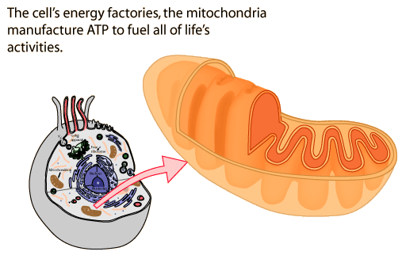**Glycolysis** - cytosol
* **Citric Acid Cycle**: Inner matrix of mitochondria (also called the Krebs cycle or the TCA cycle.
* **Electron transport**: Inner membrane of mitochondria.
* **ATP synthesis**: Inner membrane of mitochondria

**Energy Currency:**

Stored in the following ways:

* Redox compounds (NADH, FADH2)
* Membrane potentials (concentration gradient and voltage difference across a membrane)
* "High energy" chemical species (ATP, and sometimes GTP):

**Energy Utilization:**

* Chemical synthesis reactions (e.g. protein synthesis, DNA synthesis
* Mechanical work (e.g. transport, muscle function, kinesins in mitosis)
* Electrical work (e.g. nerve conduction)

**Overall Carbon & Energy Interconversion during metabolism of glucose:**



Overall Reaction: C6H12O6 + 6 O2 → 6CO2+6 H2O + Energy (ATP) ΔGo = -2823 kJ/mol

Glycolysis + Citric Acid Cycle: C6H12O6 + 6H2O → 6CO2 + 24H+ + 24 e- + 4ATP

Electron Transport: 6O2 +24 H+ +24 e-→12 H2O

ATP synthesis (oxidative phosphorylation): Proton gradient + ADP & Pi → ATP

(Enzyme is called ATPase, or ATP synthase)



**General Enzyme Nomenclature:**



Name - usually consists of three parts:

i) the substrate is usually used to name the enzyme. e.g. glucose kinase

ii) the nature of the chemical reaction.

iii) most names end in *“-ase”*

**Common Enzymes Involved in Metabolism:**

**Kinase**: transfers a phosphate group from ATP to another compound (e.g. glucose kinase).

**Phosphatase**: Removes a phosphate group from a substrate, no ATP/ADP required (e.g. phosphoglucose phosphatase).



**Dehydrogenase (redox reactions)**:

* Oxidizes or reduces compounds by removal or addition of electrons.
* Usually two electrons are removed/add at a time, often transferred with a proton (e.g. H+ + e-)
* Oxidation is usually accompanied by the addition of oxygen to the compound (but there are exceptions)
* **Oxidation generally releases energy as electrons are pulled towards the more electronegative oxygen.**



OILRIG:

* oxidation involves loss
* reduction involves gain.
* Electrons (and energy) are captured by organic electron carriers:
  + **NAD+ converted to NADH**
  + FAD converted to FADH2