**Lecture 23: Replication, Transformation, mRNA Processing, Carbohydrates.**

**Lagging strand synthesis** – Replicated in sections, with replacement of multiple RNA primers by DNA pol I and joining of segments by DNA ligase.

Identify the differences between each image – what happened and who did it?

Black = template Blue = RNA primers Red = New DNA

5’CCCCCTTAACCTCCAAAATAGTTTCATTCTGTCATACTAGTCTATGAGTATCTTTAGACACCGC-

3’gggggaattggaggttttatcaaagtaagacagtaTgatcagatacTCAtagaaatctgtGGCG-

5’CCCCCTTAACCTCCAAAATAGTTTCATTCTGTCATACTAGTCT

**gaauu5’** ATGAGTATCTTTAGACACCGC-

5’**cuccaa** tacTCAtagaaatctgtGGCG-

3’gggggaattggaggttttatcaaagtaagacagtaTgatcaga

5’CCCCCTTAACCTCCAAAATAGTTTCATTCTGTCATACTAGTCTATGA

*GGGG***gaauu5’** GTATCTTTAGACACCGC-

5’**cuccaaaatagtttcattctgtcatactagtc** CAtagaaatctgtGGCG-

3’gggggaattggaggttttatcaaagtaagacagtaTgatcagaTACT

5’CCCCCTTAACCTCCAAAATAGTTTCATTCTGTCATACTAGTCTATGAGTAT

***GGGG*gaauu5’** **AUCAG5’**  CTTTAGACACCGC-

5’**cuccaaaatagtttcattctgtcatactagtctatgagta** gaaatctgtGGCG-

3’gggggaattggaggttttatcaaagtaagacagtaTgatcagaTACTCATA

5’CCCCCTTAACCTCCAAAATAGTTTCATTCTGTCATACTAGTCTATGAGTAT

***GGGG*gaauu5’aggttttatcaaagtaagacagtatg**AUCAG5’ CTTTAGACACCGC-

5’**cuccaaaatagtttcattctgtcatactagtctatgagta** gaaatctgtGGcG-

3’gggggaattggaggttttatcaaagtaagacagtaTgatcagaTACTCATA

5’CCCCCTTAACCTCCAAAATAGTTTCATTCTGTCATACTAGTCTATGAGTAT

***GGGG* aggttttatcaaagtaagacagtatgAUCAG5’** CTTTAGACACCGC-

5’**cuccaaaatagtttcattctgtcatactagtctatgagta** gaaatctgtGGCG-

3’gggggaattggaggttttatcaaagtaagacagtaTgatcagaTACTCATA

broken phosphodiester (nick)

5’CCCCCTTAACCTCCAAAATAGTTTCATTCTGTCATACTAGTCTATGAGTAT

**GGGGgaattggaggttttatcaaagtaagacagtatgaucag5’** CTTTAGACACCGC-

5’**cuccaaaatagtttcattctgtcatactagtctatgagta** gaaatctgtGGCG-

3’gggggaattggaggttttatcaaagtaagacagtaTgatcagaTACTCATA

5’CCCCCTTAACCTCCAAAATAGTTTCATTCTGTCATACTAGTCTATGAGTAT

**GGGGgaattggaggttttatcaaagtaagacagtatgaucag5’** CTTTAGACACCGC-

5’**cuccaaaatagtttcattctgtcatactagtctatgagta** gaaatctgtGGCG-

3’gggggaattggaggttttatcaaagtaagacagtaTgatcagaTACTCATA

5’CCCCCTTAACCTCCAAAATAGTTTCATTCTGTCATACTAGTCTATGAGTATCTTTAGACACCG

**GGGGgaattggaggttttatcaaagtaagacagtatgaucag5’** **UGUGG** C-

5’**cuccaaaatagtttcattctgtcatactagtctatgagta**tctttagacacc G-

3’gggggaattggaggttttatcaaagtaagacagtaTgatcagaTACTCATAgaaatctgtGGC

5’CCCCCTTAACCTCCAAAATAGTTTCATTCTGTCATACTAGTCTATGAGTATCTTTAGACACCGC-

3’gggggaattggaggttttatcaaagtaagacagtaTgatcagatacTCAtagaaatctgtGGCG-

5’CCCCCTTAACCTCCAAAATAGTTTCATTCTGTCATACTAGTCTATGAGTATCTTTAGACACCGC-

3’gggggaattggaggttttatcaaagtaagacagtaTgatcagatacTCAtagaaatctgtGGCG-

**Online material to help with DNA Replication:** https://oli.cmu.edu/

* Register using course key: DNAREP-D
* Complete pre-quiz, view material, complete post-quiz (2 pts bonus for course).
* Send comments/suggestions to me ([rule@andrew.cmu.edu](mailto:rule@andrew.cmu.edu)) for improvements.

**Bacterial Transformation & Antibiotic Resistance**

**Transformation –** process of putting plasmid DNA into bacteria.



**Selectable marker** – gene contained on the plasmid that can produce a protein that makes the bacteria resistant to antibiotics.

* Growth of transformed cells in the presence of the antibiotic is referred to as selection, because it selects for those bacteria that contain the plasmid.
* It is necessary to have the antibiotic present at all times, otherwise the plasmid will be lost from the cells.

**(image from** [**http://2012.igem.org/Team:St_Andrews/Public-outreach**](http://2012.igem.org/Team:St_Andrews/Public-outreach)**)**

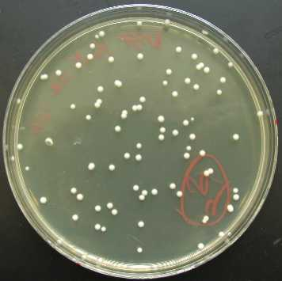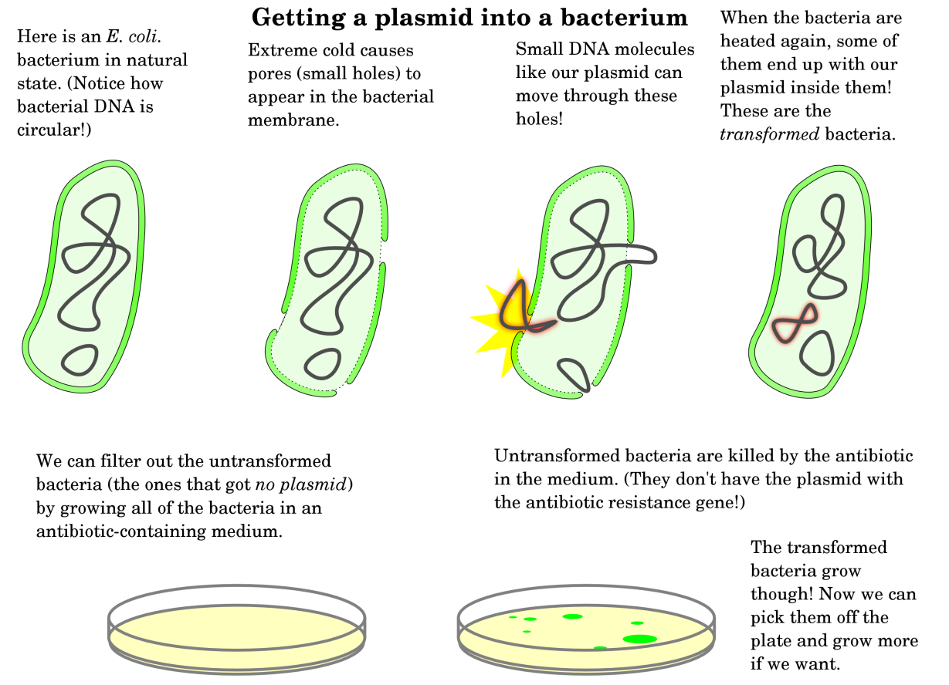

**Summary of Plasmid elements:**

**Restriction sites** (EcoR1 and BamH1): Used to insert coding region into plasmid via sticky ends and DNA ligase.

**Promoter** – Binding site for RNA polymerase, generates mRNA from DNA sequence

**Lac Operator** – Lac repressor binds here, on/off switch for mRNA production.

**mRNA termination** – end of mRNA

**Ribosome binding site** – binds mRNA to ribosome, positions start codon in P-site.

**Start codon** – first codon, recognized by tRNAfMET, all prokaryotic proteins begin with a modified methionine residue.

**Codons** – coding for the amino acid sequence of our desired protein, anything can be made.

**Stop codon** – Signals protein release factor to release completed protein from ribosome, breaking bond between the last tRNA and the new protein.

**Origin of replication** – so that the plasmid will be replicated and passed on to daughter cells.

**Antibiotic resistance gene** – so that we can select for cells that have our plasmid.

**mRNA processing in Eukaryotic Cells**

**Poly A addition.** A series of A residues are added to the end of the mRNA by specialized enzymes. This is important for:

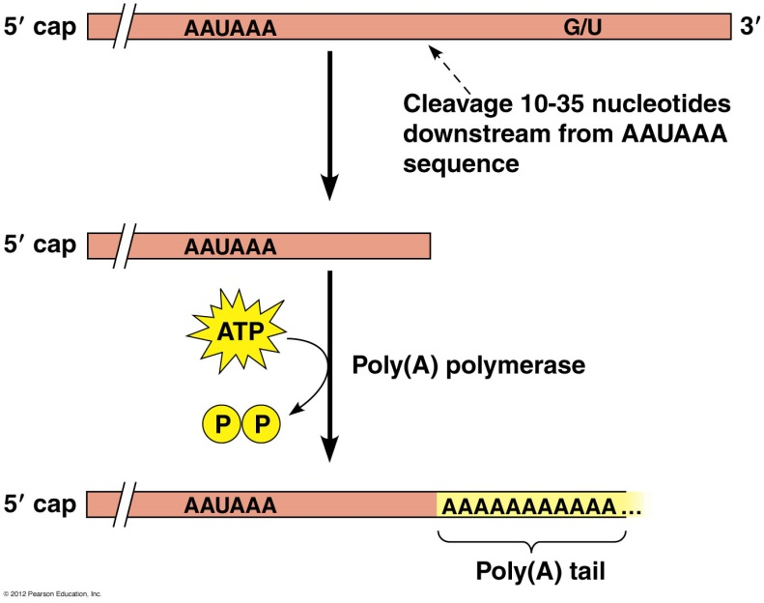

* Nuclear export
* Translation (protein synthesis)
* enhancing the stability of mRNA.

**mRNA splicing**.

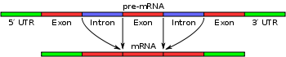

The initial transcript is composed of:

* Exons that code for amino acids
* Introns are intragenic regions that are removed during splicing.
* Splicing requires the following sequences in the intron to guide the splicing machinery:



1. a 5’ donor site
2. a 3’ acceptor site
3. a branch sequence within the intron

* Steps:

1. A in branch breaks phosphodiester at 5’ splice site
2. 3’ OH at 5’ splice site forms new phosphodiester with 3’splice site

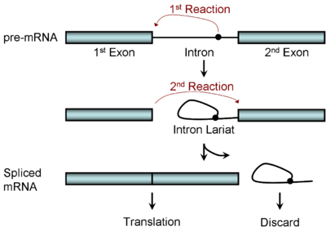

**Alternative splicing** is common, with different exons retained in different tissues. This allows the same gene to produce many different proteins.

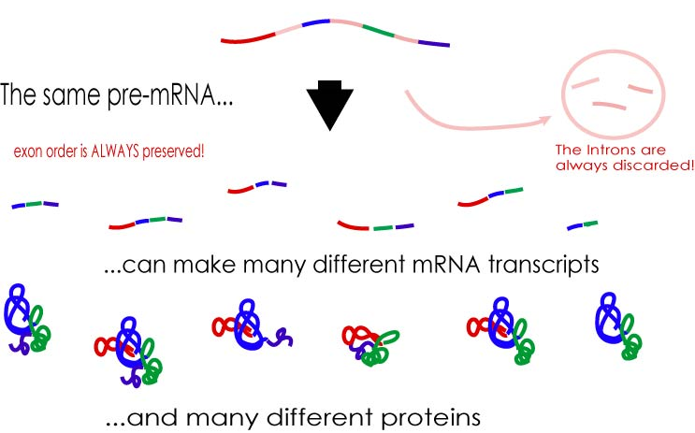

**Genetic Diseases:**

* Mutations in the splicing machinery can cause wide-spread problems in mRNA splicing.
* Mutations in the donor or acceptor site can cause incorrect splicing of individual mRNAs.

**Introduction to Carbohydrates:**

**Monosaccharides:** All carbons in monosaccharides are 'hydrated' -hence the name *carbohydrate (general formula (CH2O)N). Each carbon is bound to one oxygen. The first or the second carbon is a C=O.*



1. The simplest monosaccharides contain three carbons (dihydroxyacetone, glyceraldehydes)
2. When the C=O group is at the 2nd position it's called an **ketose**, because the functional group is a ketone, e.g. dihydroxyacetone.
3. When the C=O group is at the very begining it's an **aldose**, because the functional group is an aldehyde, e.g. glyceraldehydes.
4. Additional hydrated carbons (HO-C-H) are added just below the aldehyde or ketone group.
5. The added carbon generates a new chiral center. Each aldose differs from its neighbor by the configuration of at least one of the carbon.



**Ketoses:** The addition of three (HO-C-H) units to dihydroxyacetone gives the 6 carbon ketose - fructose, an important sugar in metabolism.



**Ring Formation in Glucose**

1. Six membered ring created by forming a bond between C1 and O5.



2. The C1 carbon *becomes* chiral and is called the ***anomeric*** carbon

3. The new OH group (on C1) can exist in either the  or β form.

α-down β-up

4. The α and β forms can readily inter-convert via the linear intermediate.