**Lecture 20: Regulation by lac Operon, Introduction to Protein Synthesis**



**Regulation of the Lac operon**

* **Repressor protein** (lac repressor) is produced by the lac I gene, it has its own promoter and is not regulated. The lac I gene is on the chromosome of the bacteria.
* The lac repressor protein binds to its **operator**, preventing the production of proteins required for the usage of lactose by the bacteria. The binding is sequence specific – the lac repressor recognizes a specific DNA sequence, the lac operator.



* When lactose is present, it binds to the lac repressor, causing it to leave the DNA. Lactose is an **inducer** – because it induces the production of enzymes.



* Enzymes for the usage of lactose are then produced by the cell and lactose is used as a source of energy.

**Controlled Expression of HIV protease using the Lac operon Machinery.**

1. The continuous expression of high levels of almost any protein is toxic to the bacteria.



* Protein is toxic
* Cell dies making so much of the protein

2. IPTG, an analog of lactose, also binds to and causes the lac repressor to leave the operator sequence on the DNA.

3. mRNA coding for HIV protease is then made by RNA polymerase, this is used by the ribosome to make the enzyme.

4. Typically, a large number of cells are grown up, and then IPTG is added, production of mRNA starts, and then HIV protease is made.

HIV Protease->

mRNA------------------------------------------->

**TTGACA**TTTATGCTTCCGGCTCG**TATAAT**GTGTG**TGAGCGGATAACAATTTCACACA**GGAAACAGCT**ATG**..

-35 -10 <--lac operator---------> Met…



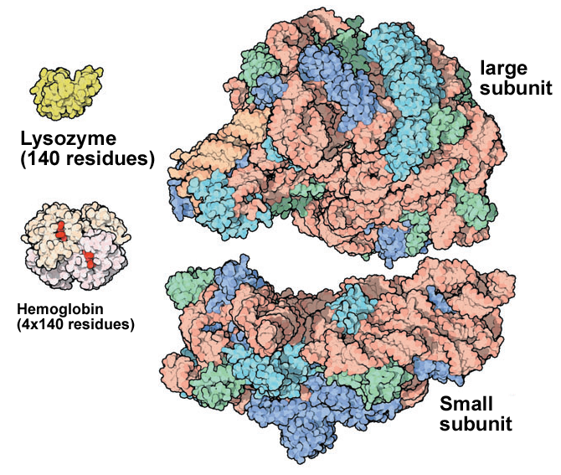**Introduction to Protein Synthesis.**

**Expectations:**

1. Ribosome Structure – role of small and large subunit, overall structure, tRNA binding sites.

2. Control Elements on Plasmid (mRNA): Ribosome binding site, start codon, stop codon.

3. RNA molecules involved in protein synthesis. Role of each type of RNA.

4. tRNA charging. Addition of the correct amino acid to the correct tRNA.

6. Overall process of peptide chain elongation. Role of SD sequence, GTP, instead of ATP, provides energy required.

7. Effect of antibiotics on protein synthesis.

**RNA molecules involved in protein synthesis:**

a) **mRNA** – messenger RNA is copy of the DNA that encodes a gene. mRNA specifies the order of amino acids to be used in making the protein.

b) **tRNA** – transfer RNA is the dictionary the converts the codon to a specific amino acid. One part of the tRNA recognizes the codon, the other part contains the aminoacid to add.

c) **rRNA** – ribosomal RNA is found in the ribosome and is responsible for most of the function in protein synthesis.

**Protein Synthesis - Overview:**

1. 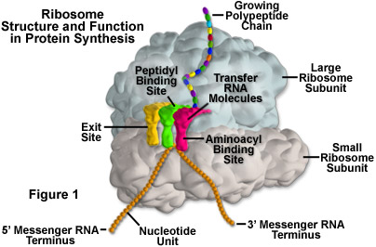The information content of the mRNA is *translated* into a polypeptide chain by the **ribosome**. The ribosome is a large complex structure contains both proteins and RNA (rRNA). It contains two subunits – one large and one small.
2. Has three tRNA binding sites, Amino acyl site (A), Peptidyl site (P), exit site (E).
3. mRNA binds to small subunit, at the 5’ end of the mRNA.
4. Polypeptide chain emerges from the top of the large subunit, through the exit tunnel.
5. Three nucleotide bases in the mRNA, or a **codon**, encode each amino acid.
6. Synthesis of the polypeptide chain proceeds in the **amino→carboxy** direction, as new amino acids are added to the carboxy terminus of the growing peptide chain.

*The ribosome is a mRNA (template) dependent protein polymerase – no primer required.*

**Control Sequences on the Plasmid** These function at the mRNA level, but need to be part of the plasmid DNA sequence so that they are copied to the mRNA sequence.



1. Ribosome binding site: Positions the mRNA on the ribosome
2. Start codon: AUG – sets reading frame, codes for 1st amino acid
3. Stop codon: Signals the end of the protein

**Features of the mRNA** (Example - Synthesis of Met-Lys-Ala).

**Beginning with the DNA:**

**TTGACA**TTTATGCTTCCGGCTCG**TATAAT**GTGTG**G**AAT**TGTGAGCGGATAACAATTTCACACA**GGAGGAACAGCT**ATGAAAGCTTAATTTATG.**

**AACTGT**AAATACGAAGGCCGAGC**ATATTA**CACAC**C**TTAACACTCGCCTATTGTTCCCGTGTGTCCTCCTTGTCGA**TACTTTCGAATTAAATAC**.

-35 -10 → Lac operator

Promoter mRNA start

**The mRNA:**

*Without punctuation – more than one possible start codon (AUG).*

**G**AAUUGUGAGCGGAUAACAAUUUCACACAGGAGGAACAGCU**AUG**AAAGCUUAAUUU**AUG.....**

**123456789012345678901234567890123456789012345678901234567890**

*With punctuation (correct reading frame defined by Ribosome binding site on mRNA).*

**G**AAUUGUGAGCGGAUAACAAUUUCACAC**AGGAGG**AACAGCU**AUG,AAA,GCU,UAA,UUU,AUG...**

**fMet-Lys-Ala-STOP**

|  |  |  |  |
| --- | --- | --- | --- |
| **Ribosome Binding Site (RBS)**: (Shine-Dalgarno [SD] sequence-AGGAGG.)  *Positions mRNA on the ribosome so that the correct start codon is used.* | **Start codon:** AUG codes for the 1st amino acid, always a modified methionine (N-formyl methionine, fMet).  *This codon sets the reading frame.*    N-formylMet Met | **Codons:** Each triplet of bases following the start codon codes for one amino acid.  *Translation performed by appropriately charged tRNAs.* | **Stop codon:**  Signals end of the protein (UAG, UAA, UGA)  Completed protein is released from ribosome |

**tRNA:**

* There are at least 20 tRNA molecules, one for each amino acid.
* Since there are fewer tRNAs than codons, some tRNAs recognize more than one codon.
* **Acceptor stem:** amino acids are attached to the 3' terminus of the tRNA by enzymes called **aminoacyl-tRNA Synthetases (aaRS).** These enzymes attach the *correct* amino acid to the *correct* tRNA. This process is often referred to as “charging” the tRNA.
  + There is one aaRS for each tRNA.
  + The amino acid is covalently linked to the 3’ end of the tRNA via an ester linkage.
  + Energy is required to add the amino acid to the tRNA. This energy is provided by ATP.
* **Anti-codon arm**: contains the anticodon triplet that translates the codon in mRNA to an amino acid. Watson-Crick H-bonds are used here.

