**Lecture 15: DNA Polymerases**

A polymerase is an enzyme that makes a polymer. DNA polymerases play an important role in the normal replication of cellular DNA. They can also be used to manipulate DNA in the laboratory, and, in particular, can be used to determine the sequence of DNA.

**DNA Polymerases:**

1. Utilize a **template** to direct the order of added bases.
2. Require a basepaired **primer** that provides the -3’ OH to add additional bases. The location which the primer anneals to the template defines the start of the newly synthesized chain. The primer is either:

* A short RNA – produced during DNA replication in the cell.
* A short DNA oligonucleotide – purchased from a company.

1. Synthesize chains from **5'→3' direction. Always adding new bases to the 3' hydroxyl of the existing polymer.**
2. Use deoxynucleoside triphosphates (dNTPs), producing a chain one base longer + pyrophosphate (PPi).
3. Fidelity of base incorporation is dependent on Watson-Crick base-pairing (A-T, G-C), *plus* purine-pyrimidine matching. Phosphodiester bond formation occurs quickly (1 msec) when the correct match is made. Bond formation is slow when the bases are incorrectly matched – allowing time for an incorrect dNTP to leave before it is incorporated (proofreading)
4. Incorrectly incorporated bases can be removed by a proofreading activity: 3'→5' exonuclease activity.

i) This activity is found in *most* polymerases.

ii) This activity is absent in many viral polymerase (such as HIV reverse transcriptase), leading to high mutation rates in the virus and therefore a high number of viruses that are resistant to HIV drugs.

**5'**→**3' Polymerase –** activity found in ALL DNA polymerases.



*5'A-T3'OH 5'A-T-****C****3'OH 5'A-T-C-****C****3'OH*

*3'-C-T-A-G-G-T- 3'-C-T-A-G-G-T-*  *3'-C-T-A-G-G-T-*

**3'**→**5' Exonuclease – Proofreading, found in most polymerases.**

(exo = from the end, nuclease = an enzyme that degrades nucleic acids)

*5'A-T3'OH 5'A-T-****G****3'OH 5'A-T3'OH*

*3'-C-T-A-G-G-T- 3'-C-T-A-G-G-T- 3'-C-T-A-G-G-T-*



|  |  |  |  |
| --- | --- | --- | --- |
| **Polymerases involved in replication:** | **Template** | **5'-3' Polymerase** | **3'-5' Exonuclease** |
| **DNA Pol III (***E. coli, bacteria***)** |  |  |  |
| **HIV Reverse Transcriptase** |  |  |  |

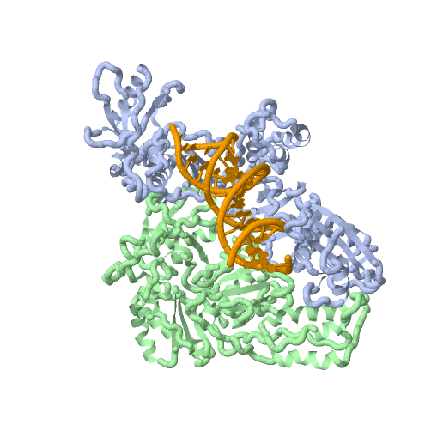

**HIV Reverse transcriptase: (RTase_**

Quaternary structure – heterodimer – two different polypeptide chains.

RTase has the following activities:

i. RNA dependent DNA polymerase activity, to copy the viral RNA to DNA. Uses RNA as the template, making a DNA strand.

ii. RNase activity, degrades RNA template after it has been copied

iii. DNA dependent DNA polymerase activity, to allow the synthesis of the second, complementary, DNA strand, using the first strand it made as the template.

**Inhibitors of HIV Reverse Transcriptase:**

**i) Competitive inhibitors:**



**ii) Allosteric inhibitors:**



**Expectations:** Know the general mechanism of polymerases & editing function and why HIV reverse transcriptase is error prone. Distinguish between competitive and allosteric inhibitors of reverse transcriptase.

**Consequences of Errors in Replication:** Mutations in the genome, causing alterations in protein sequence.

**Example 1: HIV protease**

* Replication of the HIV genetic material by reverse transcriptase leads to many changes in the sequence of the HIV genetic material.
* Mutations in the HIV protease gene can result in amino acid changes in the HIV protease enzyme.
* These changes can make the protease inhibitors bind poorly, preventing effective treatment of HIV with protease inhibitors.
* The virus can then resume replication, causing AIDS.

A very common mutation is converting Val82 in the specificity pocket of HIV protease to asparagine, converting a non-polar contact with the drug to a less favorable polar contact. Modification of the drug can restore inhibition of the mutant enzyme.



**Example 2 – Sickle cell Anemia**

Although human polymerases do have proofreading, they still make mistakes (but not nearly as many as reverse transcriptase). The error rate is approximately 1 in 108 in DNA replication.

* 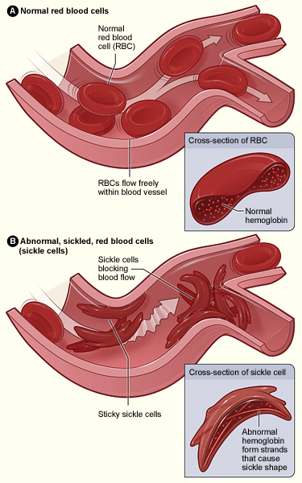Single base change in the DNA that codes for hemoglobin (oxygen transport protein) changes a glutamic acid (Glu) to valine (Val).
* Under conditions of low oxygen concentration (e.g. in tissues) the hemoglobin molecules with the valine aggregate to form strands that distort the shape of the red blood cell, causing them to become sickle shaped.
* The sickle shaped red blood cell clogs capillaries, interfering with the delivery of oxygen to the tissues.

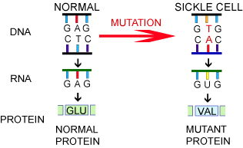

This mutation is very serious and can cause life-threating conditions. Why is the mutant gene so prevalent in Africa?