**Lecture 14: Nucleic Acids** (Chapter 7)



**Monomeric Units**



1. Nucleoside triphosphates are the building blocks of nucleic acids.
2. Consist of phosphate + sugar (ribose/deoxyribose) + nitrogenous base.
3. The carbon atoms on the sugar are numbered 1' to 5'. The primes distinguish the atoms on the sugar from those on the base.
4. The base ("sidechain") is connected to the C1' of the sugar ("mainchain") by a covalent bond.

Base + sugar = **nucleoside**.

Base + sugar + 1 phosphate=**nucleotide,** nucleotides are found in DNA and RNA

1. DNA differs from RNA in the sugar (deoxyribose/ribose).
2. Four different monomers, A, G, C, T in DNA. U replaces T in RNA. Both U and T have the same H-bonding capability.
3. A and G are purines (two rings), C, U, and T are pyrimidines (one ring)

*(Angels are “pure” and have two wings – purines have two rings)*

**Short-hand nomenclature:**

Deoxynucleoside triphosphates; dATP & dGTP & dCTP & dTTP = **dNTPs**

Nucleoside triphosphates: ATP & GTP & CTP & TTP = **NTPs**

**You will be expected to answer questions like the following:**

1. Label the 3’ and 5’ carbons of this nucleoside.



2. Would you find this in DNA or RNA? Why?

3. Is the base a purine or a pyrimidine?

4. Label all hydrogen bond donors and acceptors on the **base**.

5. The short-hand name of this compound is:

**DNA and RNA are Polynucleotides**



The **phosphodiester** backbone is comprised of deoxyribose (DNA) or ribose (RNA) sugars bridged by phosphates between the **3' and 5'** positions of the sugars.

i) The phosphates are always ionized (pKa~1), therefore nucleic acids are **polyanions**.

ii) Note the polarity, 5' → 3'.

For single stranded DNA (ssDNA) sequence of nucleotides is written in the 5'-3' direction:

**Expectations**:

* Familiar with overall structure,
* Be able to identify the 5’(and 3’ end)
* Be able to write sequence based on structure, from 5’ to 3’

**Watson, Crick, Wilkins & Franklin:** DNA exists in anti-parallel double stranded form.

**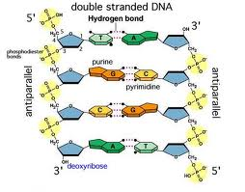**

**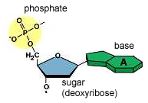**

|  |  |
| --- | --- |
|  |  |
| dna_top | Double stranded DNA is written to represent the anti-parallel duplex: 5’→3’ on the top, 3’→5’ on the bottom. A-T, G-C pairs.  **5’-TGC-3’**  **3’-ACG-5’** |

**Base pairing:**

i) Hydrogen bond donors and acceptors match up. “Watson-Crick” H-bonds shown as blue lines.

ii) Purine is always paired with a pyrimidine (ensured by enzymes that copy DNA – use both hydrogen bonds and size of the base pair to insert the correct base.)

iii) Additional hydrogen bonding capabilities are found on the edges of the bases – proteins can utilize these to bind to DNA (and RNA) in the grooves of the DNA.

**Expectations – You should know the following:**



a) The DNA chains are **anti-parallel**.

b) **10 bp/turn**

c) The helix interior is filled with stacked base.

d) Negatively charged phosphates (& pentose) are on the outside.



e) T pairs with A via two "WC H-bonds"

f) C pairs with G via three "WC H-bonds"

g) How to write the sequence of duplex (double stranded) DNA (dsDNA)

**H-Bonding & Nitrogen:** N-H is always a donor, but when is N an acceptor? Here are the rules:

* When N is in a ring and bonded to 3 other atoms, it cannot accept. NH2 groups on a ring also cannot accept.
* When N is in a ring and bonded to 2 other atoms, it can accept a hydrogen bond, on the edge of the ring.

**RNA versus DNA Helical Structure:**

|  |  |
| --- | --- |
| **RNA** | **DNA** |
| rna_helix_side |  |

i) DNA and double-helical RNA. Complementary sequences have similar anti-parallel structure. Both have ~10 basepairs/turn.

ii) U pairs with A in RNA.

iii) single stranded RNA can form complicated folded structures, such as in transfer RNA (tRNA), a molecule used for protein synthesis (left), as well as hairpin structures (right).

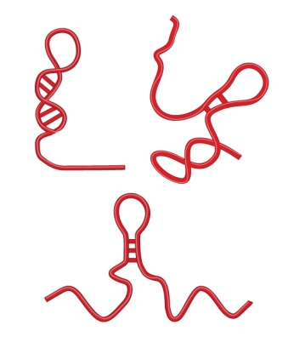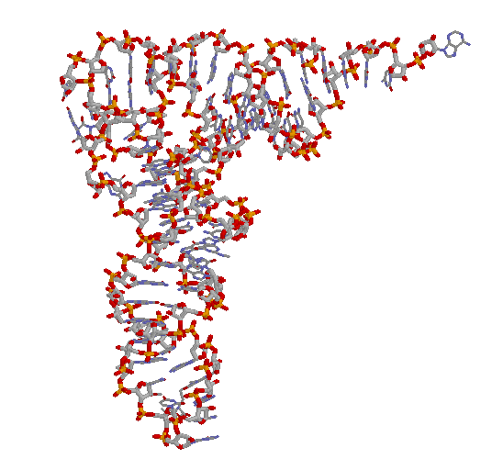

**tRNA RNA hairpins**