Lecture 10 – Application of Antibodies, Production of Antibodies, Vaccine Development.
Learning objectives:

- Understand how antibodies can be used to treat drug overdoses and cancer.
- Understand the role of T_{H} cells in B-cell development.
- Understand role of memory cells in immunlogical memory
- Compare and contrast a passive to active immunization
- Describe types of vaccines
- Understand concept of herd immunity
- Understand rational for selection of a disease for vaccine development.

Applications of Antibodies:
A) Drug detoxification – antibodies bind drugs, preventing them from being toxic.
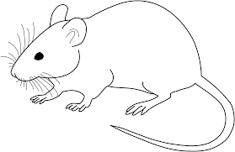
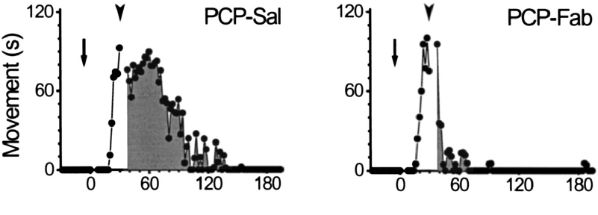
PCP-Ab

B) Treatment of Cancer
Trade Name | Used to Treat: | Approved in:
Rituxan | Non-Hodgkin lymphoma | 1997
Herceptin | Breast cancer | 1998
Mylotarg* | Acute myelogenous leukemia (AML) | 2000
Zevalin* | Non-Hodgkin lymphoma | 2002
Bexxar* | Non-Hodgkin lymphoma | 2003
Erbitux | Colorectal, Head & neck cancers | 2004, 2006
Avastin | Colorectal cancer | 2004
Cancer cells eliminated by:

i) Antibody carries drug to target cell.
ii) Antibody on surface causes the immune system to destroy the target cell.

Production of Antibodies - Humoral (body fluids) = antibodies. Entire process takes ~2 weeks.
a) B-cell binds antigen (e.g. bacteria) on the antibody on its surface.
b) Antigen is brought into the cell (internalized)
c) Antigen is broken down
d) A small protein fragment from the antigen is displayed (presented) on the MHC on the B-cell
e) B-cell is recognized by T_{H}-cell due to MHC-TCR interaction.
f) B-cell develops into plasma cell
g) Plasma cell secretes antibody that binds to antigen, leading to its destruction.
h) Memory B and T-cells are also generated, as immunological memory.

Vaccination and Vaccine Development
The renaissance in the vaccine market continues with strong growth and new prospects to continue to grow this part of the market, which now stands at about $25 billion. Once a commodity market with low margins, the vaccines on the market now include blockbusters and megablockbusters. New candidates for vaccinating against cancers and HIV are also projected to hit the magic milestone. The market is expected to return a compound annual growth rate of more than 8% through 2018, EvaluatePharma projects, with some segments like adult vaccines showing even better. (www.fiercevaccines.com).
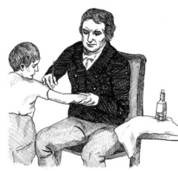
What is a Vaccine?
Origin of name – vacca = cow in Latin, original vaccines against deadly small pox were derived from the cowpox virus by Jenner.
Protects against disease symptoms, not infection.
A. Passive Immunization: The introduction of antibodies that bind to the pathogen and destroy it.
Source of antibody:
- From mother, across the placenta and from milk.
- From large animals (e.g. goats), injected in response to crisis (e.g. snake bite)
Permanent or temporary?
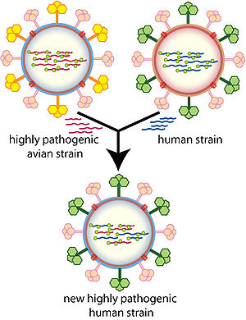
B. Active Immunization: Production of B and T memory cells - can provide life-long immunity.
Induction methods:
- Get sick (and survive!)
- Get injected with:
- Purified antigen from pathogen.
- Killed pathogen (Salk Polio vaccine)
- Attenuated pathogen (Sabin polio)
- Non-pathogenic organism (e.g. cowpox).
Some common criticism of vaccines:
- Don’t work e.g. I have to get a new flu shot each year. Reason – flu virus is different each year due to changes in genetic material.
- Cause autism – no.
- Contain harmful material – no.

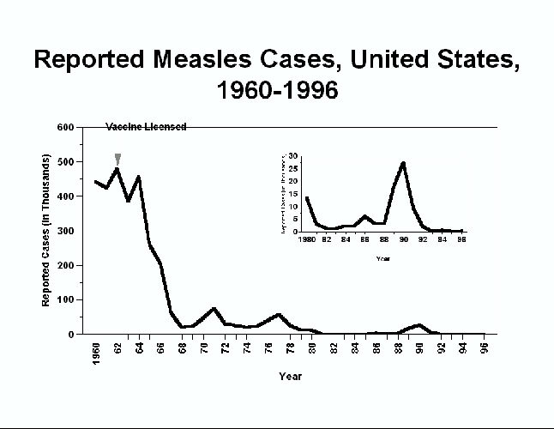
Herd Immunity: High levels of vaccination are important to protect the entire community.

Vaccine Development: How does pharma select what vaccines to develop for active immunization? Which of the following diseases would you advise developing a vaccine against?

Common cold:

Flu like virus:

Ebola:

