**Lecture 5: pH, Protonation State, Amino Acids**

**Goals**

1. What is the pH scale? What are acid, basic and neutral solutions?

2. What is the difference between a strong acid and a weak acid?

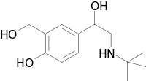

3. Predict protonation as a function of pH (pKa given).

4. Explain why amino acids have chiral centers. Be able to explain why amino acids are grouped.

5. You should be able to draw/explain how peptide bonds are formed.

6. Identify amino & carboxy terminus, mainchain, sidechain

7. Give sequence of a protein.

**Recap - Hydrogen Bonding:**

Identify donors (X-H) and acceptors (Y) on the above molecule (albuterol, used to treat asthma)

**pH – Acidity and Ionization.**

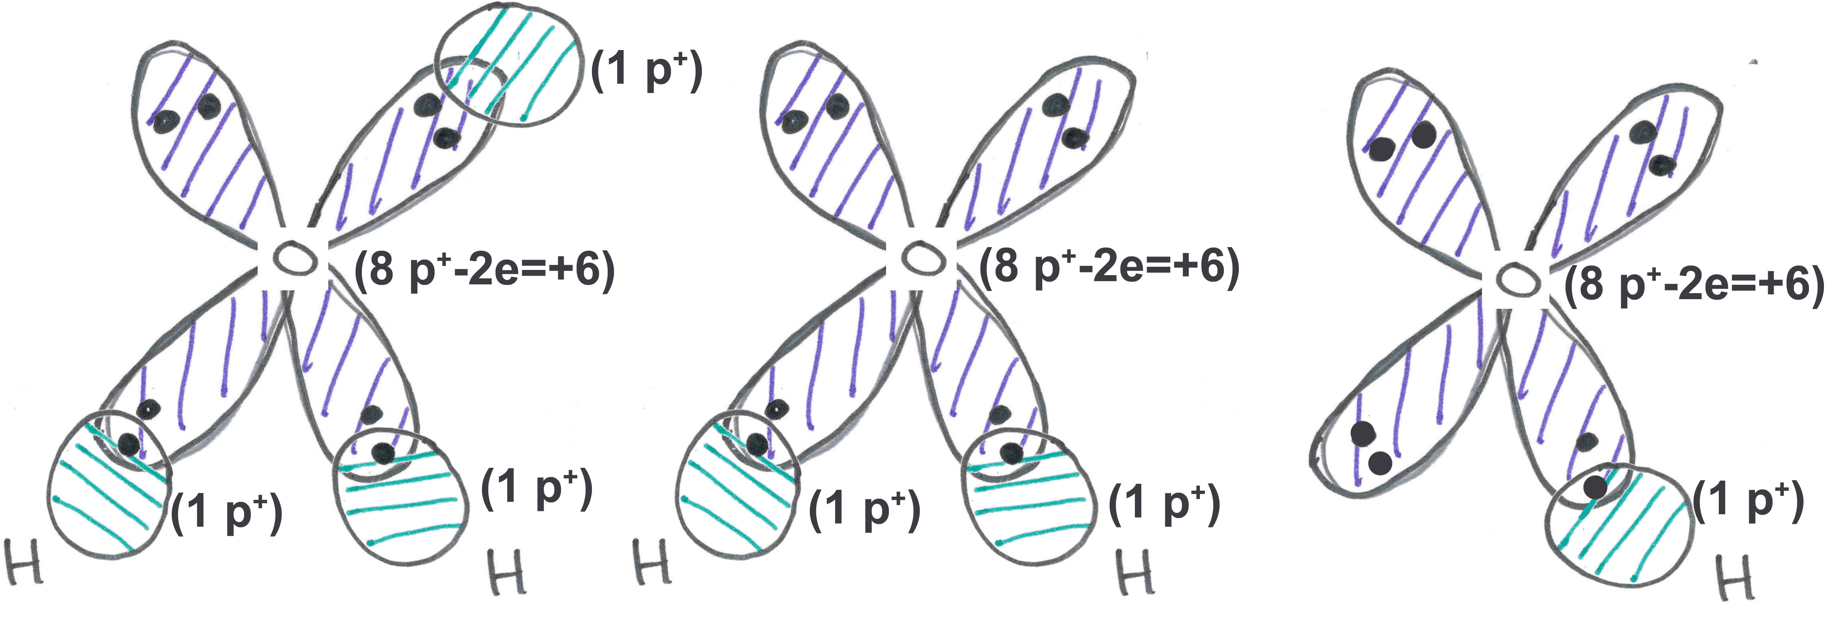

**Pure water contains three chemical species:**

* Water can gain a hydrogen ion (H+) to become a **hydronium ion**. In this case oxygen is forming three bonds! The added proton (H+) interacts with the full orbital of oxygen.



* The hydronium ion is often simplified as a bare proton – H+.
* Water can lose a hydrogen ion to become a negatively charged **hydroxide** **ion**, the exiting hydrogen left its electron to complete the 2nd shell of oxygen.

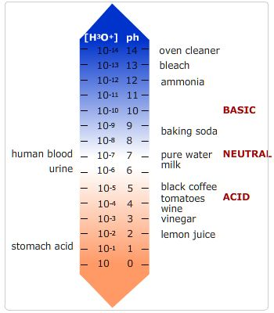

**pH:**

* pH is measured as the -log[H+], smaller pH, more acidic the solution.
* Neutral pH is 7.0. At this pH there are an equal number of H+ and OH- ions in solution. [H+]=10-7 M.
* Solutions with pH values above 7 are referred to as alkaline or basic solutions.

**Why pH is important:**

When a functional group ionizes, its charge changes by an entire unit, either creating a charge or removing a charge. This can affect:

i) Ability of the drug to go through cell membranes. Membranes have a non-polar core and charged molecules cannot cross a membrane.



ii) Binding of the drug to its target. Charges on are drug will be matched by an opposite charge on its target (usually a protein), resulting in strong binding due to an electrostatic interaction (opposites attract).



**Acids and Bases:**

* **Acid**: can donate protons, typically used to describe groups that are more acidic than water. All bases, when protonated, are acids – they can release H+.
* **Base**: can accept protons. Typically used to describe groups that are less acidic than water. All acids, when deprotonated, are bases – they can accept H+.

**Weak acid (e.g. acetic acid)** – partially ionized, both the acid (HA) and the deprotonated acid (A) can be found in solution. An example of a common weak acid is acetic acid, which is vinegar:



**Strong acid (e.g. hydrochloric)** – always ionized

**Characterization of Acid Strength Using pKa.**

Different acids have different acid strengths, or the likelihood they will ionize. This depends on the chemical structure of the acid. The strength of an acid is represented by its pKa, which is related to the equilibrium constant for the dissociation of the acid (see supplemental material). The weak acids shown at the top of the page have different pKa values.



***The lower the pKa the stronger the acid – it is more likely it will want to lose its attached hydrogen ion.***

**Some Biologically Important Weak Acids:**

**Effect of pH on Degree of Protonation:** The degree of protonation (or ionization) depends on **both** the pH of the solution and the pKa. the pH (hydrogen ion concentration) of a solution can be easily changed by adding a strong acid (HCl) or base (NaOH). The pKa is a constant for a particular acid, *never changing*.

As the pH decreases (hydrogen ion increases) the amount of protonated acid will increase, the reaction is “forced” to the right by the high concentrations of H+.



* When the pH of the solution = pKa of the acid, ½ of the acid will be protonated and ½ will be deprotonated.
* If the pH is lower than the pKa, more than ½ of the acid molecules will be protonated.
* If the pH is higher that the pKa, less than ½ of the acid molecules will be protonated.

**Example:** Consider the following two acids. Which one will be more protonated at a fixed pH, the stronger acid (carboxylate) or the weaker one (amino)?



**Answer:** Sketch the fraction protonated:



versus pH for each acid, using the following rules:

pH = pKa fHA = 0.5

pH = pKa -1 fHA = 0.9

pH << pKa fHA = 1.0

pH = pKa +1 fHA = 0.1

pH >> pKa fHA = 0.0



**Amino Acids (Chapter 6)**

* An amino group attached to a central carbon (α-carbon).
* A carboxylic acid group attached to the α-carbon.
* The amino group, α-carbon, and carboxylic acid will become the “mainchain” of a protein.
* One of twenty different “sidechains” attached to the α-carbon.
* The α-carbon is chiral in all but one amino acid.
* Only one enantiomer (L-form) is present in proteins.

**Protein Structure**



* Amino acids are linked together in linear chains to form proteins.
* The **peptide bond** is formed when two amino acids are linked, releasing a water molecule (**condensation reaction**)
* When incorporated into a protein, an amino acid is called a **residue** (“amino acid residue”).
* Sequence is written starting from the amino terminus to the carboxy-terminus

**Twenty common amino acids found in proteins** (You do not need to memorize these).

**Glycine**: side chain is –H, neither polar or non-polar.



**N**on-polar, non-aromatic (Ala, Val, Leu, Ile)

**A**romatic, polar (His) to non-polar (Phe)

**P**olar sidechain (Ser, Thr, Met, Asn, Gln)

**A**cidic side chain, these groups ionize at pH=7, giving them a negative charge (Asp, Glu).

**B**asic side chains, these groups are protonated at pH=7, giving them a positive charge (Lys, Arg).