Course Web site: http://www.andrew.cmu.edu/user/rule/03_131/
Lecture 2: Foundations of Chemistry (Chapter 4).
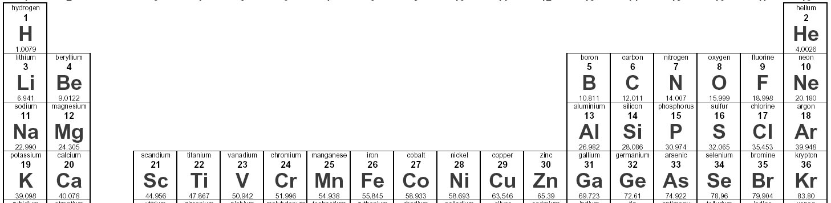
Atoms & Periodic Table:
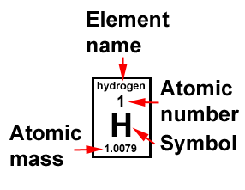
Proton: fundamental particle, + charge
Neutron: fundamental particle, neutral
Electron fundamental particle, - charge.
Atoms are neutral # protons = # electrons
Atomic number: # of protons → define element
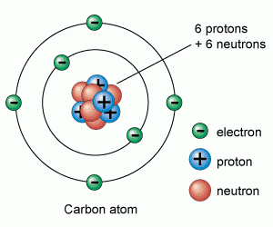
Atomic mass/weight: weight of 1 mol (6.02x10²³) of atoms = sum of protons & neutrons, averaged over all isotopes
Isotopes: Atoms with same number of protons (and electrons), different number of neutrons. All isotopes have the same chemical properties, but differ in mass, e.g. He³ and He⁴.
Atoms contain a nucleus (protons and neutrons) surrounded by electrons.
Electrons and Atomic Orbitals:
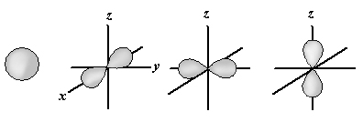
Electrons are found in orbitals that surround the nucleus. They are labeled as: 1s, 2s, 2p, 3s, 3p, 3d
All orbitals hold at most 2 electrons.
The s orbital is spherically symmetric. The three p orbitals (p_{x}, p_{y}, p_{z}) are bi-lobed and hold a total of 6 electrons (2 each)
Orbitals are grouped together as shells:
1st shell is just the 1s orbital – holds 2 electrons
2nd shell contains 2s and 2p_{x}, 2p_{y}, 2p_{z} orbitals – 8 electrons
Order of filling: 1s, 2s, 2p,3s,3p. When orbitals of equal energy are filled (e.g. 2p) the electrons fill the orbitals with one electron first.
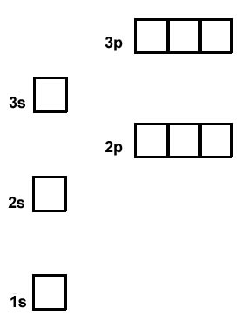
Inert Gases (e.g. Helium, Neon):

Ions (e.g. Li⁺, F⁻)

General Rule:

Bonding
Covalent bonds occur with the sharing of electrons between atoms. Two half-filled orbitals combine to form the bond. Hence hydrogen forms one bond while carbon forms four bonds.
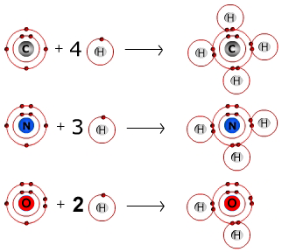
In summary:
H: 1s¹ 1 bond
C: 1s² 2s² 2p² 4 bonds
N: 1s² 2s² 2p³ 3 bonds
O: 1s² 2s² 2p⁴ 2 bonds
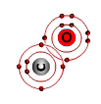
S: ... 3s² 3p⁴ 2 bonds
P: ...3s² 3p³ 5 bonds
Single Bonds occur when two atoms share one pair of electrons.
Double bonds occur when two atoms share two pairs of electrons, e.g. C=O.

Chemical Diagrams:
- Hydrogens are added to atoms to complete the number of bonds that the atom can form.
- Carbon is often not labeled, but indicated by a kink in lines
Examples:

Structural Features of Molecules – 3D Shape.
A. When carbon is bound to three atoms, it is planer – all atoms lie on the same plane.
- This places the atoms as far away as possible, giving the lowest energy.
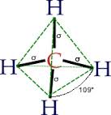
B. When carbon is bound to four atoms, it is tetrahedral, the atoms are on the corners of a tetrahedron.
- This places the atoms as far away as possible, giving the lowest energy.

Chirality: When carbon is bound to four different atoms, two different molecules are generated that are mirror images of each other. The two molecules are called enantiomers. The two molecules have identical chemical properties, but they cannot be superimposed on each other.
Enantiomers may have very different biological properties.

Solid wedge: atom is above plane.
Dashed wedge: atoms is below plane.
Review – Lecture 2:
- Why are inert gasses chemically stable?
- Can you determine the charge on an ion, e.g. Mg?
- Covalent bonding occurs due to sharing of electrons to complete the shell of an atom.
- Single bond – sharing one pair, double bond-two pairs.
- Hydrogens are added to complete the number of bonds.
- Carbon can adopt two different geometries when bonding – planer or tetrahedral to attain the lowest energy.
- When four different atoms are bonded to carbon, two different arrangements (enantiomers) are possible. These are mirror images of each other and cannot be superimposed.

