Lecture 1: Introduction to Cellular Biology
Readings: Part I - Molecular and cell biology for dummies

Chemicals of Life – Small molecules & Polymers
Some molecules are small:
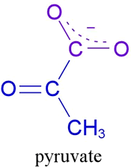 | 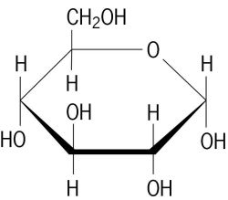 | 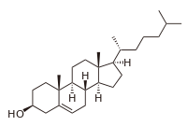 | 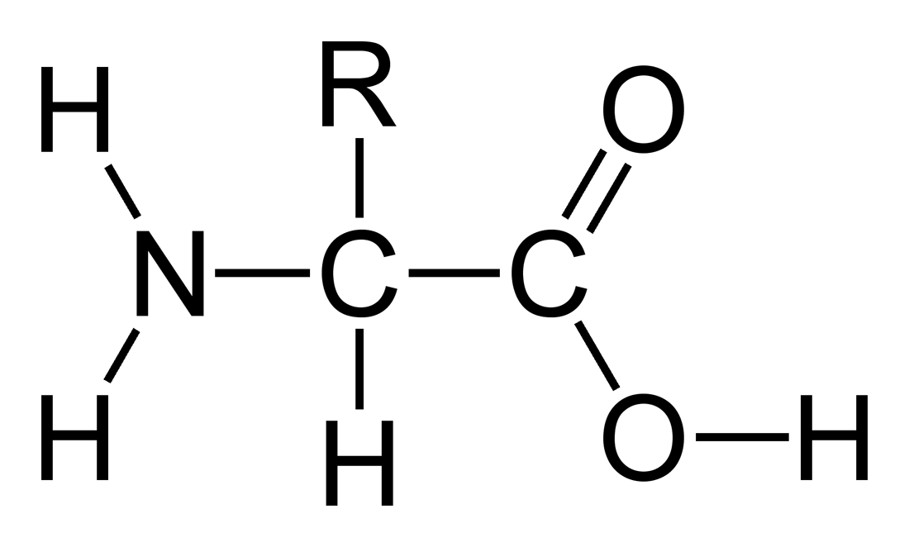 | 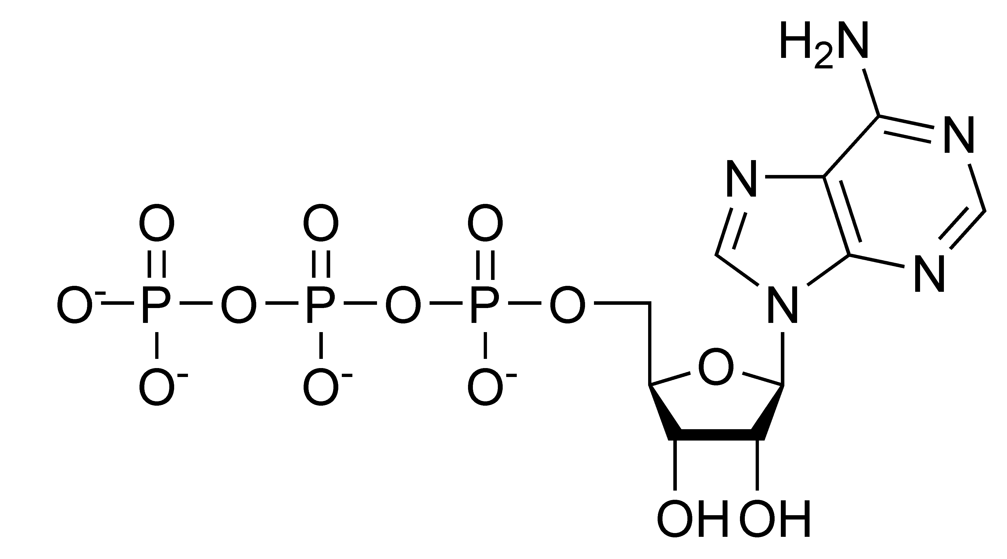
Organic Intermediate | Carbohydrate | Lipid (cholesterol) | Amino Acid (protein) | Nucleic Acid  (ATP)
Many form polymers:
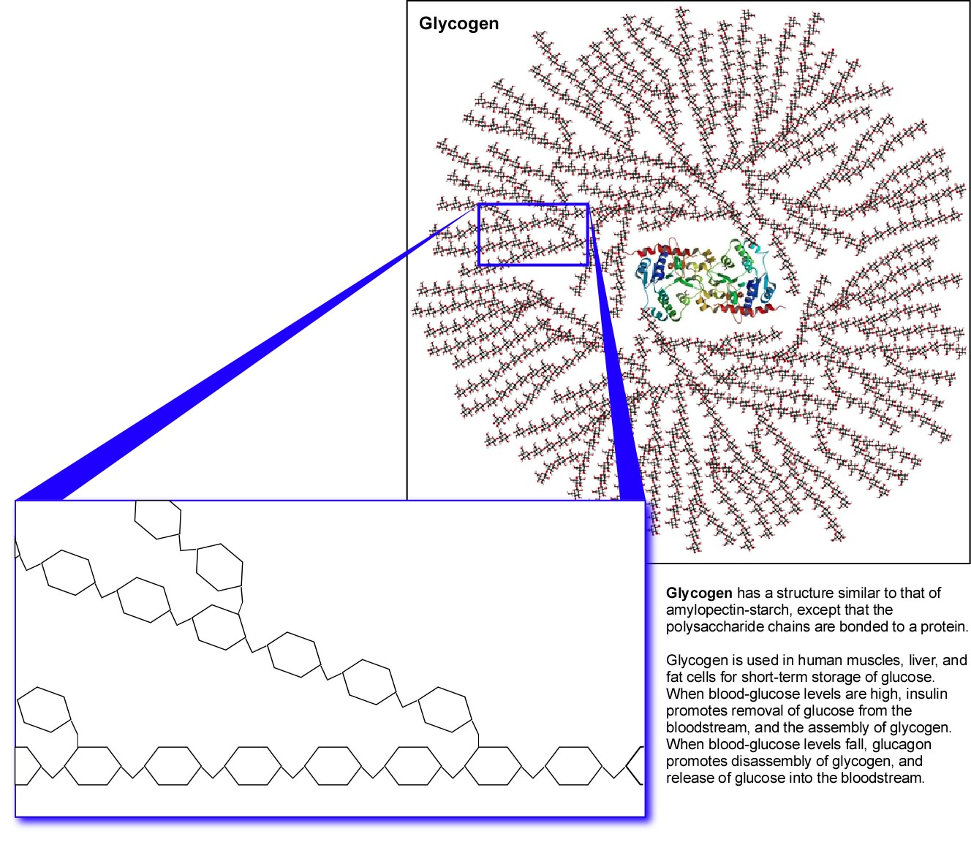 | 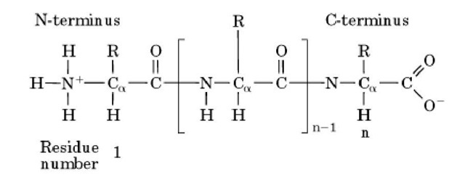 | 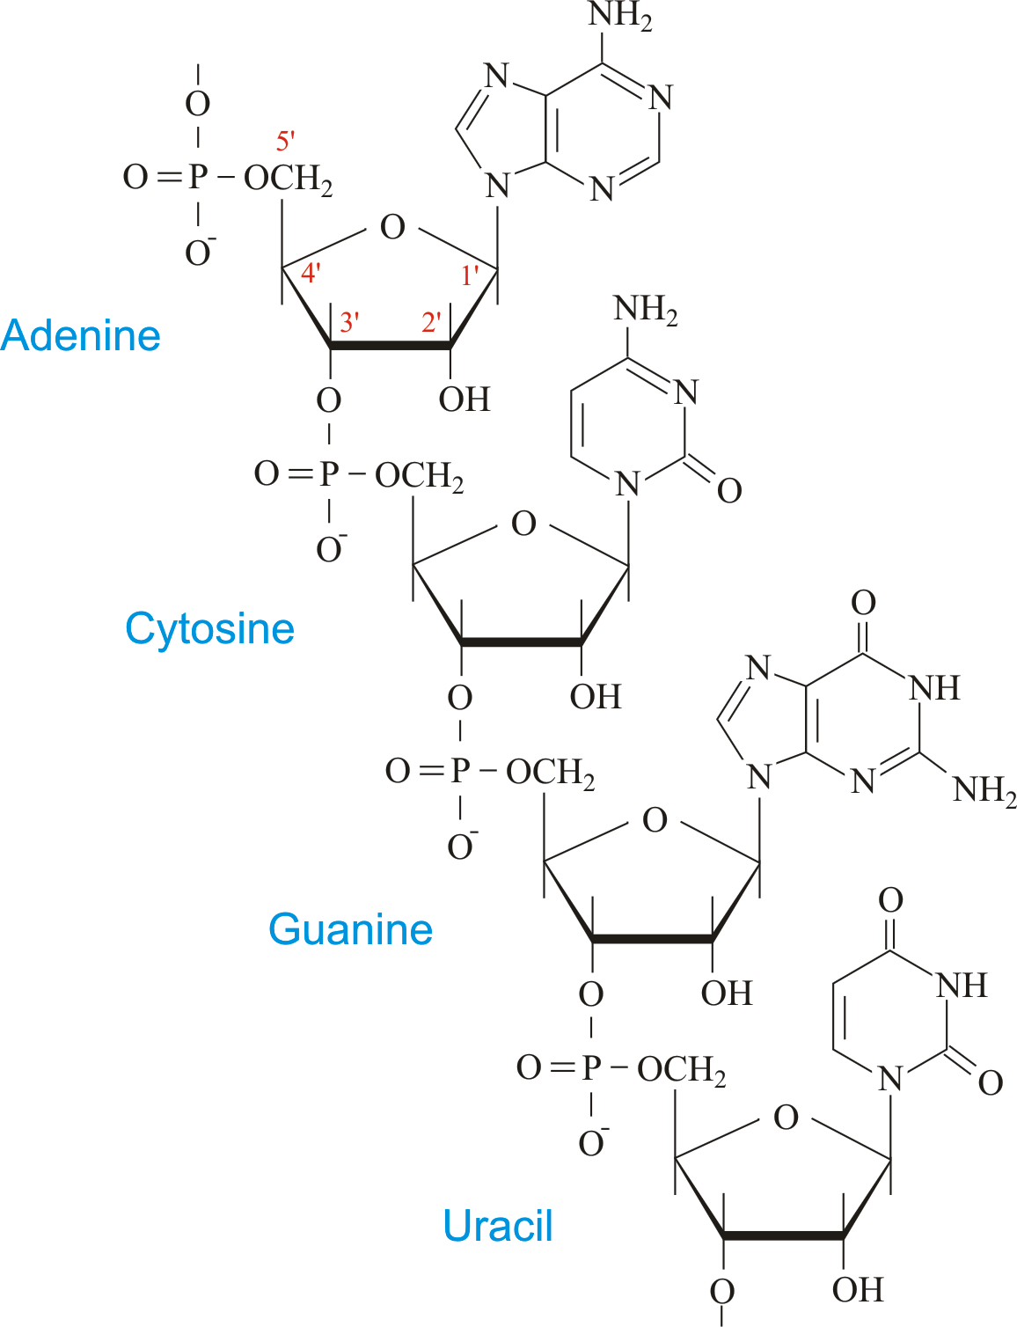
Glycogen (glucose) | Proteins (amino acids) | DNA & RNA (nucleic acids)
How are all of these things made?
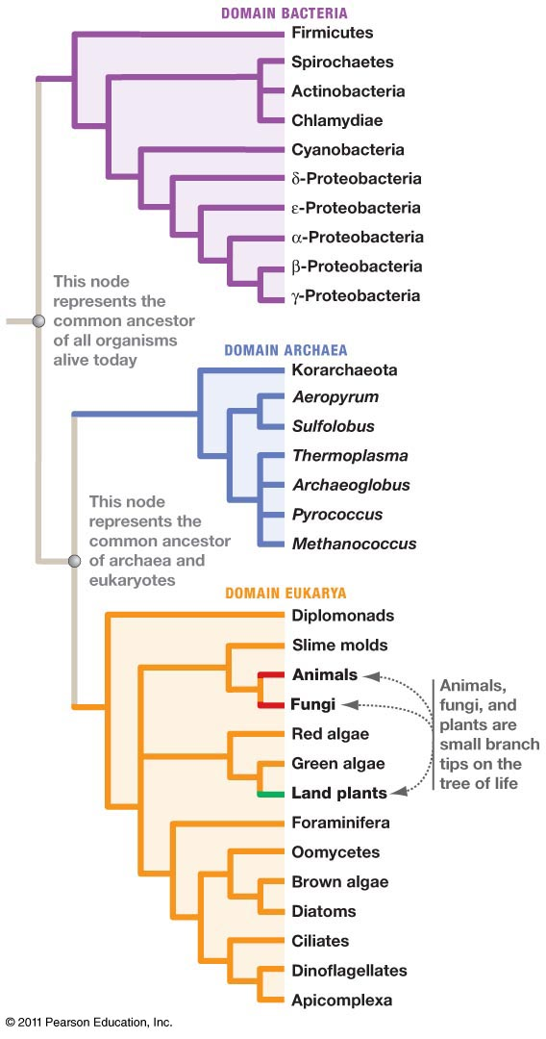

Cellular Basis of Life:
- All cells come from other cells
- Cells require energy to grow
- Cell division involves the passage of hereditary material to new cells

Fundamental Types of Cells:
Prokaryotic:

Eukaryotic:

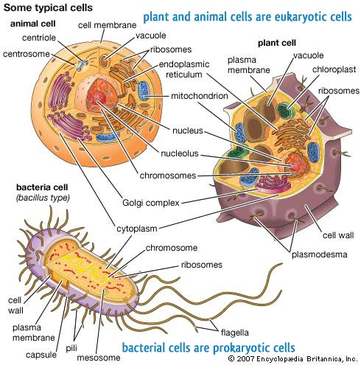
Key Components in all cells:
1.
2.
3.
4.
New features common to all Eukaryotic Cells:
1.
2.
3.
4.
One common feature of bacterial and plant cells:

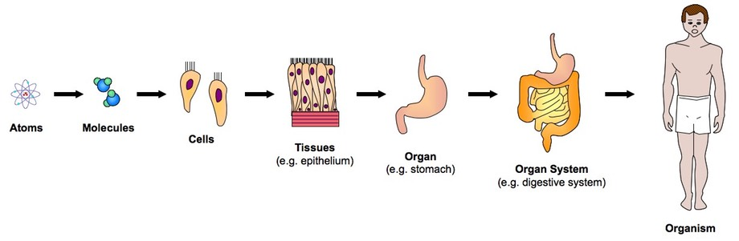
Aspects of Multi-Cellular Organisms:

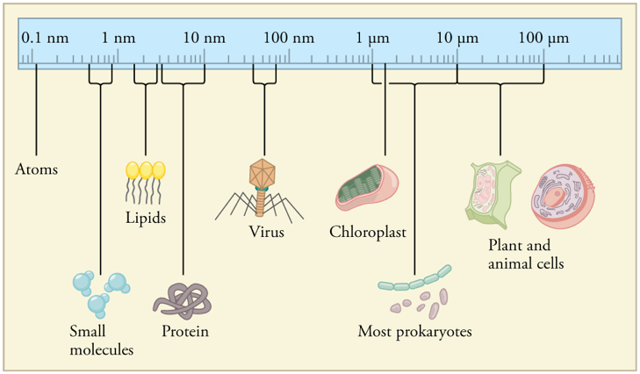
Viruses
Virus is a non-living particles that contain:
i) genetic material (RNA or DNA)
ii) External protein coat
iii) May have a membrane envelope

Can infect animals, plants, or bacteria (bacteriophage).

Rely on a combination of host and virally encoded enzymes to reproduce.

General Categories:
- Helical
- Polyhedral
- Enveloped
- Complex
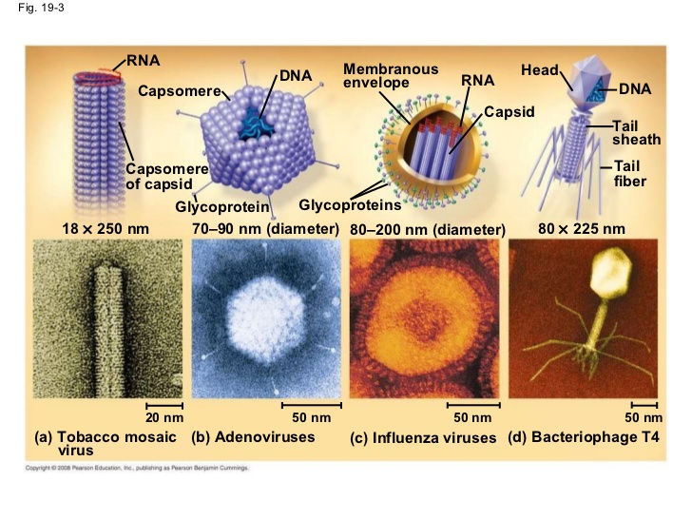
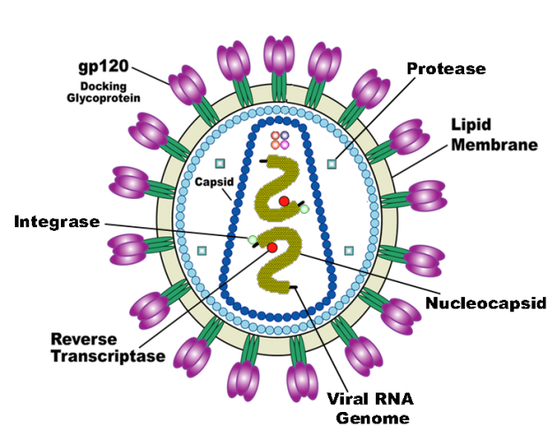
HIV Virus:
Genome: complete genetic information of an organism)
gp120: used by virus to attach to T-cell
lipid membrane: derived from membrane of host cell (T-cell)
nucleocapsid: contains genome
reverse transcriptase: converts RNA to DNA
integrase: integrates viral DNA into host DNA
protease: maturation of viral proteins.
-ase: an enzyme
HIV Lifecycle:
Central Dogma of Molecular Biology:
DNA→RNA→protein
Retroviruses (human immunodeficiency virus, HIV): RNA→ DNA→RNA→protein
- RNA genome
- Convert RNA to DNA as a first step in replication.
HIV Viral Infection of T-cells:
(Image: Modified from biology.arizona.edu)
1. Viruses bind to two proteins proteins displayed on the T_{H} cell membrane.
2. The virus then fuses with the cell membrane. Release of RNA genome from its lipid envelope in the cytoplasm, along with reverse transcriptase, integrase, and HIV protease
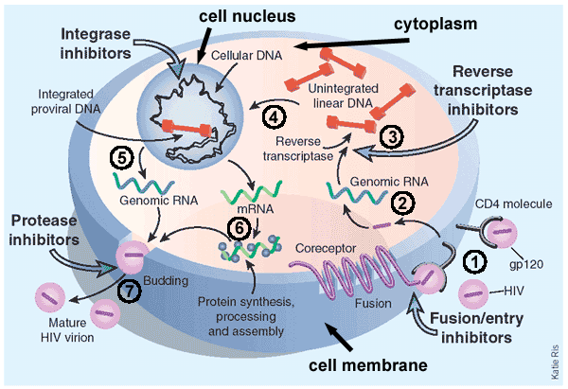
3. The enzyme reverse transcriptase first makes a DNA copy of the viral RNA molecule. This process is error prone, leading to mutations in the virus. These mutations cause drug resistant strains of the virus to arise.
4. The copied DNA is integrated into the host’s DNA in the nucleus due to activity of the enzyme integrase.
5. Viral RNA for new viruses is made from integrated viral DNA. Viral proteins are also made from RNA.
6. Assembly of the mature virus occurs. HIV protease required for maturation of viral proteins and the production of new viruses.
Other types of Viruses:
- Double stranded DNA: Smallpox, DNA replicated in the nucleus of host cell
- Double-stranded RNA: Plant viruses, replicated in cytoplasm of host cell.
- Single-stranded RNA.:
- Negative sense, must be copied to pos. sense before viral proteins are made.
- Positive-sense – can be used directly to make proteins.
Review:
- Fundamental building blocks and polymers: sugars, amino acids, nucleic acids
- Properties of Eukaryotic and Prokaryotic cells (similarities/differences)
- Structural properties of viruses (helical, polyhedral, enveloped, complex)
- HIV virus structure/enzymes
- HIV virus life-cycle
- Other forms of viruses (dsDNA, dsRNA, ssRNA)

