**Lecture 22: mRNA processing in Eukaryotic Cells, DNA Replication**

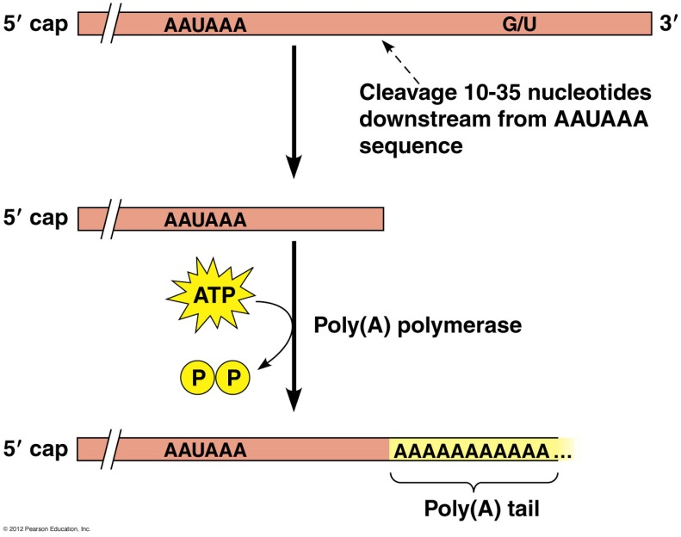**Poly A addition.** A series of A residues are added to the end of the mRNA by specialized enzymes. This is important for:

* Nuclear export
* Translation (protein synthesis)
* enhancing the stability of mRNA.

**mRNA splicing**.

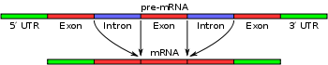

The initial transcript is composed of:

* Exons that code for amino acids
* Introns are intragenic regions that are removed during splicing.
* Splicing requires the following sequences in the intron to guide the splicing machinary:

i) a 5’ donor site

ii) a 3’ acceptor site

iii) a branch sequence within the intron

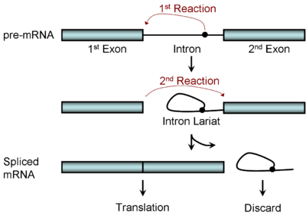

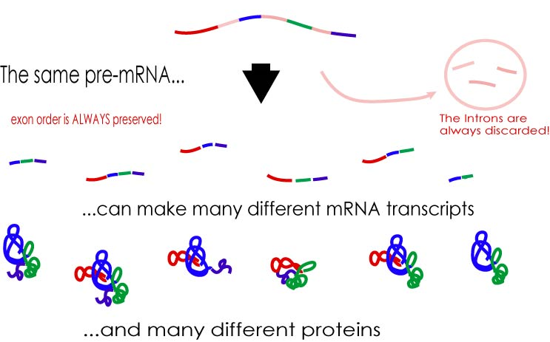**Alternative splicing** is common, with different exons retained in different tissues. This allows the same gene to produce many different proteins.

**Genetic Diseases:**

* Mutations in the splicing machinery can cause wide-spread problems in mRNA splicing.
* Mutations in the donor or acceptor site can cause incorrect splicing of individual mRNAs.

**DNA Replication**



**Origin of Replication: A** DNA sequence is recognized by proteins to initiate the replication of our plasmid.

**Proteins required for DNA Replication:**

|  |  |
| --- | --- |
| **Protein** | **Role** |
| Helicase (DnaB) | Opens up the helix, using the energy of ATP. |
| Single stranded binding protein | Binds to opened single stranded regions to keep them open. |
| Gyrase  (also called topoisomerase) | Releases the strain introduced into DNA due to unwinding. Enzymes of this type are called **topoisomerases** because they change the topology or shape of DNA. |
| Primase | Generates RNA primers, it is a DNA dependent RNA polymerase that requires no primer itself. |
| Polymerase III | Major polymerase, works on synthesis of leading and lagging strand |
| Polymerase I | Replaces RNA primer with DNA. |
| Ligase | Generates phosphodiester bond after RNA primer is replaced by DNA. |

**DNA Polymerases involved in Cellular DNA Replication in E. coli.**

|  |  |  |  |
| --- | --- | --- | --- |
|  | **5'-3' Polymerase**  **(Strand Synthesis)** | **3'-5' Exonuclease**  **(Error Correction)** | **5'-3' Exonuclease**  **(Strand Removal)** |
| **DNA Pol I -** RNA Primer Removal | Yes | Yes | Yes |
| **DNA Pol III -**Major Syn Enzyme | Yes | Yes | **NO** |

5'→ 3' Polymerase (Pol I & III):

G-C-T-A G-C-T-A-T G-C-T-A-T-G

C-G-A-T-A-C-C-G-C C-G-A-T-A-C-C-G-C C-G-A-T-A-C-C-G-C

5'→3' Exonuclease (Pol I):(**rUGGCG** = RNA primer)

G-C-T-A **U-G-G-C-G** G-C-T-A

C-G-A-T-A-C-C-G-C C-G-A-T-A-C-C-G-C

**A: Initiation**: Open up the double helix and generate a primer for DNA polymerase to use.

1. Replication initiates at the origin of replication.



a) A number of proteins, that you don't have to worry about, bind at the origin of DNA replication.

2. The initiating complex contains the following proteins

1. **Helicase (DnaB)**, uses the energy from ATP to unwind the DNA double helix, forming single stranded (ss) DNA to be used as a template.
2. ssDNA is coated with **single stranded binding protein** (SSB) to prevent re-annealing of DNA.
3. **DNA gyrase**, removes over-twists in the DNA in front of the replication fork. Theover- twisting occurs during the separation of strands by helicase.
4. **DNA primase** generates RNA primers to start the synthesis of DNA.

**B: Propagation:**

DNA synthesis occurs at two bidirectional **replication forks**. Replication at each fork is:



* **Continuous** on one strand (leading strand)
* **Discontinuous** on the other strand (lagging strand)

**1. Movement of the Replication Fork:**

a) **Helicase** (DnaB)**, u**ses the energy in ATP to unwind the helix.

b) **SSB** (single stranded binding protein) prevents single stranded DNA from reannealing.

c) **DNA gyrase**, removes the twists the DNA in front of the replication fork that are caused by unwinding by helicase.

**2. Leading strand Synthesis:** Pol III in a continuous fashion.

**3. Lagging strand synthesis**

A: Generation of an RNA primer by **primase.**

B: DNA synthesis by **Pol III**.

C: Release of PolIII from the lagging stranded when it reaches the RNA primer from the previous priming event.

D: Pol I binds to the 5’ end of the primer and removes the RNA primer (and a little DNA) using its 5’-3’ exonuclease function (this is not the usual error correcting function).

E: **Pol I** 5'-3' polymerization activity 'fills the gap'

F: **DNA ligase** seals the break in the phosphodiester bond.

**Note**: In the above diagram, the pol III enzymes on the leading and lagging strand act independently. In fact, they are joined together. Thus the DNA has to bend to allow lagging strand synthesis at the same location as leading strand synthesis.