Dear Carnegie Mellon Organization Presidents:
For the second year the sisters of Kappa Kappa Gamma and the brothers of Kappa Delta Rho are hosting and event called Quarter Mile of Quarters. We partnered with the Free Care Fund at Children’s Hospital of Pittsburgh to raise money for the children in our city.
Since opening their doors in 1890, Children’s has pledged that no child will be denied medical care because of his or her family’s lack of health insurance or inability to pay. They have preserved this pledge through the outstanding financial support of individuals, foundations and corporations who support their Free Care Fund.
The concept behind QMQ is unique and exciting. When quarters are placed end to end for a quarter of a mile, the path is worth $3960. Last year we exceeded our goal and raised nearly $5,500. This year QMQ will be held Friday, September 27th at 4:30pm on the CFA Lawn. On the day of the event there will be a celebration free food, inflatables and music. The event is designed to raise awareness and encourage philanthropy among all Carnegie Mellon students and the Pittsburgh Community and we are asking for your help.
We want to make QMQ even more successful this year. We would like you to encourage your members to participate in the event. You can get your organization together and participate in the Quarter Race and collect quarters in your houses. You can encourage your members to buy raffle tickets outside of Doherty the week before the event. And even if nothing else, please encourage your organization to come out and celebrate with us the day of the event. Come out and wear your organization's shirts and show your support. There will be a place for people who aren't participating in the quarter race to lie out quarters as well. Even one quarter makes a difference!
If you have any questions or would like more information, please contact Xiang Li at xiang@andrew.cmu.edu or Katy Tanis at krt@andrew.cmu.edu. Thank you for your help!
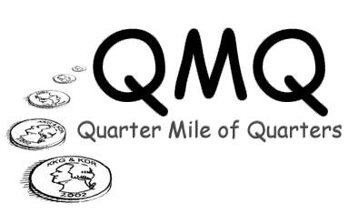
Form a Quarter Race Team and win a party!

quarters mile of quarters

Quarter Race
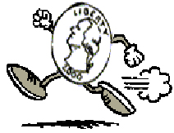

Friday, September 27, 2002
4:30 on the CFA Lawn.
Inflatables! Free Food! Music! Fun!
and
lots of QUARTERS
All for a good cause.

How does it work?
Get together at team. It can be a campus organization, a living area on campus or just a group of friends. Collect as many quarters as you can. Then on September 27th you and your team will lay out your quarters in a line. The team with the longest line wins a party for 50 people at Pittsburgh Deli Company. Winning team will be recognized the day of the event.

Register that by Monday September 23rd, 2002. To register email: krt@andrew.cmu.edu with your team name and number of people on the team.

All money raised goes to Pittsburgh Children's Hospital's Free Care Fund
sponsored by Kappa Kappa Gamma and Kappa Delta Rho

Join Our Goal to Raise:
One Quarter Mile of Quarters =
$3960 =
15, 840 Quarters!
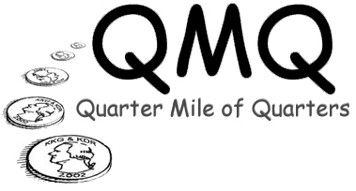

Friday, September 27, 2002
4:30 on the CFA Lawn.
Inflatables! Free Food! Music! Fun!
and
lots of QUARTERS
All for a good cause.

EVERYONE IS INVITED TO COME AND HELP US CELEBRATE!
Bring your friends, some quarters and a smile!

BUY RAFFLE TICKETS!
OVER $2000 WORTH OF PRIZES!
You can help! Bring your quarters to the event. Or buy raffle tickets in front of Doherty (rainsite: UC) on September 19th & 20th and 23rd - 27th.

All money raised goes to Pittsburgh Children's Hospital's Free Care Fund
sponsored by Kappa Kappa Gamma and Kappa Delta Rho

