OLI-C@CM is not your typical course. There is no textbook; there are no required lectures; there isn’t even a single day and time when all students in the course will take the final exam. Instead, you will work through the material on your own schedule and at your own pace.
While you will have more flexibility than in a “normal” course, you will also have more responsibility for your own learning. You will need to:
- Plan when to start each unit.
- Determine how to use the various features of the course to help you learn.
- Determine how to move through the text and activities in a given module
- Decide when you are ready to take the final exam
What you need to know about each unit
Each unit in this course has features designed to support you as an independent learner. [include an example or thumbnail illustration for each feature described below.]
Pre-assessments: Three features at the beginning of each unit help you assess your own abilities in relation to the learning objectives for the unit.
- Assess Yourself: These questions ask you to evaluate your own abilities in relation to the unit learning objectives so you can reflect on what you already know and what you need to learn.
- Test Your Performance: This short quiz at the beginning of each unit lets you check your actual performance on questions related to the learning objectives.
- Reflect and Plan: This short reflective exercise allows you to compare your performance against your self-assessment, reassess your abilities if necessary, and plan how best to approach the rest of the unit.
Explanatory Text: This is the informational “meat” of every chapter. It consists of short passages of text with information, examples, and explanations.
Activities: Different types of activities are interspersed throughout the unit that will help you practice the skills in the unit and check your understanding as you go. They appear in a number of different forms. [link to 2-3 examples]
Exam Readiness Quiz: Taking this quiz at the end of every unit will help you gauge your readiness for the final exam.
Getting the most out of each C@CM unit
Think about how you can use the features of this course not only to learn the material well but also to learn it as efficiently as possible, and consider what approaches would make the most sense in the following scenarios.
Scenario 1: Sonya just got to the Information Literacy unit of her C@CM course. Thinking back to all the research papers she wrote in high school, she feels confident that she knows the material in the unit. Finding, evaluating, and citing sources? No problem. She completes the “assess yourself” portion of the pre-assessment, giving herself a high rating in all these areas. But when she takes the “assess your performance” quiz, she doesn’t do well. “Still”, she concludes, “I know this stuff.” So she skips the explanatory text, activities, and unit review quiz, sure she’ll do fine on the final exam...
Is the strategy Sonya plans to pursue a good one? Hint: There is a mismatch between how well Sonya believes she knows this material (very well) and how she actually performs when answering questions on the material (not well). Which evidence is more likely to be accurate?
- Yes. Why should she waste time going over material she already knows? Even though Sonya has a feeling of confidence on this topic, her performance indicates that she doesn’t know the material as well as she believes. She is probably not ready to skip ahead to the final exam.
- No. She thinks she knows the material, but the pre-test shows she may not. We agree. Sonya is better off trusting the results of the performance assessment and rethinking her self-assessment. [correct]
There is a mismatch between how Sonya rates herself and her actual performance on this material, so which result is more accurate? In fact, a performance assessment – which tests what you can actually do, not what you believe you can do – is generally a more reliable indicator of one’s abilities than a self-assessment. Research shows that people are remarkably bad at assessing their own abilities. In fact, the less they know, the more inaccurate they tend to be! Given this, Sonya should probably conclude that she overestimated her abilities, and work through the material in the unit to improve her skills and knowledge.
Does this mean you should skip the self-assessment in favor of the performance assessment? Not at all. Doing the self-assessment (which takes seconds to complete) and comparing your self-evaluation to your actual strengths and weaknesses is a good way to develop greater accuracy at self-evaluation, a critical skill for independent learning. If Sonya revises her self-assessment in light of her results on the performance assessment and continues to do this throughout the course, she will begin to develop more accurate and reliable skills of self-assessment, which will serve her well not just in C@CM but in numerous other academic and non-academic situations.
Scenario 2: Joe has just started the Safe Computing unit in C@CM. He wants to get through it as quickly as possible while still making sure he is prepared for the proctored exam in two weeks. He sees a bunch of text with some activities sprinkled throughout and is trying to decide how to proceed.
Which of the following strategies would likely be most effective and efficient for Joe? Hint: Think about which of these different strategies will be most likely to give Joe (a) all the information he needs for the proctored exam and (b) opportunities to practice applying that information and check his understanding?
- Jump straight to the activities without reading the text. For each activity, select different answer choices to see if they’re right or wrong and read the feedback text that comes up; Learning by doing can be a good idea. However, Joe should keep in mind that the feedback for correct and incorrect answers will not be as complete as the preceding text, so he might be missing important information.
- Jump straight to the first activity and if he cannot answer it, go back to the beginning of the module to read the text; The good thing about this strategy is that Joe uses the activities as a way to assess his own capabilities and then adjusts his approach accordingly. Moreover, by deciding to go back to read the preceding text, Joe is giving himself a chance to practice independent learning. [count as correct]
- Jump straight to the activities and after realizing that he has no idea how to answer the first few, quit out of OLI and plan to attend his C@CM class time (recitation section?) that week; Seeking help to learn something is a good idea but not before you’ve tried to learn it yourself. By skipping the OLI material, Joe misses the chance to practice learning independently, won’t know what to ask about at the class session, and likely will end up spending more time than if he simply went back to the beginning of the module.
- Read the text straight through from the beginning and do the activities as they come up; This is a good approach unless Joe already knows the unit material fairly well, in which case it is inefficient. The pre-assessments could help him recognize whether he needs to work through the text systematically, focus on specific skills, or skip to the next unit. [also count as correct]
- Read the text straight through from the beginning but skip the activities; Although reading the text will provide Joe with the information content of this module, by skipping the activities he will miss the chance to practice using this information and check his understanding.
Joe is weighing the options outlined here in order to plan a strategy. Kudos to Joe. In fact, most people neglect planning, opting instead to simply start in on the task at hand [citations? Or include in a MSW?] While this might seem efficient (after all, who wants to spend time planning when they could be doing?) it can ultimately be inefficient (consider how much longer it can take to drive somewhere if you don’t take the time to get directions or plan your route). In fact, one of the characteristics that distinguishes experts from novices is that experts spend far more time planning their approach to a task and then end up spending less time actually completing it, while novices do the reverse: rushing through the planning stage, but spending a lot more time overall.
In this course, we encourage you to use the pre-assessment activities for each unit to help you plan how to approach that unit so you can work through it as efficiently as possible, given what you know. Improving your skills at planning as you work through the material in C@CM can help you become a more strategic and thoughtful learner, building skills that will help you plan your approach to assignments, exams, and projects in other courses.
Developing skills for independent learning
The kinds of skills Sonya and Joe are developing (in Sonya’s case the skill of accurately assessing her own strengths and weaknesses in relation to particular tasks, and in Joe’s case, the skill of planning strategies for learning particular topics) are part of metacognition. Metacognition involves five distinct skills.
[Have each stage in the picture click-able, with text that explains it: Assess: get a handle on what is involved in completing a task (i.e., the steps or components required for success) and any constraints (e.g., time, resources). Evaluate: evaluate your own skills and knowledge in relation to a task.] Plan: take into account your assessment of the task and your evaluation of your own strengths and weaknesses in order to devise an appropriate plan.] Apply and Monitor: continually monitor your progress as you are working on a task, comparing where you are to the goal you want to achieve.] Reflect and Adjust: look back on what worked and what didn’t work so that you can adjust your approach next time and, if needed, start the cycle again.]
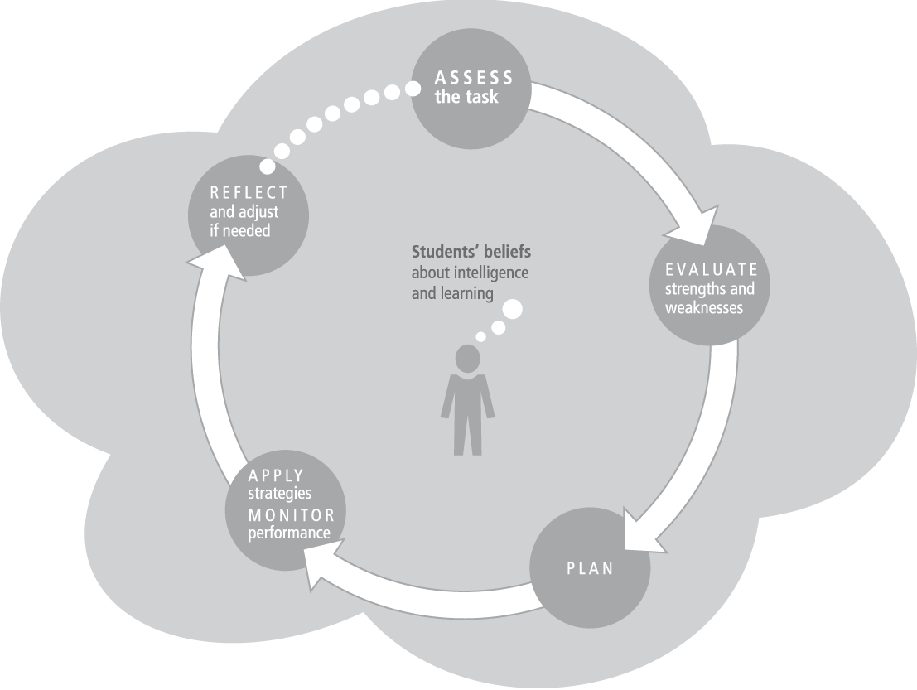

Consider each of the scenarios below and identify which metacognitive skill the student is struggling with.
Rudolfo anticipates a very busy semester, so he completes his entire C@CM course by the second week of the semester, passing each unit review test easily. While this frees up some of his time for other courses, he finds that when he goes to take the final exam, he has forgotten a lot of what he learned. [Hint 1: Click on the definitions for each skill in the metacognitive cycle above to see if one looks like a match. Hint 2: Consider, for example, that Rudolfo would have been better prepared for the final exam if he had scheduled regular work on C@CM throughout the semester.]
- Assessing the task No, if Rudolfo managed to work through the course so quickly, he probably assessed the task accurately.
- Evaluating one’s own strengths and weaknesses No, if Rudolfo managed to work through the course so quickly, he probably assessed his own skills accurately.
- Planning a strategy CORRECT. Rudolfo didn’t spend enough time planning his study strategy. Because he did the work so far in advance, it was not fresh in his mind when he took the final exam.
- Applying strategies and monitoring one’s own performance No, Joe could not have been monitoring his strategy effectively, because he didn’t realize it wasn’t working until it was too late.
- Reflecting and adjusting one’s approach as needed No, Rudolfo did not have the opportunity to adjust his approach because he only realized his strategy was unsuccessful at the end of the semester.
Penelope has worked her way through the entire C@CM course by skipping the text and jumping straight to the activities, which she enjoys. Unfortunately, she does not pass the final exam the first time it’s offered, and thus has to learn the material all over again in time for the next final exam date. “Oh well,” she sighs: “Back to the drawing board.” She opens the first unit and goes straight to the activities. [Hint 1: Click on the definitions for each stage in the metacognitive cycle above to see if one looks like a match. Hint 2: Notice that Penelope’s key decision point now is whether she will learn from her past approach to this unit and find a more effective way to go through the unit so she can learn the material.]
- Assessing the task From the story, we can’t really know whether Penelope assessed the task inaccurately. What we do know is that she neither learned from her experience nor adjusted her approach for the next time.
- Evaluating one’s own strengths and weaknesses From the story, we can’t really know whether Penelope assessed her own strengths and weaknesses inaccurately. What we do know is that she neither learned from her experience nor adjusted her approach for the next time.
- Planning a strategy While Penelope did not plan an effective strategy for working through C@CM, her bigger mistake was not reflecting on and adjusting her approach after it failed.
- Applying strategies and monitoring one’s own performance While Penelope clearly did not monitor her performance closely enough to know her initial approach to studying was not effective, her bigger mistake was to employ the same approach the second time around.
- Reflecting and adjusting one’s approach as needed CORRECT. Penelope is employing the same unsuccessful approach the second time she takes the course, without learning from her mistakes the first time.
Trevor jumps over the pre-assessment at the beginning of the Responsible Computing unit and dives straight into the text, reading everything, doing all the activities, and completing the unit quiz. After acing the final exam, he complains to one of his friends: “I knew all that Digital Citizenship stuff to begin with. I really don’t know why I had to do all that work.” [Hint 1: Click on the definitions for each stage in the metacognitive cycle above to see if one looks like a match. Hint 2: Notice that Trevor didn’t consider his prior knowledge of the material until after he finished the whole course.]
- Assessing the task We don’t know from reading this story if Trevor read the Digital Citizenship unit objectives before beginning. What we do know is that he missed the opportunity to assess his own abilities in relation to those objectives. If he had done the pre-assessments and scored well, he would have realized that he didn’t need to read the text or do the exercises, and he could have saved time by skipping much of the Digital Citizenship unit.[or we could say “by skipping to the Unit Review Quiz at the end of the Digital Citizenship unit”]
- Evaluating one’s own strengths and weaknesses CORRECT. If Trevor had done the pre-assessments – and realized that he didn’t need to read the text or do the exercises – he could have skipped [most of? OR to the Unit Review Quiz for] the Digital Citizenship unit and saved himself some time.
- Planning a strategy While Trevor may not have planned an efficient strategy, he lacked some key information to do so. If he had taken the pre-assessments – and realized that he didn’t need to read the text or do the exercises – he could have skipped the Digital Citizenship unit and saved himself some time.
- Applying strategies and monitoring one’s own performance If Trevor had monitored his own performance better, he might have realized that the material was too easy for him and skipped ahead. However, doing the pre-assessments would have told him that up front, saving even more time.
- Reflecting and adjusting one’s approach as needed Depending on the skills you have or need to gain, the best strategy for one unit may not be the best strategy for another unit. Thus, Trevor would have had trouble adjusting his approach without evaluating his own strengths and weaknesses.

Margot doesn’t give much thought to how she approaches C@CM; she just goes to a unit, tries things, then takes the unit review quiz. Sometimes she does well, sometimes she doesn’t. She’s really not sure how she’ll do on the final exam. [Hint 1: Click on the definitions for each stage in the metacognitive cycle above to see if one looks like a match. Hint 2: Notice that Margot has no idea how her various strategies are working.]
- Assessing the task Although Margot may not have assessed the task carefully or accurately, her main problem is that she is not monitoring her performance to figure out what strategy will be most effective for her.
- Evaluating one’s own strengths and weaknesses Although Margot may not have assessed her abilities accurately, her main problem is that she is not monitoring her performance to figure out what strategy will be most effective for her.
- Planning a strategy Although it is true that Margot is not showing the best (or really any) planning, her main problem is that she is not monitoring her performance to figure out what strategy will be most effective for her. [should we make this one also correct?]
- Applying strategies and monitoring one’s own performance Margot really doesn’t have a strategy; she’s just trying things without giving her approach much thought. She’s also isn’t monitoring her own performance, which is why she has no idea what is and isn’t working, or how prepared she is for the final exam. [correct]
- Reflecting and adjusting one’s approach as needed This is close, but reflecting and adjusting is something that usually occurs at the end of a task. Margot’s problem is occurring as she works through the course.
Pablo has a busy semester, and he does not want to give too much time to C@CM. After all, it’s just a pass/fail course. So he ignores the course all semester, figuring that he’ll spend an entire weekend at the end of the term working through the whole course. [Hint 1: Click on the definitions for each stage in the metacognitive cycle above to see if one looks like a match. Hint 2: Notice that Pablo may be in trouble because he hasn’t considered how long it will actually take to complete C@CM effectively.]
- Assessing the task CORRECT. Pablo is underestimating the task, and leaving too little time to complete it. This is also reflected in his strategy: he has not planned appropriately.
- Evaluating one’s own strengths and weaknesses If Pablo ignores the course until the end of the semester, we can assume that he has not evaluated the task, never mind his own strengths and weaknesses in relation to it.
- Planning a strategy ALSO CORRECT. Pablo’s plan for working through his C@CM course will not allow sufficient time, a result in large part of his inaccurate assessment of the task.
- Applying strategies and monitoring one’s own performance Pablo will have limited opportunity to monitor his own performance because he has failed to assess the task accurately and thus leaves all his work until the last minute.
- Reflecting and adjusting one’s approach as needed No, the problem is not that Pablo isn’t reflecting back on his approach, rather that he’s failing to think ahead.
Strong metacognitive skills are essential for independent learning, so use the experience of monitoring your own learning for C@CM as an opportunity to hone these skills for other classes and other tasks. Good luck!

Note that there are regularly scheduled optional support meetings and several opportunities during the semester when you could take the final exam to see if you have mastered the material enough to pass the course.

