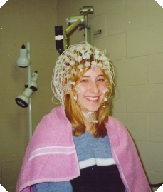
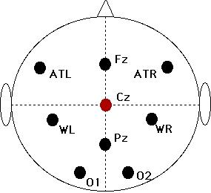
Experimental Setup
- Subject-Verb Number Agreement
(Similar in English & Spanish)
-Significant difference

- Sentences, word pairs (with feedback), sentences

