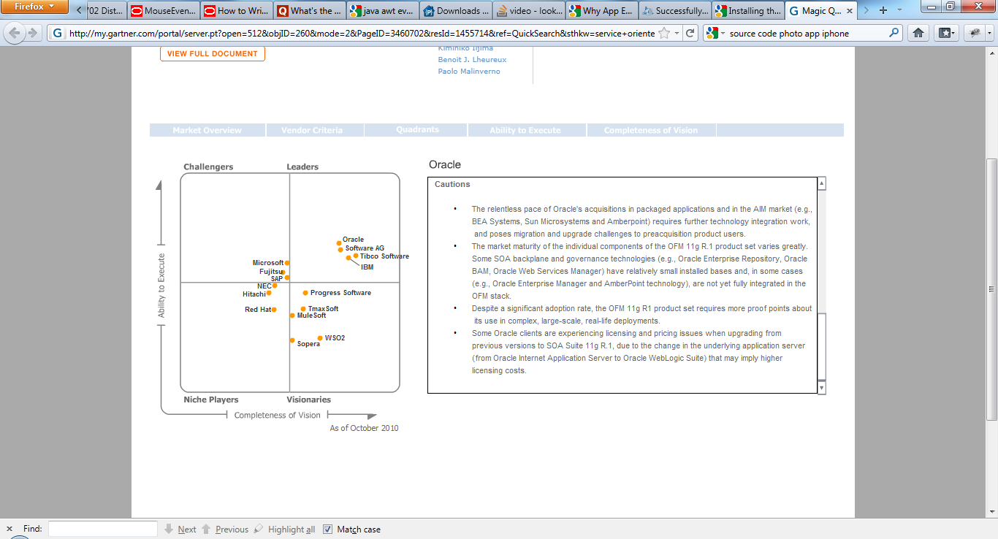

Figure 1 Quadrant

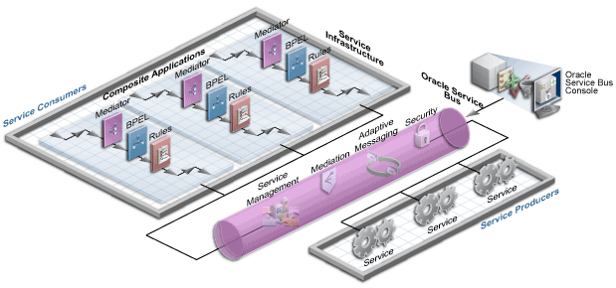

Figure 2 Service Bus

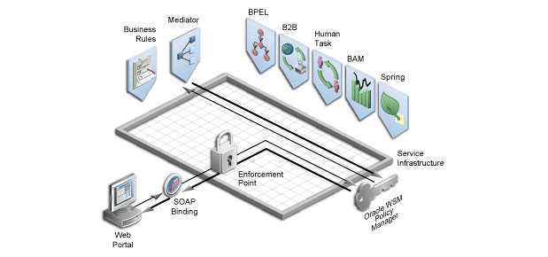

Figure 3 Web Services Manager

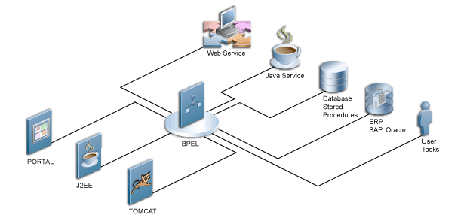

Figure 4 Business Process Execution Language

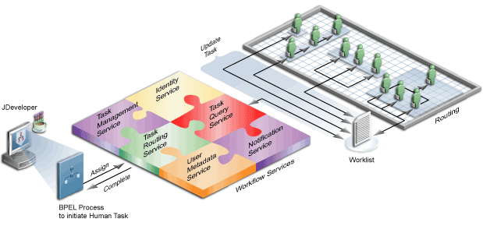

Figure 5 Human Workflow

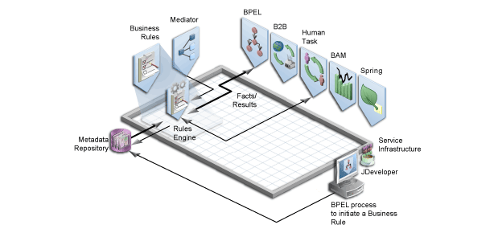

Figure 6 Business Rules

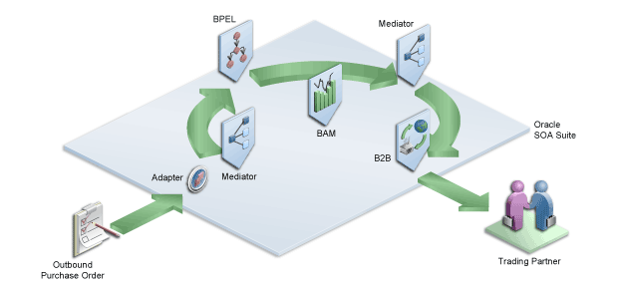

Figure 7 Oracle B2B

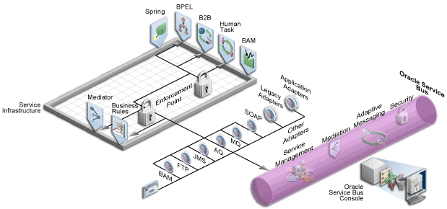

Figure 8 Adapters

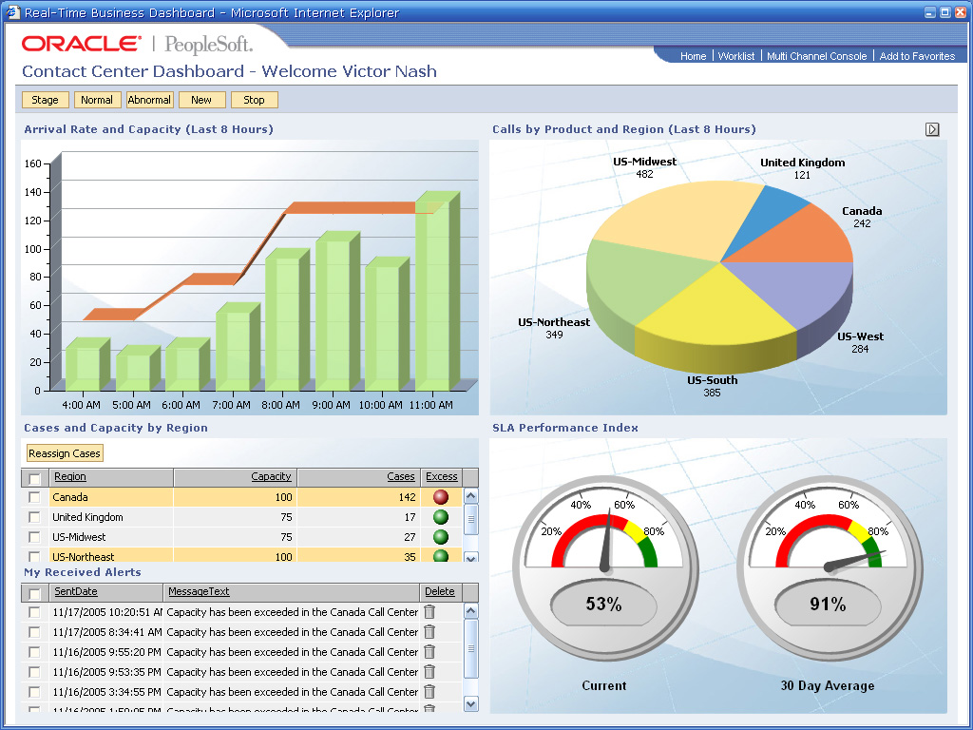

Figure 9 Business Activity Monitoring (BAM)

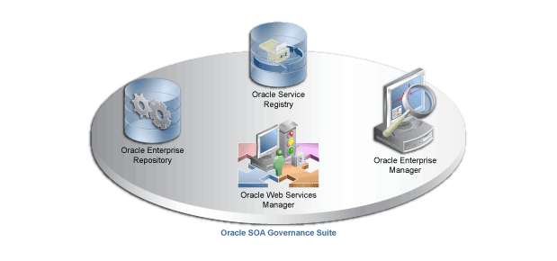

Figure 10 Governance