ORACLE ESB INSTALLATION AND GETTING STARTED GUIDE

- Prerequisites
  - Download the required software

- To download any software from oracle you need to register with oracle and create your username and password. Register yourself as a student using software for evaluation and study purpose. This registration screen will be available to you when you are trying to download software after accepting the agreement.
- Download the versions suited for your laptop operating system (win- 32 bit/ win -64 bit/ other OS)
- If you do not have a JDK installed on your computer
Download the latest JDK version from
http://www.oracle.com/technetwork/java/javase/downloads/index-jsp-138363.html
- Download Oracle Weblogic Server from http://www.oracle.com/technetwork/middleware/weblogic/downloads/index.html
- Download the Oracle Service Bus from
http://www.oracle.com/technetwork/middleware/service-bus/downloads/index.html

  - Install the JDK version if it does not exists in your system. No the path of the installed JDK. It will be required to be entered during installation later on.

  - After the JDK installed, now install the Weblogic Server.

- Go the download directory when you have placed the downloaded file of Weblogic server. The downloaded file would be a single file of around 1 GB generally named as wls1034_oepe111161_win32.exe. This is a generic version works on both 32 and 64 bit versions of OS.
- Double Click on the file to start the installation. The following screen appears. Follow the screen by screen instruction by clicking next or other valid button to move forward.

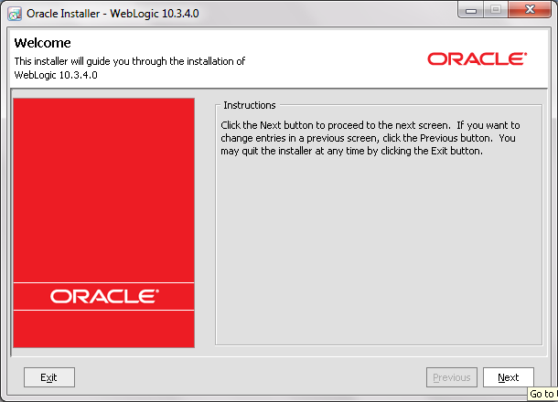

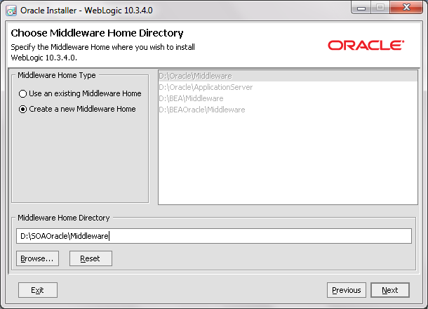

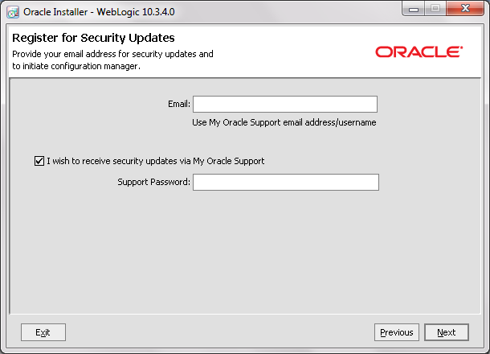
- Uncheck the tick to receive security updates. Click Yes to confirm.
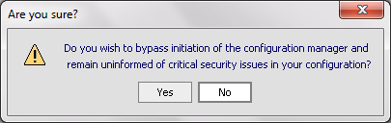

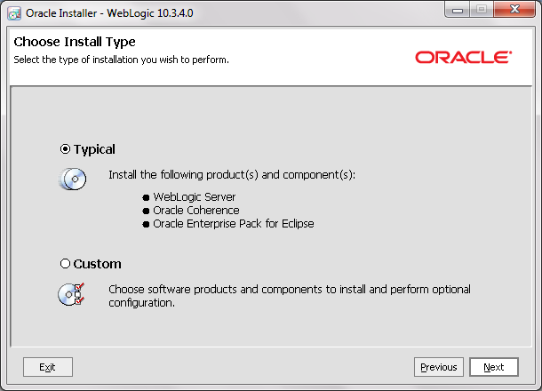

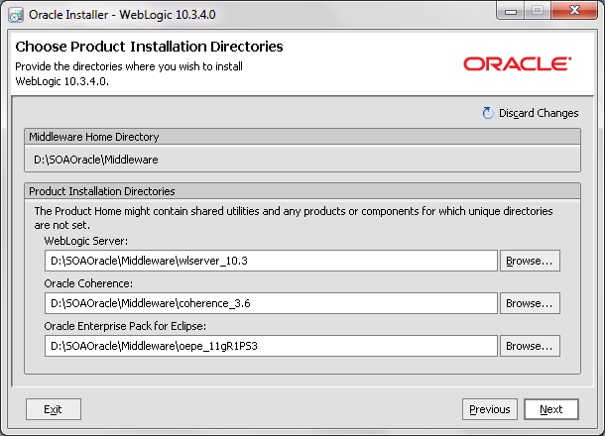

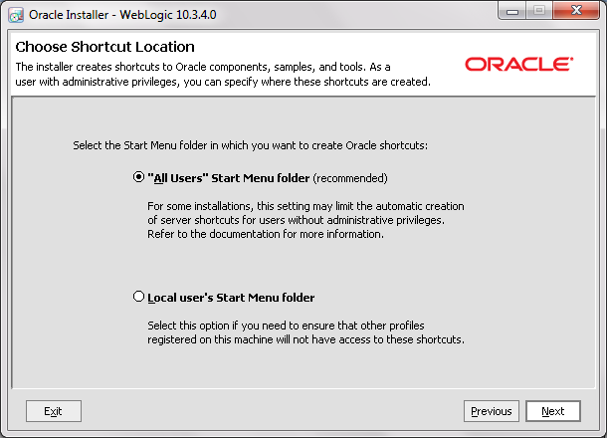

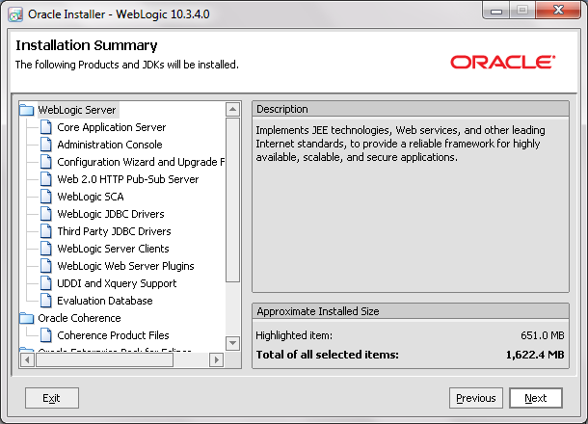

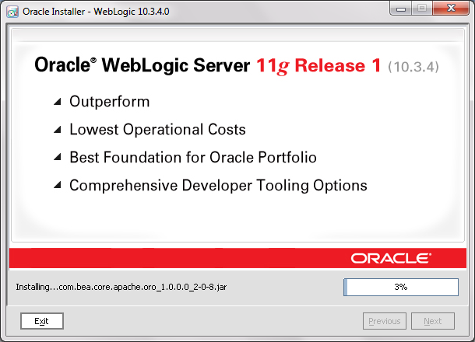

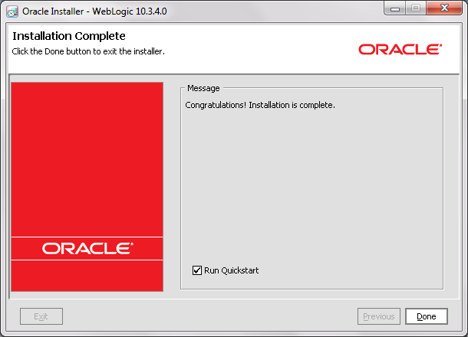

- Uncheck Run Qucik Start and Click Done.

- Oracle Weblogic Server is now installed at the location D:\SOAOracle\Middleware

- The directory structure of the installed server is shown below.

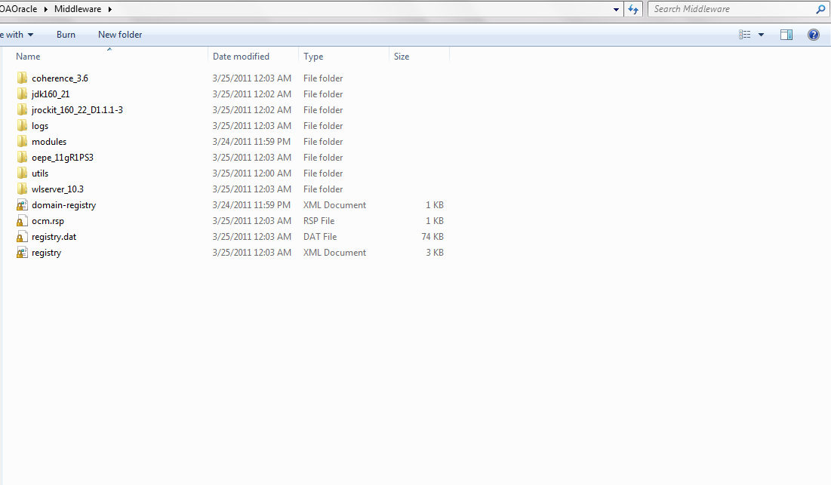

  - Installing Oracle OSB
      - Unzip the folder downloaded for Oracle ESB. Lets assume you donloaded and unzip it to D:\softwares\ ofm_osb_generic_11.1.1.4.0_disk1_1of1
      - Go to the the following folder
D:\softwares\ofm_osb_generic_11.1.1.4.0_disk1_1of1\Disk1\install\win64
      - If its 32 bit operating system go to
D:\softwares\ofm_osb_generic_11.1.1.4.0_disk1_1of1\Disk1\install\win32

      - The example illustrates the installation of a 64 bit version.

      - Click on the setup .exe file
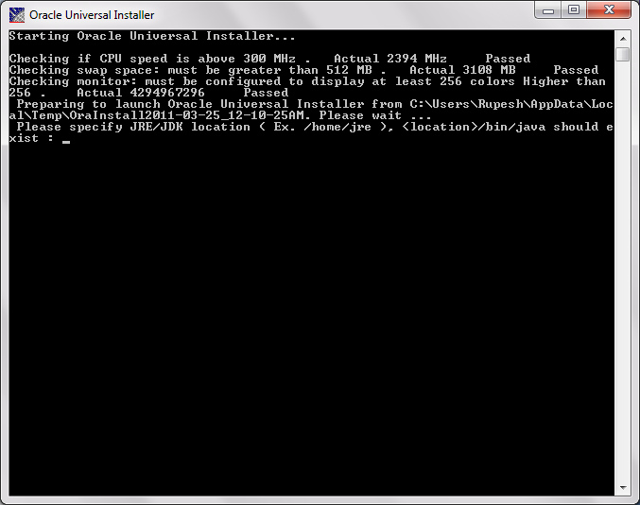
      - A new command window opens up asking to specfiy the path of the JDK directory in the system.
Generally a JDK is installed at the location as mentioned above in the prequisite at C:/ProgramFiles/Java/jdk1.6.0_21 Enter the value to open the installer

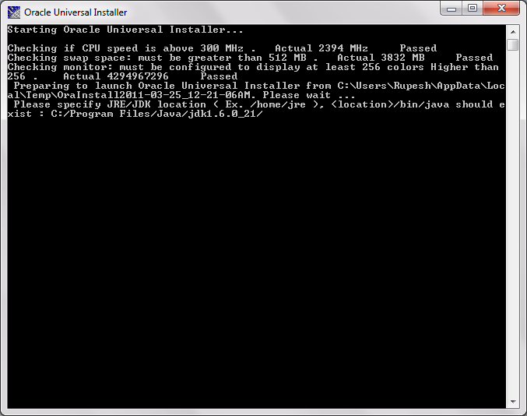

      - Follow the screen shots here on to install the Oracle OSB
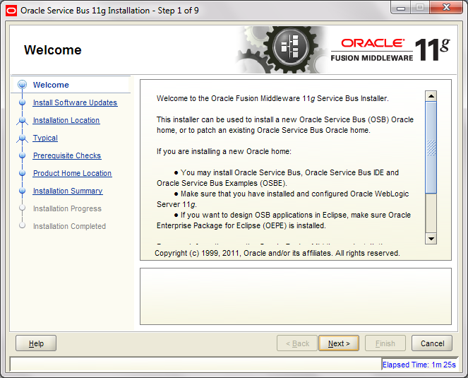

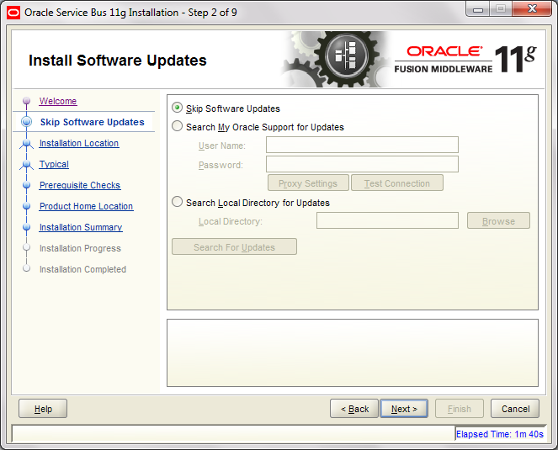
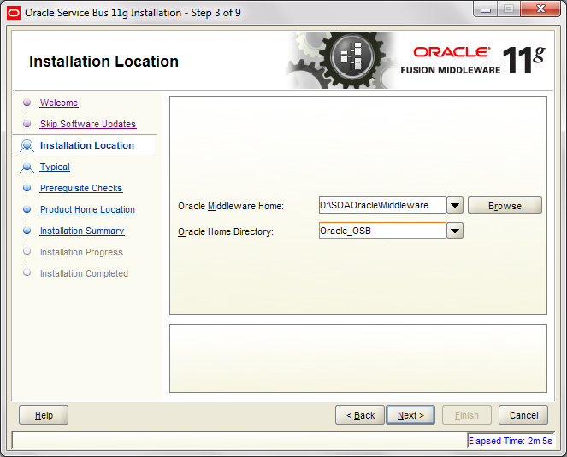
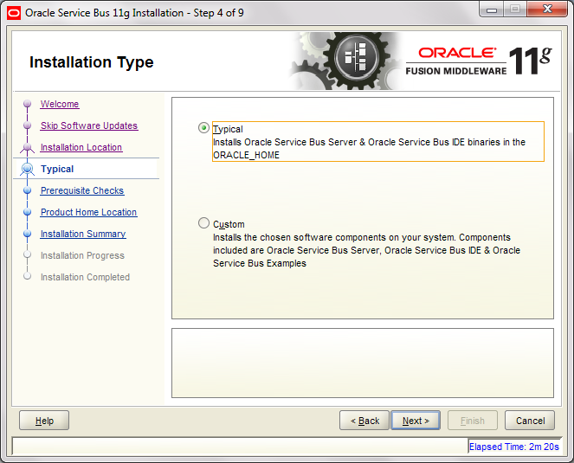
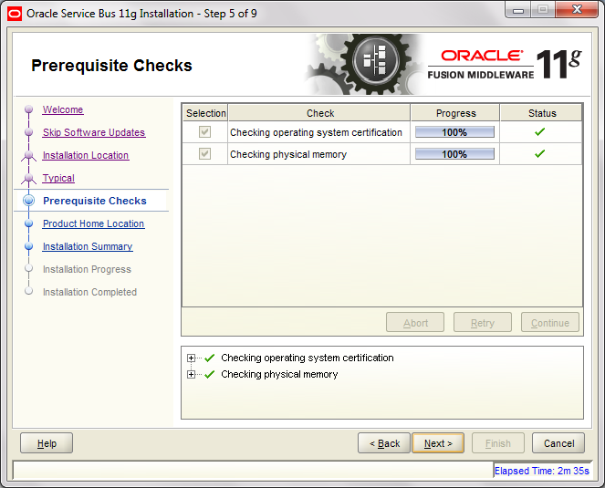

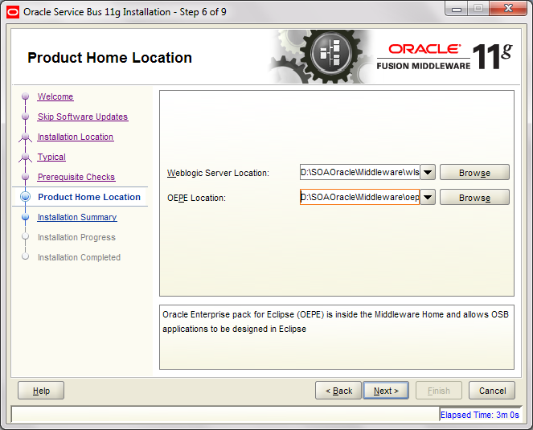

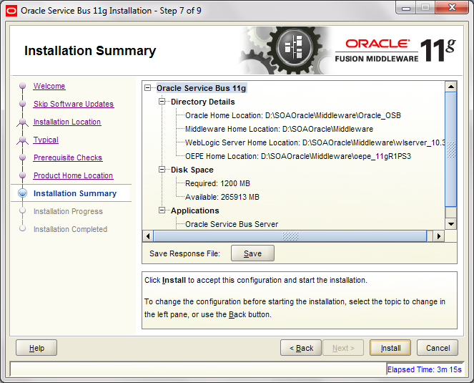

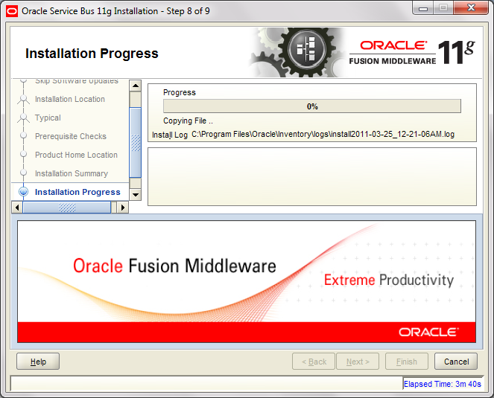
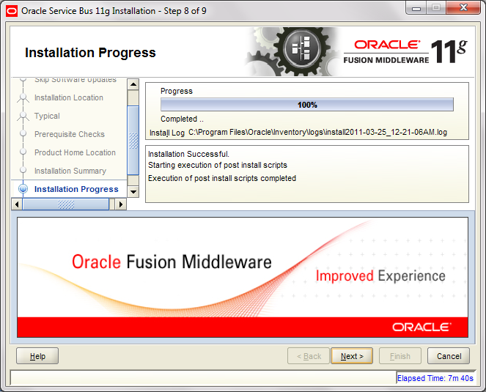
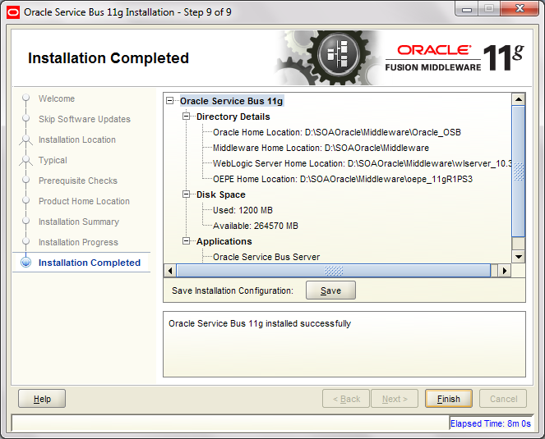
      - Click on Finish to compete the installation of Oracle OSB
  - Configuring the Oracle Service Bus by creating a domain in the weblogic server

      - Go to Program Files -> Oracle Service Bus Home -> Configuration Wizard. Follow the screens.

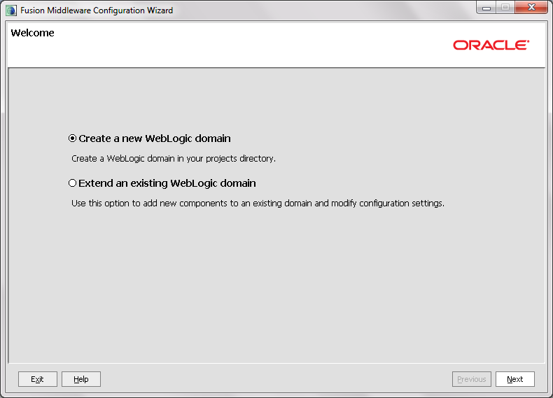

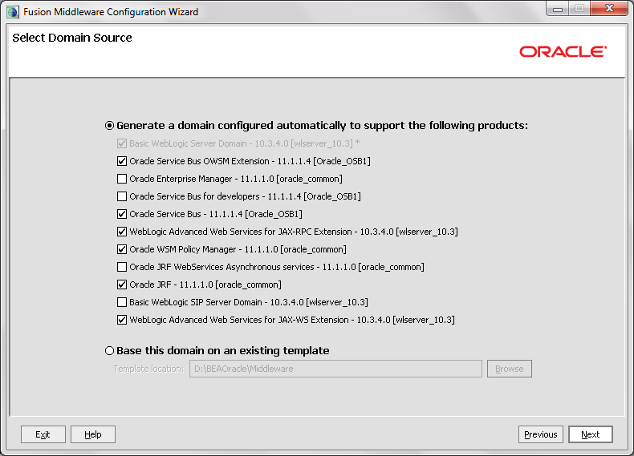

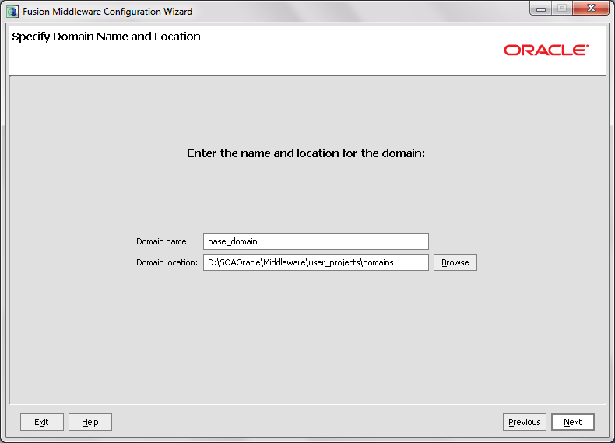

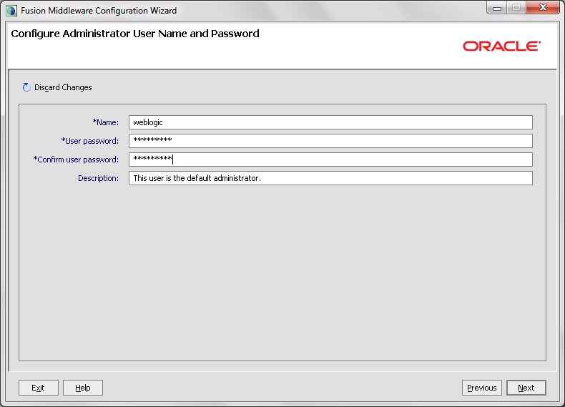

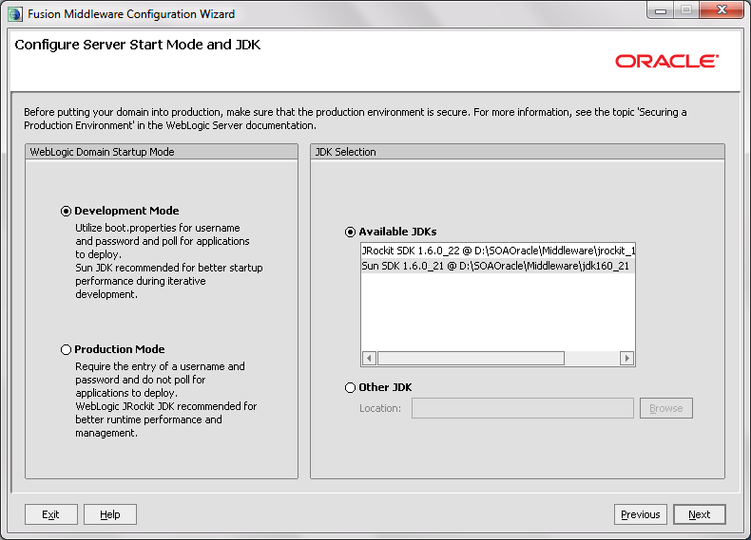

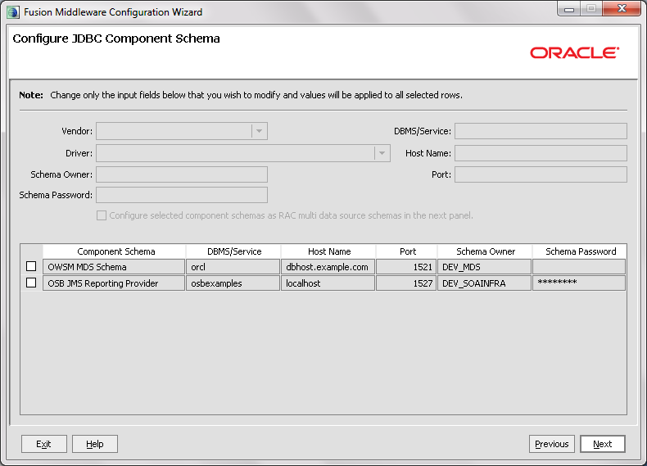

      - Click on the OWSM MDS Schema and enter the schema password. Click Next

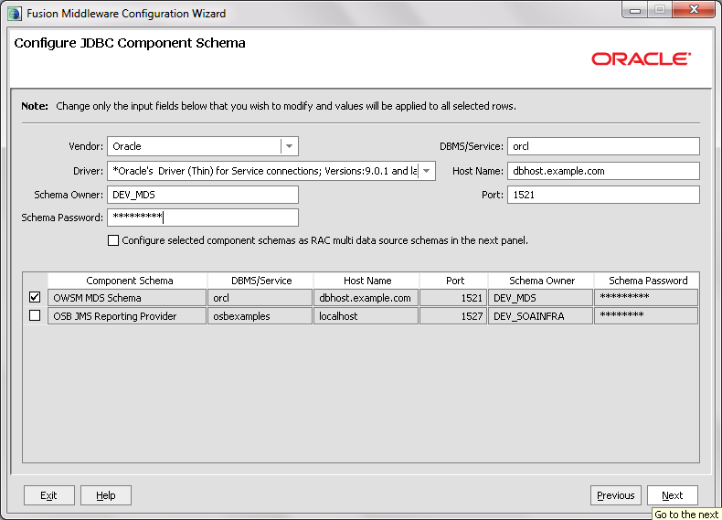

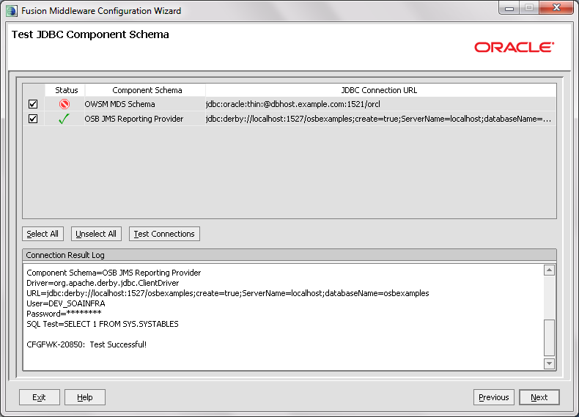

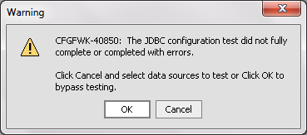

      - Ignore this message and click and OK
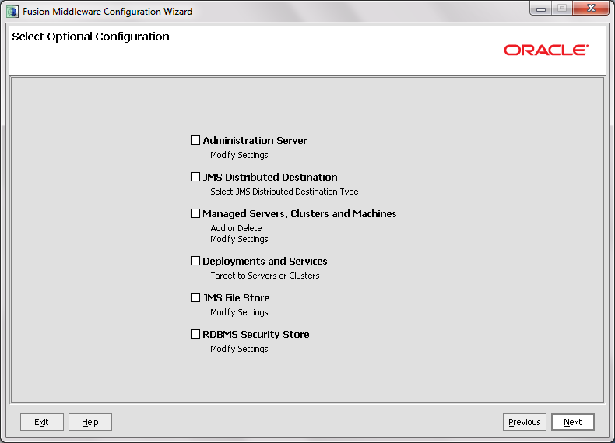
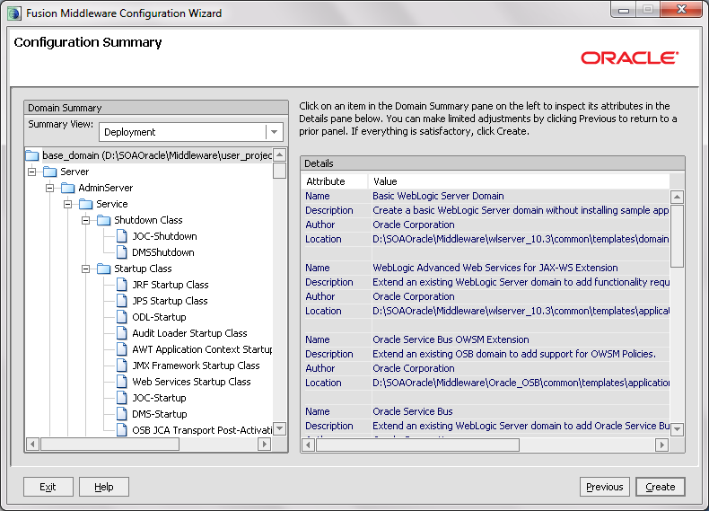
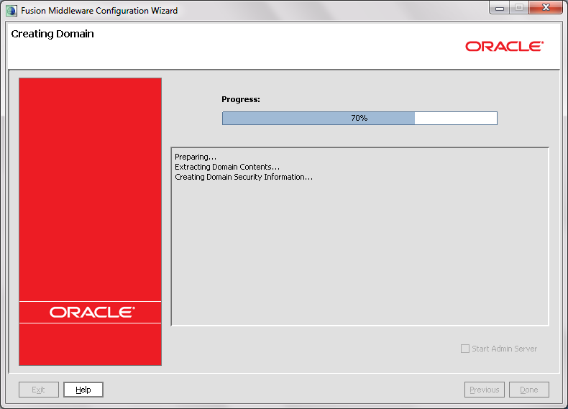
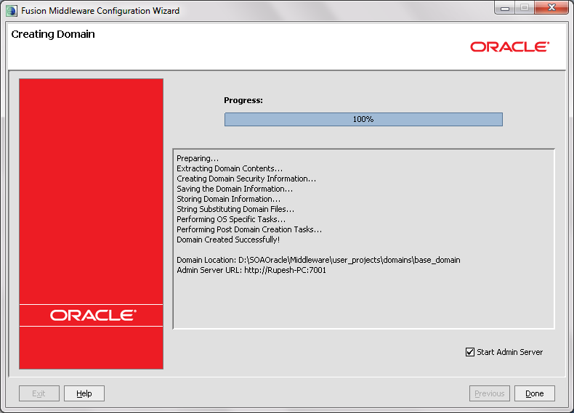
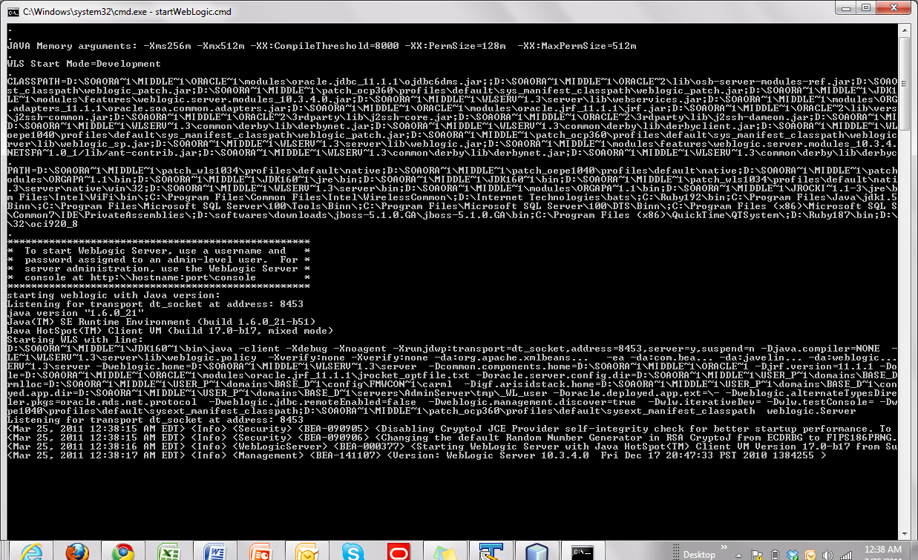
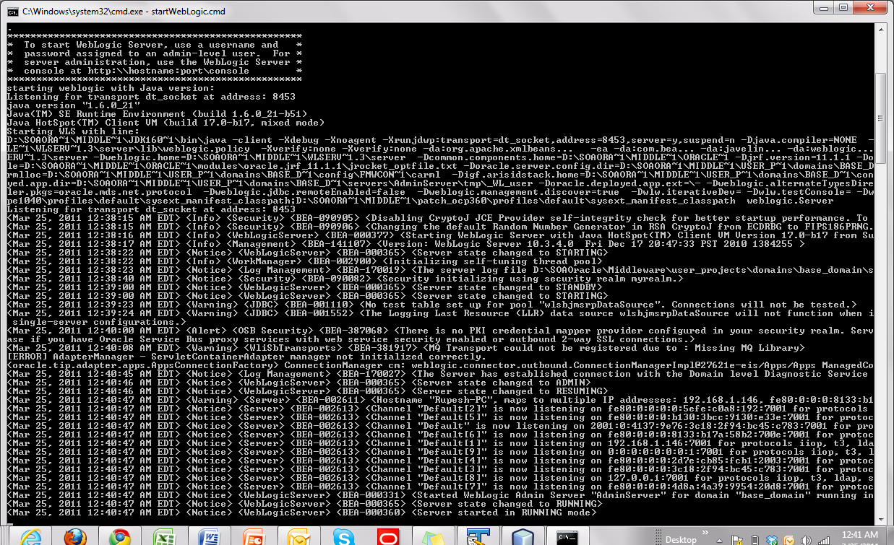
  - Checking the admin console of Weblogic server and Oracle OSB
      - Type http://localhost:7001/console and then enter the username and password assigned during installation.

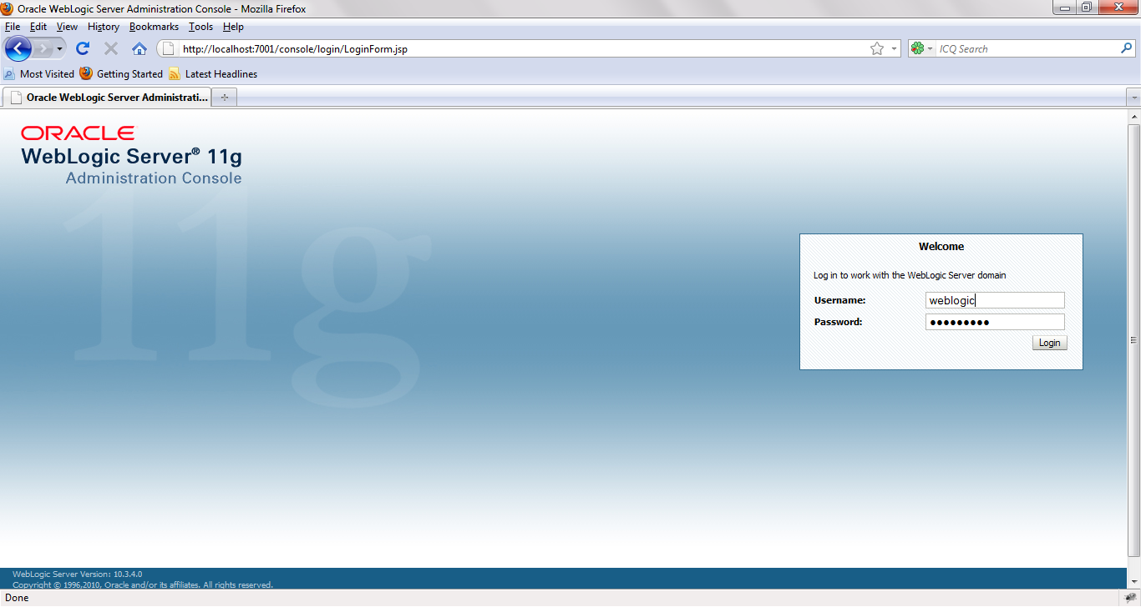

      - Admin Console of Weblogic Server
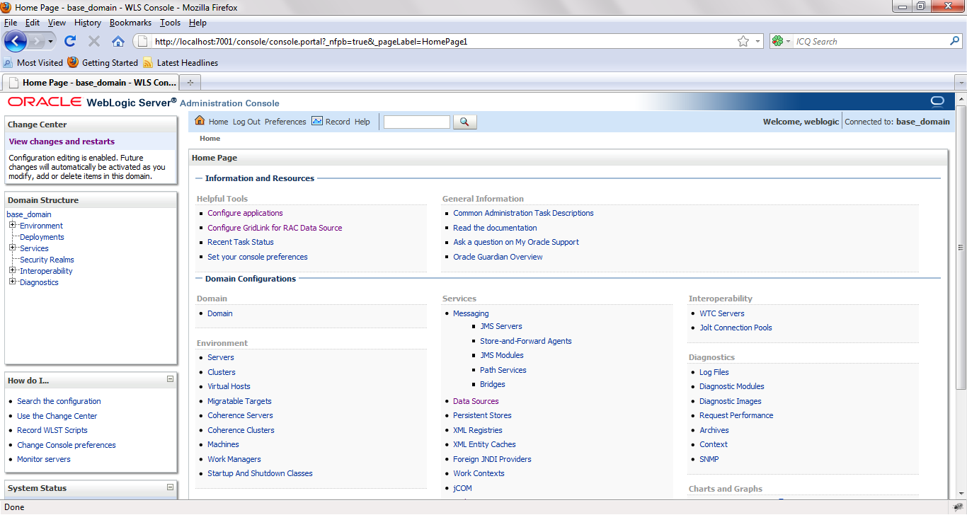

      - Go to Deployments
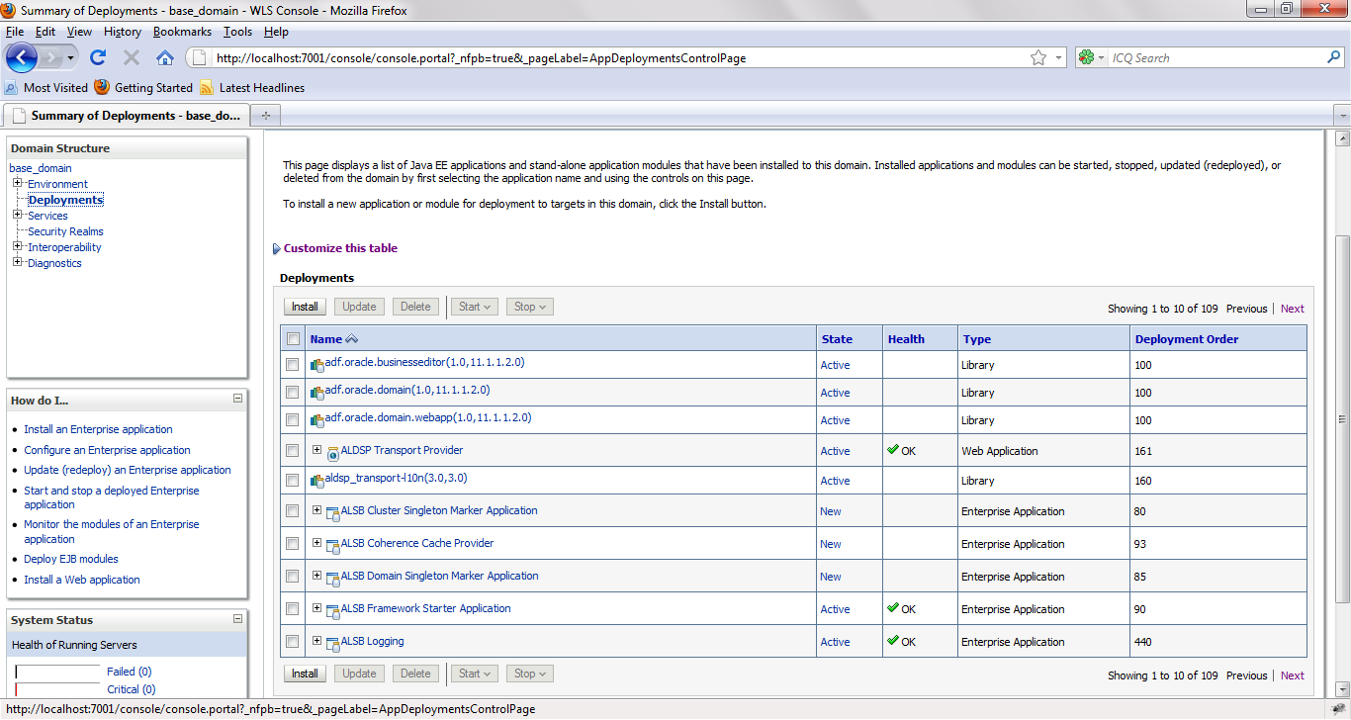

      - The visibility of packages with ALSB gives an idea that Oracle Service Bus is deployed on the Weblogic Server
      - Now go http://localhost:7001/sbconsole/ . This is the admin console of the Oracle Service Bus

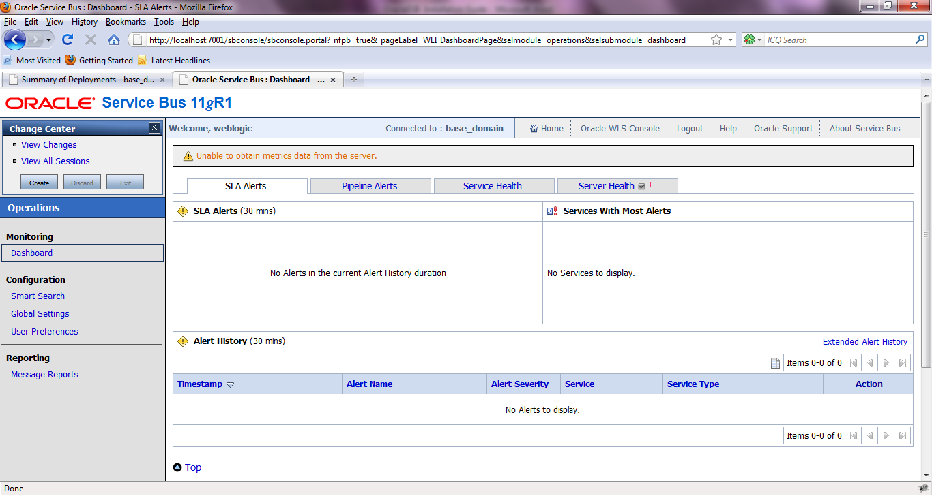
  - Oracle ESB tutorial
      - Download the tutorial for Oracle from
http://download.oracle.com/docs/cd/E13159_01/osb/docs10gr3/pdf/tutorial.pdf
      - Install the Webs services for the client application on the application server as guided on page no 25 of the tutorial. The jar of web services required to install are embedded below.
      - Complete tutorial 1 and 2 as instructed thereafter.

