95-843 Service Oriented Architecture Homework 2

Due: Thursday April 17.

Part A. JAX-WS 50 Points

JDK 6 supports JSR 224, the Java API for XML-Based Web Services (JAX-WS) 2.0. Use this API to build three cooperating web services and a client. One web service will perform loan processing orchestration. Another will act as a loan assessor and a third will act as a loan approver. The client will make a call on the loan processing orchestration. The page below contains a sketch of how your orchestration will behave. You are not required to perform parallel execution.

Submit three web services and a client. Turn in screen shots showing your client getting responses from the orchestration. See the slides on JAX-WS for help.

The implementation of each web service, except the orchestration services, is largely up to you. You might write the assessor web service and approver web service to use random numbers to make loan decisions.

I followed these steps in building a working system:

JAX-WS 2.0 Java Orchestrtation

1) Compile the first two services.

The service LoanApprover.java (port 8084) is in the directory approverservice.
The service LoanAssessor.java (port 8082) is in the directory assessorservice.
The service LoanProcessingOrchestration.java (port 8080) is in the directory
loanserviceorchestration.

Create a appoverdist directory.
Create a assessordist directory.

Populate the distribution directories:

apt -d approverdist approverservice/LoanApprover.java
apt -d assessordist assessorservice/LoanAssessor.java

2) Run the first two services.

java -cp assessordist assessorservice/LoanAssessor
java -cp approverdist approverservice/LoanApprover

3) We need the wsdl generated stubs before we can compile the orchestration.

Get the stub code of the approver service and place the generated code
in the approverstub directory.

wsimport -d approverstub -p approverservice –keep
http://localhost:8084/loanapprover?wsdl

Get the stub code of assessor service and place the generated code
in the assessorstub directory.

wsimport -d assessorstub -p assessorservice -keep
http://localhost:8082/loanassessor?wsdl

Now we can compile the orchestration service.

apt -cp assessorstub;approverstub -d loanserviceorchestrationdist
loanserviceorchestration/LoanProcessingOrchestration.java

Run the orchestrtation service.

java -cp assessorstub;approverstub;loanserviceorchestrationdist
loanserviceorchestration/LoanProcessingOrchestration

4) Compile the client of the orchestration.

Get stub code of second service and place the generated code
in the client directory

wsimport -p client -keep http://localhost:8084/loanprocessingorchestration?wsdl

javac –cp . client/Client.java

5) Run the client.

java -cp . client/Client
Joe Not approved
Mike Approved

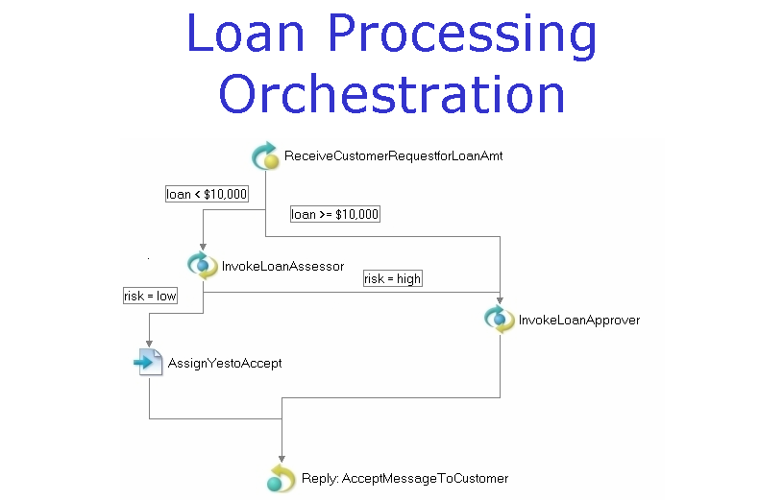

Part B. Active VOS Tutorial 50 Points

In this part of homework 2 you will be generating a BPEL process using the ActiveEndpoints tool. The main activity will be to work through the ActiveBPEL
Tutorial provided in the ActiveBPEL designer.

The CMU user id for Active VOS is activevos.
The CMU password is asE2euGqy.
These will expire on April 21.

1) On Windows, execute Start then Run. You'll need a Heinz ID and password.
\\thunderbolt.heinz.cmu.edu\Lobby\Software

On Mac, choose the Finder then Go and Connect to Server.
smb://thunderbolt.heinz.cmu.edu/Lobby/Software

Copy the ActiveVOS folder to your system.

2) Complete the first 10 parts of the Active Endpoints
BPEL Tutorial. The tutorial is available on start up.

3) Modify the LoanService so that it always approves
anyone whose first name is your name.
In all other respects, it behaves as described in
the tutorial.

4) Submit the source code of your final BPEL document and screen shots
showing the orchestration diagram.

