Homework 3 Due: July 15

A group of M > 0 soldiers find themselves surrounded by an overwhelming enemy force. There is no hope for victory without reinforcements. There is only one horse available for escape. The soldiers agree among themselves on a scheme to determine which one of them will take the horse and summon help. They form a circle and pick an integer N > 0 from a hat. One of their names is also chosen. Beginning with the soldier whose name was picked, they count clockwise around the circle until the count reaches N, that soldier is removed from the circle. Once a soldier is removed from the circle he is no longer counted. The process continues, the count begins with the next soldier until the count again reaches N. The process continues until one soldier remains. This lucky soldier gets to take the horse and summon help while the rest of the soldiers remain and fight.

Example: M = 9 and N = 13

The soldiers are arranged in clockwise order starting with Ajax whose name was entered first.
1

2

Ajax
3

Otho Brutus
4

Maximus Cato

Drusus

Hector Flavius

Gaius

The soldiers are eliminated in the following order:
Drusus, Otho, Hector, Maximus, Cato, Flavius, Gaius, and Ajax. Brutus takes the horse to summon help.

You are to solve this problem in two distinct ways:
- Using a circular list (solution_1)
- Using an almost complete binary tree (solution_2)

I will not describe solution_1 that uses a circular list, since it is straightforward. I will leave the details to you.

On the other hand solution_2 requires further explanation. We will build an almost complete binary tree with M leaves, where each node consists of two fields, a string representing a soldier’s name and an integer representing the number of leaves rooted at that node. Note that each leaf contains a soldier’s name while each interior node contains the empty string. As we proceed from left to right, the leaves contain the names of the soldiers appearing in clockwise order (like in the diagram above). The integer stored in each is leaf is 1. Remember, in an almost complete binary tree it is easy to go from a node to its parent, or from a parent to its left or right child, or from a node to its right brother (see the slides on Trees slide 36-37) http://www.andrew.cmu.edu/~mm6/95-771/PowerPoint/05A_Trees.ppt).

The almost complete binary tree generated from the example above is

9
5
2
3
4
2
2
2
Ajax
1
Brutus
1
Cato
1
Drusus
1
Flavius
1
Gaius
1
Hector
1
Maximus
1
Otho
1

This tree is stored in an array as follows:
“” 9
“” 5
“” 4
“” 3
“” 2
“” 2
“” 2
“” 2
“Cato” 1
“Drusus” 1
“Flavius” 1
“Gaius” 1
“Hector” 1
“Maximus” 1
“Otho” 1
“Ajax” 1
“Brutus” 1
0
1

2
3
4

5
6

7
8
9
10

11
12

13
14
15

16
The algorithm for solution_2 is shown below:

Input M (number of soldiers) and N (number used to eliminate soldiers).
Input the names of the soldiers in clockwise order.
Construct the almost complete binary tree T.

Let p point to the root of T.
Let the number of leaves that remain to be counted = N % M.
while there is more than one leaf in T
{
//Locate the next soldier to be eliminated
while there is more than one leaf in the subtree pointed to by p
{
Set p to point to its left child.
if number of leaves that remain to be counted > number of leaves in the subtree pointed to by p
{
Decrement number of leaves that remain to be counted by number of leaves in the subtree
pointed to by p
Set p point to its right brother
}
}

// At this place, p should be pointing to the next soldier to be eliminated from the circle
Display the soldier pointed to by p.
Set q point to the same node that p points to.
while q points to a node in the tree
{
//Reduce the count of each ancestor of q
Decrement number of leaves in the subtree pointed to by q by 1.
if number of leaves in the subtree pointed to by q equals 1 then
{
if number of leaves in the subtree pointed to by the left child of q equals 1 then
replace the soldier's name in q with the soldier's name in q's left child
else
replace the soldier's name in q with the soldier's name in q's right child
}
Set q to q's parent
}

Let the number of leaves that remain to be counted be set to N.
if p points to a left child then
Set p to point to it right brother

while (number of leaves that remain to be counted > number of leaves in the subtree
pointed to by p) and (p not equal to T)
{
Decrement number of leaves that remain to be counted by the number of leaves in the subtree
pointed to by p
while p points to a right child
Set p to point to its father

if p does not point to T then
Set p to point to its right brother
}

if p points to T then
set number of leaves remaining to be counted to itself modulo the number of leaves in the
subtree pointed to by T
}

// At this point only one leaf remains containing the lucky soldier who goes for reinforcements
A sample run is shown below

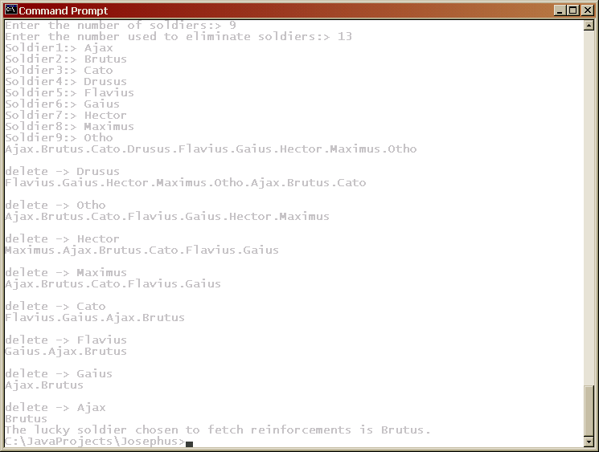

You are to submit each solution in separate folders labeled “With Circular List” and “With Almost Complete Binary Tree”. Each folder must contain all related files to your solution.

Your solutions must be general to handle an arbitrary number of soldiers. Enjoy!

