Internet Technologies Homework 2 Due Thursday, April 26,2007

Lab Topic: Extensible Style Sheet Language for Transformations XSLT

In this lab we will be programming in a transformation language called XSLT. XSLT is used to transform one XML document into another XML document (with a different structure). In order to write programs in XSLT, we need an XML parser (XSLT programs are XML documents) and an XSLT interpreter. The parser is called “Xerces”. The interpreter is called “Xalan” (Xalan uses Xerces).
The required jar files for XSLT processing using Xalan are : xalan.jar, xercesImpl.jar, xml-apis.jar and xsltc.jar. These may be downloaded from the Apache Foundation.
In Part I of this homework, you will test your installation from the command line. In Part II you will experiment with using XSLT from within a Java program. Finally, in Part III, you will be asked to write several XSLT programs and servlets.
You are required to use the same names as used here for files and directories. Otherwise, the lab will be very difficult to grade and it will be harder for me to give you help
Part 1 Command Line XSLT
=============================
For DOS based machines, create a directory called "bats" and place a batch file called "xalan.bat" in that directory. Place the path to your bats directory in the system path variable.
The file xalan.bat will hold the following:
java org.apache.xalan.xslt.Process –IN %1 -XSL %2 -OUT %3

You will need to have the jar files mentioned above on your classpath before running xalan.bat.

For Unix based machines, you would use a script file called xalan with execute permissions. My xalan jar files are saved in /Users/mm6/Applications/xalan

#!/bin/sh
export XALAN_HOME=/Users/mm6/Applications/xalan
export CP=$XALAN_HOME/xalan.jar:$XALAN_HOME/xercesImpl.jar:$XALAN_HOME/xml-apis.jar:$XALAN_HOME/xsltc.jar
java -classpath $CP org.apache.xalan.xslt.Process -IN $1 -XSL $2 -OUT $3

Testing. The following is an xml file called books.xml that contains data on books. It’s a copy of the file found on Page 70 of the XSLT Programmer’s Reference by Michael Kay.

<?xml version="1.0"?>
<books>
<book category="reference">
<author>Nigel Rees</author>
<title>Sayings of the Century</title>
<price>8.95</price>
</book>
<book category="fiction">
<author>Evelyn Waugh</author>
<title>Sword of Honour</title>
<price>12.99</price>
</book>
<book category="fiction">
<author>Herman Melville</author>
<title>Moby Dick</title>
<price>8.99</price>
</book>
<book category="fiction">
<author>J. R. R. Tolkien</author>
<title>The Lord of the Rings</title>
<price>22.99</price>
</book>
</books>

We would like to transform this file into an HTML document as shown here (result.html):

<html>
<body>
<h1>A list of books</h1>
<table width="640">
<tr>
<td>1</td>
<td>Nigel Rees</td>
<td>Sayings of the Century</td>
<td>8.95</td>
</tr>
<tr>
<td>2</td>
<td>Evelyn Waugh</td>
<td>Sword of Honour</td>
<td>12.99</td>
</tr>
<tr>
<td>3</td>
<td>Herman Melville</td>
<td>Moby Dick</td>
<td>8.99</td>
</tr>
<tr>
<td>4</td>
<td>J. R. R. Tolkien</td>
<td>The Lord of the Rings</td>
<td>22.99</td>
</tr>
</table>
</body>
</html>

In order to carry out this transformation, we will use the XSLT programming language. While it is the case that XSLT is Turing complete, that is, we can solve a wide variety of problems using XSLT, it is especially good at performing XML transformations. Our first XSLT program looks like this (booklist.xsl):

<xsl:stylesheet xmlns:xsl="http://www.w3.org/1999/XSL/Transform" version="1.0">
<xsl:template match="books">
<html>
<body>
<h1>A list of books</h1>
<table width="640">
<xsl:apply-templates/>
</table>
</body>
</html>
</xsl:template>

<xsl:template match="book">
<tr>
<td>
<xsl:number/>
</td>
<xsl:apply-templates/>
</tr>
</xsl:template>
<xsl:template match="author | title | price">
<td>
<xsl:value-of select="."/>
</td>
</xsl:template>
</xsl:stylesheet>

Place the two files (books.xml and booklist.xsl) into a directory and make sure that xalan is working properly by running the following command. The output file should look like result.html.

xalan books.xml booklist.xsl result.html

When debugging XSLT programs, it is often much more helpful to view your output in an editor like Notepad rather than to view your output in a browser like Netscape or IE or Safari. Look at the HTML document in A browser only after you are satisfied with the way it looks in Notepad. The browser view is often quite deceiving and makes a poor debugging tool.

Part 2 Running Xalan from within Java
============================================

While command line xalan makes a very nice tool, it is often necessary to make calls for XSLT processing from within other programs. Here is a Java program that performs the same transformation as above. But this time the transformation is performed under application program control.

// ProduceHTML.java is a simple program that demonstrates how XSLT programs
// can be executed from within Java.

import java.io.IOException;
import java.io.OutputStream;
import java.io.FileInputStream;
import java.io.FileOutputStream;

import javax.xml.transform.Source;
import javax.xml.transform.stream.StreamSource;
import javax.xml.transform.stream.StreamResult;
import javax.xml.transform.Result;
import javax.xml.transform.TransformerFactory;
import javax.xml.transform.Transformer;
import javax.xml.transform.TransformerException;

public class ProduceHTML {

public static void main(String a[] ) {

Source xmlDoc, xslDoc;
Result result;
try {
FileInputStream xml = new FileInputStream("books.xml");
FileInputStream xsl = new FileInputStream("booklist.xsl");
FileOutputStream out = new FileOutputStream("out.html");

xmlDoc = new StreamSource(xml);
xslDoc = new StreamSource(xsl);
result = new StreamResult(out);

TransformerFactory factory = TransformerFactory.newInstance();
Transformer trans = factory.newTransformer(xslDoc);
trans.transform(xmlDoc,result);
}
catch(TransformerException e) {
System.out.println("Transformer Probem" + e);
}
catch(IOException e) {
System.out.println("An I/O problem");
}
}
}

PART 3 Introductory XSLT Programming
====================================================

When completed, submit this entire document to blackboard.

- 10 Points. Using command line XSLT, write an XSLT program that displays all of the attribute values in the book.xml file. The html, when displayed in a browser, should like the following:

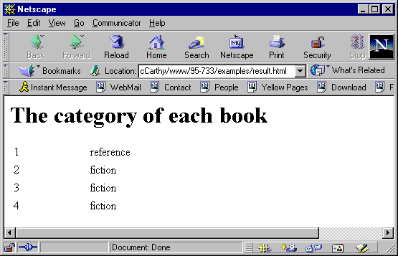

  - Paste the XSLT program here.

  - Paste the HTML file here.

- 10 Points. Using command line XSLT, write an XSLT program that displays all of the authors in the book.xml file. The html, when displayed in a browser, should like the following:

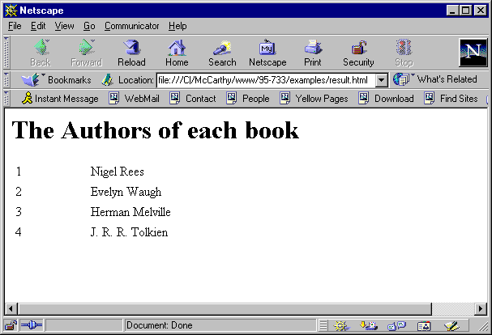

  - Paste the XSLT program here.

(b) Paste the HTML file here.

(3) 20 Points. Using command line XSLT, write an XSLT program that displays all of the data in the book.xml file sorted by title. The html, when displayed in a browser, should look like the following:

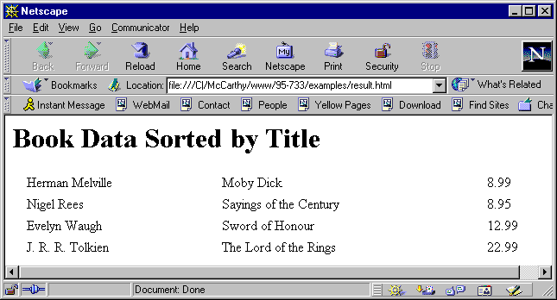

(a) Paste your XSLT program here.

(b) Paste your HTML file here.

The following xml file describes courses available from a computer science department at a fictional university. This file is called Course_Descriptions.xml.

<?xml version="1.0"?>
<Course_Descriptions>
<Course>
<Course-ID id="Math100"/>
<Title>Algebra I</Title>
<Description> Students in this course study introductory algebra.
</Description>
<Prerequisites/>
<Instructor>
<Name> Adam Bell </Name>
<Office> 100 CL4</Office>
<Email> ab@duke.edu </Email>
<Phone> 412-111-1122 </Phone>
</Instructor>
</Course>

<Course>
<Course-ID id = "Geom100"/>
<Title>Geometry I</Title>
<Description> Students in this course study how to prove several
theorems in geometry.
</Description>
<Prerequisites/>
</Course>

<Course>
<Course-ID id="Calc100"/>
<Title>Calculus I</Title>
<Description> Students in this course study the derivative.
</Description>
<Prerequisites pre="Math100 Geom100" />
<Text>
<Text-Title> Introduction to The Calculus </Text-Title>
<Text-ISBN> 0-201-43315-X </Text-ISBN>
<Text-Pub> Addison Wesley Longman </Text-Pub>
</Text>
<Text>
<Text-Title> Using MathMatica </Text-Title>
<Text-ISBN> 0-245-48815-X </Text-ISBN>
<Text-Pub> Wolfgram Software </Text-Pub>
</Text>
</Course>
<Course>
<Course-ID id = "Calc200" />
<Title>Calculus II</Title>
<Description> Students in this course study the integral.
</Description>
<Prerequisites pre="Calc100" />
<Text>
<Text-Title> Introduction to The Calculus </Text-Title>
<Text-ISBN> 0-201-43315-X </Text-ISBN>
<Text-Pub> Addison Wesley Longman </Text-Pub>
</Text>
</Course>
<Course>
<Course-ID id = "Calc300" />
<Title>Calculus III</Title>
<Description> Students in this course study the derivative and
the integral (in 3-space).
</Description>
<Prerequisites pre="Calc200" />
<Instructor>
<Name> Ellen Bell </Name>
<Office> 104 Jones </Office>
<Email> Eb@duke.edu </Email>
<Phone> 412-344-5612 </Phone>
</Instructor>
<Text>
<Text-Title> Introduction to The Calculus </Text-Title>
<Text-ISBN> 0-201-43315-X </Text-ISBN>
<Text-Pub> Addison Wesley Longman </Text-Pub>
</Text>
</Course>
<Course>
<Course-ID id = "CS1" />
<Title>Introduction to Computer Science I</Title>
<Description> In this course we study Turing machines.
</Description>
<Prerequisites pre="Calc100" />
</Course>
<Course>
<Course-ID id = "CS2" />
<Title>Introduction to Computer Science II</Title>
<Description> In this course we study basic data structures.
</Description>
<Prerequisites pre="Calc200 CS1"/>
</Course>
<Course>
<Course-ID id = "Philo45" />
<Title>Ethical Implications of Information Technology</Title>
<Description> In this course we will study the impact of XML
on life.
</Description>
<Prerequisites/>
<Instructor>
<Name> Susan Smith </Name>
<Office> 102 Smith Hall </Office>
<Email> suem@duke.edu </Email>
<Phone> 412-344-2121 </Phone>
</Instructor>
<Text>
<Text-Title> The XML Bible </Text-Title>
<Text-ISBN> 1-833-93399-X </Text-ISBN>
<Text-Pub> Addison Wesley Longman </Text-Pub>
</Text>
<Text>
<Text-Title> The Human Use of Human Beings </Text-Title>
<Text-ISBN> 4-833-93445-X </Text-ISBN>
<Text-Pub> Addison Wesley Longman </Text-Pub>
</Text>
</Course>
</Course_Descriptions>

(4) 50 Points. Write a Java servlet, Courses.java, that uses Xalan to call on three different XSLT programs to provide four different views of the data contained in Course_Descrptions.xml. From within your servlet, you will need to read the course descriptions file and the corresponding stylesheet with code like this:

ServletContext context = getServletContext();

String extraPath;
String contentType;

extraPath = null;

if(req.getPathInfo() != null) {
extraPath = req.getPathInfo();
extraPath = extraPath.substring(1);
}

contentType = "text/html";

res.setContentType(contentType);

PrintWriter out = res.getWriter();

Source xmlDoc;
Source xslDoc;
Result result;

String styleSheetName = extraPath;

try {
InputStream xml =

(InputStream)(context.getResourceAsStream("/Course_Descriptions.xml"));

InputStream xsl =
(InputStream)(context.getResourceAsStream("/"+styleSheetName + ".xsl"));

xmlDoc = new StreamSource(xml);
xslDoc = new StreamSource(xsl);
result = new StreamResult(out);

TransformerFactory factory = TransformerFactory.newInstance();

Transformer trans = factory.newTransformer(xslDoc);
trans.transform(xmlDoc,result);

The servlet should find your xml and xslt files in the web application’s web directory. Your web.xml file will assign a URL pattern to the Courses servlct.

The user of the browser will select the particular XSLT program that is executed by the servlet.

The first XSLT program that you will write, Titles.xsl, processes the Course_Descriptions.xml file and generates a list of course titles marked up nicely in HTML.

The second XSLT program, texts.xsl, processes the Course_Descriptions.xml file and generates a list of textbook titles marked up nicely in HTML.

The third XSLT program, ISBN.xsl, processes the Course_Descriptions.xml file and generates a list of textbook ISBN numbers marked up nicely in HTML (with numbering as shown below).

Note that you need not provide an HTML front end (index.html) unless you want to. The view that the user is interested in is accessed from within the servlet with the getPathInfo() method of the HttpServletRequest object. In order to do this, you must use “/Courses/*” in your web.xml file.

The user (browser) will be able to select which view it wants as follows:

http://localhost:8080/books/Courses/titles The servlet gets Course Titles
http://localhost:8080/books/Courses/texts The servlet gets Text Book Titles
http://localhost:8080/books/Courses/isbn The servlet gets ISBN numbers

For the first two cases your browser must look exactly the same as these. Note how the ISBN’s are numbered.

A visit by a browser to the servlet selecting titles:

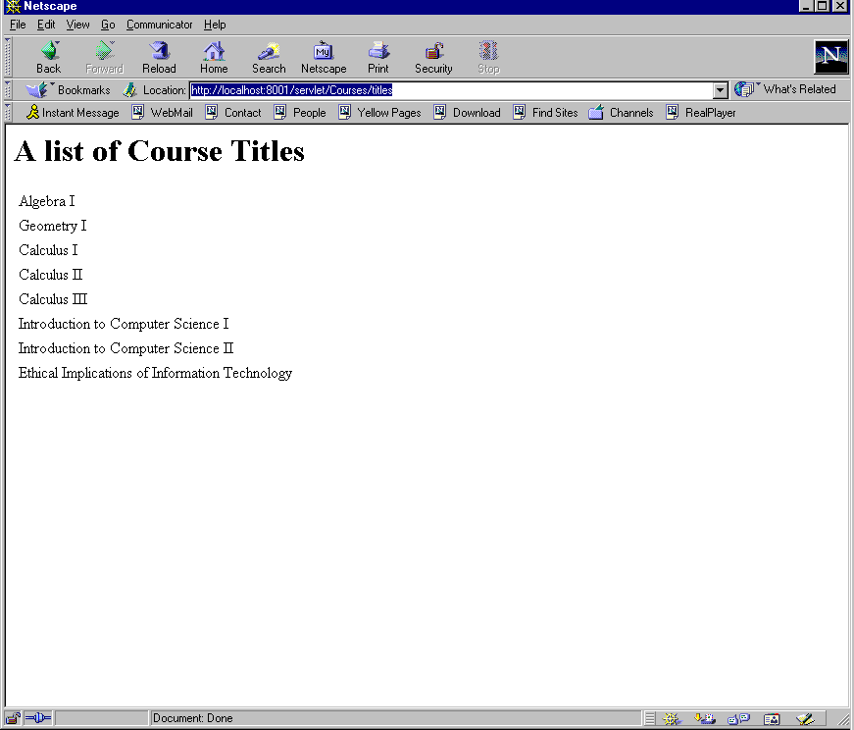

A visit by a browser to the servlet selecting ISBN numbers (note how the numbers increase when a
course has more than one book):

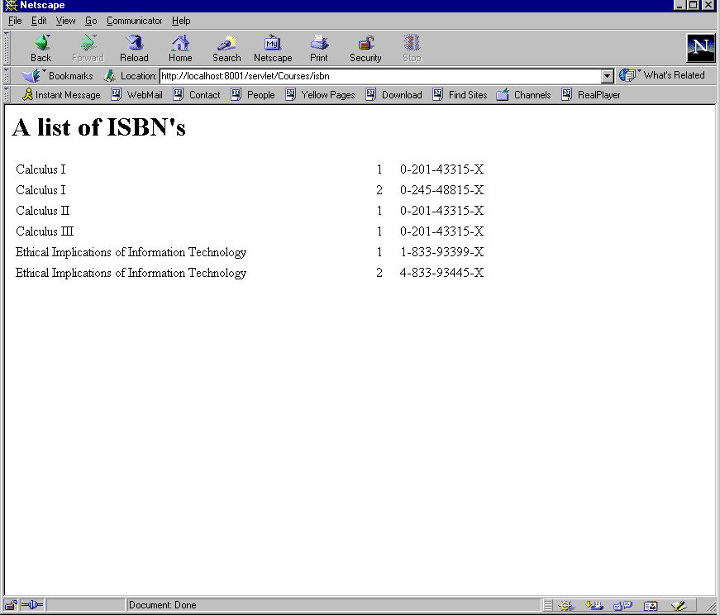

Paste a copy of your documented servlet called Course.java here.

Paste a copy of your titles.xsl program here.

Paste a screen of a browser viewing titles here.

Paste a copy of your texts.xsl program here.

Paste a screen of a browser viewing text titles here.

Paste a copy of your isbn.xsl program here.

Paste a screen of a browser viewing ISBN numbers here.

5) 10 Points. Download and install an Openwave Phone Simulator from the following URL: http://developer.openwave.com/dvl/tools_and_sdk/phone_simulator/. Write an XSLT stylesheet that transforms the course descriptions file into an appropriate document for the phone simulator. The document should be marked up in HTML-MP (Hypertext Markup Language Mobile Profile). A tutorial on this markup may be found at http://developer.openwave.com/dvl/support/documentation/guides_and_references/xhtml_tutorial/index.htm. Be able to demonstrate that a phone user can conveniently browse course descriptions.

In my solution, as used the following declarations at the top of my xsl file:

<xsl:stylesheet
xmlns:xsl="http://www.w3.org/1999/XSL/Transform"
version="1.0"
>

<xsl:output method = "html"
omit-xml-declaration = "no"
doctype-public="-//OPENWAVE//DTD XHTML Mobile 1.0//EN"
doctype-system="http://www.openwave.com/dtd/xhtml-mobile10.dtd"
/>

<xsl:strip-space elements="*"/>

Paste a copy of your mobilePhone.xsl program here.

Paste a copy of your XHTML-MP document (generated by your XSLT program) here.

Paste a several screen shots of an Openwave phone viewing course descriptions here. These views should show the user efficiently navigating through the course descriptions.

Motivation for Lab 2

This lab was motivated by the description (found in Goldfarb’s XML text) of IBM’s web site.

How does IBM manage a web site providing 2 gigabytes (about 70 Pittsburgh telephone books) of data?

1. Prior to any HTTP requests, an automated process
on the web server retrieves each XML document.

2. Each XML document is associated with one or more
XSL documents.

3. Each XML document is processed with one or more
of the XSL documents.

4. The HTML documents are cached.

5. An HTTP request comes in from the client.

6. The correct HTML document is sent to the client.

Client
Web
Server
1
XSL
Processor
HttpRequest
HTML doc
XML document
XSL stylesheet
XSL & XML
HTML doc
5
6
2
4
3

