Lab 1 Due Wednesday, January 30, 2002

Tomcat Installation, WAR Files and Servlets

In this lab we will be using an HTTP server called Tomcat available from the Jakarta Apache Project. In Part 1, we will present the details associated with the installation and basic configuration of Tomcat running under either Windows ’95 or Windows NT (you may also use Linux). In Part 2 we will experiment with WAR files, authentication and servlets. Because of few but occasional incompatibilities, let’s agree to use Netscape for browsing.

Part I Installing Tomcat on Windows 95/Windows NT

1) If you have not already done so, you need to install the Java programming language on your system. Obtain a copy of the JDK1.3.0 (Java 2 SDK) compiler. If you already have installed JDK1.2 then that will work fine. This compiler is available from Sun Microsystem’s web site at http://java.sun.com/j2se/1.3/download-windows.html. You should also download and install the Java documentation. This is available from Sun at http://java.sun.com/j2se/1.3/docs.html. Choose the Browse and Download documentation option and then download one large bundle in HTML format. These files arrive in a compressed format. You can use winzip to expand them. You can download an evaluation copy of winzip from http://www.winzip.com/winzip/download.html. Be sure to set your path variable (so that the Java compiler and Java interpreter can be run from any directory using simple commands). Also be sure to set your classpath variable (so that javac and java can find the locations of the classes that your programs will use). The following web site contains directions on how to set the path and classpath variables: http://java.sun.com/j2se/1.3/install-windows.html.

2) Visit the Jakarta Project web site at http://jakarta.apache.org/builds/jakarta-tomcat-4.0/release/v4.0.1/bin/. Choose jakarta-tomcat-4.0.1.zip from the left hand column. After downloading, use winzip to expand the file Jakarta-tomcat-4.0.1.zip to your C or D drive. This expansion will automatically create a directory called d:\jakarta-tomcat-4.0.1. (If you have chosen C the directory will be called c:\jakarta-tomcat-4.0.1.) Make sure that your classpath contains the dot “.”. Also, add the servlet.jar file to your classpath. My classpath includes the following line: D:\jakarta-tomcat-4.0.1\common\lib\servlet.jar. Also, ensure that you JAVA_HOME system variable is set to the location of the JDK. My JAVA_HOME variable is set to D:\jdk1.2.2

TESTING THE INSTALLATION

Using the MyComputer icon, look over the files in the new directory. You should see a directory structure containing many files and subdirectories. Your path to the webapps directory should look like the following:

D:\jakarta-tomcat-4.0.1\webapps

The following directions will assume that you have such a directory structure.

3) After changing to the Jakarta directory with the command cd D:\jakarta-tomcat-4.0.1\bin, run the startup.bat batch file by typing startup. This should execute Tomcat in a new DOS window called Catalina.

Starting service Tomcat-Standalone
Apache Tomcat/4.0.1
Starting service Tomcat-Apache
Apache Tomcat/4.0.1

4) Enter the following URL in Netscape http://localhost:8080/index.html. Your browser screen should display the Tomcat default screen. The html file that generates this screen can be found under

D:\jakarta-tomcat-4.0.1\webapps\ROOT\index.html.

5) The index.html file and its parent directory are contained in a directory structure similar to the one shown below (the ‘classes’ and ‘lib’ directories are not found under ‘webapps/ROOT’ but are typical of the web applications we will write):

D:\Jakarta-tomcat-4.0.1
|
conf
|
--- server.xml this is a serverwide configuration file
|
|
webapps the directory holding web applications
|
ROOT a web application whose contents are publicly | accessible
|
--- index.html home page for this web application
|
WEB-INF contents not served directly to clients but
| contains classes and configuration information
---web.xml deployment descriptor containing configuration
| information for this web application
|
classes this directory contains servlet classes
|
--- someservlet.class
|
lib this directory holds classes held in jar files
|
--- my.jar

Part II Building a Simple WAR File

- One purpose of WAR (Web Application Archive) files is to make the distribution of web applications simpler. In what follows, I would like you to work under a directory structure away from Tomcat. After we have completed these steps, we will copy the resulting WAR file to Tomcat’s webapps directory. Let’s begin by creating a new directory called “simpleapp”. Under “simpleapp” create a new file called “index.html” as shown in Figure 1.1. Under the directory “simpleapp”, create another directory called “WEB-INF”. Within “WEB-INF”, create a directory called “classes”. Under the directory “classes”, create a servlet called HandleForm.java as shown in Figure 1.2. Compile this program with javac. Under the “WEB-INF” directory, create a deployment descriptor called web.xml as shown in Figure 1.3.

<!-- index.html -->
<html>
<head>
<title>Introductions</title>
</head>
<body>
<form method="get" action="processForm">
Hi, what is your name?
<input type="text" name = "name"> <p>
<input type = "submit">
</form>
</body>
</html>
Figure 1.1

// HandleForm.java
// An introductory servlet

import java.io.*;
import javax.servlet.*;
import javax.servlet.http.*;

public class HandleForm extends HttpServlet {

public void doGet(HttpServletRequest req,
HttpServletResponse response)
throws ServletException,
IOException {

String name = req.getParameter("name");

response.setContentType("text/html");

PrintWriter out = response.getWriter();

String docType = "<!DOCTYPE HTML PUBLIC \"//W3C//DTD HTML 4.0 ";
docType += "Transitional//EN\">\n";

out.println(docType +
"<HTML>\n" +
"<HEAD><TITLE>Hello" + name + "</TITLE></HEAD>\n" +
"<BODY>\n" +
"<H1>Hello "+ name + "</H1>\n" +
"</BODY></HTML>");
}

}
Figure 1.2

<?xml version="1.0" encoding="UTF-8"?>

<!DOCTYPE web-app
PUBLIC "-//Sun Microsystems, Inc.//DTD Web Application 2.2//EN"
"http://java.sun.com/j2ee/dtds/web-app_2.2.dtd">

<web-app>

<servlet>
<servlet-name>TestServlet</servlet-name>
<servlet-class>HandleForm</servlet-class>
</servlet>
<servlet-mapping>
<servlet-name>TestServlet</servlet-name>
<url-pattern>/processForm/*</url-pattern>
</servlet-mapping>
</web-app>

Figure 1.3

- Next we will build a WAR file. From within the “simpleapp” directory enter the command “jar –cvfM ../simpleapp.war ../simpleapp”. Ignoring the exact size of HandleForm, the output should look like the following:

C:\McCarthy\www\95-733\examples\Tomcat2\simpleapp>jar -cvfM ../simpleapp.war ../simpleapp

adding: ../simpleapp/(in = 0) (out= 0)(stored 0%)
adding: ../simpleapp/go.bat(in = 227) (out= 130)(deflated 42%)
adding: ../simpleapp/index.html(in = 274) (out= 167)(deflated 39%)
adding: ../simpleapp/WEB-INF/(in = 0) (out= 0)(stored 0%)
adding: ../simpleapp/WEB-INF/classes/(in = 0) (out= 0)(stored 0%)
adding: ../simpleapp/WEB-INF/classes/HandleForm.class(in = 2866) (out= 1619)(def
lated 43%)
adding: ../simpleapp/WEB-INF/classes/HandleForm.java(in = 4549) (out= 1466)(defl
ated 67%)
adding: ../simpleapp/WEB-INF/web.xml(in = 1229) (out= 495)(deflated 59%)

C:\McCarthy\www\95-733\examples\Tomcat2\simpleapp>

- Now, copy the “simpleapp.war” file to the webapps directory within Tomcat’s directory structure. Next, run Tomcat by entering the “startup” command in Tomcat’s “bin” directory. You should note that Tomcat expands the “simpleapp.war” file into the directory structure that we built in the previous steps. Tomcat must be run after copying the “WAR” file and not before.
- We can now visit our web application by entering the URL http://localhost:8080/simpleapp into Netscape.

Lab 1 Activities Sheet

Directions: Complete the activities listed on this sheet and type or paste your answers directly in the space provided. The Activities Sheet must be submitted to blackboard’s digital dropbox (www.cmu.edu/blackboard) as a single Microsoft Word document called Lab1Submission.doc. Only turn in the Lab1 Activities Sheet portion of this document. Please don’t submit Part I or Part II. Also, you must submit a WAR file called simpleapp.war that can be expanded into the web application described below. The servlet HandleForm.java should contain all the additional features described below.

To capture a screen shot, hit Alt+PrtScreen on the window you want to copy. You can paste the screen shot into the Word document with the Edit/Paste menu. To capture the entire screen, use Ctrl+PrtScreen. Please only paste a screen shot when and where you are asked to do so.

Note: Each question counts for 5 points. 5 points will be deducted if the submission is not neat, organized, and easy to grade. The final servlet is worth 50 points and should be documented with your name and brief descriptions about what each Java statement does.

1) Many HTTP request headers sent by the client are only used by servers (such as Tomcat) and not by servlets (such as HandleForm). On occasion servlets are interested in the values of various HTTP headers. The Accept header, for example, specifies the media types the client prefers to accept. Each media type is represented by a type/subtype pair with “*” used as a wild card. If not passed by the client to the server the server may assume the client accepts all media types. We can access the Accept header from within a servlet by calling the getHeader() method of the HttpServletRequest object. The result is a java String.

fromClient = req.getHeader("Accept") + "<p>";

Add code to the servlet in Figure 1.2 so that it displays the contents of the Accept header on the browser.

The User-Agent header gives information about the client software. A servlet can use this information to keep statistics or customize its response based on the type of the client browser.

fromClient += req.getHeader("User-Agent") + "<p>";

Add code to the servlet in Figure 1.2 so that it displays the contents of the User-Agent header on the browser.

The Referer header gives the URL of the document that refers to the requested URL.

fromClient += req.getHeader("Referer") + "<p>";

Add code to the servlet in Figure 1.2 so that it displays the contents of the Referer header on the browser.

Post a screen shot here showing the browser after making the above three modifications.

- You will now add a user name and a password to the newly modified servlet. First, modify Tomcat’s “Jakarta-tomcat-4.0.1/conf/tomcat-users.xml” file so that it includes your name as a user and your role as student. Assign a password of “seseme” to this new user. Next, replace the code in the “web.xml” file (Figure 1.3) with the following:

<?xml version="1.0" encoding="UTF-8"?>

<!DOCTYPE web-app
PUBLIC "-//Sun Microsystems, Inc.//DTD Web Application 2.2//EN"
"http://java.sun.com/j2ee/dtds/web-app_2.2.dtd">

<web-app>

<servlet>
<servlet-name>TestServlet</servlet-name>
<servlet-class>HandleForm</servlet-class>
</servlet>
<servlet-mapping>
<servlet-name>TestServlet</servlet-name>
<url-pattern>/processForm/*</url-pattern>
</servlet-mapping>

<security-constraint> <!-- this tag protects a -->
<web-resource-collection> <!-- web resource collection -->
<web-resource-name>
My protected application
</web-resource-name>
<url-pattern>/processForm/*</url-pattern>
<http-method>GET</http-method>
</web-resource-collection>
<auth-constraint> <!-- to only students. -->
<role-name>
student
</role-name>
</auth-constraint>
</security-constraint>

<login-config>
<auth-method>BASIC</auth-method> <!-- BASIC, DIGETS, FORM, CLIENT-CERT -->
<realm-name>DEFAULT</realm-name>
</login-config>
</web-app>

Show a screen shot of your browser requesting a user name and password. This screen shot should show that the html file was available prior to running the protected servlet. Your screen should be similar to the following, except that it should be your screen shot with your name.

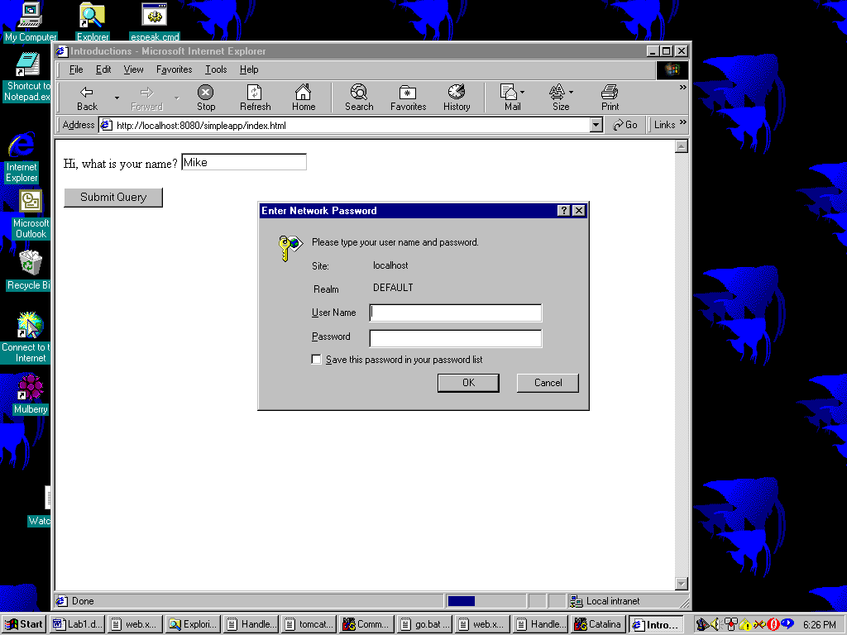
3) After we place the servlet within a realm the Authorization header will contain data that is available to the servlet. It will contain a Base64 encoding of the string "username:password". Include the following code in your servlet.

// Display authorization data from the server
String auth = "";
auth = req.getHeader("Authorization");
String userPassEncoded = auth.substring(6);

sun.misc.BASE64Decoder dec = new sun.misc.BASE64Decoder();
String userPassDecoded = new String(dec.decodeBuffer(userPassEncoded));

fromClient += auth + "<p>";
fromClient += userPassDecoded + "<p>";

Paste a screen shot here showing the output of the servlet after the server performs authorization.

The servlet that you turn in will be tested without any authorization being performed by Tomcat. Therefore, you should make sure that the above code works with or without this authorization. Wrap the above logic in an appropriate “if” statement so the servlet works whether Tomcat is doing user authorization or not.

4) Continue to make modifications to the web applicationso that the html page requests the user’s name and credit card number. After the Submit button is pressed the location bar (which lists the current URL) on the top of the browser contains a query string representing the user’s name and credit number. Paste the contents of the location bar, including the query string generated. (You need not do an entire screen shot for this question)

5) Modify the html file from question (4) so that a Post method is used rather than a Get method. Do not change the servlet at this time. When you click the submit button in the html file you will receive an error message. Paste the error message generated from the Netscape browser.

6) Continuing from question (5), add a doPost() method to your servlet. It should contain the same parameters as doGet() and should throw the same exceptions. Have your doPost() method call doGet(). Paste the contents of the location bar after hitting the submit button. (You need not do an entire screen shot for this question)

7) Continue to modify the servlet so that it displays on the browser screen the number of times this particular servlet has been visited. You will need to add an integer member to the HandleForm class. Paste a screen shot of the output generated by this new servlet after five visits.

8) Continue to modify the servlet so that it displays the total number of times that it has been visited but this time using System.out.println(). The result will not be sent to the browser. What happened? Type your answer here. Include an explanation.

9) Continue to modify the servlet so that it displays the time in seconds that has elapsed since the last visit. Use the Date class in java.util. Paste a screen shot of the output generated by this new servlet.

10) Continue to modify the servlet so that it sets the content type to text/plain on the response object. Does the servlet still keep track of the time? Explain what you see?

Please submit one Word document and one WAR file to blackboard. The Word document will contain all of the screen shots mentioned above and the WAR file will contain your web application named “simpleapp”.

