Lab 3 Due Thursday, March 13, 2003

Extensible Style Sheet Language Transformations (XSLT)

In this lab we will be programming in a transformation language called XSLT. XSLT is used to transform an XML document into another XML document (with a different structure). In order to write programs in XSLT, we need an XML parser (XSLT programs are XML documents) and an XSLT interpreter. The parser is called “Xerces”. The interpreter is called “Xalan” (Xalan uses Xerces). We have downloaded and installed both of these in an earlier lab. My classpath variable, when working with Xalan and servlets is
d:\jwsdp-1_0_01\common\lib\servlet.jar;.;d:\jwsdp-1_0_01\common\endorsed\xalan.jar;d:\jwsdp 1_0_01\common\endorsed\xercesImpl.jar
In Part I we will test the installation. In Part II we will experiment with using XSLT from within a Java program. Finally, in Part III, you will be asked to write several XSLT programs and servlets.

You are required to use the same names as used here for files and directories. Otherwise, the lab will be very difficult to grade and it will be harder for me to give you help.

Part I Experimenting with XSLT

1) You will need to create a batch file so that you can type a simple command like “xalan f1.xml f2.xsl f3.wml”. The command shows an XML document being transformed by an XSLT program. The result is a WML (Wireless Markup Language) document.

Place the following file (xalan.bat) in a directory called c:\batch.

Contents of c:\batch\xalan.bat
java org.apache.xalan.xslt.Process –IN %1 -XSL %2 -OUT %3

Place the new directory, c:\batch, in the path variable so that the command interpreter knows where to look for DOS commands. This can be done on an NT machine by choosing start/settings/control panel/system/environment and changing the system variable “path” to include c:\batch.

Figure 3.1 is an xml file called books.xml that contains data on books. It’s a copy of the file found on Page 70 of the XSLT Programmer’s Reference by Michael Kay.

<?xml version="1.0"?>
<books>
<book category="reference">
<author>Nigel Rees</author>
<title>Sayings of the Century</title>
<price>8.95</price>
</book>
<book category="fiction">
<author>Evelyn Waugh</author>
<title>Sword of Honour</title>
<price>12.99</price>
</book>
<book category="fiction">
<author>Herman Melville</author>
<title>Moby Dick</title>
<price>8.99</price>
</book>
<book category="fiction">
<author>J. R. R. Tolkien</author>
<title>The Lord of the Rings</title>
<price>22.99</price>
</book>
</books>
Figure 3.1

Figure 3.2 is an xslt program called booklist.xsl that converts the xml tree derived from Figure 3.1 into a new tree as shown in Figure 3.3.

<xsl:stylesheet xmlns:xsl="http://www.w3.org/1999/XSL/Transform" version="1.0">
<xsl:template match="books">
<html>
<body>
<h1>A list of books</h1>
<table width="640">
<xsl:apply-templates/>
</table>
</body>
</html>
</xsl:template>

<xsl:template match="book">
<tr>
<td>
<xsl:number/>
</td>
<xsl:apply-templates/>
</tr>
</xsl:template>
<xsl:template match="author | title | price">
<td>
<xsl:value-of select="."/>
</td>
</xsl:template>
</xsl:stylesheet>
Figure 3.2

Place the two files in a directory and make sure that xalan is working properly by running the following command. The output file should look like Figure 3.3 (result.html).

xalan books.xml booklist.xsl result.html

When debugging XSLT programs, it is often more helpful to view your output in an editor like Notepad than to view your output in a browser like Netscape. Look at the HTML document in Netscape only after you are satisfied with the way it looks in Notepad.

<html>
<body>
<h1>A list of books</h1>
<table width="640">
<tr>
<td>1</td>
<td>Nigel Rees</td>
<td>Sayings of the Century</td>
<td>8.95</td>
</tr>
<tr>
<td>2</td>
<td>Evelyn Waugh</td>
<td>Sword of Honour</td>
<td>12.99</td>
</tr>
<tr>
<td>3</td>
<td>Herman Melville</td>
<td>Moby Dick</td>
<td>8.99</td>
</tr>
<tr>
<td>4</td>
<td>J. R. R. Tolkien</td>
<td>The Lord of the Rings</td>
<td>22.99</td>
</tr>
</table>
</body>
</html>
Figure 3.3

Part II Running Xalan from within Java

In Figure 3.4 we have a Java program that uses Xalan (and Xerces) to perform the same transformation we did above from the command line. Later in this lab, we will use this technique to perform transformations through a servlet. Please make sure that you are able to run this program producing the file “out.html”.

// ProduceHTML.java is a simple program that demonstrates how XSLT programs
// can be executed from within Java.

import java.io.IOException;
import java.io.OutputStream;
import java.io.FileInputStream;
import java.io.FileOutputStream;

import javax.xml.transform.Source;
import javax.xml.transform.stream.StreamSource;
import javax.xml.transform.stream.StreamResult;
import javax.xml.transform.Result;
import javax.xml.transform.TransformerFactory;
import javax.xml.transform.Transformer;
import javax.xml.transform.TransformerException;

public class ProduceHTML {

public static void main(String a[] ) {

Source xmlDoc, xslDoc;
Result result;
try {
FileInputStream xml = new FileInputStream("books.xml");
FileInputStream xsl = new FileInputStream("booklist.xsl");
FileOutputStream out = new FileOutputStream("out.html");

xmlDoc = new StreamSource(xml);
xslDoc = new StreamSource(xsl);
result = new StreamResult(out);

TransformerFactory factory = TransformerFactory.newInstance();
Transformer trans = factory.newTransformer(xslDoc);
trans.transform(xmlDoc,result);
}
catch(TransformerException e) {
System.out.println("Transformer Probem" + e);
}
catch(IOException e) {
System.out.println("An I/O problem");
}
}
}

Figure 3.4

Lab 3 Activities Sheet

Directions: Complete the activities listed on this sheet and type or paste your answers directly in the space provided. The Activities Sheet must be submitted as a single Microsoft Word document. It must be called Lab3Submission.doc. Only turn in the Lab3 Activities Sheet portion of this document. Please don’t submit Part I or Part II. There are 10 questions at 10 points each.

- Write an XSLT style sheet that displays all of the attribute values in the book.xml file. The html, when displayed in the browser should like the following:

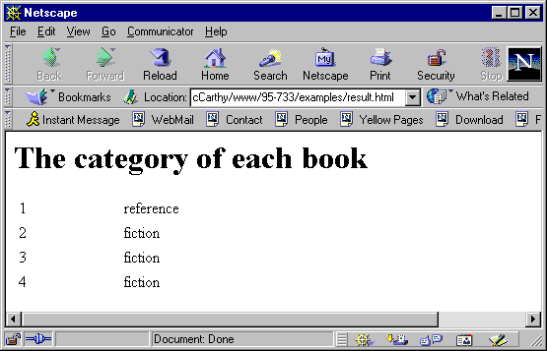

  - Paste the XSLT program here.

  - Paste the HTML file here.

- Write an XSLT style sheet that displays all of the authors in the book.xml file. The html, when displayed in the browser should like the following:

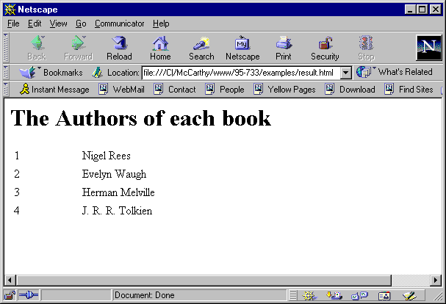

  - Paste the XSLT program here.

  - Paste the HTML file here.

- Write an XSLT style sheet that displays all of the data in the book.xml file sorted by title. The html, when displayed in the browser, should look like the following:

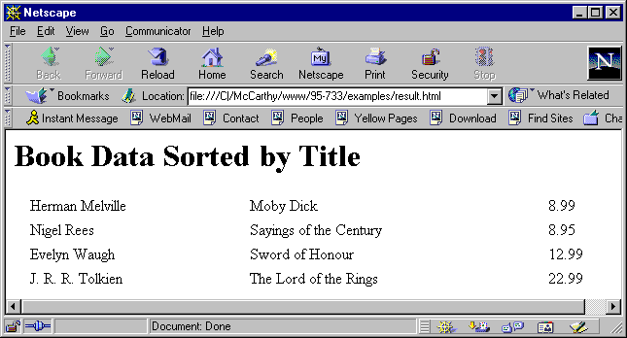

(a) Paste your XSLT program here.

(b) Paste your HTML file here.

The following xml file describes courses available from a computer science department at a fictional university. This file is called Course_Descriptions.xml.

<?xml version="1.0"?>
<Course_Descriptions>
<Course>
<Course-ID id="Math100"/>
<Title>Algebra I</Title>
<Description> Students in this course study introductory algebra.
</Description>
<Prerequisites/>
<Instructor>
<Name> Adam Bell </Name>
<Office> 100 CL4</Office>
<Email> ab@duke.edu </Email>
<Phone> 412-111-1122 </Phone>
</Instructor>
</Course>

<Course>
<Course-ID id = "Geom100"/>
<Title>Geometry I</Title>
<Description> Students in this course study how to prove several
theorems in geometry.
</Description>
<Prerequisites/>
</Course>

<Course>
<Course-ID id="Calc100"/>
<Title>Calculus I</Title>
<Description> Students in this course study the derivative.
</Description>
<Prerequisites pre="Math100 Geom100" />
<Text>
<Text-Title> Introduction to The Calculus </Text-Title>
<Text-ISBN> 0-201-43315-X </Text-ISBN>
<Text-Pub> Addison Wesley Longman </Text-Pub>
</Text>
<Text>
<Text-Title> Using MathMatica </Text-Title>
<Text-ISBN> 0-245-48815-X </Text-ISBN>
<Text-Pub> Wolfgram Software </Text-Pub>
</Text>
</Course>
<Course>
<Course-ID id = "Calc200" />
<Title>Calculus II</Title>
<Description> Students in this course study the integral.
</Description>
<Prerequisites pre="Calc100" />
<Text>
<Text-Title> Introduction to The Calculus </Text-Title>
<Text-ISBN> 0-201-43315-X </Text-ISBN>
<Text-Pub> Addison Wesley Longman </Text-Pub>
</Text>
</Course>
<Course>
<Course-ID id = "Calc300" />
<Title>Calculus III</Title>
<Description> Students in this course study the derivative and
the integral (in 3-space).
</Description>
<Prerequisites pre="Calc200" />
<Instructor>
<Name> Ellen Bell </Name>
<Office> 104 Jones </Office>
<Email> Eb@duke.edu </Email>
<Phone> 412-344-5612 </Phone>
</Instructor>
<Text>
<Text-Title> Introduction to The Calculus </Text-Title>
<Text-ISBN> 0-201-43315-X </Text-ISBN>
<Text-Pub> Addison Wesley Longman </Text-Pub>
</Text>
</Course>
<Course>
<Course-ID id = "CS1" />
<Title>Introduction to Computer Science I</Title>
<Description> In this course we study Turing machines.
</Description>
<Prerequisites pre="Calc100" />
</Course>
<Course>
<Course-ID id = "CS2" />
<Title>Introduction to Computer Science II</Title>
<Description> In this course we study basic data structures.
</Description>
<Prerequisites pre="Calc200 CS1"/>
</Course>
<Course>
<Course-ID id = "Philo45" />
<Title>Ethical Implications of Information Technology</Title>
<Description> In this course we will study the impact of XML
on life.
</Description>
<Prerequisites/>
<Instructor>
<Name> Susan Smith </Name>
<Office> 102 Smith Hall </Office>
<Email> suem@duke.edu </Email>
<Phone> 412-344-2121 </Phone>
</Instructor>
<Text>
<Text-Title> The XML Bible </Text-Title>
<Text-ISBN> 1-833-93399-X </Text-ISBN>
<Text-Pub> Addison Wesley Longman </Text-Pub>
</Text>
<Text>
<Text-Title> The Human Use of Human Beings </Text-Title>
<Text-ISBN> 4-833-93445-X </Text-ISBN>
<Text-Pub> Addison Wesley Longman </Text-Pub>
</Text>
</Course>
</Course_Descriptions>

(4-9) Write a Java servlet, Courses.java, that uses Xalan to call on four different XSLT programs to provide four different views of the data contained in Course_Descrptions.xml.

The user of the browser will select the particular XSLT program that is executed by the servlet. The first XSLT program that you will write, titles.xsl, processes the Course_Descriptions.xml file and generates a list of course titles marked up nicely in HTML. The second XSLT program, texttitles.xsl, processes the Course_Descriptions.xml file and generates a list of textbook titles marked up nicely in HTML. The third XSLT program, ISBN.xsl, processes the Course_Descriptions.xml file and generates a list of textbook ISBN numbers marked up nicely in HTML (with numbering as shown below). Finally, write an XSLT program called wireless.xsl that generates the entire document in WML. Information about the proper format of WML documents can be found at http://www.wirelessdevnet.com/channels/wap/training/. You need not become an expert at WML. You do need to master enough WML to program simple document navigation on a phone.

In the WML case, The servlet should set the response object’s content type to text/vnd.wap.wml. This HTTP content type header should be set before you access a PrintWriter from the response object. In the other three cases the content type should be set as text/html.

Note that you need not provide an HTML front end. The view that the user is interested in is accessed from within the servlet with the getPathInfo() method of the HttpServletRequest object.

The user (browser) will be able to select which view it wants as follows:

http://localhost:8080/books/servlet/Courses/titles The servlet gets us Course Titles
http://localhost:8080/books/servlet/Courses/texts The servlet gets us Text Book Titles
http://localhost:8080/books/servlet/Courses/isbn The servlet gets us ISBN numbers
http://localhost:8080/books/servlet/Courses/wireless The servlet gets us the whole document in
WML. In this case the browser is a phone simulator.

You will need to organize your web application in the same way that you did in Lab 1. Please name your main directory “CourseXSLT”. Your course description xml data will be placed in the file: “CourseXSLT/Course_Descriptions.xml”. Your four XSLT programs will be placed in the same directory. In the build.properties file, be sure to provide the line “app.path=/books” and within your web.xml file, map your servlet name to the URL pattern “/servlet/Courses/*”.

Start Tomcat from the CourseXSLT directory so that the servlet can access the XSLT and XML files from there.

The phone simulator must be downloaded from http://developer.openwave.com/download/index.html#sdk (choose the sdk3.2 SDK.) Then choose “HDML 3.0 – Windows”. The simulator will act as your browser when requesting the data marked up in WML. Experiment with the simulator. Note that you can set the language the phone accepts (English, Spanish, etc.). Note that you can view the arriving source via the “info” menu. You can also set the Home URL using the Settings/UP.Link settings. My settings look as follows:

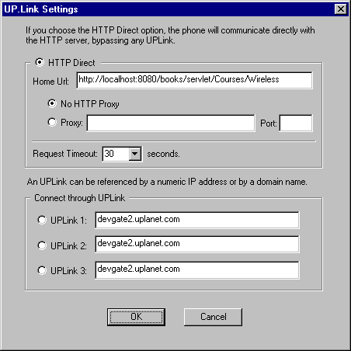

The three browser screens below show solutions for the titles, isbn and wireless problems in Netscape and the phone simulator. For the first two cases your browser must look exactly the same as these. Note how the ISBN’s are numbered. The third case is incomplete. It currently does not allow the user to navigate from one course to the next. The WML document that was generated by the servlet is shown below the screen of the phone. Your solution must allow for simple navigation from one course to the next and so this WML document only represents a first attempt.

A visit by Netscape to the servlet selecting titles:

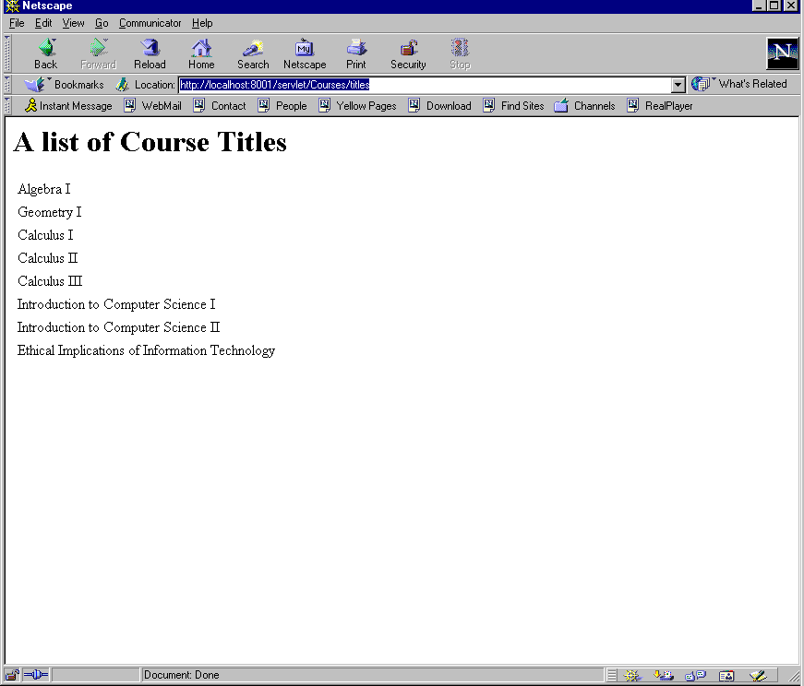

A visit by Netscape to the servlet selecting ISBN numbers (note how the numbers increase when a course has more than one book):

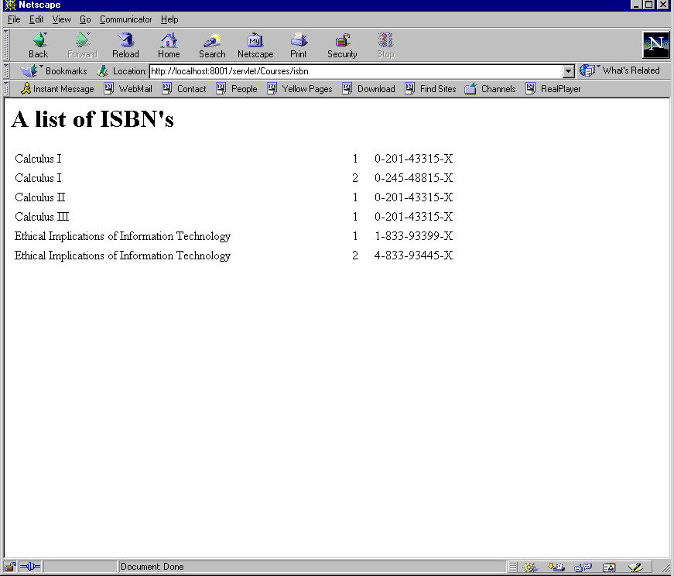

A visit by a phone simulator to the servlet selecting a wireless description:

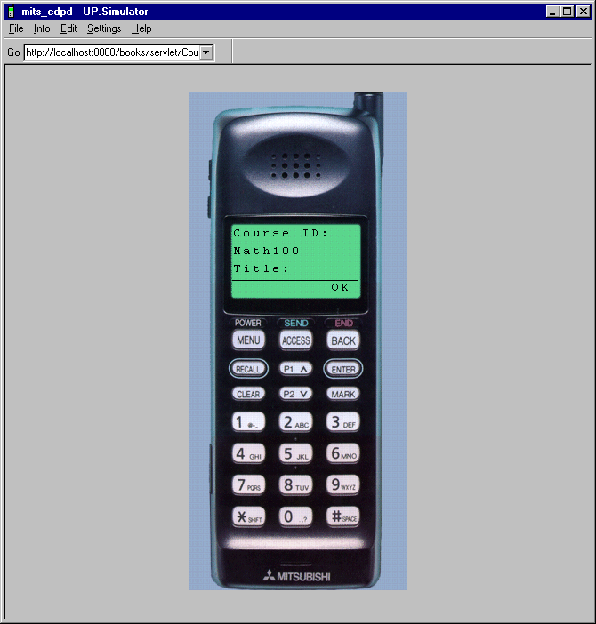

The WML document fetched by the phone (with whitespace added for readability) is shown below. Your solution must allow for simple course-to-course navigation and so while this works, it is incomplete.

<?xml version="1.0" encoding="utf-8"?>
<!DOCTYPE wml PUBLIC "-//WAPFORUM//DTD WML 1.1//EN" "http://www.wapforum.org/DTD/wml.xml">
<wml>
<card>
<p>Course ID: Math100</p>
<p>Title: Algebra I</p>
<p>Description: Students in this course study introductory algebra.
</p>
<p>Prerequisites: </p>
<p>Instructor:
Adam Bell
100 CL4
ab@duke.edu
412-111-1122
</p>
</card>

<card>
<p>Course ID: Geom100</p>
<p>Title: Geometry I</p>
<p>Description: Students in this course study how to prove several
theorems in geometry.
</p>
<p>Prerequisites: </p>
</card>

<card>
<p>Course ID: Calc100</p>
<p>Title: Calculus I</p>
<p>Description: Students in this course study the derivative.
</p>
<p>Prerequisites: Math100 Geom100</p>
<p>Text:
Introduction to The Calculus
0-201-43315-X
Addison Wesley Longman
</p>
<p>Text:
Using MathMatica
0-245-48815-X
Wolfgram Software
</p>
</card>
<card>
<p>Course ID: Calc200</p>
<p>Title: Calculus II</p>
<p>Description: Students in this course study the integral.
</p>
<p>Prerequisites: Calc100</p>
<p>Text:
Introduction to The Calculus
0-201-43315-X
Addison Wesley Longman
</p>
</card>
<card>
<p>Course ID: Calc300</p>
<p>Title: Calculus III</p>
<p>Description: Students in this course study the derivative and
the integral (in 3-space).
</p>
<p>Prerequisites: Calc200</p>
<p>Instructor:
Ellen Bell
104 Jones
Eb@duke.edu
412-344-5612
</p>
<p>Text:
Introduction to The Calculus
0-201-43315-X
Addison Wesley Longman
</p>
</card>
<card>
<p>Course ID: CS1</p>
<p>Title: Introduction to Computer Science I</p>
<p>Description: In this course we study Turing machines.
</p>
<p>Prerequisites: Calc100</p>
</card>
<card>
<p>Course ID: CS2</p>
<p>Title: Introduction to Computer Science II</p>
<p>Description: In this course we study basic data structures.
</p>
<p>Prerequisites: Calc200 CS1</p>
</card>
<card>
<p>Course ID: Philo45</p>
<p>Title: Ethical Implications of Information Technology</p>
<p>Description: In this course we will study the impact of XML
on life.
</p>
<p>Prerequisites: </p>
<p>Instructor:
Susan Smith
102 Smith Hall
suem@duke.edu
412-344-2121
</p>
<p>Text:
The XML Bible
1-833-93399-X
Addison Wesley Longman
</p>
<p>Text:
The Human Use of Human Beings
4-833-93445-X
Addison Wesley Longman
</p>
</card>
</wml>

Phones typically have a small amount of memory and you will need to work within the memory constraint found on this particular simulator. In the past, some students simply downloaded a bigger phone! It should also be noted that the document above had whitespace removed by XSLT before it was sent to the phone. This was accomplished with the following code in the XSLT program:

<!— This xslt program converts the course descriptions to WML. Wireless.xsl→
<xsl:stylesheet
xmlns:xsl="http://www.w3.org/1999/XSL/Transform"
version="1.0"
>

<xsl:output method = "xml"
omit-xml-declaration = "no"
doctype-public="-//WAPFORUM//DTD WML 1.1//EN"
doctype-system="http://www.wapforum.org/DTD/wml.xml"
/>

<xsl:strip-space elements="*"/>

(10) In this final exercise you will build a small web application that distributes the schedule.xml file from homework 2 to a phone in two languages. (You may add a third if you like.) If the phone is set for Spanish a servlet will select the appropriate stylesheet and display the schedule in Spanish, otherwise the schedule will be sent to the phone in English. You are required to read from the http request header to determine what language the phone accepts. You are also required to construct your two stylesheets in the following way and with the following names:

Spanishschedule.xsl imports schedule.xsl. The variables defined in spanishschedule.xsl will take precedence over those same variables defined in schedule.xsl. schedule.xsl contains the actual program logic that builds the WML document. It does this using a language neutral approach. That is, it uses variable values for the English text.

Spanishschedule.xsl is very simple. It sets some variable values and imports another stylesheet. It is shown below. These variables can be accessed by expressions like <xsl:value-of select = "$lang.available"/>.

<!-- spanishschedule.xsl --> <!—Use this stylesheet for Spanish speaking phones →

<xsl:stylesheet
xmlns:xsl="http://www.w3.org/1999/XSL/Transform"
version="1.0"
>

<xsl:import href="schedule.xsl"/> <!—this stylesheet, on its own, handles English requests →

<xsl:output method = "xml"
omit-xml-declaration = "no"
doctype-public="-//WAPFORUM//DTD WML 1.1//EN"
doctype-system="http://www.wapforum.org/DTD/wml.xml"
/>

<xsl:strip-space elements="*"/>

<!-- Isolate local specific content . These same variables are defined in schedule.xsl but in English. →
<xsl:variable name = "lang.monday" select="'Lunes'" />
<xsl:variable name = "lang.tuesday" select="'Martes'" />
<xsl:variable name = "lang.wednesday" select="'Miercoles'" />
<xsl:variable name = "lang.thursday" select="'Jueves'" />
<xsl:variable name = "lang.friday" select="'Viernes'" />
<xsl:variable name = "lang.saturday" select="'Sabado'" />
<xsl:variable name = "lang.sunday" select="'Domingo'" />
<xsl:variable name = "lang.available" select = "'tiempo disponible'" />

</xsl:stylesheet>

Below is the phone being accessed for Spanish.

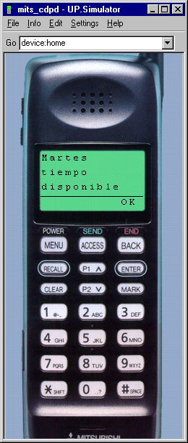

4 Paste a copy of your documented servlet called Course.java here.

5. Paste a copy of your titles.xsl program here.

Paste a screen of Netscape viewing titles here.

6. Paste a copy of your texts.xsl program here.

Paste a screen of Netscape viewing text titles here.

7. Paste a copy of your isbn.xsl program here.

Paste a screen of Netscape viewing ISBN numbers here.

8. Paste a copy of your wireless.xsl program here.

9. Paste several screens of a phone viewing courses here. These screen shots will show the user navigating
among the courses.

10. Paste screen shots of your phone showing a user navigating the schedule in Spanish and in English. Also, paste
three files here:

spanishschedule.xsl

schedule.xsl

ScheduleHandler.java servlet

Motivation for Lab 3

This lab was motivated by the description (found in Goldfarb’s XML text) of IBM’s web site.

How does IBM manage a web site providing 2 gigabytes (about 70 Pittsburgh telephone books) of data?

1. Prior to any HTTP requests, an automated process
on the web server retrieves each XML document.

2. Each XML document is associated with one or more
XSL documents.

3. Each XML document is processed with one or more
of the XSL documents.

4. The HTML documents are cached.

5. An HTTP request comes in from the client.

6. The correct HTML document is sent to the client.

Client
Web
Server
1
XSL
Processor
HttpRequest
HTML doc
XML document
XSL stylesheet
XSL & XML
HTML doc
5
6
2
4
3

