95-733 Internet Technologies Lab 1 Due Thursday, January 30, 2003

Java Web Services Installation and Servlets

In this lab we will be using an HTTP server called Tomcat. Tomcat is contained in Sun’s Java Web Services Developer Pack (JWSDP). In Part 1, we will present the details associated with the installation and basic configuration of Tomcat running under Windows NT or Windows 2000 (you may also use Linux). In Part 2 we will experiment with authentication and servlets.

Part I Installing Tomcat on Windows NT/Windows 2000

1) First, you must install the latest edition of Java on your machine. Obtain a copy of the Java 2 SDK Standard Edition (Java 2 SDK) compiler. This compiler is available from Sun Microsystem’s web site at http://java.sun.com/j2se/1.4/download.html. Be sure to download the SDK and not the JRE. You should also download and install the Java documentation. This is available from the same page. Note that the same page contains instructions on installation of the SDK and the documentation. Some of these files arrive in a compressed format. You can use winzip to expand them. You can download an evaluation copy of winzip from http://www.winzip.com/winzip/download.html. Be sure to set your path variable (so that the Java compiler and Java interpreter can be run from any directory using simple commands). Also be sure to set your classpath variable (so that javac and java can find the locations of the classes that your programs will use). The following web site contains directions on how to set the path and classpath variables: http://java.sun.com/j2se/1.3/install-windows.html.

2) Next, we will download and install the Java Web Services Developer Pack. This is the “web services developer pack jwsdp-1_0_01”. This should be downloaded from Sun’s web page at http://java.sun.com/webservices/downloads/webservicespack.html. Please note that you are asked for a username and password during installation. Please remember these for later use (see figure 1.4 below).

3) At this point you will need to set four environment variables. On an NT machine, this is done by clicking “Start/Settings/Control Panel/System/Environment” and adding values to the User Variables. On Windows 2000, this is done by clicking Start/Settings/Control Panel/System/Advanced/Environment Variables and adding values to the User Variables. You will need the following:

JAVA_HOME D:\j2sdk1.4.0_01 this is where I installed the SDK
JWSDP_HOME D:\jwsdp-1_0_01 this is where I installed the developer pack

Also, place the following at the front of your path variable:
Path D:\j2sdk1.4.0_01\bin;D:\jwsdp-1_0_01\bin

Your classpath variable should be set with d:\jwsdp-1_0_01\common\lib\servlet.jar;. (note the dot).

TESTING THE INSTALLATION

Using the MyComputer icon, look over the files in the new directory. You should see a directory structure containing many files and subdirectories. For example, your path to the webapps directory should look like the following:

D:\jwsdp-1_0_01\webapps

4) Since you have set the path variable to D:\jwsdp-1_0_01\bin you should be able to start the Tomcat web server by executing “startup” at the DOS prompt. Type startup. A small box labeled Tomcat should appear on your screen.

5) Enter the following URL in a browser http://localhost:8080/index.html. Your browser screen should display some information on web services:

JavaTM Web Services Developer Pack 1.0_01

The source of this html can be found in the file:

D:\jwsdp-1_0_01\webapps\ROOT\index.html.

6) The index.html file and its parent directory are contained in a directory structure similar to the one shown below (the ‘classes’ and ‘lib’ directories are not found under ‘webapps/ROOT’ but are typical of the web applications we will write):

D:\jwsdp-1_0_01
|
conf
|
--- server.xml this is a serverwide configuration file
|
|
webapps the directory holding web applications
|
ROOT a web application whose contents are publicly | accessible
|
--- index.html home page for this web application (JSP pages go here too)
|
WEB-INF contents not served directly to clients but
| contains classes and configuration information
---web.xml deployment descriptor containing configuration
information for this web application
|
classes this directory contains servlet classes (built by ant in this homework)
|
--- someservlet.class
|
lib this directory holds classes held in jar files
|
--- my.jar

Part II Building a Web Application

- In what follows, I would like you to work under a directory structure away from the web services developer pack. Let’s begin by creating a new directory called “ANewApp”. Under AnewApp, create the following directories: docs, src, and web. Under “AnewApp/web” create a new file called “index.html” as shown in Figure 1.1. Under the directory “AnewApp/web”, create another directory called “WEB-INF”. Note that WEB-INF must be in caps even though it will not appear to be entirely in upper case in some displays. Within the “AnewApp/src” directory, create a servlet called HandleForm.java as shown in Figure 1.2. Under the “web/WEB-INF” directory, create a deployment descriptor called web.xml as shown in Figure 1.3.

<!-- index.html -->
<html>
<head>
<title>Introductions</title>
</head>
<body>
<form method="get" action="ProcessForm">
Hi, what is your name?
<input type="text" name = "name"> <p>
<input type = "submit">
</form>
</body>
</html>
Figure 1.1

// HandleForm.java
// An introductory servlet

import java.io.*;
import javax.servlet.*;
import javax.servlet.http.*;

public class HandleForm extends HttpServlet {

public void doGet(HttpServletRequest req,
HttpServletResponse response)
throws ServletException,
IOException {

String name = req.getParameter("name");

response.setContentType("text/html");

PrintWriter out = response.getWriter();

String docType = "<!DOCTYPE HTML PUBLIC \"//W3C//DTD HTML 4.0 ";
docType += "Transitional//EN\">\n";

out.println(docType +
"<HTML>\n" +
"<HEAD><TITLE>Hello" + name + "</TITLE></HEAD>\n" +
"<BODY>\n" +
"<H1>Hello "+ name + "</H1>\n" +
"</BODY></HTML>");
}

}
Figure 1.2

<?xml version="1.0" encoding="UTF-8"?>

<!DOCTYPE web-app
PUBLIC "-//Sun Microsystems, Inc.//DTD Web Application 2.2//EN"
"http://java.sun.com/j2ee/dtds/web-app_2.2.dtd">

<web-app>

<servlet>
<servlet-name>TestServlet</servlet-name>
<servlet-class>HandleForm</servlet-class>
</servlet>
<servlet-mapping>
<servlet-name>TestServlet</servlet-name>
<url-pattern>/ProcessForm/*</url-pattern>
</servlet-mapping>
</web-app>

Figure 1.3

- Next we will create a build.properties file with the contents shown in Figure 1.4. Place your own user name and password in the file as shown and save it directly under the AnewApp directory.
# build.properties Context path to install this application on
app.path=/MyCoolApp

# Tomcat 4 installation directory
catalina.home=d:/jwsdp-1_0_01

# Manager webapp username and password
manager.username=put your user name here with no quotes
manager.password=put your password here with no quotes

Figure 1.4

- Next we will place a file called build.xml directly under the AnewApp directory. This file will contain instructions for ant. Save the file shown in Figure 1.5 as build.xml. If ant does not work after copying this file, try deleting the first few characters of the file and then replacing them.

<!—build.xml
General purpose build script for web applications and web services,
including enhanced support for deploying directly to a Tomcat 4
based server.

This build script assumes that the source code of your web application
is organized into the following subdirectories underneath the source
code directory from which you execute the build script:

docs Static documentation files to be copied to
the "docs" subdirectory of your distribution.

src Java source code (and associated resource files)
to be compiled to the "WEB-INF/classes"
subdirectory of your web applicaiton.

web Static HTML, JSP, and other content (such as
image files), including the WEB-INF subdirectory
and its configuration file contents.

$Id: build.xml.txt,v 1.6 2002/03/09 22:39:19 craigmcc Exp $
-->

<!-- A "project" describes a set of targets that may be requested
when Ant is executed. The "default" attribute defines the
target which is executed if no specific target is requested,
and the "basedir" attribute defines the current working directory
from which Ant executes the requested task. This is normally
set to the current working directory.
-->

<project name="My Project" default="compile" basedir=".">

<!-- ===================== Property Definitions =========================== -->

<!--

Each of the following properties are used in the build script.
Values for these properties are set by the first place they are
defined, from the following list:

* Definitions on the "ant" command line (ant -Dfoo=bar compile).

* Definitions from a "build.properties" file in the top level
source directory of this application.

* Definitions from a "build.properties" file in the developer's
home directory.

* Default definitions in this build.xml file.

You will note below that property values can be composed based on the
contents of previously defined properties. This is a powerful technique
that helps you minimize the number of changes required when your development
environment is modified. Note that property composition is allowed within
"build.properties" files as well as in the "build.xml" script.

-->

<property file="build.properties"/>
<property file="${user.home}/build.properties"/>

<!-- ==================== File and Directory Names ======================== -->

<!--

These properties generally define file and directory names (or paths) that
affect where the build process stores its outputs.

app.name Base name of this application, used to
construct filenames and directories.
Defaults to "myapp".

app.path Context path to which this application should be
deployed (defaults to "/" plus the value of the
"app.name" property).

app.version Version number of this iteration of the application.

build.home The directory into which the "prepare" and
"compile" targets will generate their output.
Defaults to "build".

catalina.home The directory in which you have installed
a binary distribution of Tomcat 4. This will
be used by the "deploy" target.

dist.home The name of the base directory in which
distribution files are created.
Defaults to "dist".

manager.password The login password of a user that is assigned the
"manager" role (so that he or she can execute
commands via the "/manager" web application)

manager.url The URL of the "/manager" web application on the
Tomcat installation to which we will deploy web
applications and web services.

manager.username The login username of a user that is assigned the
"manager" role (so that he or she can execute
commands via the "/manager" web application)

-->

<property name="app.name" value="myapp"/>
<property name="app.path" value="/${app.name}"/>
<property name="app.version" value="0.1-dev"/>
<property name="build.home" value="${basedir}/build"/>
<property name="catalina.home" value="../../../.."/> <!-- UPDATE THIS! -->
<property name="dist.home" value="${basedir}/dist"/>
<property name="docs.home" value="${basedir}/docs"/>
<property name="manager.url" value="http://localhost:8080/manager"/>
<property name="src.home" value="${basedir}/src"/>
<property name="web.home" value="${basedir}/web"/>

<!-- ================== Custom Ant Task Definitions ======================= -->

<!--

These properties define custom tasks for the Ant build tool that interact
with the "/manager" web application installed with Tomcat 4. Before they
can be successfully utilized, you must perform the following steps:

- Copy the file "server/lib/catalina-ant.jar" from your Tomcat 4
installation into the "lib" directory of your Ant installation.

- Create a "build.properties" file in your application's top-level
source directory (or your user login home directory) that defines
appropriate values for the "manager.password", "manager.url", and
"manager.username" properties described above.

For more information about the Manager web application, and the functionality
of these tasks, see <http://localhost:8080/tomcat-docs/manager-howto.html>.

-->

<taskdef name="install" classname="org.apache.catalina.ant.InstallTask"/>
<taskdef name="list" classname="org.apache.catalina.ant.ListTask"/>
<taskdef name="reload" classname="org.apache.catalina.ant.ReloadTask"/>
<taskdef name="remove" classname="org.apache.catalina.ant.RemoveTask"/>

<!-- ==================== Compilation Control Options ==================== -->

<!--

These properties control option settings on the Javac compiler when it
is invoked using the <javac> task.

compile.debug Should compilation include the debug option?

compile.deprecation Should compilation include the deprecation option?

compile.optimize Should compilation include the optimize option?

-->

<property name="compile.debug" value="true"/>
<property name="compile.deprecation" value="false"/>
<property name="compile.optimize" value="true"/>

<!-- ==================== External Dependencies =========================== -->

<!--

Use property values to define the locations of external JAR files on which
your application will depend. In general, these values will be used for
two purposes:
* Inclusion on the classpath that is passed to the Javac compiler
* Being copied into the "/WEB-INF/lib" directory during execution
of the "deploy" target.

Because we will automatically include all of the Java classes that Tomcat 4
exposes to web applications, we will not need to explicitly list any of those
dependencies. You only need to worry about external dependencies for JAR
files that you are going to include inside your "/WEB-INF/lib" directory.

-->

<!-- Dummy external dependency -->
<!--
<property name="foo.jar"
value="/path/to/foo.jar"/>
-->

<!-- ==================== Compilation Classpath =========================== -->

<!--

Rather than relying on the CLASSPATH environment variable, Ant includes
features that makes it easy to dynamically construct the classpath you
need for each compilation. The example below constructs the compile
classpath to include the servlet.jar file, as well as the other components
that Tomcat makes available to web applications automatically, plus anything
that you explicitly added.

-->

<path id="compile.classpath">

<!-- Include all JAR files that will be included in /WEB-INF/lib -->
<!-- *** CUSTOMIZE HERE AS REQUIRED BY YOUR APPLICATION *** -->
<!--
<pathelement location="${foo.jar}"/>
-->

<!-- Include all elements that Tomcat exposes to applications -->
<pathelement location="${catalina.home}/common/classes"/>
<fileset dir="${catalina.home}/common/endorsed">
<include name="*.jar"/>
</fileset>
<fileset dir="${catalina.home}/common/lib">
<include name="*.jar"/>
</fileset>
<pathelement location="${catalina.home}/shared/classes"/>
<fileset dir="${catalina.home}/shared/lib">
<include name="*.jar"/>
</fileset>

</path>

<!-- ==================== All Target ====================================== -->

<!--

The "all" target is a shortcut for running the "clean" target followed
by the "compile" target, to force a complete recompile.

-->

<target name="all" depends="clean,compile"
description="Clean build and dist directories, then compile"/>

<!-- ==================== Clean Target ==================================== -->

<!--

The "clean" target deletes any previous "build" and "dist" directory,
so that you can be ensured the application can be built from scratch.

-->

<target name="clean"
description="Delete old build and dist directories">
<delete dir="${build.home}"/>
<delete dir="${dist.home}"/>
</target>

<!-- ==================== Compile Target ================================== -->

<!--

The "compile" target transforms source files (from your "src" directory)
into object files in the appropriate location in the build directory.
This example assumes that you will be including your classes in an
unpacked directory hierarchy under "/WEB-INF/classes".

-->

<target name="compile" depends="prepare"
description="Compile Java sources">

<!-- Compile Java classes as necessary -->
<mkdir dir="${build.home}/WEB-INF/classes"/>
<javac srcdir="${src.home}"
destdir="${build.home}/WEB-INF/classes"
debug="${compile.debug}"
deprecation="${compile.deprecation}"
optimize="${compile.optimize}">
<classpath refid="compile.classpath"/>
</javac>

<!-- Copy application resources -->
<copy todir="${build.home}/WEB-INF/classes">
<fileset dir="${src.home}" excludes="**/*.java"/>
</copy>

</target>

<!-- ==================== Dist Target ===================================== -->

<!--

The "dist" target creates a binary distribution of your application
in a directory structure ready to be archived in a tar.gz or zip file.
Note that this target depends on two others:

* "compile" so that the entire web application (including external
dependencies) will have been assembled

* "javadoc" so that the application Javadocs will have been created

-->

<target name="dist" depends="compile,javadoc"
description="Create binary distribution">

<!-- Copy documentation subdirectories -->
<mkdir todir="${dist.home}/docs"/>
<copy todir="${dist.home}/docs">
<fileset dir="${docs.home}"/>
</copy>

<!-- Create application JAR file -->
<jar jarfile="${dist.home}/${app.name}-${app.version}.war"
basedir="${build.home}"/>

<!-- Copy additional files to ${dist.home} as necessary -->

</target>

<!-- ==================== Install Target ================================== -->

<!--

The "install" target tells the specified Tomcat 4 installation to dynamically
install this web application and make it available for execution. It does
*not* cause the existence of this web application to be remembered across
Tomcat restarts; if you restart the server, you will need to re-install all
this web application.

If you have already installed this application, and simply want Tomcat to
recognize that you have updated Java classes (or the web.xml file), use the
"reload" target instead.

NOTE: This target will only succeed if it is run from the same server that
Tomcat is running on.

NOTE: This is the logical opposite of the "remove" target.

-->

<target name="install" depends="compile"
description="Install application to servlet container">

<install url="${manager.url}"
username="${manager.username}"
password="${manager.password}"
path="${app.path}"
war="file://${build.home}"/>

</target>

<!-- ==================== Javadoc Target ================================== -->

<!--

The "javadoc" target creates Javadoc API documentation for the Java
classes included in your application. Normally, this is only required
when preparing a distribution release, but is available as a separate
target in case the developer wants to create Javadocs independently.

-->

<target name="javadoc" depends="compile"
description="Create Javadoc API documentation">

<mkdir dir="${dist.home}/docs/api"/>
<javadoc sourcepath="${src.home}"
destdir="${dist.home}/docs/api"
packagenames="*">
<classpath refid="compile.classpath"/>
</javadoc>

</target>

<!-- ====================== List Target =================================== -->

<!--

The "list" target asks the specified Tomcat 4 installation to list the
currently running web applications, either loaded at startup time or
installed dynamically. It is useful to determine whether or not the
application you are currently developing has been installed.

-->

<target name="list"
description="List installed applications on servlet container">

<list url="${manager.url}"
username="${manager.username}"
password="${manager.password}"/>

</target>

<!-- ==================== Prepare Target ================================== -->

<!--

The "prepare" target is used to create the "build" destination directory,
and copy the static contents of your web application to it. If you need
to copy static files from external dependencies, you can customize the
contents of this task.

Normally, this task is executed indirectly when needed.

-->

<target name="prepare">

<!-- Create build directories as needed -->
<mkdir dir="${build.home}"/>
<mkdir dir="${build.home}/WEB-INF"/>
<mkdir dir="${build.home}/WEB-INF/classes"/>

<!-- Copy static content of this web application -->
<copy todir="${build.home}">
<fileset dir="${web.home}"/>
</copy>

<!-- Copy external dependencies as required -->
<!-- *** CUSTOMIZE HERE AS REQUIRED BY YOUR APPLICATION *** -->
<mkdir dir="${build.home}/WEB-INF/lib"/>
<!--
<copy todir="${build.home}/WEB-INF/lib" file="${foo.jar}"/>
-->

<!-- Copy static files from external dependencies as needed -->
<!-- *** CUSTOMIZE HERE AS REQUIRED BY YOUR APPLICATION *** -->

</target>

<!-- ==================== Reload Target =================================== -->

<!--

The "reload" target tells the specified Tomcat 4 installation to dynamically
reload this web application, to reflect changes in the underlying classes or
the "web.xml" deployment descriptor.

-->

<target name="reload" depends="compile"
description="Reload application on servlet container">

<reload url="${manager.url}"
username="${manager.username}"
password="${manager.password}"
path="${app.path}"/>

</target>

<!-- ==================== Remove Target =================================== -->

<!--

The "remove" target tells the specified Tomcat 4 installation to dynamically
remove this web application from service.

NOTE: This is the logical opposite of the "install" target.

-->

<target name="remove"
description="Remove application on servlet container">

<remove url="${manager.url}"
username="${manager.username}"
password="${manager.password}"
path="${app.path}"/>

</target>

</project>

Figure 1.5

- We need to install our application under Tomcat. So, if Tomcat is not yet running, execute the startup command. Then, run ant from within the AnewApp directory. Ant will automatically find the build.xml file. What you need to do is tell ant what target activity you would like to execute. For now, let’s run the command

ant compile

You should see something like the following:

C:\AnewApp>ant compile
Buildfile: build.xml

prepare:
[mkdir] Created dir: C:\AnewApp\build
[mkdir] Created dir: C:\AnewApp\build\WEB-INF
[mkdir] Created dir: C:\AnewApp\build\WEB-INF\classes
[copy] Copying 2 files to C:\AnewApp\build
[mkdir] Created dir: C:\AnewApp\build\WEB-INF\lib

compile:
[javac] Compiling 1 source file to C:\AnewApp\build\WEB-INF\classes

BUILD SUCCESSFUL

Total time: 27 seconds

- Now, you should attempt to install the application under Tomcat. Enter the command
ant install

If things went well, you will see something like the following:

C:\AnewApp>ant install
Buildfile: build.xml

prepare:

compile:

install:
[install] OK - Installed application at context path /MyCoolApp
[install]

BUILD SUCCESSFUL

Total time: 1 minute 40 seconds
C:\AnewApp>

- We can now visit our web application by entering the URL http://localhost:8080/MyCoolApp into out favorite browser. After entering your name and hitting the submit button you should see a browser like the following:

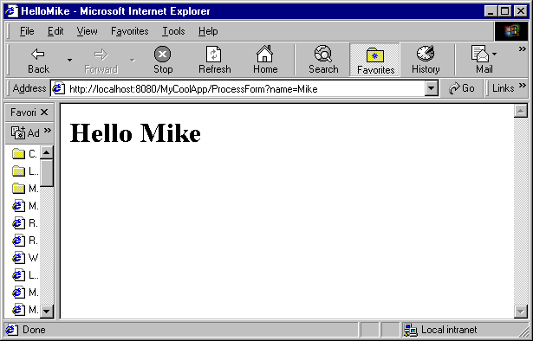

Lab 1 Activities Sheet

Directions: Complete the activities listed on this sheet and type or paste your answers directly in the space provided. The Activities Sheet must be submitted in your envelope as a single Microsoft Word document called Lab1Submission.doc. Only turn in the Lab1 Activities Sheet portion of this document. Please don’t submit Part I or Part II. Also, you must submit printouts of two servlets, HandleForm.java and ReadFpML.java, as well as copies of these files on disk.

To capture a screen shot, hit Alt+PrtScreen on the window you want to copy. You can paste the screen shot into the Word document with the Edit/Paste menu. To capture the entire screen, use Ctrl+PrtScreen. Please only paste a screen shot when and where you are asked to do so.

Note: Points will be deducted if the submission is not neat, organized, and easy to grade. In addition, both servlets should be documented with comments describing the code.

Note: after you make a change to the servlet you will need to rerun ant. Read the ant file build.xml to see what command is most appropriate. Ant install will not work if the web application is already installed.

1) Many HTTP request headers sent by the client are only used by servers (such as Tomcat) and not by servlets (such as HandleForm). On occasion servlets are interested in the values of various HTTP headers. The Accept header, for example, specifies the media types the client prefers to accept. Each media type is represented by a type/subtype pair with “*” used as a wild card. If not passed by the client to the server the server may assume the client accepts all media types. We can access the Accept header from within a servlet by calling the getHeader() method of the HttpServletRequest object. The result is a java String.

fromClient = req.getHeader("Accept") + "<p>";

Add code to the servlet in Figure 1.2 so that it displays the contents of the Accept header on the browser. 5 Points

The User-Agent header gives information about the client software. A servlet can use this information to keep statistics or customize its response based on the type of the client browser.

fromClient += req.getHeader("User-Agent") + "<p>";

Add code to the servlet in Figure 1.2 so that it displays the contents of the User-Agent header on the browser. 5 Points.

The Referer header gives the URL of the document that refers to the requested URL.

fromClient += req.getHeader("Referer") + "<p>";

Add code to the servlet in Figure 1.2 so that it displays the contents of the Referer header on the browser. 5 Points.

Post a screen shot here showing the browser after making the above three modifications.

- You will now add a user name and a password to the newly modified servlet. First, modify Tomcat’s “jwsdp-1_0_01\conf\tomcat-users.xml” file so that it includes Jethro as a user and his role as student. Assign Jethro a password of “seseme”. Next, replace the code in the “web.xml” file (Figure 1.3) with the following:

<?xml version="1.0" encoding="UTF-8"?>

<!DOCTYPE web-app
PUBLIC "-//Sun Microsystems, Inc.//DTD Web Application 2.2//EN"
"http://java.sun.com/j2ee/dtds/web-app_2.2.dtd">

<web-app>

<servlet>
<servlet-name>TestServlet</servlet-name>
<servlet-class>HandleForm</servlet-class>
</servlet>
<servlet-mapping>
<servlet-name>TestServlet</servlet-name>
<url-pattern>/ProcessForm/*</url-pattern>
</servlet-mapping>

<security-constraint> <!-- this tag protects a -->
<web-resource-collection> <!-- web resource collection -->
<web-resource-name>
My protected application
</web-resource-name>
<url-pattern>/ProcessForm/*</url-pattern>
<http-method>GET</http-method>
</web-resource-collection>
<auth-constraint> <!-- to only students. -->
<role-name>
student
</role-name>
</auth-constraint>
</security-constraint>

<login-config>
<auth-method>BASIC</auth-method> <!-- BASIC, DIGETS, FORM, CLIENT-CERT -->
<realm-name>DEFAULT</realm-name>
</login-config>
</web-app>

You will need to shutdown Tomcat so that the new Tomcat-users.xml file is noticed. To do this, enter the command

shutdown

Show a screen shot of your browser requesting a user name and password. This screen shot should show that the html file was available prior to running the protected servlet. Your screen should be similar to the following, except that it should be your screen shot with your name. 10 Points.

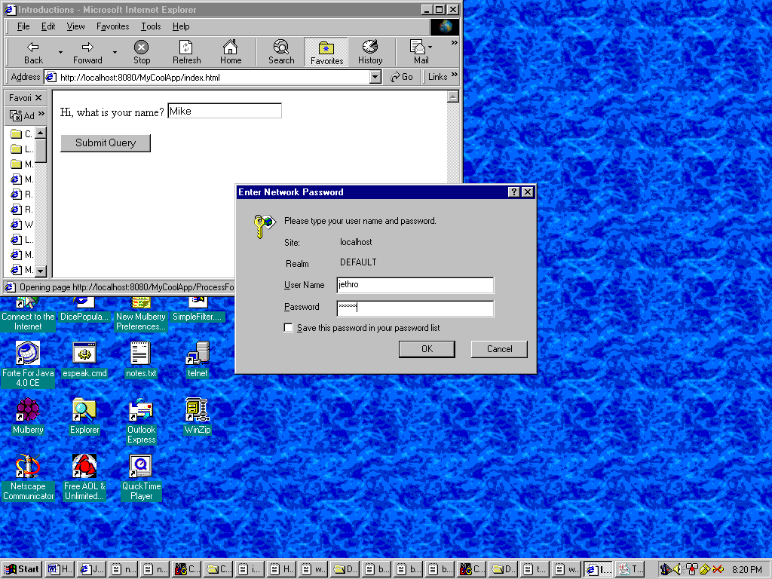

3) After we place the servlet within a realm the Authorization header will contain data that is available to the servlet. It will contain a Base64 encoding of the string "username:password". Include the following code in your servlet.

// Display authorization data from the server
String auth = "";
auth = req.getHeader("Authorization");
String userPassEncoded = auth.substring(6);

sun.misc.BASE64Decoder dec = new sun.misc.BASE64Decoder();
String userPassDecoded = new String(dec.decodeBuffer(userPassEncoded));

fromClient += auth + "<p>";
fromClient += userPassDecoded + "<p>";

Paste a screen shot here showing the output of the servlet after the server performs authorization.

The servlet that you turn in will be tested without any authorization being performed by Tomcat. Therefore, you should make sure that the above code works with or without this authorization. Wrap the above logic in an appropriate “if” statement so the servlet works whether Tomcat is doing user authorization or not. In other words, your new servlet will work whether we are using the old web.xml file (without authentication) or the new one. 10 Points.

4) Continue to make modifications to the web application so that the html page requests the user’s name and credit card number. After the Submit button is pressed the location bar (which lists the current URL) on the top of the browser contains a query string representing the user’s name and credit number. Paste the contents of the location bar, including the query string generated. (You need not do an entire screen shot for this question.) 5 Points

5) Modify the html file from question (4) so that a Post method is used rather than a Get method. Do not change the servlet at this time. When you click the submit button in the html file you will receive an error message. Paste the error message generated from the Netscape browser. If you don’t have access to Netscape then show what IE5 does. 5 Points.

6) Continuing from question (5), add a doPost() method to your servlet. It should contain the same parameters as doGet() and should throw the same exceptions. Have your doPost() method call doGet(). Paste the contents of the location bar after hitting the submit button. (You need not do an entire screen shot for this question.) 5 Points.

7) Continue to modify the servlet so that it displays on the browser screen the number of times this particular servlet has been visited. You will need to add an integer member to the HandleForm class. Paste a screen shot of the output generated by this new servlet after five visits. 5 Points.

8) Continue to modify the servlet so that it displays the time in seconds that has elapsed since the last visit. Use the Date class in java.util. Or, if you prefer, use the Calendar class. Paste a screen shot of the output generated by this new servlet. 10 Points.

9) Continue to modify the servlet so that it sets the content type to text/plain on the response object. Does the servlet in question 8 still keep track of the time since the last visit? Explain what you see? 5 Points.

10) Write a new password protected application ( a servlet called ReadFpML.java with a new index.html file) that allows the user to enter the name of an FpML document in a browser. Your program will then read the FpML document and send it back to the browser as plain text. There is no need to parse the XML with a parser. You may assume that your user is friendly and that the file name is correct. Take at least two different FpML documents from www.fpml.org and use these to display to the user. Paste a screen shot here that shows the browser displaying the user selected FpML. The FpML documents will be stored on files under Tomcat. 30 Points

Submission and documentation - Please submit one Word document on paper and two Java files called HandleForm.java and ReadFpML.java on paper and on disk (all placed in a large envelope). The Word document will contain all of the screen shots mentioned above and the servlets will be documented and indented well.

Notes:

To change the default port from 8080, work with the file conf/server.xml.
Check logs/catalina.out for servlet output (used to be on Tomcat console)
To see who is visiting see the access_log Date files under logs/

