Lab 3 Due: Monday, October 11, 2004

Java Server Faces

Write a Java Server Faces Application that implements the JSP based system that we reviewed in class. In other words, rebuild the JSP application that demonstrated a shopping cart using JSP and JavaBeans, as a JSF application.

Your best source of information on JSF may be in The J2EE Tutorial(see chapters 17 through 21).

The AddToShoppingCart.jsp page looks like this in a browser:

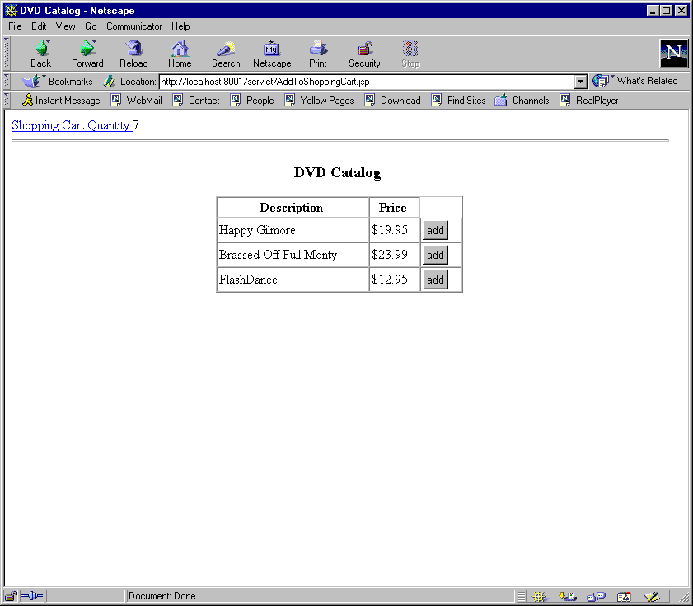

The ShoppingCart.jsp page displays the current contents of the cart and looks like this:
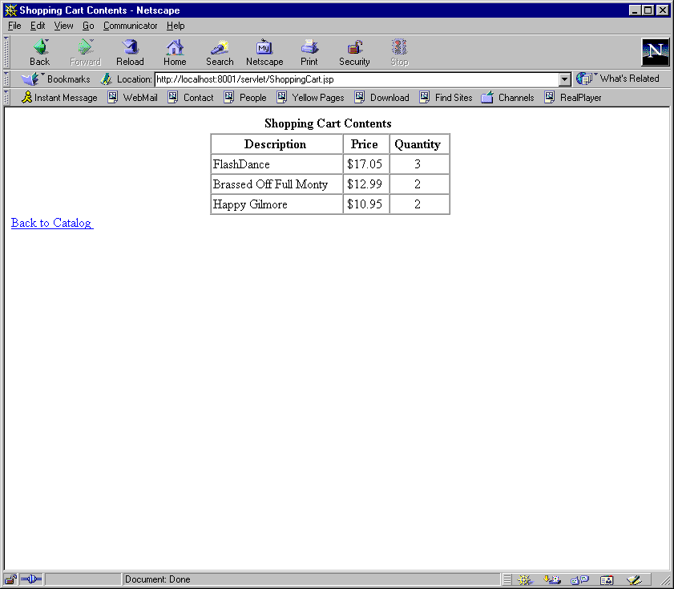

Notes on how I wrote this application using JavaServer Faces:

The AddToShoppingCart.jsp page uses a dataTable tag and references a DataModel. The class DataModel is an abstract class that is made concrete by such classes as the ListDataModel and ArrayDataModel.

The dataTable tag looks like this:

<h:dataTable value = "#{movieTable.movieTableModel}" var="movie">

A command button component is placed on each row by the dataTable tag. So, within the dataTable tag, we have the following sequence of tags:

<h:column>
<h:commandButton id= "number" value="Add"
action="addToShoppingCart"
actionListener="#{movieTable.addToQuantity}"/>
</h:column>

When one of the buttons is clicked, a call back occurs to the action listener method addToQuantity. This method is found within the MovieTable bean. Mine looks like this:

public void addToQuantity(ActionEvent event) {

int row = movieTableModel.getRowIndex();

String current = movieCnt[row].getCount();
int cur = Integer.parseInt(current);
cur++;

String result = (new Integer(cur)).toString();

movieCnt[row].setCount(result);

qty++;
}

Another important part of this code defines the DataModel which wraps an array:

import javax.faces.context.FacesContext;
import javax.faces.event.ActionEvent;

import java.util.*;
import javax.faces.component.*;

import javax.faces.model.DataModel;
import javax.faces.model.ArrayDataModel;

public class MovieTable {

private DataModel movieTableModel = null;

:
:
public DataModel getMovieTableModel() {

if(movieTableModel == null) {
movieTableModel = new ArrayDataModel();
}
movieTableModel.setWrappedData(getMovies());
return movieTableModel;
}

Submission Guidelines

- Show several screen shots of your application running. Copy and paste several browser visits here. 30 Points
- Paste a copy here of your faces-config.xml. 10 Points
- Paste a copy here of all the (well-documented) Java beans that you wrote. 30 Points
- Paste a copy here of all of the JSP pages that you wrote (including index.jsp). 30 Points

